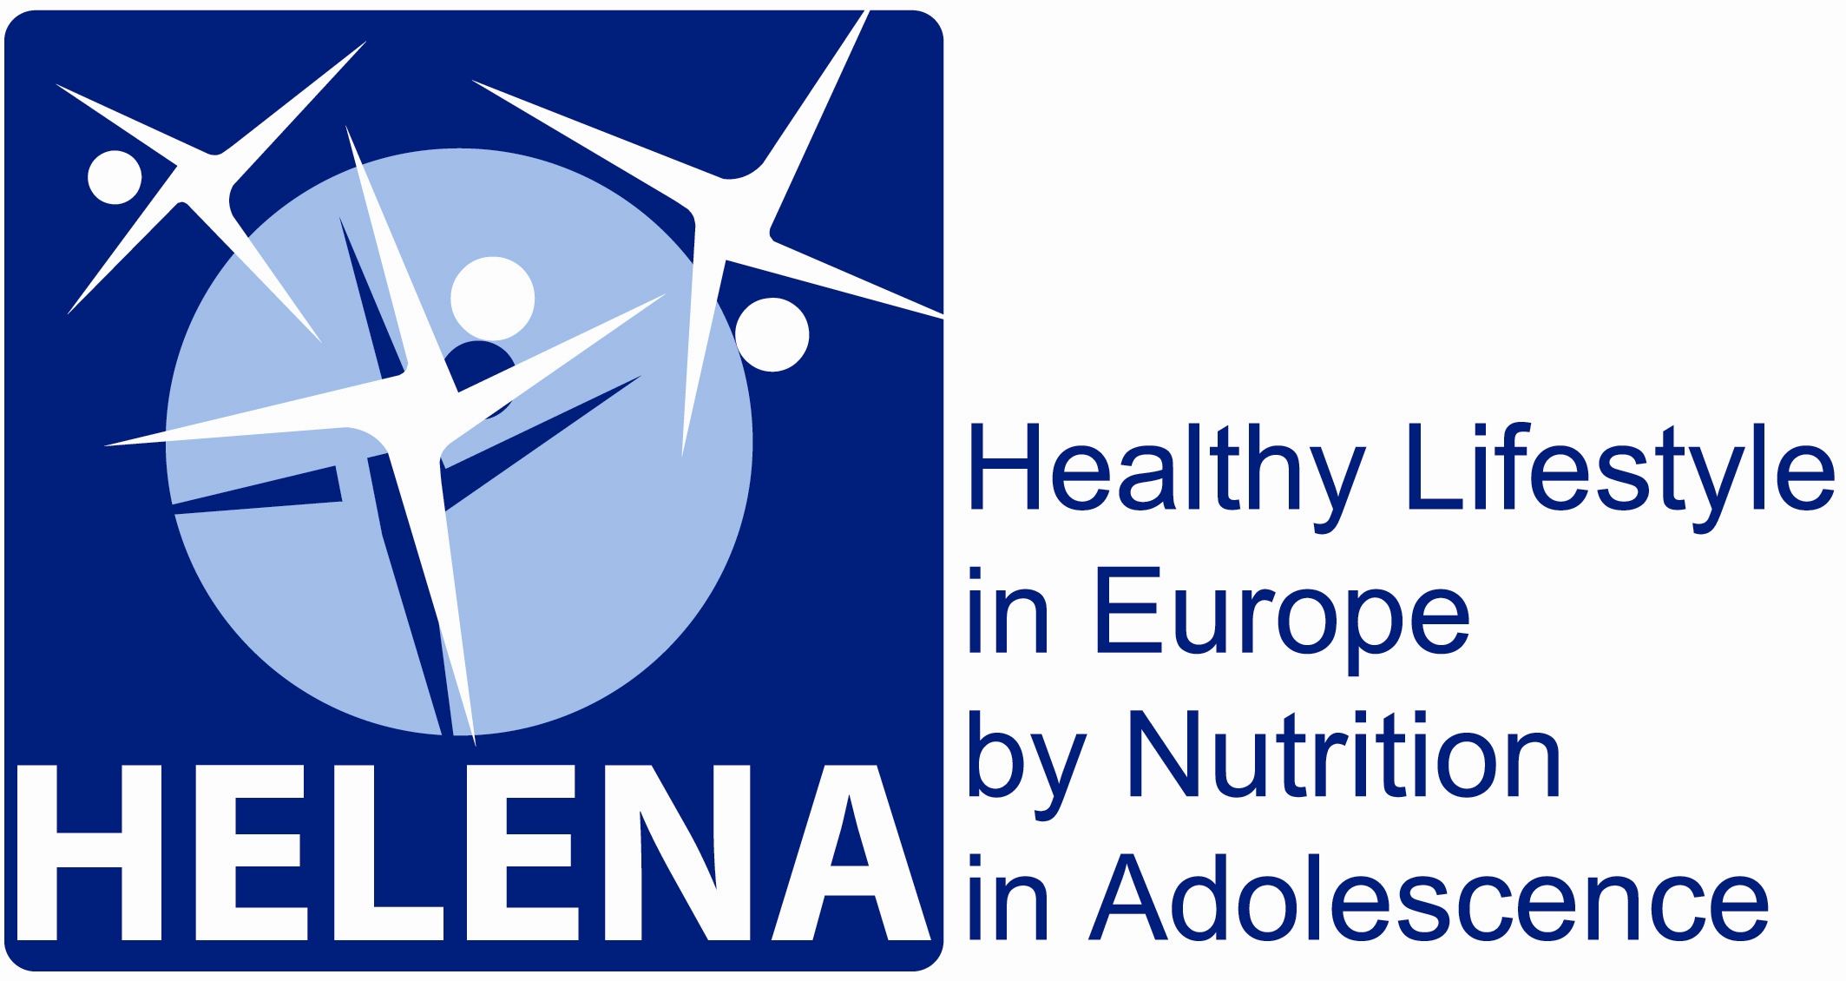

Project no.: 007034

HELENA

Healthy Lifestyle in Europe by Nutrition in Adolescence

Instrument: STREP
Thematic Priority: 5

Publishable final activity report

Period covered: May 2007 to October 2008
Date of preparation: January 2009
Start date of project: May 1st, 2005 Duration: 3 1/2 years

Project coordinator name: Luis A. Moreno Aznar
Project coordinator organisation name: Universidad de Zaragoza

Draft version
Project execution

Project objectives

The main objective of the project was to obtain reliable and comparable data of a representative sample of European adolescents, concerning: foods and nutrients intake, food choices and preferences, obesity prevalence, dislipidemia, insulin resistance, vitamin and minerals status, immunological markers for subclinical malnutrition, physical activity and fitness patterns, and variations of the nucleotide sequence in selected genes. This will contribute to understand why health-related messages are not being as effective as expected in the adolescent population. The requirements for health promoting foods will also be identified, and three sensory acceptable products for adolescents will be developed.

This general objective will be achieved through the following specific objectives:

- To develop and harmonise innovative methods for the assessment of lifestyle habits of adolescents across Europe with special focus on diet, nutrition and physical activity.
- To assess dietary and physical activity patterns as well as nutritional status among European adolescents.
- To investigate knowledge and attitudes towards nutrition and physical activity among adolescents and to establish the main determinants of their food choice and preference.
- To describe regional, cultural, social, genetic and gender differences and similarities across Europe.
- To identify adolescents at risk of eating disorders, dislipemia, obesity and/or type 2 diabetes.
- To develop a number of healthy foods and identify marketing strategies for consumers, in order to improve the diet of adolescents.
- To develop a Lifestyle Education Programme and test its efficacy for improving adolescents´ health.
Contractors involved

Partic.Role* | Partic. no. | Participant name | Participant short name | Country | Date enter project** | Date exit project**
CO | 1 | Universidad de Zaragoza | UNIZAR | Spain | Month 1 | Month 42
CR | 2 | Consejo Superior de Investigaciones Científicas | CSIC | Spain | Month 1 | Month 42
CR | 3 | Université de Lille 2 | UL2 | France | Month 1 | Month 42
CR | 4 | Research Institute of Child Nutrition Dortmund | FKE | Germany | Month 1 | Month 42
CR | 5 | Pécsi Tudományegyetem | PTE | Hungary | Month 1 | Month 42
CR | 6 | University of Crete | UOC | Greece | Month 1 | Month 42
CR | 7 | Rheinische Friedrich Wilhelms Universität | Uni Bonn | Germany | Month 1 | Month 42
CR | 8 | University of Granada | UGR | Spain | Month 1 | Month 42
CR | 9 | Istituto Nazionale di Ricerca per gli Alimenti e la Nutrizione | INRAN | Italy | Month 1 | Month 42
CR | 10 | University of Napoli “Federico II” Department of Food Science | DSA-UNINA | Italy | Month 1 | Month 42
CR | 11 | Ghent University | BE-TUG | Belgium | Month 1 | Month 42
CR | 12 | University of Vienna | AKH-WIEN | Austria | Month 1 | Month 42
CR | 13 | Harokopio University | HUA | Greece | Month 1 | Month 42
CR | 14 | Institut Pasteur de Lille | IPL | France | Month 1 | Month 42
CR | 15 | Karolinska Institutet | KI | Sweden | Month 1 | Month 42
CR | 16 | Asociación de Investigación de la Industria Agroalimentaria | AINIA | Spain | Month 1 | Month 42
CR | 17 | Campeen & Chorleywood Food Research Association | CCFRA | United Kingdom | Month 1 | Month 42
CR | 18 | SIK – Institutet foer livsmedel och bioteknik | SIK | Sweden | Month 1 | Month 42
CR | 19 | Meurice Recherche & Developpement asbl | Meurice R&D | Belgium | Month 1 | Month 42
CR | 20 | Campden & Chorleywood Food Development Institute, Hungary | CCFRA – Hungary | Hungary | Month 1 | Month 42
CR | 21 | Productos Aditivos SA | PASA | Spain | Month 1 | Month 42
CR | 22 | Carnicas Serrano SL | SERRANO | Spain | Month 1 | Month 42
CR | 23 | Cederroth International AB | Cederroth | Sweden | Month 1 | Month 42
CR | 24 | Cerealia R&D AB | Cerealia | Sweden | Month 1 | Month 42
CR | 25 | EUFIC | EUFIC | Belgium | Month 1 | Month 42
CR | 26 | Universidad Politécnica de Madrid | UPM | Spain | Month 9 | Month 42

*CO = Coordinator
CR = Contractor
Work performed and end results

In the cross sectional study (HELENA-CSS), we included those subjects having 12.5 to 17.5 years, having no exclusion criteria, weight and height measured, and at least 75% of the questionnaires available. The recruitment obejectives were achieved, because the number of adolescents included was:

 | Total |  | Blood
 | Boys | Girls | Boys | Girls
12.5 – 13.9 | 508 | 571 | 140 | 167
14 – 14.9 | 402 | 479 | 146 | 160
15 – 15.9 | 417 | 435 | 120 | 142
16 – 17.5 | 366 | 338 | 107 | 115
Total | 1693 | 1823 | 513 | 584
Total | 3516 |  | 1097

They had a complete assessment of physical characteristics, including pubertal development, blood pressure and anthropometric measurements. Personal and family history, socio-economic status and environmental conditions were also assessed. Dietary intake, nutrition knowledge, eating behaviours and food preferences were assessed by means of questionnaires. Physical activity and sedentary behaviours were assessed using accelerometers and questionnaires. Physical fitness was assessed using a battery of tests considering different fitness dimensions. Biochemical nutritional status and genetic polymorphisms were assessed in a sub-sample. These measurements allow us to describe the nutritional situation of the European adolescents, and then to accomplish the project objectives in this regard.
65% of adolescents were breastfed, 33% received exclusive breast fed at least during the first 3 months of life. 30% of adolescents have allergy. Adolescents underestimated their weight by 0.85 kg and overestimated their height by 0.76 cm, this discrepancy is more marked for girls. 75% of adolescents have internet connexion at home, 74% of adolescents have their own bedroom.
To assess dietary intake, a computer based tool called International-YANA-C was developed. About 50 % of the adolescents had fat intakes higher than 35 % of energy intake (the reference intake for adolescents). About 50 % of the adolescents (boys 43 %; girls 45 %) had carbohydrate intakes higher than 50 % of energy intake (the reference intake). About 19 % of the boys and 15 % of the girls had fibre intakes of more than 2.4 (reference intake males) and 3 g/MJ (reference intake females).

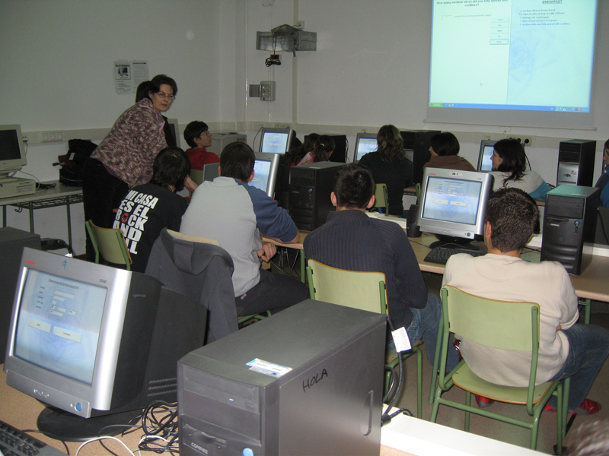

Overall, the most preferred snack foods were pizza (90.3% of adolescents expressed liking to some degree), pasta dishes (88.5%), fresh fruit (87.2%), chocolate/chocolate bars (86.4%), French fries (85.9%), bread/toast (85.1%), sandwiches (84.2%), cookies (82.6%) and sweets (82.5%). Overall, the most disliked snack foods were oatmeal/porridge (52.1% expressed disliking to some degree), dried fruits (45%) and meat based snacks (40.1%).
When asked to select their main reason for snacking, 41.3% of adolescents selected 'I feel hungry', 11% selected 'I feel bored', 9.9% selected 'I need some energy', and 9.4% selected 'I'm craving something sweet e.g. cookies or chocolate'. For boys, the top 3 reasons for snacking were hunger (46.2% selected), needing energy (11%), and boredom (8.3%). For girls, the top 3 reasons for snacking were hunger (37.2% selected), boredom (13.5%), and craving something sweet (11.2%). Girls were more likely than boys to say that they snacked out of boredom, stress and sadness.
During a typical school week, 51.1% of adolescents said they go home for lunch, 27.5% eat at the school restaurant or canteen and 12.8% bring their lunch from home. The two most trustworthy sources of information regarding healthy eating and lifestyle were 'my parents/guardian' (69.6%) and 'my doctor' (59.8%). Overall, the three most important influences on food choice across all meal occasions were 'how hungry you are', 'the taste of the food' and 'your parents or guardian'. Overall, the statements which achieved the highest level of agreement were: I like the food my parents prepare at home (87% agreed to some degree), the taste of a food is very important to me (83.3%), I choose my own snacks (81.3%), I enjoy eating fruit and vegetables (74.8%), food I eat at home is healthy (73.6%), I like the food I eat when I am out with my friends (73.5%).
Girls showed higher levels of agreement to the following statements compared to the boys: I worry about what I eat because I do not want to gain weight, if there is the option to choose a low fat version of a food, I will choose it, if there is the option to choose a whole grain version of a food, I will choose it, what I eat now will have a big impact on my future health, information regarding healthy eating is difficult to put into practice, I enjoy eating fruit and vegetables, I often skip breakfast. On the other hand, boys showed slightly higher agreement to: I think that my diet is healthy, the taste of food is more important to me than the healthiness of the food, a high fat food tastes better than the lower fat version, healthy foods do not fill me up, most healthy foods do not taste very nice.
Data on physical activity among the European adolescents have been collected using objective methodology (accelerometry), to avoid difficulties with methods using self-reports. The analyses of the data collected show that only about 20 per cent of the girls and 40 per cent of the boys spend at least 60 minutes per day at moderate intensity or higher (60 min is the current recommendation).
The adolescents who were physically active for at least 60 minutes per day at a moderate intensity level or higher, had: higher cardio-respiratory fitness; favourable body composition among boys (BMI, Sum of six skinfolds, Waist circumference), among girls only for Sum of six skinfolds; favourable blood lipid profile among boys (for triglycerides, HDL-C, LDL-C), and also apolipoprotein A and B; other favourable blood parameters among boys (for total homocysteine and C-reactive protein). No differences were found regarding the diabetes-markers (insulin and glucose) in relation to physical activity.
While two thirds of the European adolescents (60%) have a cardiorespiratory fitness associated with a lower cardiovascular risk, the remaining 40% may be at increased risk of future cardiovascular disease. Most of the traditional and novel cardiovascular disease risk factors are positively influenced by the levels of cardiorespiratory fitness in European adolescents. Body mass index, skinfold thickness and waist circumference were significantly lower in both female and male adolescents with high cardiorespiratory fitness, compared to those with low cardiorespiratory fitness. Likewise, levels of LDL-C, HDL-C, triglycerides, C-reactive protein, apolipoprotein B, and insulin were also significantly lower in both female and male adolescents with high cardiorespiratory fitness, compared to those with low cardiorespiratory fitness.

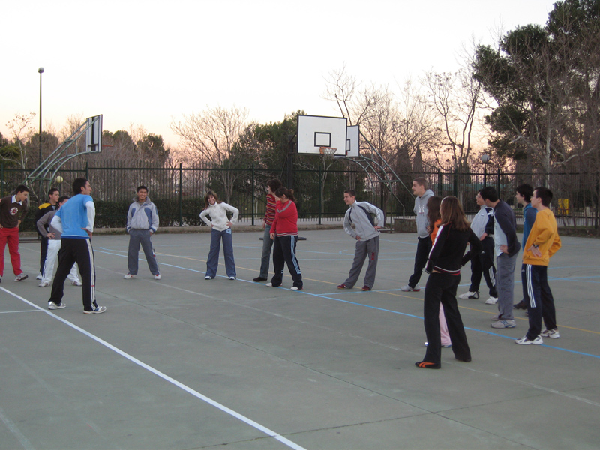

The frequency of overweight was found to be 19.6% in boys, and 16.4% in girls. The frequency of obesity was found 7.9% in boys, and 4.7% in girls. The frequency of overweight and obesity increases parallel with the age.
Total homocysteine levels increased and plasma folate, Cobalamin and active B12 concentrations decreased with increasing age and increasing Tanner stage. Females showed higher Cobalamin values compared with males and males had higher total homocysteine values compared with females. The MTHFR 677 TT-genotype displayed lower concentrations of plasmafolate, RBC folate, Cobalamin and a higher concentration of total homocysteine compared with the CC-genotype. Smokers had lower folate concentrations than non-smokers. Vitamin supplement users showed significantly higher concentrations of plasmafolate, RBC folate, Cobalamin, and lower total homocysteine concentrations than non-supplement users. Females showed higher vitamin C and tocopherol values compared with males but males had higher ß-carotene values compared with females. Vitamin D and retinol serum concentrations increased significantly according to age.
The overall prevalence of iron depletion was 22.2%. The iron depletion results were significantly higher in females (25.7%) than in males (18.2%). The female young adolescent, (12.5-13.99 and 14.0-14.99 of age), showed a lower proportion of low iron storage (23% - 24% respectively) compared to female adolescents of more age (15.0-17.49 and 28%). Iron deficient levels (sTfR > 8.5 mg/L; serum ferritin < 15 μg/L) were observed in 4.8% of the adolescents, and was higher in females (5.4%) than in males (4.0%). Iron deficiency anaemia level was present in 1.6% of the studied population.

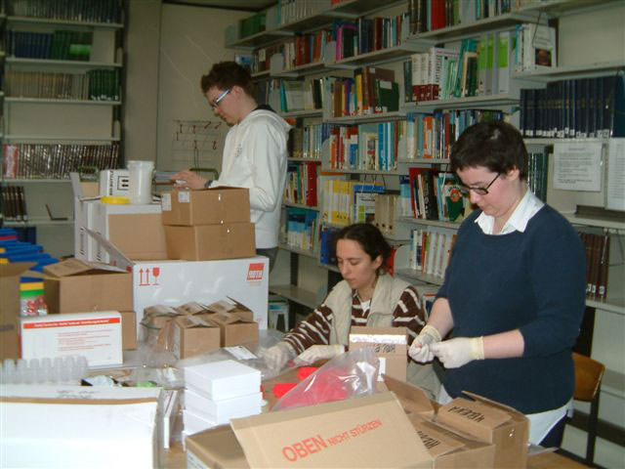

Nearly 6% of the adolescents had TG levels over 130 mg/dL Approximately 8% had higher TC (>200 mg/dL) and higher LDL (>130 mg/dL) levels, respectively. 83% had normal (>45 mg/dL) HDL-cholesterol levels. 21% had Lipoprotein(a) levels over 300 mg/L. 11% had apolipoprotein B levels over 0.8 g/L. Girls showed significant higher means compared to boys in all parameters. Male TG levels were influenced by age and sexual maturation. Gender had a significant impact on insulin levels, mean values being higher in females than in males.
Naïve T helper lymphocytes decrease with age during the adolescent range 13 to 17 years and a parallel increase of memory T helper cells occurs at this stage of life. The number of naïve T helper lymphocytes was lower in obese adolescents than in the normal weight adolescents. The number of memory T helper lymphocytes was higher in overweight adolescents compared to those with normal weight. Underweight boys and girls showed relative lymphocytosis when compared to their normal weight peers. According to chronological age, C3, C4, albumin, increase with age while L-selectin, E-selectin, VCAM-1 and ICAM-1 generally decrease with age. According to sexual maturation, albumin levels increase with age while L-selectin, E-selectin, VCAM-1 and ICAM-1 generally decrease with age. Regarding weight status, WBC, CRP, AGP C3, C4 and E-selectin increase with increasing weight status.
Qualitative research was performed by the HELENA-behaviour and food (HELENA-BEFO) group, in Spain, Belgium, Hungary, Sweden and the UK (AINIA, CCFRA, SIK, MEURICE R&D, CCFRA-HUNGARY) fitting with the project objectives. A total of 44 focus groups (304 adolescents in total) took place, where the groups were divided evenly by gender and age (13-14 and 15-16 years old). There were many similarities across the five countries with regard to factors influencing food choices. By far, “taste” was the most important factor across all meal occasions and all countries. It is also clear that “parents” still exert an important influence, particularly at dinner. Other important influences were “habit”, “health” and convenience factors such as “easy to prepare” and “readily available”. There were some differences between countries; for example, “habit” was an important influence (particularly on breakfast and snacks) in Belgium and Spain whereas this had less influence on food choices in the UK and Hungary. Interestingly, “school” is an important factor in Sweden, having an influence at both breakfast and lunch.
Key barriers towards healthy eating were identified as: Healthy food tastes bad or is “boring”, healthy food doesn't fill you up, healthy food takes too much effort, healthy food is too expensive, lack of immediate concern about unhealthy eating habits or lifestyle, misconceptions combined with a lack of nutritional knowledge regarding healthy eating (theory and practice). Differences in meal patterns were also observed between countries. However, snacking between meals was a consistent finding across all countries. Food choices and preferences at each meal occasion also varied from country to country.

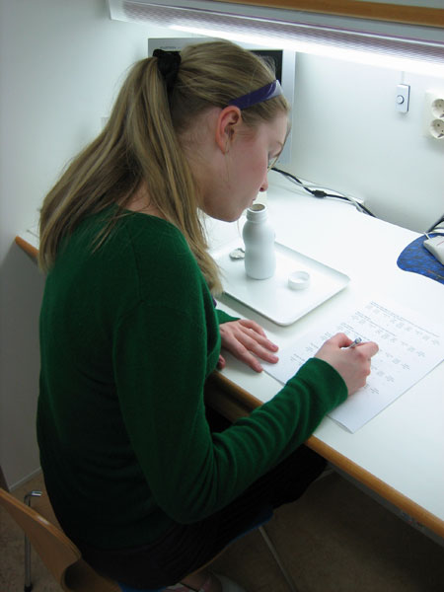

We developed three new healthy and appealing products, fitting with the project objectives. Three new foods that differed considerably in their technological characteristics and with beneficial nutritional profiles to adolescents were developed in a consumer-led product development process. The healthiness of the new products was safeguarded by interviewing nutritional experts on what they considered to be desired nutritional characteristics of the new products. The new products face various challenges in filling the gap between product characteristics that adolescents like and characteristics that they perceive to be healthy. It was found that the new products – especially the low fat hamburger and the snack bar - were well accepted by European adolescents, but there were differences between degrees of liking between different countries. The results demonstrate an approach that can be successfully employed by food industry in the development of foods that are both healthy and attractive to adolescents.

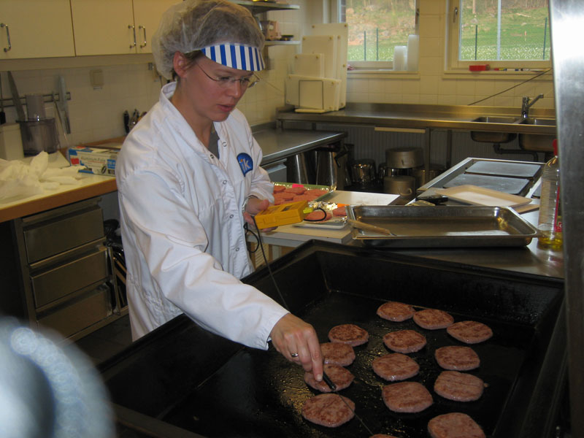

The intervention study (HELENA-LSEI) was nested in the cross sectional study. The computer-tailored physical activity intervention showed positive effects across different European countries. The pilot version of a novel computer-tailored nutrition intervention showed modest effects, however there was a clear effect for percent energy from fat, especially in the overweight group. The implementation of internet based computer tailored interventions were feasible in most but not all countries.
A randomised crossover intervention design (HELENA-COMS) was carried out in female adolescents from four different European countries (Greece, Hungary, Italy and Spain). 77 subjects were enrolled. Ten subjects dropped out of the study because of illness, the constraints of the study or other personal reasons. Thus results from 67 subjects were analyzed. Subjects were first invited to consume during a 3-week run-in period (adaptation period) a diet which complied with basic healthy nutritional criteria. Thereafter, subjects were randomly invited to follow for 21 days a high-glycaemic index low-fibre diet (HGI-LF) or a low-glycaemic index high-fibre diet (LGI-HF). After a wash-out period of 10 days (during which the adaptation diet was consumed), subjects crossed over to the other arm of the study. At the end of each dietary period blood sampling were performed. Overall, there were no effects of dietary treatment on thirst, nausea, bloating, constipation, flatulence and diarrhoea. On the other hand, a significant reduction of desire to eat and increase of fullness occurred during LGI-HF diet compared to adaptation diet and HGI-LF diet. Only very small and not significant differences in total cholesterol, LDL-cholesterol, HDL-cholesterol, triglycerides, selected hormones or variables related to inflammation were observed by comparing the two experimental diets.
Concerning the plan for using and disseminating the knowledge, focus groups, concept testing exercises were undertaken to evaluate the acceptability of 3 concepts for each of 3 categories of products: for meat-based, cereal-based, and vitamin-enriched products. Companies could, in the future, use these results to develop new food/drink products aimed at adolescents. The industrial partners within the HELENA consortium will endeavour to develop new products based on the insight achieved from these focus groups.

Web site: www.helenastudy.com
Dissemination and use

The Food-O-Meter and the Activ-O-Meter are 2 separate web based tools generating individual tailored advice on eating habits and physical activity. Both tools are part of the HELENA lifestyle intervention (LSEI). The LSEI consists of 2 parts, a physical activity part (the Activ-O-Meter) and a nutrition part (the Food-O-Meter). The 2 parts have a common heading but can be used as separate interventions.
The Food-O-Meter consists of following components 1) a validated food frequency questionnaire for measuring the dietary intake of adolescents; 2) a corresponding food composition database; 3) a decision tree for generating an individualised advice for fiber, vit C, calcium, iron and total fat.
The aim of the intervention is to encourage adolescents, not meeting the nutritional goals for a healthy lifestyle, to change and enhancing their eating habits. The intervention starts with an introductory page giving information on the aim of the intervention, some demographic questions including gender, height and weight and screening questions for eating disorders. Adolescents identified as at risk for eating disorders cannot continue filling in the questionnaires and get a standard advice on healthy eating. To avoid that adolescents get bored and to make it more attractive, cartoons have been added to the program.
To measure the energy intake and intake of target nutrients (fat, fiber, calcium, vitC and iron) of the adolescents a Food Frequency Questionnaire (FFQ) has been developed, extended and further adapted to measure the intake of the target nutrients. For calculating the nutrient intake a food composition data base has been built with a total of 137 items mainly from the German so called Federal Food Code (BLS), and supplemented with the Dutch and the Belgian Food Composition Table.
The nutritional advice is given in a short tabular form, consisting of normative feedback, followed by a symbol indicating if the adolescent reached the goals for the target nutrients and in a final column some suggestions are given to enhance the intake of the nutrients when needed. These suggestions are series of food items that contain the target nutrients.
The Activ-O-Meter is the translation of a computer-tailored intervention for adolescents developed in Flanders based on a previously developed computer-tailored intervention for adults. The intervention aimed at encouraging a physically active lifestyle in those adolescents who did not meet the physical activity guidelines. When compared to the adult version, formulation and content of questions and feedback has been simplified. In addition cartoons have been added to the program to make it more attractive and to avoid that adolescents get bored.
The computer-tailored program consists of three major parts: (a) an introduction page, (b) a diagnostic tool and (c) an advice. All parts are interactive on-screen and ready to be put on and transmitted over the Web. The introduction page provides some general information about the diagnostic tool to get the adolescents started. The questionnaire used in the diagnostic tool can be filled out on the computer screen and consists of three major parts. The first part concerns demographic questions. The second part of the survey consists of a physical activity questionnaire. In the third part of the survey, psychosocial determinants (attitudes. self-efficacy, social support. perceived benefits. perceived barriers, environment) related to physical activity are questioned.
After questionnaires are completed by the adolescents, feedback is selected out of a database with messages for each possible combination of answers. The physical activity advice starts with a general introduction, followed by normative feedback, which related students’ physical activity levels to the physical activity guidelines. Readiness to change is used to define the content and approach of the feedback in the physical activity advice. Adolescents who are in the precontemplation stage get general information about a physically active lifestyle and this information is provided in a non-personal way to avoid resistance. Contemplators get the same added with information on benefits and barriers of being more active. Contemplators are addressed in a more personal way. In the preparation stage information is given on how to become more physically active and information is given in a more personal direct way. In the action stage maintenance of a physically active lifestyle is emphasized and adolescents are addressed in a more supporting way. In the maintenance stage adolescents are encouraged to maintain their active lifestyles and they are also addressed in a supporting way. Based on the theory of planned behaviour, the social cognitive theory , and the attitude, social influence and self-efficacy model , adolescents eat tailored feedback about their attitudes, self-efficacy, social support, knowledge, perceived benefits and barriers related to their physical activity in the final part of the advice.
The tools can be used in the context of nutrition programmes and obesity preventions programmes of schools, school health services, hospitals, NGO’s, supermarkets, independent professionals and sports organisations, among others. Both tools have been designed as self-evaluation tools, in order that adolescents may use them properly guided by a professional (teachers, doctors, etc.).
The Food-O-Meter generates a tailored advise on the total diet and is adapted to the needs and eating habits of 5 European countries: Germany, Greece, Belgium, Sweden and Austria. Until now 2 types of web based tools were available, a first type enables a crude assessment of the overall diet however without an individual tailored advise to enhance the eating habits; a second type are web based tools giving individual tailored advise on aspects of the diet (e.g. fat, fruit and vegetables, …). The existing tools were not developed to enable the adaptation for other countries and /or other eating cultures.
The Activ-O-Meter generates a tailored advise and can without adaptation be used in other countries. Most tailored interventions were directed towards adults and only focused on an active lifestyle. This tool focuses on adolescents and integrates the active lifestyle recommendation (60 minutes moderate activity) and the sports recommendation (3 times 20 minutes vigorous activity).
The institutions which own the property rights of the Food-o-Meter and the Activ-o-Meter are the following ones: Research Institute of Child Nutrition Dortmund (Germany), University of Crete School of Medicine (Greece), Ghent University (Belgium), University of Vienna (Austria), Harokopio University (Greece) and Karolinska Institutet (Sweden). Ghent University acts on behalf of the entities mentioned above in order to manage the appropriate agreements of collaboration for both tools.

