- Final publishable summary report
Sun-induced fluorescence (SIF) has been proven to serve as a proxy of photosynthesis activity and therefore, as an early indicator of physiological alterations for global monitoring of vegetation (Damm et al., 2014; Zarco-Tejada et al., 2013). Current research efforts to monitor photosynthetic activity show a growing interest in remote sensing of the SIF signal due to its potential to be measured at both local (high resolution images) and global scales (medium and low resolution images) being a direct proxy of photosynthesis. However it remains very challenging to cover at very high resolution the large areas required for forest monitoring analysis. This has hitherto been the main limitation in studying physiological condition of forest canopies with higher detail, as currently available satellite sensors are limited by their spatial and spectral resolution for SIF retrieval purposes. To address this gap, the ESA’s Earth Explorer Mission of the ‘Fluorescence Explorer’ (FLEX) (Kraft et al., 2012), the first mission designed to observe the photosynthetic activity of the vegetation layer has been recently approved, with 2022 as the tentative launch date. This mission will make possible, for the first time, the assessment of the dynamics of photosynthesis on forest canopies through SIF at 300 m spatial resolution, and with potential to distinguish different fluorescence signals from PSI and PSII (Rossini et al., 2015). However, the interpretation of SIF over different spatial resolutions is critical to bridge the existing gap between local and global scales.
Strategies to simulate the spectral signature in heterogeneous forest canopies have been limited by difficulties in simulating canopy structure such as Leaf Area Index (LAI), tree density, fractional cover (FC), crown overlapping or mutual shading and multiple scattering between crowns. The researcher, Dr. Hernández-Clemente aimed to fill these gaps and in doing so to assess the potential of chlorophyll fluorescence signal retrieval as an early indicator of forest decline. Dr. Hernández-Clemente proposed a 3-D integrated RTM to calculate reflectance and fluorescence in the observation direction as a function of canopy components. The novel approach consists of coupling the leaf optical model FLUSPECT (Vilfana et al., 2016) and the three-dimensional (3-D) ray-tracing model FLIGHT developed by North, (1996) to carry the scaling up approach from leaf to canopy dealing with multiple canopy components. This model has not been done in the host institute before she arrives and has become successful knowledge transfer to the department of Geography. The FluorFLIGHT model was specifically developed to assess the sensitivity of the fluorescence signal on heterogeneous forest canopy images. This study provides insight into the influence of scene components, and forest structure and composition on the quantification of the red and far-red fluorescence signal as an early indicator of forest decline.
Dr. Hernández-Clemente conducted several field and airborne campaigns over an oak forest (Quercus ilex) affected by water stress and Phytophthora infection in the southwest of Spain. Field data collection was satisfactory and used to accomplish this research. SIF retrievals through the Fraunhofer Line Depth (FLD) principle with three spectral bands F (FLD3) was assessed using high resolution (60 cm) hyperspectral imagery extracting sunlit crown, full crown and aggregated pixels.
Results of this study showed the link between F (FLD3) extracted from sunlit crown pixels and the tree physiological condition in this context of disease infection, yielding significant relationships (r2=0.57, p<0.01) for midday xylem water potential (ψ), (r2=0.63, p<0.001) for the de-epoxidation state of the xanthophyll cycle (DEPS), and (r2=0.74, p<0.001) for leaf-level measurements of steady-state fluorescence yield (Fs). In contrast, a poor relationship was obtained when using aggregated pixels at 30 m spatial resolution, where the relationship between the image-based F (FLD3) and Fs yielded a non-significant relationship (r2=0.25, p>0.05). Dr. Hernández-Clemente demonstrates the need for methods to accurately retrieve crown SIF from aggregated pixels in heterogeneous forest canopies with large physiological variability among individual trees. This aspect is critical where structural canopy variations and the direct influence of background and shadows affect the SIF amplitude masking the natural variations caused by physiological condition. FluorFLIGHT, a modified version of the three dimensional (3-D) radiative transfer model FLIGHT was developed for this work, enabling the simulation of canopy radiance and reflectance including fluorescence at different spatial resolutions, such as may be derived from proposed satellite missions such as FLEX, and accounting for canopy structure and varying percentage cover. The 3-D modelling approach proposed here significantly improved the relationship between Fs and F (FLD3) extracted from aggregated pixels (r2=0.70, p<0.001), performing better than when aggregation effects were not considered (r2=0.42, p<0.01) (Fig1.a). The FluorFLIGHT model used in this study improved the retrieval of SIF from aggregated pixels as a function of fractional cover, leaf area index and chlorophyll content yielding significant relationships between Fs ground-data measurements and fluorescence quantum yield estimated with FluorFLIGHT at p<0.01 (r2=0.79). Dr. Hernández-Clemente also demonstrated the capability of FluorFLIGHT for mapping SIF at the tree level for single tree assessment of forest physiological condition in the context of early disease detection (Fig 1.b).
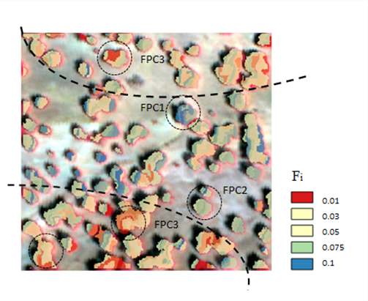
(a)
(b)
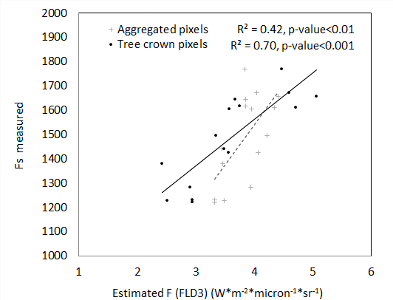

Fig. 1. Relationships between F_{s} ground-data measurements and fluorescence estimations retrievals using FluorFLIGHT applied to aggregated pixels without accounting for pixel aggregation (30x30 m aggregated pixels) and accounting for pixel aggregation (full crown pixels) with FluorFLIGHT (a) F_{i} retrieval at the crown level estimated from the 60-cm hyperspectral image using the fluorescence in-filling method F (FLD3) within the oak forest (b).

Throughout this individual Marie Curie fellowship, Dr. Hernández-Clemente has published 5 articles in international peer-reviewed scientific journals (SCI, SSCI), many of them in top tier journals such as Remote Sensing of Environment (RSE) (1/28, according to SCOPUS (SJR)), IEEE Transactions on Geoscience and Remote Sensing (2/28, according to SCOPUS (SJR)) and Agricultural and Forest Meteorology (1/65, according to SCOPUS (SJR)). She has also contributed with 6 conference papers and one book. This includes participation one Spanish National Project (QUERCUSAT) which has supported field data collection and airborne field campaigns. She has supervised 11 Master’s theses and is currently supervising 3 PhD theses in different universities (University of Cordoba and University of Helsinki). She is also a reviewer for international scientific journals such as RSE, Remote Sensing, IEEE Journal of Selected Topics in Applied Earth Observations and Remote Sensing (J-STARS), Acta Physiologiae Plantarum and Ecological Indicators.

Web page of the project:
www.fluorflight.com
Corresponding author:
rociohclemente@gmai.com
References
Damm, A., Guanter, L., Laurent, V.C.E., Schaepman, M.E., Schickling, A., Rascher, U., 2014. FLD-based retrieval of sun-induced chlorophyll fluorescence from medium spectral resolution airborne spectroscopy data. Remote Sens. Environ. 147, 256–266. doi:10.1016/j.rse.2014.03.009
Kraft, S., Bello, U.D., Bouvet, M., Drusch, M., Moreno, J., 2012. FLEX: ESA’s Earth Explorer 8 candidate mission, in: 2012 IEEE International Geoscience and Remote Sensing Symposium. Presented at the 2012 IEEE International Geoscience and Remote Sensing Symposium, pp. 7125–7128. doi:10.1109/IGARSS.2012.6352020
North, P.R.J., 1996. Three-dimensional forest light interaction model using a Monte Carlo method. Geosci. Remote Sens. IEEE Trans. On 34, 946–956. doi:10.1109/36.508411
Rossini, M., Nedbal, L., Guanter, L., Ač, A., Alonso, L., Burkart, A., Cogliati, S., Colombo, R., Damm, A., Drusch, M., Hanus, J., Janoutova, R., Julitta, T., Kokkalis, P., Moreno, J., Novotny, J., Panigada, C., Pinto, F., Schickling, A., Schüttemeyer, D., Zemek, F., Rascher, U., 2015. Red and far red Sun-induced chlorophyll fluorescence as a measure of plant photosynthesis. Geophys. Res. Lett. 42, 2014GL062943. doi:10.1002/2014GL062943
Vilfan, N., van der Tol, C., Muller, O., Rascher, U., Verhoef, W., 2016. Fluspect-B: A model for leaf fluorescence, reflectance and transmittance spectra. Remote Sens. Environ. 186, 596–615. doi:10.1016/j.rse.2016.09.017
Zarco-Tejada, P.J., González-Dugo, V., Williams, L.E., Suárez, L., Berni, J.A.J., Goldhamer, D., Fereres, E., 2013. A PRI-based water stress index combining structural and chlorophyll effects: Assessment using diurnal narrow-band airborne imagery and the CWSI thermal index. Remote Sens. Environ. 138, 38–50. doi:10.1016/j.rse.2013.07.024

