The project set out to understand the dynamical and computational implications of connecting many single neurons, where each one is endowed with multiple timescales.

Since the beginning of the project, I have refined existing models of single neurons by analysis of recent experimental data. Specifically, I developed a novel computational model for the long term dynamics of excitability in single neurons. The model provides a compact description that fits the neural response to a wide range of stimuli. These results have been presented in international conferences, and were published in a peer reviewed journal (Xu and Barak, JNS 2017)

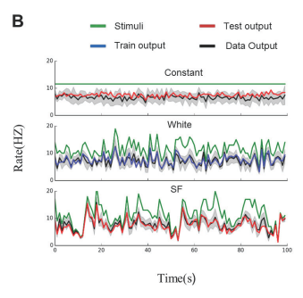
Model response (red) compared to experimental measures (black) in response to varying input (green). From Xu & Barak 2017.

Furthermore, I gained a deeper understanding of the dynamics of trained recurrent neural networks (without excitability dynamics). Even our simplest actions, like raising a hand, involve millions of neurons in the brain connected in a complex network. Our new analysis sheds light on the interplay between the simplicity of the network's output and the complexity of its internal dynamics. As a model we rely on artificial neural networks. These are engineering systems, inspired by the brain’s structure. Recently these networks achieved human level performance in areas such as image & speech recognition. The initial connectivity of the network is random, and training sculpts the connectivity to obtain the desired output. So far, it was not known how training affects the dynamics of these artificial networks, let alone in their biological counterparts. In this work, we show how the demands imposed on the network's output translate to modifications of the internal dynamics. We found that a small number of dynamical modes are recruited to support a desired. These results have also been presented in international conferences and were published in a peer reviewed journal (Rivkind and Barak, PRL 2017)

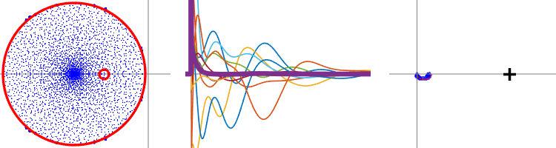
Eigenvalue distribution (left) explains an apparent paradox in the behavior of trained networks (right). The thick line shows the rapid recovery of the output of a network, contrasted with very slow recovery of individual neurons (thin lines). From Rivkind & Barak 2017

The overall approach of using trained recurrent neural networks has received increasing attention in recent years. During the second reporting period I wrote an invited opinion paper in Current Opinions in Neurobiology. I was also invited to numerous seminars and conferences to present my approach to this topic.
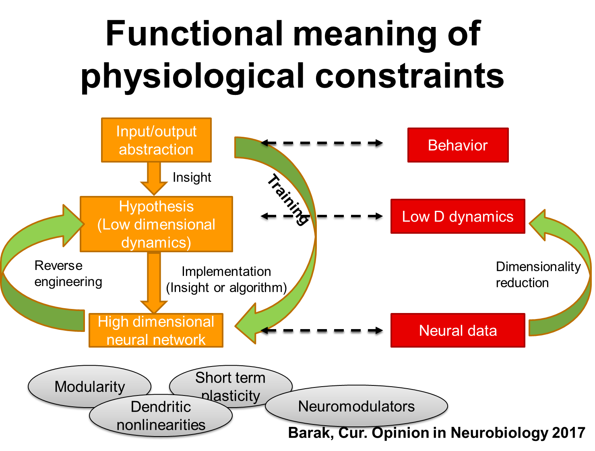
A new framework for using trained recurrent neural networks as tools to study the brain. From Barak 2017

I have begun to integrate these two strands by analyzing the effect of training networks in which individual neurons have slow excitability dynamics. Specifically, we are now training recurrent neural networks that are controlling an agent navigating in a virtual environment. We showed that incorporating slow excitability dynamics can enhance the spatial memory of the agent, and are currently studying this in more detail.

The close collaboration with neighboring experimental labs was instrumental to my career integration. The funds from the Career Integration Grant have been very helpful to this goal.
The project website is http://barak.net.technion.ac.il

