Nudge-it Final report

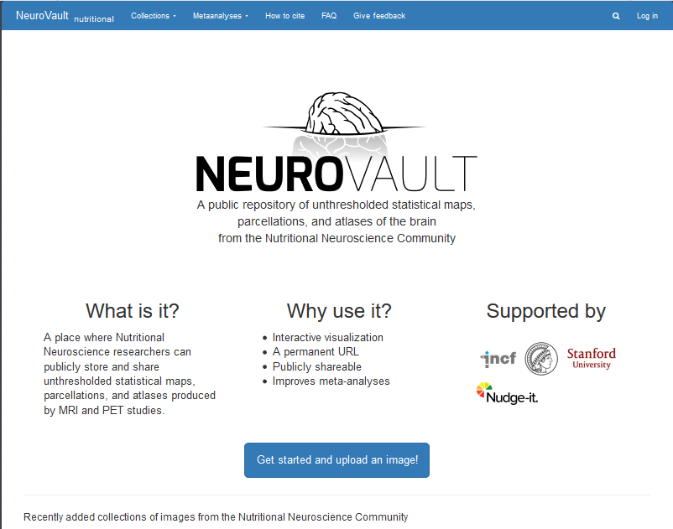

The neuroimaging data-sharing and analysis platform tailored to nutritional neuroscience was implemented building on the successful NeuroVault platform (D3.5, MS3.3, <https://neurovault.org/communities/nutritional>

The UZH paper “Acute Stress Impairs Self-Control in Goal-Directed Choice by Altering Multiple Functional Connections within the Brain’s Decision Circuits in Neuron gained widespread attention in newspapers, news websites, and magazines all over Europe (Switzerland, Austria, Germany, France, UK, Italy, Spain) as well as in the USA, Australia and India. It was featured on CBS news and ABC news in the USA as well on radio and TV in Europe. In total 83 features appeared in various forms of news reporting.

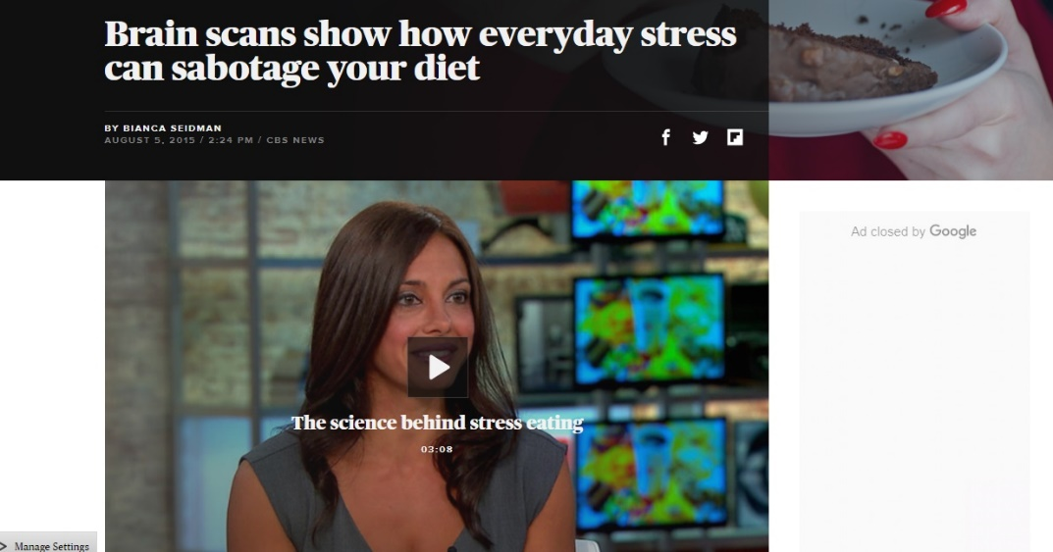

The CBS News Feature

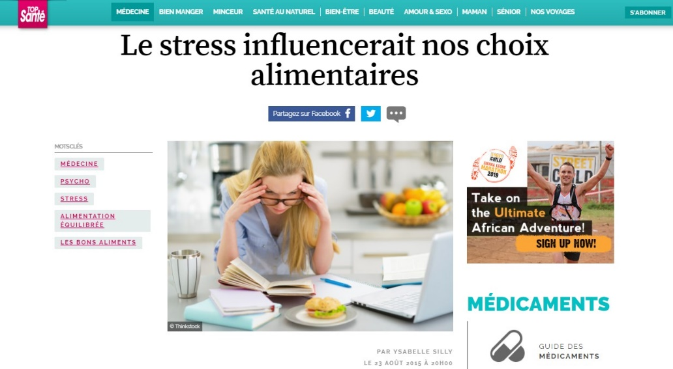

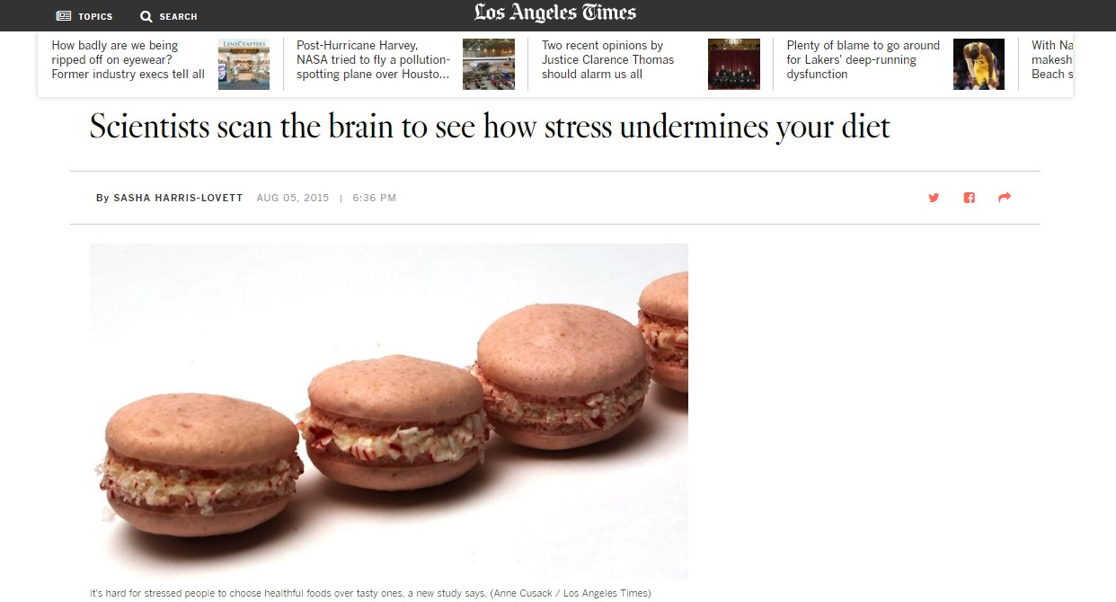

Some examples of news coverage

Time Magazine news article from published a paper on measuring gastric emptying with MRI, and the occurrence of ‘phantom fullness’ from WUR

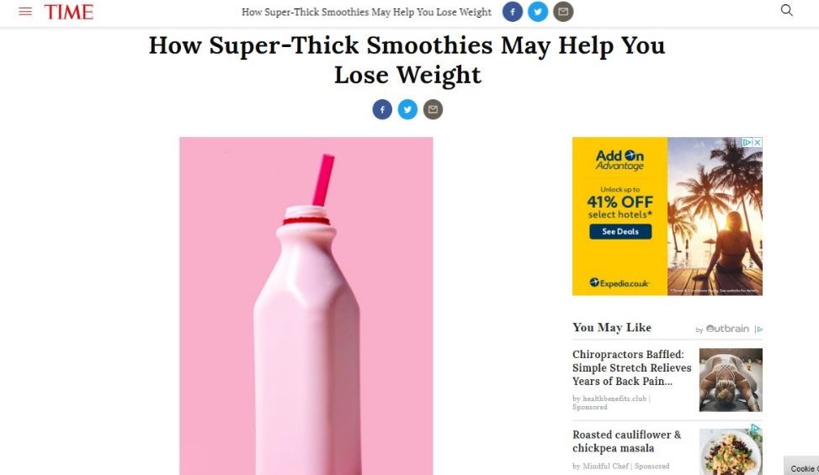

UNIBRIS took part in a Live Science experiment at the London Science Museum

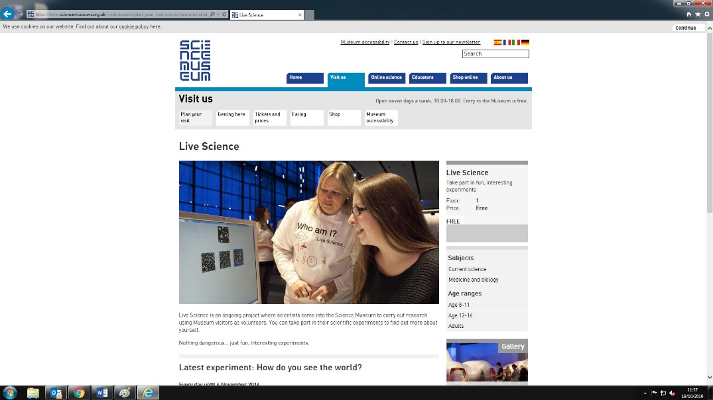

BBC public interactive-science web page that focuses on Nudge-it related activities and findings <http://www.bbc.co.uk/guides/z9t7qty> (UNIBRIS)

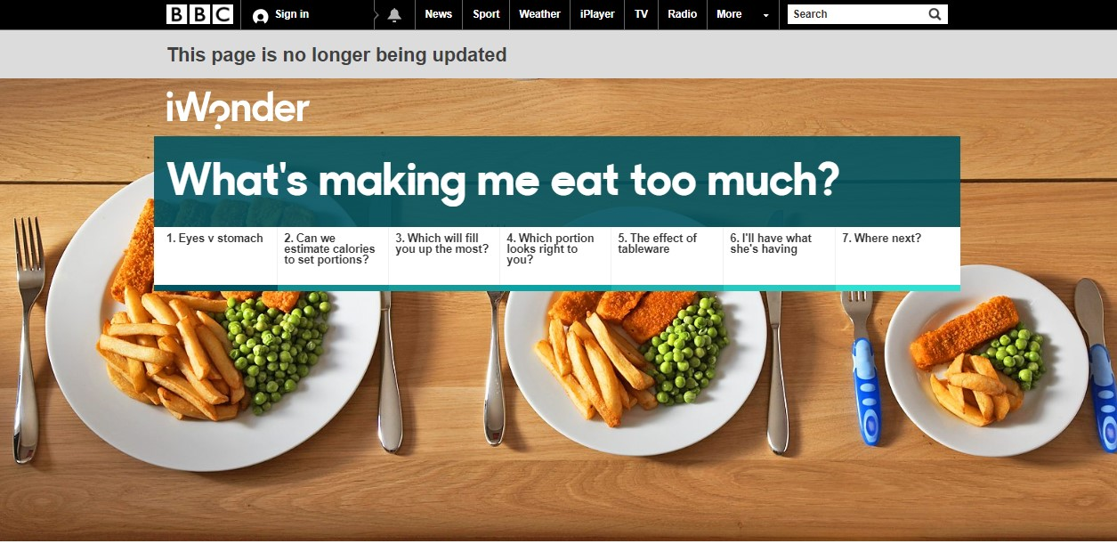

Article on Gravitostat

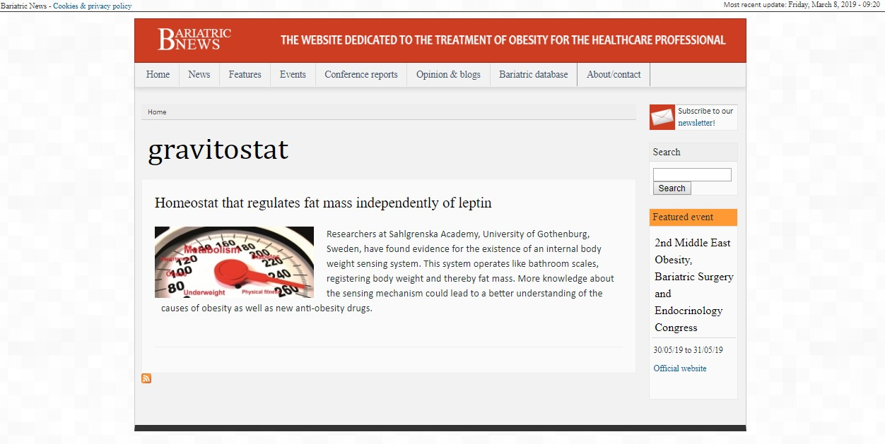

The Gravitostat (UGOT) on BBC

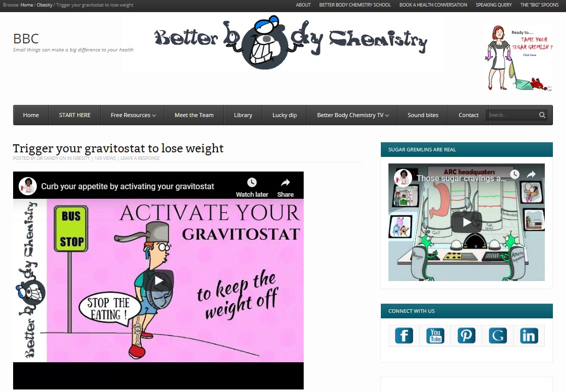

The Nudge-it website

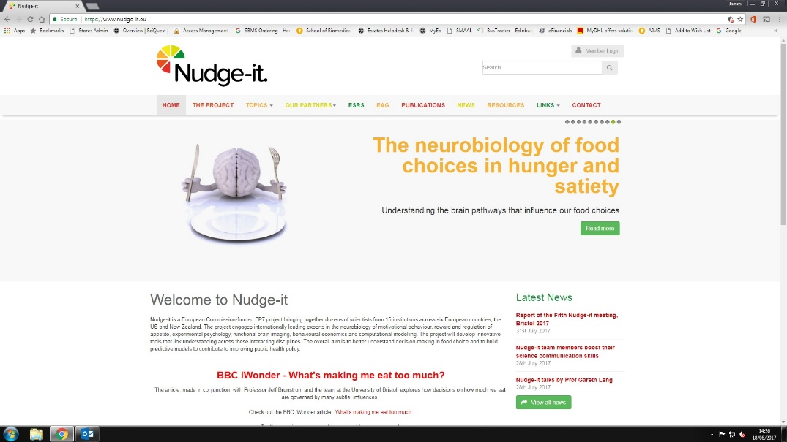

*The Nudge-it news page*

