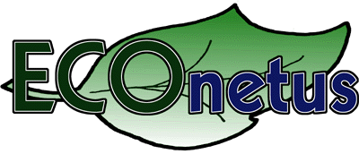

Project no. GOCE 514966

Project acronym
ECOnetus

Project title
Support for networks creation in the field of Global Change and ECOsystems – from idea through proposal submission and project managing till completion and successful audit

Instrument: specific support action

Thematic Priority: 1.1.6.3 Global Change and Ecosystems

PUBLISHABLE FINAL ACTIVITY REPORT

Period covered: from 01/09/2005 to 31/08/2007 Date of preparation: 15/11/2007

Start date of project: 01/09/2005 Duration: 24 months

Project coordinator’s name Jerzy Mościński
Project coordinator organisation’s name POLITECHNIKA SLASKA
Revision 1
1. Project execution.
On 01/09/2005 Politechnika Slaska as the coordinator together with partners from other regions of Poland (Gdansk, Warsaw and Krakow) and partners from Lithuania, the United Kingdom, and Austria started to realize ECOnetus project “Support for networks creation in the field of Global Change and ECOsystems – from idea through proposal submission and project managing till completion and successful audit”.
The main objectives of the project are:
- `implementation of the priority thematic area of Environment (including Climate Change) work programme through supporting international co-operation between RTD projects participants from New MC and ACC (represented by Poland and Lithuania) and MC (the UK, Austria).
- encouragement of participation of researchers and industrial units’ representatives in RTD projects concerning Environment (including Climate Change)
- establishment of international co-operation between RTD projects participants from New MC and ACC (represented by Poland and Lithuania) and MC (the UK, Austria), which will encourage research projects generation,
- improvement and widening of cooperation between New MC and ACC’s researchers and the EU researchers
- preparation of New MC and ACC’s participants to future activities concerning project management and results dissemination, with a view to enabling the Community to achieve its RTD strategic objectives

The ECOnetus’ consortium consists of the below specified partners:
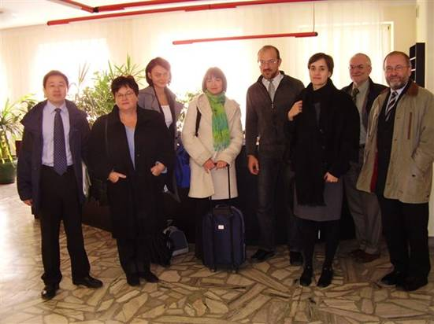
  - Silesian University of Technology / RCP
  - Krakow University of Technology / RCP
  - Gdansk University of Technology/ RCP
  - Institute of Fundamental Technological
Research Polish Academy of Sciences / NCP
  - University of Glamorgan
  - Oesterreichische Forschungsfoerderungsgesellschaft mbH / NCP
  - Agency For International Science And Technology Development Programmes in Lithuania / NCP

Co-ordinator contact details:
Politechnika Śląska/Silesian University of Technology,
ul. Akademicka 2a, 44-100 Gliwice,
tel. +48 32 237 20 92, fax +48 32 237 24 50, e-mail: rpk@polsl.pl
Econetus webpage http://www.econetus.polsl.pl/
The activities of the ECOnetus project were divided into 6 Work Packages:
- Beneficiaries’ data collection
- Brokerage events of subtopic groups
- Knowledge acquisition
- Workshops and consulting meetings
- Dissemination of the results
- Management.

The project started with preparation of consortium agreement which was done by Politechnika Śląska – Silesian University of Technology (Coordinator). The agreement was distributed among partners. On 20-21/10/2005 in Gliwice the kick-off-meeting of Steering Committee and Management Group was organized. There were 18 participants and they agreed on the plans for future activities within the project presented by the co-ordinator and adopted a work plan. As the result of the meeting in Gliwice the consortium agreement was signed.
The kick-off meeting was combined with the meeting of Scientific Advisory Group (SAG) and Assistance Group (AG). During this meeting SAG and AG members developed a questionnaire which has served as a tool of recruiting scientists and researchers interested in the topic of Environment (including Climate Change) from all over Europe. The construction of the questionnaire is such that it allows to divide the participants into 6 subtopics groups in 6 subtopics of Environment (including Climate Change) as it is described below:
- Climate change, pollution and risks: Pressures on environment and climate,
- Climate change, pollution and risks: Environment and health; Natural hazards,
- Sustainable Management of Resources: Conservation and sustainable management of natural and man-made resources,
- Sustainable Management of Resources: Evolution of marine environments,
- Environmental Technologies : Environmental technologies the sustainable management and conservation of the natural and man-made environment; Technology assessment, verification and testing,
- Earth observation and assessment tools: Earth observation; Assessment tools for sustainable development.
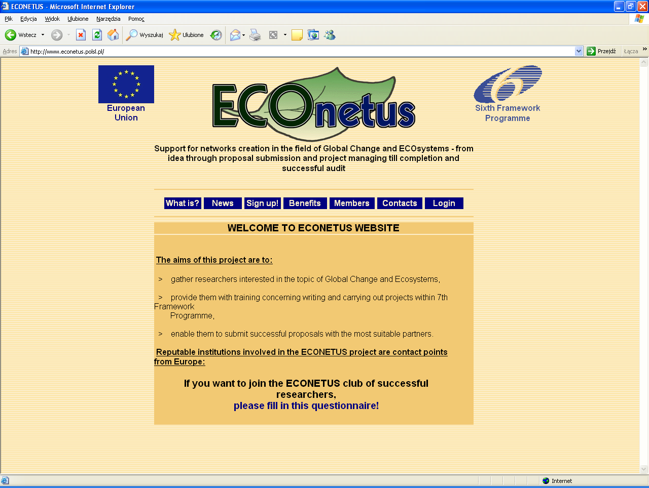
In December the software operating the database was prepared and published on the project’s webpage http://www.econetus.polsl.pl/. The co-ordinator and project’s partners have access to the base and are able to add new participants, various news and modify the other data.
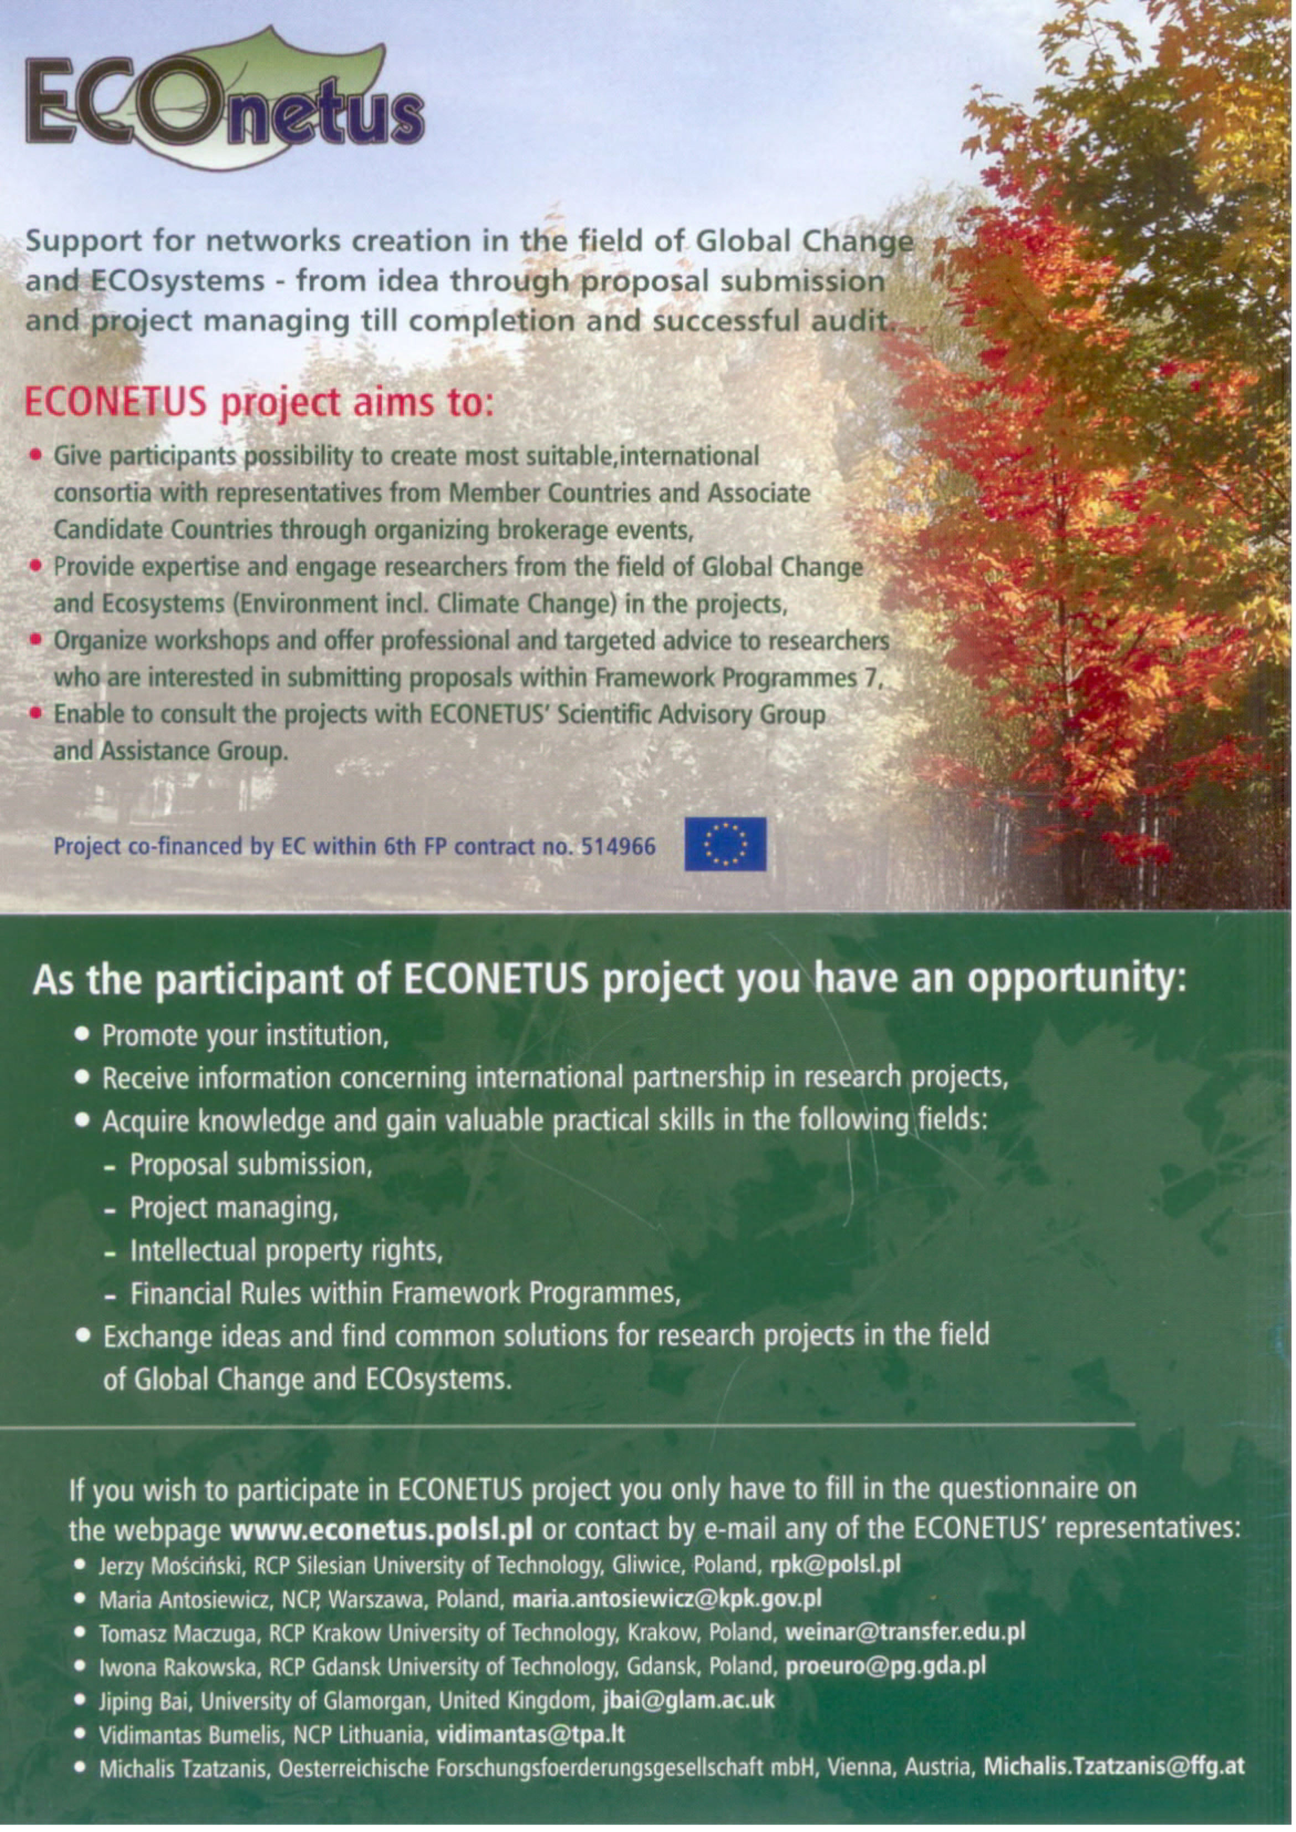
To achieve the main objective of ECOnetus project – creation of the network – the idea of ECOnetus’ database was promoted. The members of AG started the process of promotion of the project all over Europe among potential participants of RTD projects which finally led to collection of questionnaires and creation of the database.
During the projec’s duration the coordinator printed 13000 leaflets promoting ECOnetus project and distributed them among the project’s partners. Later on these leaflets were distributed during conferences in Europe. ECOnetus partners promoted the idea of the project and its database among the representatives from all the world (MC, ACC and third countries) participating with short presentation on over 30 thematic conferences organized in Europe with over 4000 audience. The Econetus database was joined by 220 new researchers since the end of the first reporting period and at the end of the project comprised 535 members.

The division of scientists in the date base by country and by topic of interest is as follows:

Each of six project’s partners were responsible for one subtopic within the priority Environment (including Climate Change). Enrolment in the database allowed the members to choose the subtopic of their interest. This way in 2007 6 working groups were formed and 6 workshops and 6 brokerage meeting were organized to establish international co-operation between RTD projects’ participants from New MC and ACC (represented by Poland and Lithuania) and MC (represented by UK, Austria), to encourage research projects generation and implement the above mentioned priorities. Most members of the database were interested in more than one subtopic so the potential participants could choose the location and date best suiting their needs. SAG members for each subtopic were providing advice for the researchers during the workshops, via telephone and e-mails.
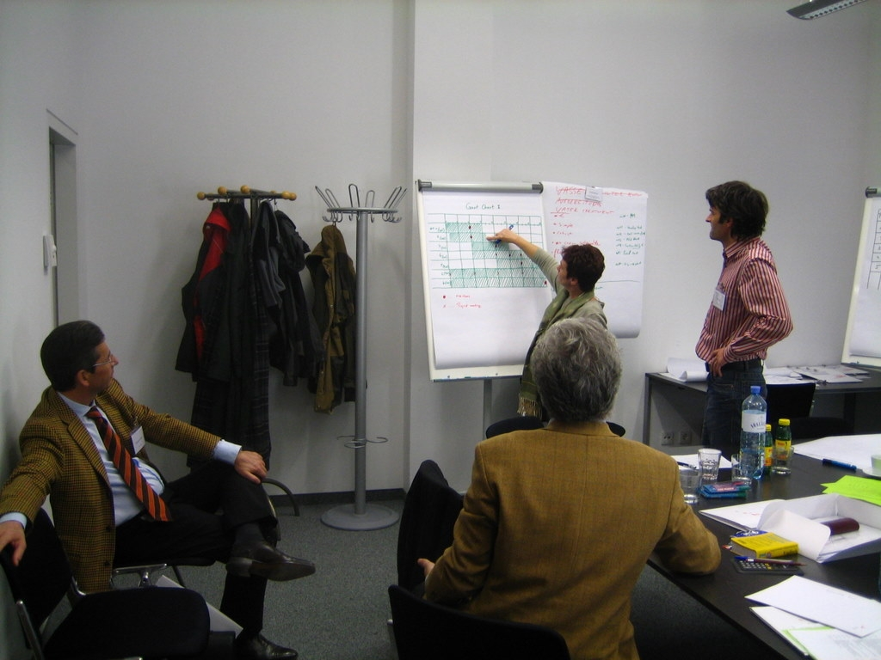
The workshops and brokerage meetings took place between 28 February and 21 March 2007 in Gliwice, Gdansk, Krakow, Vienna, Glamorgan and Vilnius. During these meetings and afterwards Scientific Advisory Group and Advisory Group provided help and professional advice to participants. The meetings, tailored to the needs of participants were carried out during three days: two days were devoted to workshops “Financial procedures and provisions for Framework Programmes” and “How to write a good proposal”, and one day for the brokerage meetings. The events resulted in submission of 10 project proposals to the call within Environment (including Climate Change).

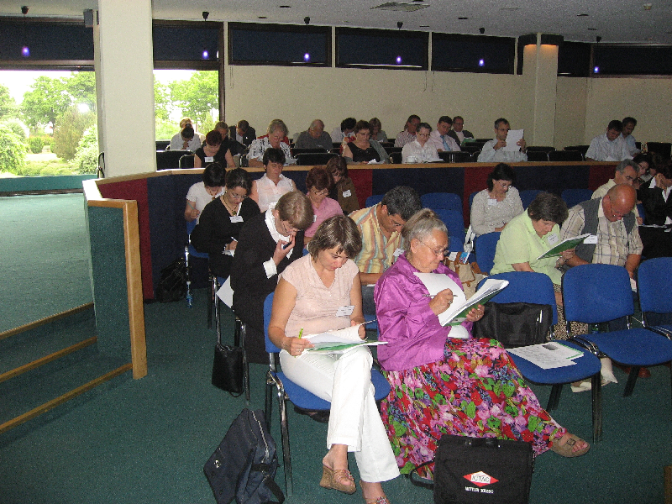
On 11-13 June 2007 the project’s closing conference was organized. This 3-day Conference was held in Gdansk and gathered 90 participants from European institutions from the Econetus’s database. Representatives of National Contact Points from EU and MC and ACC who have not participated in this project were also present at the conference. That allowed spreading information about the project’s database among the researchers, who have not participated in ECOnetus. For the conference a CD version of the Econetus database was prepared and distributed among participants.

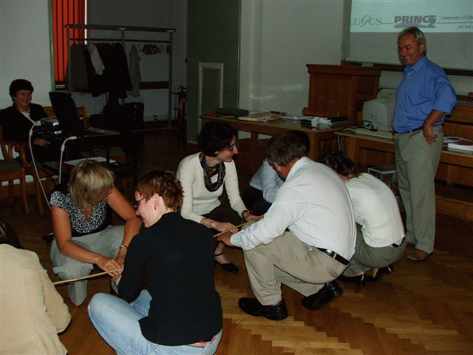
Another aim of the ECOnetus project was the preparation of participants from ACC countries and New MC to future activities concerning project management and results dissemination, with a view to enabling the Community to achieve its RTD strategic objectives of Environment (including Climat Change). On 4 and 5 September 2006 Knowledge acquisition workshops were organized in Warsaw by Institute of Fundamental Technological Research Polish Academy of Sciences. These workshops concerned:

1.Negotiations and contracts – provided by representatives of Oesterreichische Forschungsfoerderungsgesellschaft mbH, Vienna, Austria
2. Project management – provided by representatives of University of Glamorgan, Glamorgan, United Kingdom

The aim of the workshops was to train the staff of Assistance Group and representatives of NCPs from other NMSs and ACCs. After the workshops 28 experts form ACC had wider knowledge in scope of negotiations and contracts and project management, and have able to provide high quality services for researchers, industrial units and SMEs in their countries which guaranteed an operational and effective functioning of the Assistance Group.
Well-informed staff of Assistance Group is a very important asset for effective managing of numerous proposals, not only in the topic of Environment (including Climate Change).

As the result of the project 10 proposal with participant from the ECOnetus database were submitted within the Environment call closed in year 2007.
All the objectives foreseen in the ECOnetus project were achieved and European research community interested in the priority Environment (including Climate Change) were reached with information, advice and support so much needed to take part in the FP calls. It is granted that Econetus will be a great base for many new proposals. It also significantly decreased the lack of communication between the scientists involved in Climate Change topic and give them opportunity for contact and common work. Our chance is in people because they and their ideas create our future.

2. Dissemination and use.
The project itself is a dissemination activity, with information being communicated to the organisations in ACC, New MC and MC through the activities provided under the project.

Using the available contacts the ECONETUS partners participated in many international conferences all over Europe and informed about creation of the ECONETUS network. Also, the leaflets were distributed during international events. Mailing lists being in possession of ECONETUS project consortium were used to inform the potential partners, from respective countries, about opportunities of international co-operation within the priority Environment (including Climat Change) within Framework Programme and possibilities to receive an intensive training concerning preparing the proposal and its realisation.
The consortium will disseminate information through Internet making it available to all MC, New MC and ACC.

Distribution of information during the ECONETUS project was as follows:

FFG, Austria (MC)
Slovenia
Czech Republic
Hungary
Malta

Bulgaria
Romania
University of Glamorgan,
United Kingdom (MC)
SUT, Poland (New MC)
GUT, Poland (New MC)
CUT, Poland (New MC)
AISTDP, Lithuania (New MC)
other MC countries
other MC countries
knowledge and partners
partners and ideas
knowledge and partners
partners and ideas
Slovakia
Cyprus
Estonia
Turkey
Latvia

The main aim of the ECONETUS webpage (www.econetus.polsl.pl) with electronic catalogue is the collection of data about the researchers and representatives of industrial units interested in research related to subject Environment (including Climat Change), as well as matchmaking the members of this database into six working groups:
- Climate change, pollution and risks: Pressures on environment and climate,
- Environmental Technologies : Environmental technologies for observation, prevention, mitigation, adaptation, remediation and restoration of the natural and man-made environment, Technology assessment, verification and testing,
- Sustainable Management of Resources: Evolution of marine environments,
- Climate change, pollution and risks: Environment and health, Natural hazards,
- Sustainable Management of Resources: Conservation and sustainable management of natural and man-made resources,
- Earth observation and assessment tools: Earth observation, Forecasting methods and assessment tools.

The database of ECONETUS participants is a fundamental base for any subsequent activities determined in other work packages, like thematic brokerage events, workshops and internet resources with information concerning Environment (including Climat Change).

Since the database has been published, and after signing up and becoming fully registered participant of the ECONETUS database, each member of ECONETUS database is able to:
- review the data of the ECONETUS members using various criteria – research topic, country, organization type, planned projects to be realized etc.
- modify own profile,
- have an access to the conference materials from ECOnetus events link “DOCUMENTS”; potential partners within ECOnetus network will be provided with special measures concerning consulting their projects during “whole project life” and other measures, which will smooth and facilitate their successful start in European projects; the content of all training workshops will be published and distributed to all participants during the meetings,
- be on the ECONETUS mailing list.

The co-ordinator of the project and its partners are able to:
- add news concerning events, nearest calls etc., which are later published in the section “NEWS” ,
- add new members if their data were collected during the processes of ECONETUS project presentation and modify a profile of other members,
- review the data of the ECONETUS database’s members which allows ECONETUS partners to establish contacts among researchers and representatives of industrial units using various criteria.

The portal has been created by the Silesian University of Technology for the 6th and later on 7th Framework Programmes of the European Union and it will be available publicly also after the end of the project.

