
COOP-CT-2004-513163

flexnolead

Flexible circuits processing, performance and reliability using lead-free processes

Horizontal Research Activities Involving SMEs

Co-operative Research

PUBLISHABLE FINAL ACTIVITY REPORT

Period covered: 1 February 2005 to 30th April 2007 Date of preparation: August 2007

Start date of project: 1 February 2005 Duration: 2 years

Project co-ordinator: Damien Kirkpatrick
Project co-ordinator organisation: TWI Ltd Revision 1

1. project Execution 4
1.1. Project Summary 4
1.2. Project achievements 4
2. Participating Contractors 5
3. Initial Flexible base material selection 5
4. Base Material Testing 5
4.1. TEST - Peel Strength 6
4.2. TEST – Tensile Strength and Elongation 6
4.3. TEST – Moisture Absorption 7
4.4. TEST – Tear Strength 7
5. Design and Manufacture of Test Circuit type a 9
5.1. TEST - Dimensional Stability of Flexible Substrate 10
5.2. TEST - Flexural Fatigue 10
6. Surface mount reflow assembly of further test circuits 10
6.1. Assembly of Test Board C 12
Total 14
6.2. Assembly Trials of Test Board d 15
6.2.1. Solder Reflow Profile Optimisation 16
6.2.2. Assembly using Conductive Adhesives 19
7. Assembly of test circuits using laser Soldering Processes 20
8. Test circuit assembly observstions 24
8.1. Printed Solder Paste and conductive Adhesive Observations 25
8.2. Post Solder Reflow Observations 25
8.2.1. Substrate Deformation 26
8.2.1.1. Solder Joint Defects 26
8.3. Post Adhesive Cure Observations 26
9. Reliability Test Results of the Assembled Test Boards 27
9.1. Thermal Shock Tests 27
9.2. Humidity Tests 28
9.3. Highly Accelerated Stress Testing (HAST) 28
9.4. High Temperature Storage Testing 28
10. Life Prediction Models 28
11. Plan for Using and Disseminating the Knowledge 30
11.1. Exploitable Knowledge, Outputs and Dissemination 31
11.1.1. Materials 31
11.1.2. Alternative Flexible Circuit Substrates 32
11.1.3. Flexible Circuit Manufacturing 32
11.1.3.1. Lead–free Flexible Circuit Manufacturing by Conventional Methods 32
11.1.4. Assembly of Components on Flexible Substrates 33
11.1.4.1. Lead-free Solders – Standard Processing 33
11.1.4.2. Alternative Solder Processes 34
11.1.4.3. Conductive Assembly Techniques 34
11.1.5. Understanding the Behaviour of Flexible Circuits in Lead-free Processes 35
11.1.5.1. Reliability Testing 35
11.1.5.2. Numerical Modelling 35

project Execution
This report details the publishable results of the co-operative research project Flexible Circuit Processing, Performance and Reliability using Lead-free Processes - Flexnolead.

Project Summary
Flexible circuits are most commonly manufacture using one or two base materials, either polyimide or polyester. The former is favoured where soldering is required, the latter is generally used in low cost applications. Both flexible circuit material systems are sensitive to temperature (continuous service temperature: polyimide ~177°C, polyester ~74°C), which raises considerable concerns as to their capabilities of withstanding the higher soldering temperatures, which will be imposed by lead-free solder and its impact on their operating properties. As flexible circuits are developing into such a significant technology for electronic products, with a major role in manufacturing and assembly being played by SMEs, it is essential that an understanding of the impact of this major change in technology on flexible circuits is understood and solutions found.

This project was aimed at assisting SMEs in electronics products manufacture by establishing solutions to the lead-free soldering assembly of flexible circuits and through this opening up new opportunities via development of new environmentally friendly technology for current and next generations of electronics products.

Project achievements
The scientific and technical objectives were:

- To develop flexible circuit material processes and design techniques to ensure product manufacture, performance and reliability are not compromised by the introduction of lead-free assembly.
- To develop predictive techniques for lifetime assessment, including modelling and virtual qualification techniques, to enable confidence in product performance and reduced design and testing time.
- To undertake comprehensive testing to generate information on failure modes/criteria to enable predictive model validation.
- To provide specific recommendations on the use and maintenance of lead-free flexible current assemblies.

These were realised by the achievements of the following tasks:

- The definition of sample designs, components and attachment materials.
- Processing of substrates and analysis of IPC tests carried out.
- Development of optimised substrate materials.
- Completion of circuit assembly development with tin/lead and lead-free solder reflow processes.
- Completion of circuit assembly development with conductive adhesive curing.
- Completion of circuit assembly development using laser soldering techniques.
- Completion of life performance testing of the assembled flexible circuits.
- Completion of life predictive model for flexible circuits.
- Production of design for manufacture guide for the lead-free assembly of flexible circuits.

Participating Contractors
TWI | TWI Ltd – Project Co-ordinator (UK)
FAL | Flex-Ability (UK)
BME | Budapest University of Technology and Economics (H)
UOG | University of Greenwich (UK)
FFD | Freudenberg (DE)
E&C | Emerson and Cuming (B)
KIC | KIC International (UK)
Epigem | EPIGEM (UK)
Eldos | ELDOS (PL)
Flex-Tech | Flexible Technology (UK)
GTS | GTS Flexible Materials Ltd (UK)
Komed | KOMED (HU)
ICR | International Consulting Bureau (DE)

Initial Flexible base material selection
The first half of the project was dedicated to determining the materials to be tested, defining the processing and test specifications, designing the test vehicles and performing the tests. It was agreed between the partners to use IPC (formally the Institute of Interconnecting and Packaging Electronic Circuits) standards as the basis of the test specifications. IPC is a US-based trade association dedicated to furthering the competitive excellence and financial success of its members worldwide, who are participants in the electronic interconnect industry. It produces manufacturing and testing standards that are used globally by the electronics industry.

All the manufacturing partners within Flexnolead were invited to supply a list of the flexible material types that they wanted to be included in the initial evaluation. Table 1 shows the list of materials that were chosen:

Table 1. Materials evaluated and temperature tolerances.
Material | Stated Temperature Tolerance/°C
Polyimide - PI | 270
Liquid Crystal Polymer - LCP | 260-315
Polyethylene Napthalate - PEN | 180
Poly Ethylene Terephthalate –PET | 150
Polyvinyl Chloride - PVC | 100
Paper (Neenah Munising LP Bond) | 240

Base Material Testing
The base substrate materials were tested following exposure to thermal conditions required for soldering lead-free alloys i.e., tin/silver/copper (peak about 240°C) and tin/bismuth (peak about 180°C) and electrically conductive adhesive curing profile regimes (peak either 125 or 150°C). The results were compared to those of materials that were unheated or processed using tin/lead alloy temperatures. The tests conducted included peel test, tensile strength, moisture absorption, tear testing and flexural fatigue.

The following describes the various tests to be carried out on the flexible substrate materials to evaluate their suitability to withstand lead-free process conditions. They are all defined within the IPC test methods manual (IPC-TM-650).

TEST - Peel Strength
The peel strength is the force per unit width that is required to peel a conductor foil from a laminate perpendicular to the surface of the substrate.

IPC-TM-650, Method 2.4.9 was used. The test specimens consisted of etched conductor patterns 3.2mm wide x 152.4mm long (0.125in x 6in). Figure 1 illustrates the test procedure.

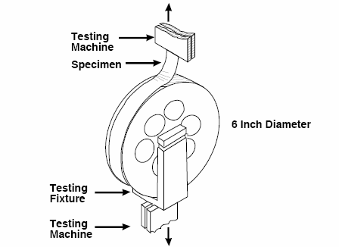
Fig1. Geometry of the peel testing equipment, IPC-TM-650 test method 2.4.9d (“Peel strength, flexible printed wiring materials”).

TEST – Tensile Strength and Elongation
The test specimen consisted of a strip of flexible material 152.4mm long x 12.7mm wide. The tensile strength of specimens cut from the machine direction of manufacture (parallel to the material roll length) and from the transverse direction (transverse to the material roll length) of manufacture were measured.

IPC-TM-650, Method 2.4.19 was used. Figure 2 illustrates the procedure.

Fig2. Diagram of tensile strength and elongation test.

TEST – Moisture Absorption
This test determines the moisture absorption properties of flexible dielectric materials.

IPC TM-650 method 2.6.2 was used. The specimens were made of square pieces of flexible material 100mm x 100mm which were first baked prior to being weighed on a balance. They were then immersed in a water bath for 24 hours and then re-weighed.

TEST – Tear Strength
Two tear tests, initiation and propagation, were conducted. The initiation tear test was conducted according to test method 2.4.16 (see fig3.) and the propagation tear test was conducted according to test method 2.4.17.1 (see fig4 and 5) of the IPC-TM-650 Test Methods Manual.
Fig3. The geometry of the IPC initiation tearing test specimen.
Fig4. The geometry of the propagation tear test specimen.

Fig5. The propagation tear test specimen configuration.

Design and Manufacture of Test Circuit type a
The Flexnolead partnership designed a specific test board (Type A) to carry out further materials investigation, see fig6. Test Board A was 100mm x 100mm in size and was used to evaluate dimensional stability (IPC 2.2.4c) and flexural fatigue and ductility (IPC 2.4.3.1c). The test board also has an area to be used for laser soldering (a requirement of Freudenberg) and has features to check for peel strength.

Fig6. Test board A.

TEST - Dimensional Stability of Flexible Substrate
Dimensional stability is a measure of the dimensional change of material that is caused by factors such as temperature changes, humidity changes, chemical treatment (ageing), and stress exposure to mechanical stress. Figure 6 shows the features on the test board used test to determine the dimensional stability of a particular flexible substrate material, this was the same structure as was used for the flexural fatigue tests.

TEST - Flexural Fatigue
Flexural fatigue is defined as the number of flexes to failure of a flexible wiring circuit pattern.
Flexible fatigue testing was carried out using IPC-650- 2.4.3.1c. Figure 7 represents the test pattern constructed on the test board to carry out the evaluation.

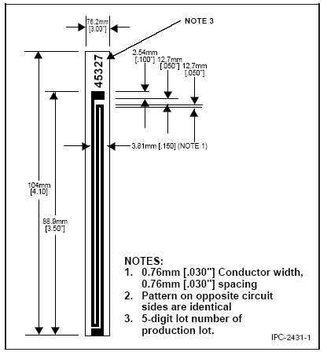
Fig7. Flexural fatigue pattern.

Surface mount reflow assembly of further test circuits
The second half of the project was dedicated to assembling test circuits with surface mounted components, and performance and the analysis of life testing. From this work a predictive model was developed. The Flexnolead partnership designed two separate assembly test boards (C and D) on which to carry out the investigation work. Test board B was not used within the project.

The Type C test board (fig8.) was designed to evaluate actual assembly processes. This test board included patterns for various components including a ball grid array (BGA), quad flat pack (QFP), light emitting diodes (LEDs), a small outline transistor (SOT), a dual in line package (DIL) and numerous surface mounted passive (resistors or capacitors) components.
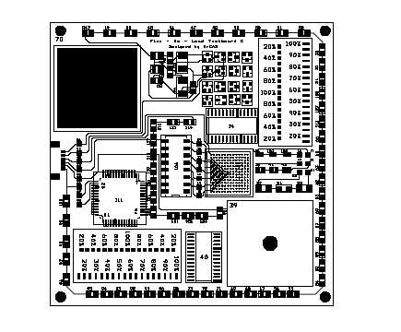
Fig8. Test board C.
Due to the complexity of Test Board C only a small number of these boards were manufactured. To increase the number of test boards within the reliability testing trials a further test board was designed. Test Board D, was of much simpler design with only passive components (0603 chip resistors) to be assembled on to it. Some samples also included a cover layer which is a protective layer on top of the circuit.

The image of Test Board D is represented in Fig9.

Fig9. Test board D.

Assembly of Test Board C
Initial assembly trials of the Type C test boards were conducted at Emerson and Cuming’s facility in Belgium and BME lab in Hungary. The manufactures of the test boards plus the number of each flexible circuit assemble are given in Table 2.

Table 2. Test board type C quantities.
Manufacturer | PI | PEN | PVC | LCP | PET
Flex-Ability | 6 | 6 | 6
Flexible Technology | 8 |  |  | 6 | 6
Eldos (GTS) | 6
Eldos (MSC) | 9
Epigem | 5

The process for assembly falls into 3 parts; applying the solder paste/conductive adhesive paste, placing the components, and interconnect through reflow. Apart from the reflow profiles, the same process and parameters were employed for lead-free and Sn/Pb solders plus the conductive pastes.

The parameters of these three processes are detailed below:

Applying the solder:
The polyimide and liquid crystal polymer substrates were first pre baked for a minimum of 2 hours at 125°C to remove moisture from them prior to assembly and reflow.

The flexible substrates were fixed to a rigid support (Standard FR4). The boards were then placed and aligned using a vacuum to the printer table.

The solder paste was printed using a DEK 249 semi-automatic printer using double steel squeegees. The stainless steel laser cut stencil with 125μm thickness was supplied by Alpha-Sigma.

Placing the components:
The placement was achieved using a Samsung CP20CV pick and machine with 2 mobile placement heads. Fixed cameras were used to align the BGA. Supports were required to hold the board during placement of the components. Placement force was regulated. The populated board was then sent through a buffer to the reflow oven.

Interconnect through reflow:
The profiles for both solders were optimised using SlimKIC 2000 technology. Details of the reflow optimisation are contained within the FLEX-TWI-DEL-10 report. The reflow oven used was a ERSA Hotflow 2/12 with 6 temperature zones both top and bottom with a 2 zone cooling area.

The lead based solder was the alloy was 63%Sn /37% Pb which melts at 183°C. The lead-free (SAC) solder was the alloy was 96.5%Sn/3.0%Ag/0.5%Cu this melts at 217°C.

Emerson and Cuming supplied three different adhesive materials, two epoxy-based, the first requiring 125°C for 8 minutes to cure, the second requiring 150°C for 5 minutes to cure. An acrylic based material was also evaluated, this required 80°C for 1 hour to cure.

Table 3 gives a break down of the materials and the process conditions used for each material type.

Table 3. Test Board C assembly break down and process conditions.
Materials | Max Process temperature (°C) |  | PI 1 | PEN | PVC | PI 2 | LCP | PET | PI 3 | PI 4 | PI 5
Pre-Bake (at least 2hrs@125°C) |  |  | YES | X | X | YES | YES | X | YES | YES | YES
SAC |  | 245 | 2 | X | X | 2 | 2 | X | 1 | 2 | 2
SnPb |  | 230 | 2 | X | X | 2 | 2 | X | 1 | 2 | 1
Epoxy Adhesive 1 |  | 150/5min | 2 | 2 | 2 | 2 | 2 | 2 | 1 | 2 | 2
Epoxy Adhesive 2 |  | 125/8 min | X | 2 | 1 | X | X | 2 | X | X | X
Acrylic Adhesive 3 |  | 100/ 60 min | X | X | 2 | X | X | X | X | X | X
 |  | Total | 6 | 4 | 5 | 6 | 6 | 4 | 3 | 6 | 5

Assembly Trials of Test Board d
Assembly trials of the Type D test boards were conducted at TWI in the UK. It followed the same basic principle as for the assembly of test board type C. The process for assembly falls into 3 parts:

- Applying the solder/conductive paste.
- Placing the components.
- Interconnect through reflow.

During this assembly trial three solder paste types were used, tin/lead (benchmark), tin/silver/copper and tin/bismuth. Two epoxy based conductive adhesive materials were also evaluated.

Apart from the reflow profiles, the same process and parameters were employed for tin/lead, lead-free (tin/silver/copper and SnBi) solders and the conductive adhesives.

Table 4 gives a summary of the combination of materials used whether they had a cover layer or not and the total quantities manufactured.

Table 4. Test board type D quantities.
Material | Cover Layer | Quantity
PI 1 | No | 22
PI 1 | Yes | 16
PI 2 | No | 16
PI 2 | Yes | 17
PI 3 | No | 5
PEN 1 | No | 21
PEN 1 | Yes | 20
PI 4 | Yes | 4
PI 5 | Yes | 8
PET | No | 16
PET | Yes | 16
PI 6 | No | 16
PI 6 | Yes | 20
PI 7 | No | 16
PI 7 | Yes | 16
PEN 2 | No | 16
PEN 2 | Yes | 16
PAPER | No | 19

Table 5 gives a summary of the combination of materials used for the assemblies and the numbers of circuits built.

Table 5. Summary of Test board D assembly build.
 |  | Board Numbers Assembled with Specific Joining Materials
Material | Cover layer Present | Tin/ lead | Tin/ silver/ copper | Tin/ bismuth | Adhesive 1 | Adhesive 2
PI 1 | No | 14 | 8 | - | - | -
PI 1 | Yes | 7 | 9 | - | - | -
PI 2 | No | 8 | 8 | - | - | -
PI 2 | Yes | 9 | 8 | - | - | -
PI 3 | No | - | 5 | - | - | -
PEN 1 | No | - | - | 8 | 9 | 4
PEN 1 | Yes | - | - | 8 | 7 | 5
PI 4 | Yes | 2 | 2 | - | - | -
PI 5 | Yes | 4 | 4 | - | - | -
PET | No | - | - | - | 8 | 8
PET | Yes | - | - | - | 8 | 8
PI 4 | No | 8 | 8 | - | - | -
PI 4 | Yes | 12 | 8 | - | - | -
PI 5 | No | 8 | 8 | - | - | -
PI 5 | Yes | 8 | 8 | - | - | -
PEN 2 | No | - | - | 8 | 8 | -
PEN 2 | Yes | - | - | 8 | 8 | -
PAPER | No | 7 | 12 | - | - | -

Solder Reflow Profile Optimisation
The profiles for the solders were optimised using SlimKIC 2000 technology. Samples of the flexible circuiits were placed onto specially designed jigs and thermocouples were attached. The thermocouples were connected to the KIC profiling unit. The assembly was then passed through the reflow oven and the temperature of the thermocouples was recorded using the KIC software.

Multiple thermal process methods were developed to test the flexible materials. These processes represented the conditions typically experienced in current lead containing solder alloys as well as those required for lead-free solder alloys.

The following graphs are copies of the reflow profiles created using the KIC profiling system and a test board with thermocouples attached.
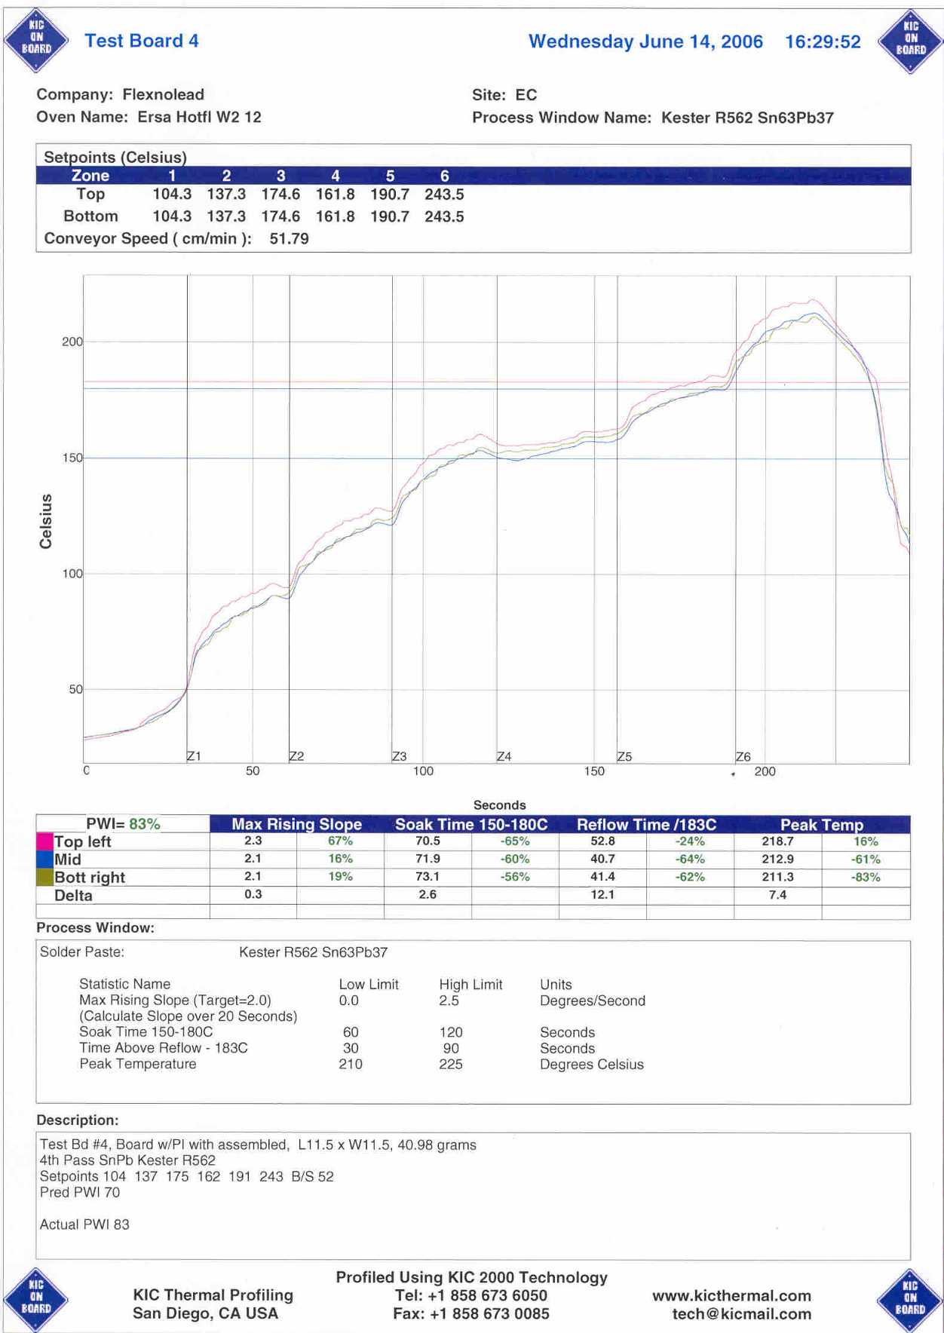
Fig10. Reflow profile for tin/lead solder alloy.

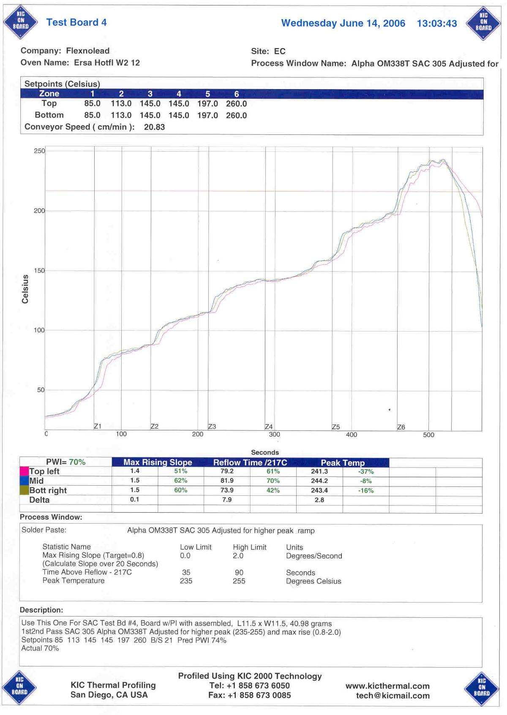
Fig11. Reflow profile for tin/silver/copper solder alloy.

Assembly using Conductive Adhesives
The test boards assembled with the adhesive materials were cured using a batch oven to help save time in creating a new profile for the reflow oven. However, it is possible to use a conveyorised reflow oven for this process.

Thermocouples are attached to the substrate and placed in the oven. The temperatures of the different areas are monitored to determine the actual temperature of the substrate. From this we can determine the time required for the adhesive to reach full cure. The typical cure profiles for ECP are as follows:

- 125°C for 8 minutes
- 150°C for 5 minutes

A graphical representation of the temperature of the thermocouples and the oven at both temperatures is below. An allowance time was given to allow the assembled boards to reach the proper curing temperature.

Fig12. 125°C adhesive cure profile.
Fig13. 150°C adhesive cure profile.

Assembly of test circuits using laser Soldering Processes
Further investigations of selective lead-free soldering on low temperature flexible substrates with a new soldering method based on a special laser technique were conducted. Freudenberg has developed through-hole solder bumping (THSB) technology in co-operation with the University of Erlangen (FAPS). The technology utilises a Nd:YAG (neodymium:yttrium aluminium garnet) laser to rapidly melt solder balls that form the joints between components and the substrate.

This is done by placing lead-free solder balls in plated through holes of a FPC and melting them with the laser, this then forms an interconnection between the substrates, fig14. The advantage of the selective soldering method is that only the pad area is heated. Therefore this technique should also be applicable for low temperature thermoplastic substrates such as Polyethylene Terephthalate (PET).

Fig14. Through-hole solder bumping (THSB) process.

As most single sided flexible circuits do not have plated through-holes the task of this part of the project was to enhance the THSB-process so that flex-to-flex interconnection Fig15, and flex-component assembly, Fig16 could be carried out on temperature sensitive non-plated through-hole flexible substrates.

Fig15. Flex-flex interconnection using non-plated through-hole.

Fig16. Component attachment onto pads with non-plated through-holes.

The initial assembly trials were carried out on a solder ball bumper at the University of Erlangen, see Fig17. The test boards had circular bond pads and the through-holes were plated. Tin-lead solder balls were used initially to evaluate the process and 0603 components were assembled onto the substrates.

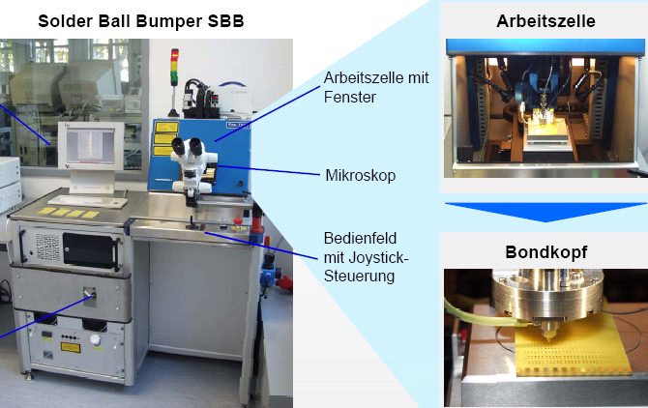

Working
cabinet
Bond
head
Working
cabinet
with
window
Microscope
Joy
stick
control
Working
cabinet
Bond
head
Working
cabinet
with
window
Microscope
Joy
stick
control
Fig17. Solder ball bumper used by Fruedenberg and the University of Erlangen.

Analysis of the results showed that the wetting of the solder to the component and the bond pads was good. The capillary force was adequate to move the solder into the small cavities. Figure 18 is a cross-section of an assembled component showing good solder wetting.

Fig18. SEM cross-sectional image of laser soldered joints using THSB method.

Further laser soldering trials were carried out by BME and Komed, again using a Nd:YAG solid-state laser. See fig19.

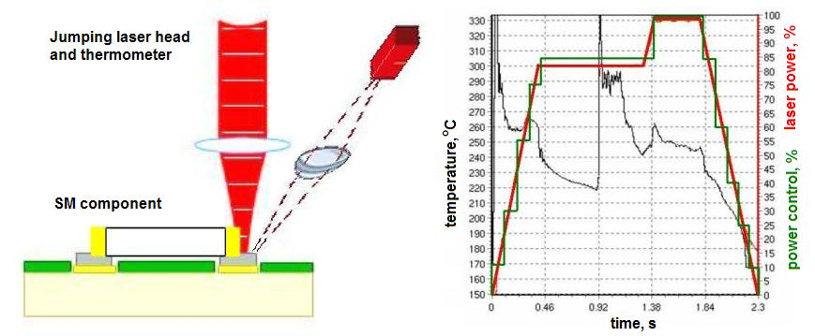
Fig19. The principle of laser soldering for surface mount components by BME and Komed.
BME and Komed investigated the use of laser soldering techniques to the selective soldering of surface mount components to flexible substrates, also the soldering of flexible circuits to rigid printed circuit boards (PCBs), see figures 20 and 21.
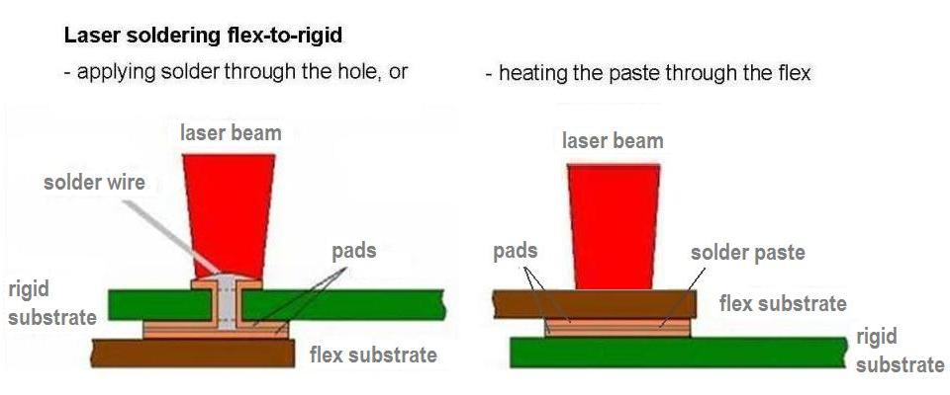
Fig20. Two methods of laser soldering flex to rigid: applying solder and heating through the hole of the rigid board, or heating solder paste through the flexible foil. BME.

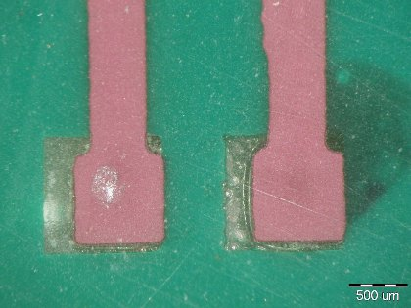
Fig21. Example PET flexible circuit soldered to rigid PCB. BME.

The laser soldered joints showed similar performance to that of conventionally oven-reflowed joints of surface mount (SM) components and flex-rigid combinations with regard to shear strength, joint resistance and life time tests. As a consequence, laser soldering could be a realistic alternative for joining SM components, in particular when using low temperature substrates, like flexible PET, PEN or PVC.

Test circuit assembly observstions
After the assembly of the test circuits had been completed each board was visually inspected to check for defects. Figure shows an example of an assembled type C test circuit made from PET material.

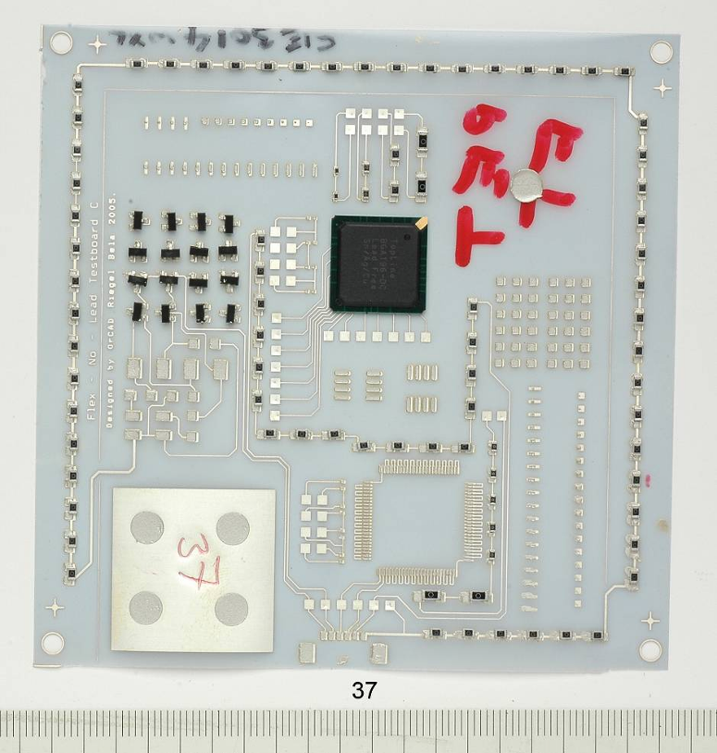
Fig21. Example of Flexible Technology PET board assembled with E&C conductive adhesive.
Figure 22 is an image of am 0603 resistor in a type D test circuit.

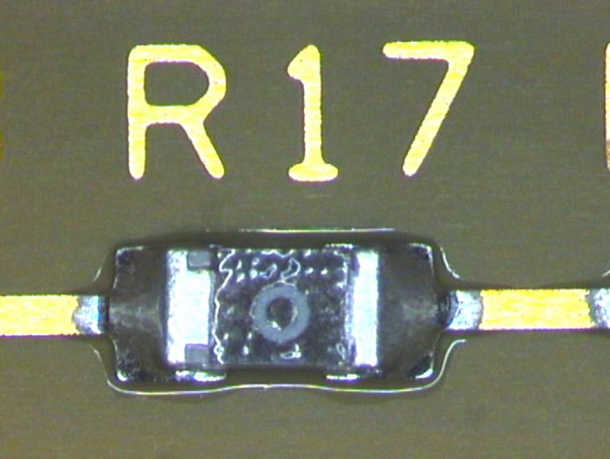
Fig22. Tin/lead solder joints on Type D flexible substrates (Flex-Ability, PI NA).

Printed Solder Paste and conductive Adhesive Observations

Solder paste printing provided no major problems, despite all substrates requiring manual alignment to a printed master because of the closeness together and variability of reflection of the fiducial markings. Any substrate showing an appreciable offset of the printed material to the component pads was removed from the assembly process, cleaned and then reintroduced.

Conductive adhesive printing required closer inspection than that for solder paste because curing adhesive does not have the ability to pull onto and wet a component pad in the same way as reflowing solder, hence the printing needed to have greater accuracy. This was achieved with no major problems; Figure 23 showing examples of printed adhesive deposits.

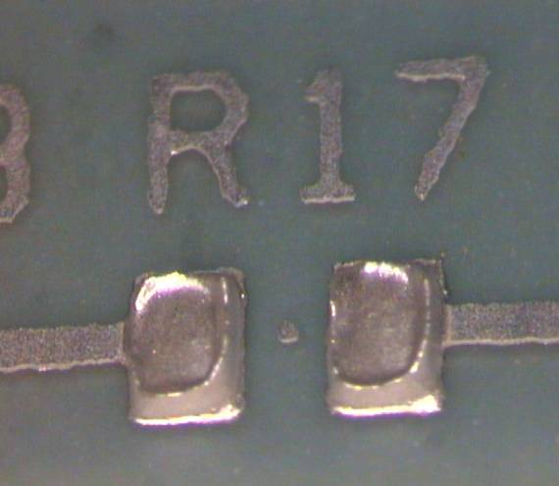
Fig23. Example of printed adhesive deposits.

Post Solder Reflow Observations
Solder joint formation after reflow for all three solder alloys occurred as expected in the majority of assembly samples, see Figures 24. For the size of trial undertaken, the yield of good solder joints was considered acceptable.

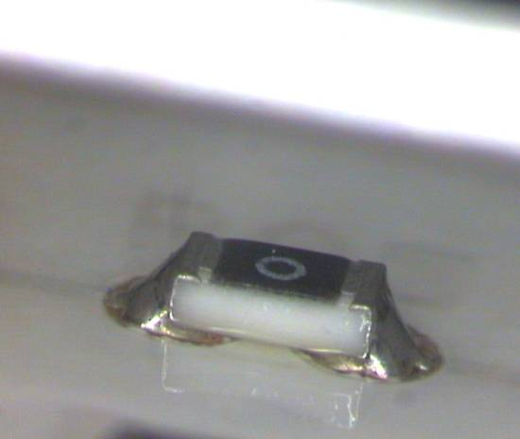
Fig24. Tin/Bismuth solder joints on flexible substrates.

Substrate Deformation
Several of the flexible substrates irreversibly deformed during the high temperature tin/silver/copper solder reflow (peak temperature 240°C) and thus created joint defects that were unreworkable.

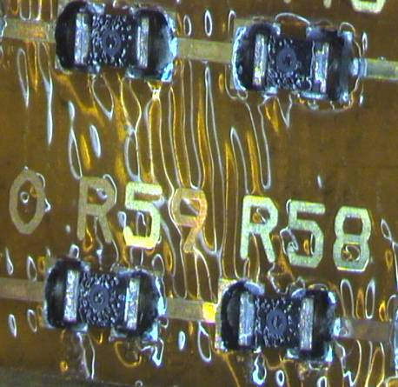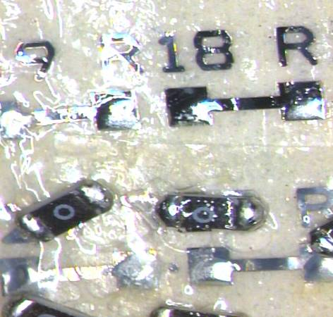
Fig25. Flexible substrate deformation following tin/silver/copper solder reflow.
- PI
- PAPER

Solder Joint Defects
There were four main defect types identified on visual inspection and electrical test of the completed builds (open joints, large joints, missing components, and misaligned and tombstoned components). Figure 26 shows an example of a tombstones resistor.

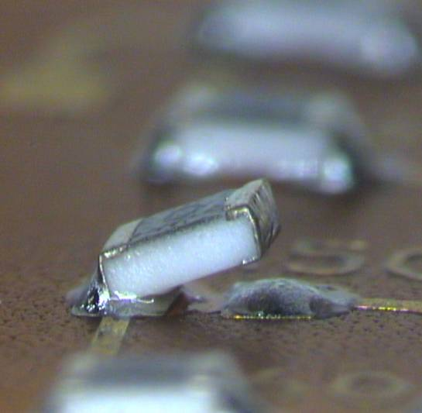
Fig26. Example of a tombstoned component.

Post Adhesive Cure Observations
Conductive adhesive cure occurred smoothly with few apparent defects being generated in this step. Unlike the reflow of solder paste, there was no clear indication that the adhesive had cured or indeed had reached full cure, as there was no change in visual form or location of the adhesive compared with its appearance after placement. Some very slight discolouration was seen in some instances, although this was generally only picked out under magnification. Manual probing of the adhesive deposits was able to distinguish that at least the assemblies had undergone a cure cycle. Figure 27 shows an example of a cured adhesive joint.

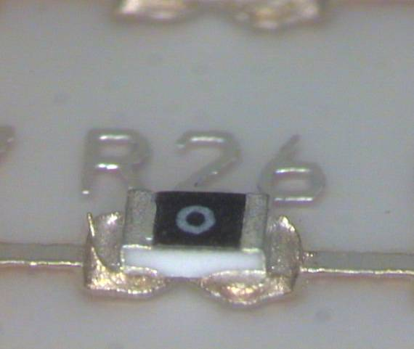
Fig27. Examples of cured adhesive joints.

Reliability Test Results of the Assembled Test Boards
After component assembly trials were conducted component electrical continuity tests were conducted plus life testing including damp heat, thermal shock, highly accelerated stress testing and high temperature storage tests were conducted.

Table 6 describes the tests, conditions and the total length of each type.

Table 6. Reliability test regimes
Test Type | Conditions | Total Test Time
Damp Heat | 85°C 85% relative humidity | 1000 hours
Highly Accelerated Stress Test | 120°C, 95% relative humidity, 2 bar pressure | 800 hours
Thermal Shock | -40°C to +125°C, dwell time 15 minutes | Conductive adhesive boards 1250 cycles.  Solder boards 2500 cycles.
High Temperature Storage | 120°C PI, PEN and Paper boards.  105°C for PET boards. | 1000 hours

Component shear test analysis was undertaken at different stages throughout the tests above. The aim was to measure the force required to shear off the components, the type of failure generated and to correlate this to methods and materials used to manufacture the circuit.

Thermal Shock Tests
The boards assembled with adhesives showed relatively high initial failure rate compared to the soldered ones. These initial failures (failures at 0 cycle) were mainly due to the assembly process. However not all initial failures could be attributed just to the assembly process.

There was no significant difference between boards assembled with the tin/silver/copper (SAC), tin/bismuth (SnBi) or tin/lead (SnPb) solders.

The thermal shock cycling did not significantly influence the contact resistance of the solder joints, but the resistance of the daisy chains on the boards manufactured by adhesive showed great variation. An increase in resistance was the general trend, however some samples did decrease in resistance. The shear strength of the tested conductive adhesive joints were generally lower than the soldered joints, whilst their resistance is slightly higher than that seen for boards assembled with solder.

Humidity Tests
The results of the humidity testing on the assembled flexible circuits again indicated that the main influence on the reliability was the method of component/substrate interconnection, i.e. solder or conductive adhesive. All the other variables, such as substrate material, component type, solder type and adhesive type were of minor consequence.

Highly Accelerated Stress Testing (HAST)
The HAST tests revealed that PEN, PET and Paper boards do not pass this test, the base materials generally became brittle and disintegrated. It is recommended that these materials should only be used in restricted applications or if protection is given. The Polyimide boards also showed reduction in component joint strength with HAST.

The results were inconclusive as to whether boards with or without cover lay were more reliable. The cover lay openings were found to be too small for the size of components used. This is likely to have impacted the number of defects observed on these boards.

High Temperature Storage Testing
The aim of this study is to evaluate the performance of various flexible substrates when subjected to high temperature storage conditions.
For the contact resistance measurements the circuits assembled with adhesive were still generally outperformed by those assemble with solder. There was a general increasing resistance trend in the results which is normal. There was little difference in the results between various solder types.

For the component shear results the adhesive was outperformed by solder. Again there is little difference in the results of the various solder types.

It should be noted that solder mask defined boards were more sensitive generally gave lower shear test results than non solder mask defined boards.

Life Prediction Models
Greenwich University conducted a number of computer modelling experiments. The aim of the modelling work was to identify materials that can be used to produce quality flexible substrates for lead-free soldering processes.

Full modeling of mechanical and physical-chemical material specifications, as well as testing prescriptions was conducted. This provided finite-element thermo-mechanical modelling support, and involved gathering relevant materials from the public domain and the project partners. The models used have predicted the temperature and stress profiles in the chosen flexible substrate materials when subjected to both lead-tin (peak temperature 210°C) and lead-free (peak temperature 250°C) solder reflow profiles.

The major features of the work were the completion of the ‘real life’ test evaluation and the validation of the predictive model. Based on the modelling results the following conclusion can be drawn:

- Effect of design rules of flexible substrate without a cover layer

  - Impact of copper track:
    - Lower track thickness induces smaller shear stress
    - Track width does not affect induced stress significantly
    - Distances between tracks has little effect on reliability

  - Impact of adhesive:
    - Adhesive thickness has negligible effect on induced stress
    - Adhesive CTE should be as low as possible

  - Impact of base film:
    - Lower substrate thickness results in slightly lower shear stress
    - Lower substrate thickness results in higher vertical (z-axis) displacement

  - Impact of dielectric material:
    - Dielectric material in between copper track reduces shear stress

- Effect of design rules of flexible substrate with cover lay :

  - Impact of adhesive:
    - Higher the adhesive thickness results in a higher the vertical (z-axis) displacement
  - Impact of base film:
    - Higher the film thickness results in a higher the vertical (z-axis) displacement

Modelling results also recommend that optimisation in design variables for substrate and cover lay can reduce the warpage/displacement of the flexible substrate.

Modelling of the reliability of solder joints under thermal shock cycling condition suggests that:

  - Solder mask defined (SMD) copper pad is better for flexible substrate with cover layer.

  - Non-solder mask defined (NSMD) copper pad is better for flexible substrate without cover layer.

Plan for Using and Disseminating the Knowledge
The expertise and knowledge-base of each partner has been substantially increased during the 27 months of the project. This has been made possible by a considerable exchange of information between the partners regarding lead-free processing of flexible printed circuits - starting with looking at the effects on materials, possible circuit processing methods and assembly of populated boards through to reliability testing data. As a result of this input a numerical model has also been developed that has been shown to characterise lead-free soldering on flexible materials.

The exploitation of the knowledge varies depending on the partner organisation, hence the academic partners will see exploitation as being the increase in content of their courses and research offerings to business, the industrial partners will aim at using the knowledge gained to further business. The organising partner, TWI, will be able to increase its consultative offerings to industry.

Knowledge gained through the course of the project may be split into several parts:
- Understanding of the way that typical materials behave in lead-free solder processes.
- Alternative manufacturing methods and materials for the production of flexible circuit materials.
- Manufacture of circuits using lead-free solder parameters.
- Alternative manufacturing methods for the lead-free assembly of FPC and components.
- Assessment of the reliability of flexible circuit boards through physical testing and numerical modelling.

Each partner is capable of disseminating their increased knowledge of lead-free soldering through improved technical discussions with potential customers, through direct advertising, web-sites and so on.

Technical conferences, seminars and exhibitions are to be used in various degree, with the aim of increasing business of all partners.

Partners who have not had direct output from the project, for example BME, are also able to show improved knowledge, which is disseminated through their academic courses through to a new generation of engineers.

Larger partners (TWI, FFD) are able to exchange information gained through internal reporting and seminars.

Each partner has been responsible for retaining its own IPR through the project, not withstanding the exchange of knowledge mentioned above.

Reporting of information and results has been made through group meetings, where results have been presented to the group as a whole.

The information and results so transmitted has been retained within the group, however it remains the property of the partner responsible.

Exploitable Knowledge, Outputs and Dissemination
The responses from each partner have been amalgamated and placed into the following four categories:
A) Materials
B) Flexible Circuit Manufacturing
C) Assembly of Components on Flexible Substrates
D) Understanding the behaviour of flexible circuits in lead-free processing

Materials
Exploitable Knowledge:
- Higher temperatures of lead-free soldering were found to require improved material systems, and these were researched by GTS through the course of the project with the result that knowledge of suitable epoxy adhesive systems for all substrates has substantially increased over the course of the project.
- Practical examples of the behaviour of materials were firstly seen in forced convection reflow tests done by TWI on standard materials.
- Temperature profiles through reflow processes were studied by TWI and KIC and distinctions made between flexible printed circuits (FPC) and rigid board measurement behaviour.
- Laminates and cover layer tapes were shown to behave differently and the amount of cure of the adhesives was shown to be important for the higher temperatures that are associated with lead-free soldering.
- Movement of circuits through reflow was shown to be important and focused attention on the CTE values of PI films and their absorption /desorption of moisture. Excessive movement was shown to cause difficulty with small component attachment.

Outputs (from GTS):
- Higher temperature epoxy adhesive systems for multilayer circuits were developed, along with research into alternative epoxy resin systems, which can ensure a more stable supply and / or lower costs for GTS.
- New flame-retardant adhesive systems were also researched using these improved resin systems – this ensures compliance to the RoHS directive which includes the requirements of removing lead from electronics.
- A non-halogen adhesive system was produced suitable for directly solderable substrates such as Polyimide (GTS 3890 / 7890 product series). The new PI materials were used to manufacture FPC’s at Flexible Technology and Eldos, which validated their suitability for ongoing sales and marketing.
- A non-halogen system was developed for lower-cost substrates such as PET and PEN.
- Several new products using the developed adhesive systems are on trial with customers outside of the flexible printed circuit market, including applications of rigid circuit bonding and electrical insulation of bus-bars.
- Lastly research was made into the manufacture of a glass-epoxy base material using higher glass-transition temperature epoxy resins researched during the project.

Assembly:
- Design ‘rules’ for the measurement of profiles in reflow processes (KIC)
- Ability to process FPC materials through reflow (TWI)

Dissemination (from GTS):
- New materials are to be advertised in trade magazines and fully launched at the Productronica show in Munich in November 2007.
- Agents and sales offices have been notified of the new range of Polyimide products.

The new epoxy adhesive systems with non-halogen flame retardant additives are being notified to potential customers with new projects or developments. This would avoid the use of the more normal brominated compounds.

Alternative Flexible Circuit Substrates
Exploitable Knowledge:
- Alternative base materials were tested through to assembly of components and the effects of reflow studied. This showed that only PI and LCP films could be expected to withstand the lead-free processes without significant distortion or physical changes.

- Other materials, such as PEN, PET, PVC and Paper were shown to require to be processed at lower temperatures – for example by use of lower temperature solders, using alternative assembly techniques or by using a conductive adhesive.

Outputs:
- Process parameters of circuit assembly are known for different materials.
- LCP film has been found to be suitable for small, high frequency FPC, however is limited by its cost.

Dissemination:
- Internal specifications for assembly for flexible circuit manufacturers depending on the material properties (KIC).
- Processing materials technical guidance notes available to employees and customers (GTS).

Flexible Circuit Manufacturing

Lead–free Flexible Circuit Manufacturing by Conventional Methods
Exploitable Knowledge:
- Handling of thin substrates through existing rigid PCB production equipment (Eldos).
- Temperature measurements (profiling) of FPC (KIC).
- Adapting an existing PCB facility to be capable of manufacture of lead-free FPC (Eldos).
- Specific understanding of the limitations and type of available materials and the effects of pre-drying of circuits before exposure to lead-free temperatures (Eldos).
- Understanding of the design of FPC (Eldos).

Outputs:
- Manufacture of lead-free FPC.
- Expertise relating to the design and production of FPC.

Dissemination:
- Marketing of new capabilities for production of flexible circuits (Eldos).
- Internal training (FFD).
- Marketing of capability of profiling with FPC (KIC).

Exploitable Knowledge (Epigem):
- Techniques suitable for the selective deposition of metals onto flexible substrates.
- Benchmarking of additive versus subtractive lead-free flexible circuit boards.
- The use of low-cost substrates such as Polyester for additive manufacture of flexible-circuits
- Use of standard flexible circuit insulation materials for manufacture of additive circuits.
- Lead-free assembly techniques used with additive circuits (lead-free solder, low melt-point solder, conductive adhesive and laser soldering).

Outputs:
- A facility to manufacture fine-line circuits by additive process based on embossing and plating.

Dissemination:
  - Advertising of capabilities once the manufacturing facility has been completed, early 2008.

Assembly of Components on Flexible Substrates

Lead-free Solders – Standard Processing
Exploitable Knowledge:
- The range of parameters suitable for the use of alternative flexible circuit substrates (GTS).
- The effect of lead-free processing temperatures on the physical properties of film substrates (TWI, GTS).
- The assembly of components onto flexible substrates either with or without coverlays (BME)
- Potential assembly problems associated with lead-free solders (all).
- Reliability of lead-free solder joints compared to standard solders (KIC)

Outputs:
- Selection of the correct materials for lead-free processing.
- Use of lead-free solders in medical applications.

Dissemination:
- Advertising of support services to members (TWI).
- Reports for internal distribution to sales offices and agents have been written, discussing the assembly of components using lead-free processes and the effect on flexible circuit materials (GTS).

Alternative Solder Processes
Exploitable knowledge:
- The effect of different solder temperatures on alternative substrates, such as low-temperature alloys on low-cost substrates, has been defined.
- Methods of using laser-soldering techniques have been investigated, with the ability to use lead-free solders together with substrates that would be impossible to use with conventional soldering techniques (FFD, KIC, BME).

Outputs:
- New methods of production.
- A Laboratory laser-soldering system.

Dissemination:
- Internally through technical seminars (FFD).
- Through electronics papers and direct advertising of capabilities (KIC).
- Patent Pending (FFD).
- Internal undergraduate courses (BME).

Conductive Assembly Techniques
Exploitable knowledge:
- The assembly of components onto different substrates using conductive adhesives (E&C)
- Assembly problems and subsequent techniques to increase accuracy of component placement have been found (E&C).
- Reliability studies of conductive adhesive joints - these benchmarking studies of conductive versus soldered joints has enabled a fine-tuning of the process to improve performance and reliability (E&C, BME).

Outputs:
- Improved conductive adhesives.

Dissemination:
- Through conferences such as Productronica, Polytronic into the automotive, handheld devices and inkjet markets.
- Direct advertising / marketing of products (E&C).

Understanding the Behaviour of Flexible Circuits in Lead-free Processes

Reliability Testing
Exploitable knowledge:
- Evaluation of the reliability of solder joints using different substrates and assembly processes (BME).
- Comparisons of the reliability of FPC manufactured using additive versus subtractive manufacturing methods (Epigem).
- Methods for reliability testing of FPC have been defined (BME).
Comparison data of the reliability of lead-free solder versus tin-lead solder (KIC).

Outputs:
- The reliability of solder joints produced on flexible circuits assembled using lead-free technologies.

Dissemination:
- Internal engineering / electronics courses for students (UOG, BME).
- Conference / seminar papers (BME, TWI).
- Advertising knowledge-base to industry (TWI).

Numerical Modelling
Exploitable Knowledge:
- A numerical model that describes flexible circuit materials has been developed, with good comparison of numerical and test data. (UOG).
- Reliability of lead-free solder joints on flexible circuits has been studied (UOG).
- The inclusion of the CTE and moisture effects have been shown to be useful and effective in characterising the behaviour of flexible circuits through lead-free solder processes. (UOG).

Outputs:
- A Numerical model of flexible circuits, capable of showing the movement of materials through reflow processes and reliability of the completed circuit joint.

Dissemination (UOG):
- Internal courses of numerical modelling.
- Conference papers.
- Advertising of capabilities to industry.
methods. It should also encourage best practice throughout Europe.

