The aim of the research proposed by "TISCH: Terahertz Imaging and Spectroscopy in Cultural Heritage" was to develop terahertz imaging and spectroscopy as a viable, non-invasive tool for the nondestructive evaluation of historical artwork and artifacts. This Marie Curie Intra-European Fellowship for Career Development was carried out from February 2014 through February 2016 by Dr. J Bianca Jackson at the University of Reading’s School of Systems Engineering, in Reading, UK. This project utilized continuous wave (CW) measurements, dispersive Fourier transform spectroscopy (DFTS), and time-domain terahertz spectroscopy (TDS). We collaborated on several projects with British churches and museums, a French cultural heritage research institute, and an Italian business. Results have been published in international journals and presented at several international conferences.

Wallpaintings

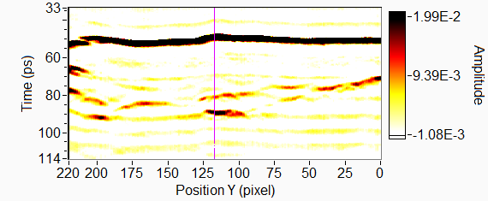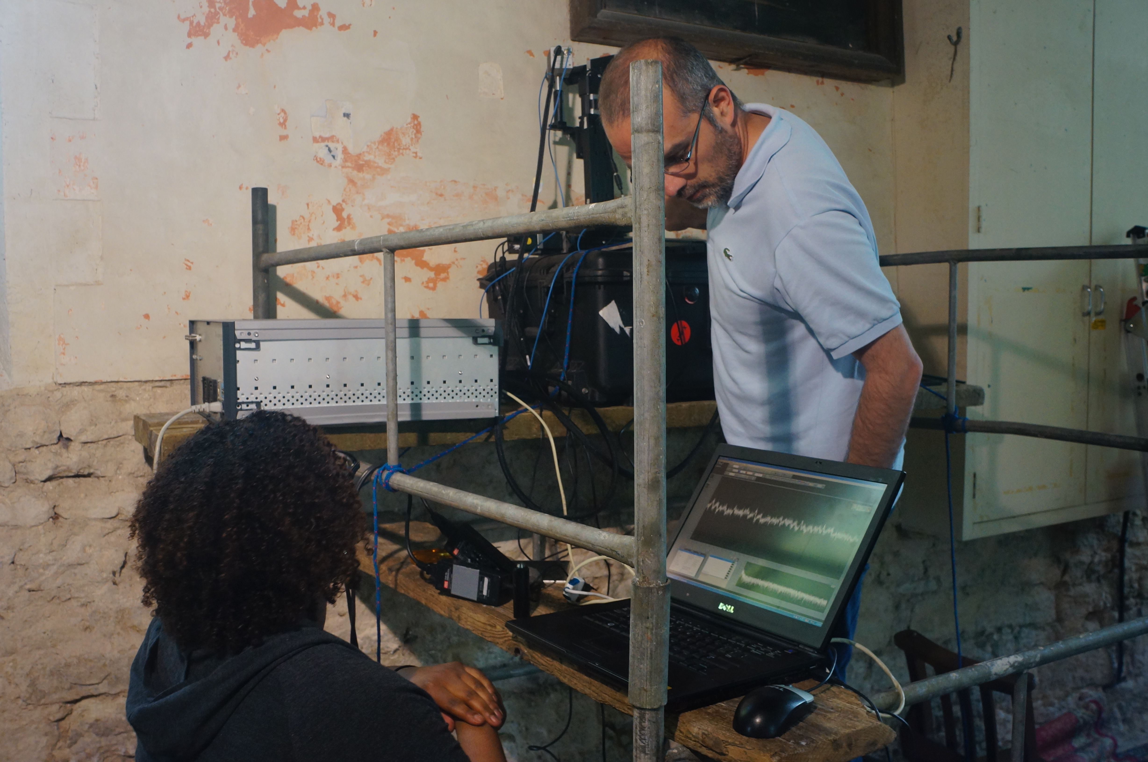

Dr. Jackson took THz time-domain measurements at the Church of Saint Mary-Chalgrove, Oxfordshire UK. We were invited by Charles Baker, chairman of the church’s building advisory committee to look for a 12th C motif beneath 13th, 18th and 19th C layers. The church was under the restoration process, and the THz group from Laboratoire de Recherche des Monuments Historiques (LRMH) was invited to help by bringing their THz-TDSI scanner. We scanned several areas, subdividing sections to manually correct the focus to compensate for the uneven wall surface. In post-processing, Dr. Jackson found layers several millimeters beneath the surface, including what may have been a medieval metal latch.

Dr. Jackson and the LRMH also examined the fresco “Les Trois Hommes Armés de Lances” twice, getting different results. We reasoned that the only material difference between the scans was that the fresco was presence of a volatile binding medium called cyclododecane (CDD). We studied different forms of CDD using DFTS and determined that it may act as a contrast-enhancing, index-matching, anti-scattering compound for porous media. One of the benefits of this substance is that is popular among heritage conservators since it sublimes entirely without residue or material interaction.

Panel Paintings

Dr. Jackson was invited by Marcello Melis of Profilocolore Srl to use THz-TDS to investigate his painting “After Fishing” by Ausonio Tanda. He had already performed hyperspectral measurements and was developing software for principle component analysis (PCA) with image fusion. The painting was scanned completely in both transmission and reflection configurations, and images were generated based on temporal and spectral information. Those images were then imported into the software and processed in a similar fashion to the hyperspectral images. PCA and image fusion enables interpretation of the THz data in ways that correlate with the hyperspectral data. Terahertz imaging was able identify defects below the painting surface that were not detectable using any of the other techniques.

Ceramics

The Tate Museum’s Conservation Laboratory approached us to determine whether terahertz could be used to monitor outdoor ceramic sculptures vulnerable to the wet climate because of their porosity. Dr. Jackson performed feasibility studies on sets of glazed ceramic tiles using DFTS and a 0.09 THz Gunn oscillator. We determined that transmission between 0.1 and 1.0 THz was less than 10% for dry specimen, therefore only high power broadband sources could be used for large sculptures. Using the CW 0.09 THz source, as much as 80% of the signal transmitted through dry samples. We also determined that glazes with more plasticity are significantly more effective at blocking moisture than brittle, crack-prone glazes. Light surface moisture penetrated localized submicron cracks and permeated through the entire specimen. As a result, we were able to successfully monitor the drying process.

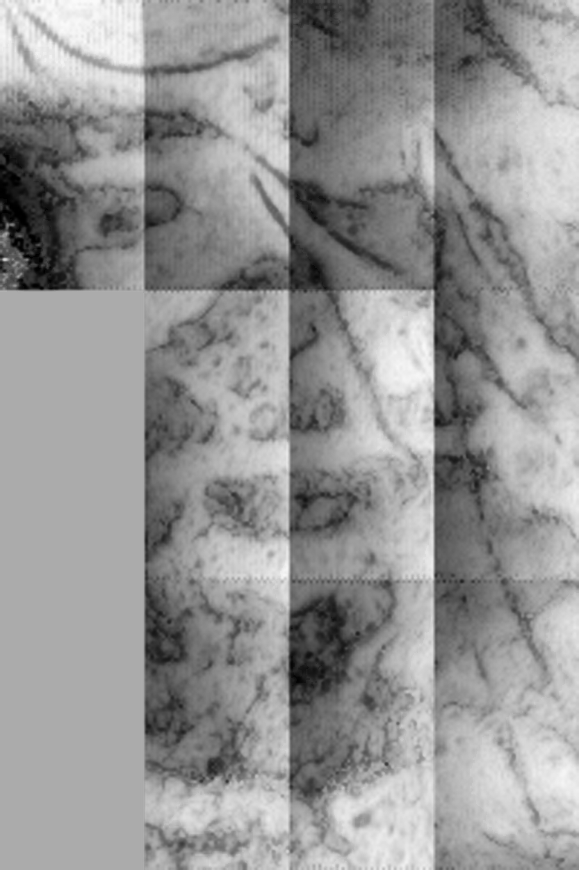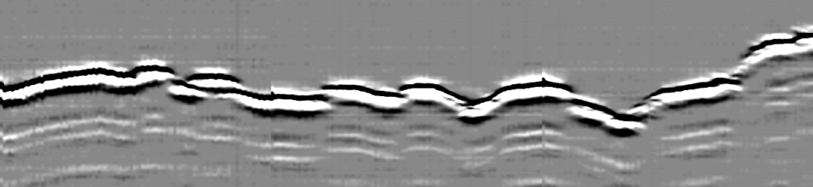Other Topics

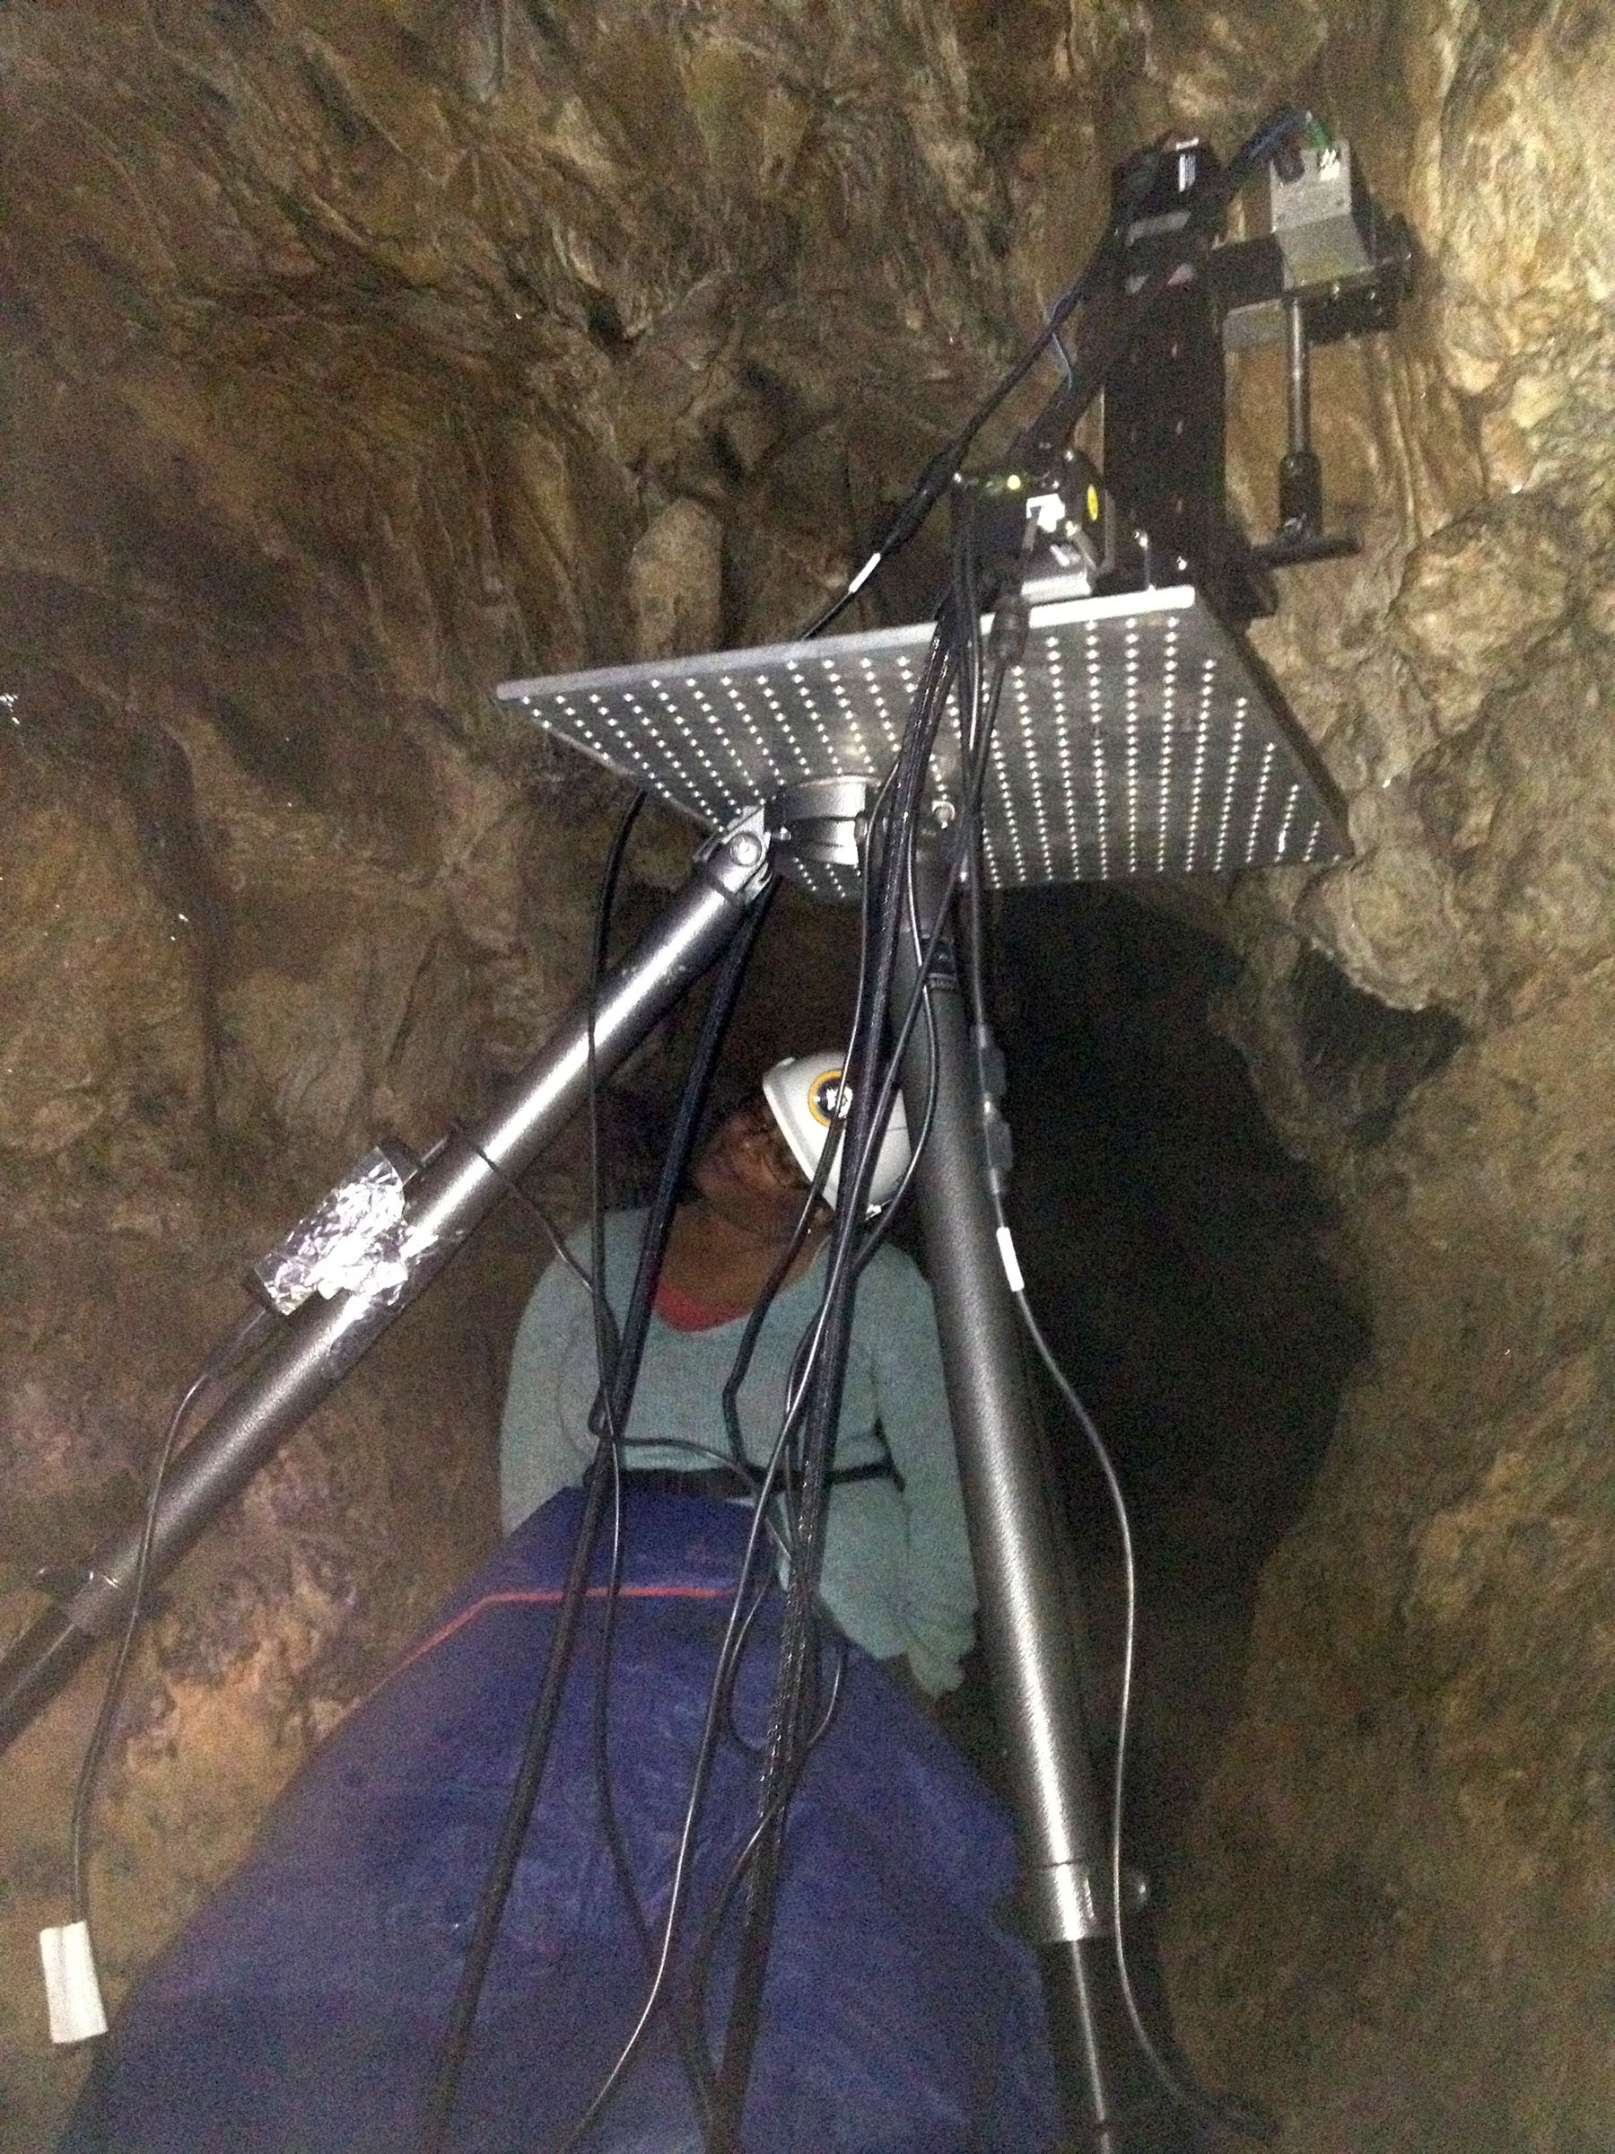

Other research projects included with TISCH: the TDS imaging of a Paleolithic cave etching in Creswell Crags UK, partially obscured by flow rock; the implementation of pigment identification using Neural Network Analysis of THz spectra on fresco samples; and the TDS analysis of transmission through a corroded bronze Sumerian vessel.