Extended Abstract

The primary objective of this research fellowship was the development of an advanced simulating tool that can be used for the investigation of liquid-solid interactions resulting from the impingement of droplets onto Non-Flat surfaces. Such a tool is applicable in both the academic and the industrial sector, since in its current form is able to simulate any droplet impingement onto a varying number of substrates (of any shape and wettability) both under iso-thermal and non iso-thermal conditions. The governing physical mechanisms are applicable in many chemical and mechanical related processes. As a reference for such applications the concept of Fluid Catalytic Cracking, which is used in the petroleum industry is used.

Primarily, the commercial package of ANSYS FLUENT was selected as the basic numerical tool, mostly because of the massive parallel capabilities that can offer compared to existing house-developed codes, as well as its user-friendly interface and the easiness in house-built models integration it offers through the use of User Defined Functions (UDF). During the initial program period, it was decided that a number of standard models applicable in the case of V.O.F (Volume of Fluid) model of ANSYS FLUENT should be further improved, namely a) the liquid physical advection, b) the wettability model and c) the sharpening of the liquid-gas interface should be further improved, so that the accuracy of the method can further increase along with its applicability in a wider range of industrial applications (e.g. fuel injection systems).

During this period, the numerical model was further enriched with a sharpening technique for the minimization of the numerical diffusion, (typical disadvantage in VOF methods), a dynamic local grid refinement technique (not available in standard Ansys/Fluent version), and a wide variety of different dynamic contact angle models. These models, together with the newly proposed Wetting Force Model (WFM) established and tested during this fellowship, can cover the entire state-of-the art modelling of the solid-liquid interaction. At this point it should be highlighted the fact that these actions were not initially described in the proposed WorkProgramme, but the CITY group believes that these are of added value for future research on the field of droplet-solid interaction the current fellowship aimed to conduct. After these updates, the predictions of the new developed numerical tool was tested against experimental data provided in the recent literature for the case of a liquid droplet impacting a solid particle. The comparison between simulation results and experimental values exhibited a good agreement.

Using as a basis the developed methodology, numerous cases of droplet impingement onto Non-Flat surfaces were tested both against other numerical results and experimental data, as well as for conditions resembling those encountered in Fluid Catalytic Crackers (FCC). For the latter to be achieved, the applied numerical model was further extended in order to incorporate a phase-change model, so that it can be capable of considering heat and mass transfer effects from an evaporating liquid-gas interface. This newly developed tool was subjected to validation tests for droplet evaporation within a hot gas medium and droplet impingement onto a flat surface under pool and film boiling conditions. After a series of numerical tests (simple or more complicated), for which either analytical solutions exist and/or literature data had as well been tracked, it was concluded that the developed model behaves satisfactorily for the conditions of interest. The “cracking” reaction was implemented as a surface reaction.

All performed simulations are considered to be novel, in terms of drop-particle collision physics, and of special industrial interest for the petro-chemistry sector. The effect of impact velocity, DTP (Droplet To Particle size ratio) and catalyst temperature on the gas (light molecular H/C) yield and the solid/liquid interacting mechanisms were investigated. The use of two and three dimensional domains justified the robustness of the new formulated and applied numerical algorithm. The main characteristics of the collisions were clarified. It was shown that small droplets should be preferred for injection against larger ones (in the range of 150 μm), as they promote higher gasoline production and less liquid-solid interaction since the direct contact of liquid phase with the solid one is hindered by a vapor cushion. This vapor layer also aids in decreasing the possibility of pore blocking of catalyst surfaces, which is a hot issue problem widely observed in industrial applications.

As an additional further step forward, the developed numerical model was used to simulate the phenomenon of a heavy fuel droplet impinging onto a cluster of 6 catalytic particles in three dimensions. This phenomenon under simulation is believed to be of added value for future research on the field of droplet-solid interaction the current fellowship aimed to conduct, since is a step forward towards the realistic interactions of a liquid droplet, not only with one single catalyst. From the numerical examples, it was concluded that the numerical model was as well able to predict real-case specific-phenomena, contributing to the extraction of important conclusions for the FCC operation, especially as concerns gasoline production and droplet levitation by a vapor layer.

Finally, the model application was proven capable of predicting the cooling effectiveness of a catalytic particle during its “bombing” by a series of four droplets that impinge on a chain fashion. The conjugated solution of both the fluid domain, where the droplet deforms in the process of its collision with the particle, as well as the solid domain, where the particle is cooled by such a collision was achieved. A parametric investigation of DTP, catalyst particle initial temperature and frequency of chain drop impact, on the cooling rates, gasoline yield and temperature temporal evolution was conducted. It was shown that the most effective way to cool down the catalytic particle was to use double sized droplets, which however decreased significantly gasoline yield production.

Representative Figures

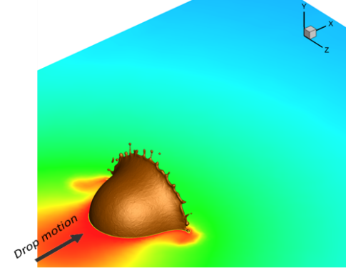 | 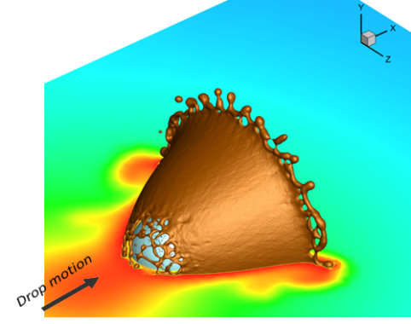 | 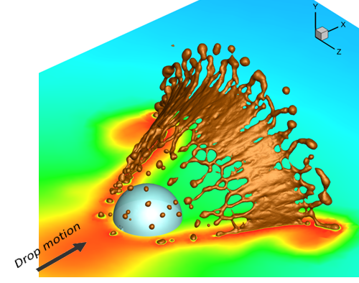
Figure 1. Formation of finger structures and sudden break-up during a heavy molecule liquid droplet onto a catalytic particle. Gasoil vapor mass fraction (kg-gasoil/kg-gas) is depicted on the symmetry boundary (values range between 0 and 0.92).
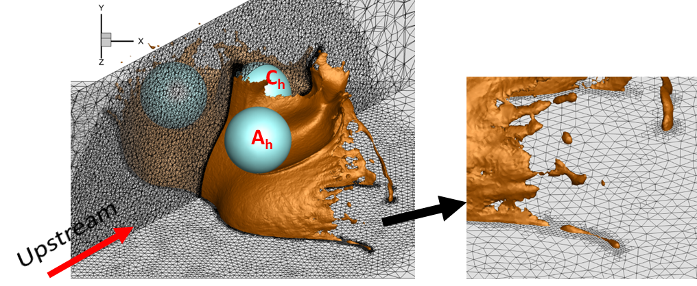
Figure 2. Local refinement algorithm application in the case of drop-particle cluster simulation case. a) Global View, b) Close-up view.

