

|  |  |
| --- | --- |
| **Final Publishable Summary** | |
| Project acronym:  Project title:  Grant Agreement no:  Project website  Period covered  Coordinator:  Organisation:  Phone:  Fax:  E-mail: | **MultiHemp**  Multipurpose hemp for industrial bioproducts and biomass  311849  http://multihemp.eu  1/9/2012 to 28/2/2017  Prof. Stefano Amaducci  Università Cattolica del Sacro Cuore  +390523599223  +390523599222  stefano.amaducci@unicatt.it |
|  | |

Executive summary

In Multihemp, a multidisciplinary team of leading researchers and a vibrant group of industrial participants, working from the level of molecular genetics through to end product demonstration, developed an integrated hemp-based biorefinery in which improved feedstock is subject to efficient and modular processing steps to provide fibre, oil, bio-composited, construction materials, fine chemicals and cosmetics using all components of the harvested biomass, and generating new opportunities within the developing knowledge based bioeconomy. Advancements of Technology Readiness Levels (TRL) were obtained for several products. A formaldehyde-free hemp based panel system has reached TRL 9 and during the course of Multihemp a new industrial plant was inaugurated. A hemp-based blow-in insulation system reached TRL 6 and is now processed for EU licencing. Hemp-oil based cosmetics reached TRL5. Test on High-tech (using long fibre) and Mid-tech (using hackling losses) Biobased composites applications showed that hemp fibres have a real potential in replacing less environmental friendly materials, like glass fibres.

To optimise the whole production chain and obtain materials and products of desirable quality, extensive research and demonstration activities were performed. Adjustments and adaptations were performed at industrial scale and on innovative prototype systems. Harvesting machines were tested and an innovative technology was designed and developed to increase seed quality and collect threshing residues for subsequent cannabinoids extraction. An innovative high-throughput quality evaluation system was developed and used to characterise thousands of stem and fibre samples.

Results from a large network of agronomic and physiological experiments supported a significant advance in hemp agronomy and the parametrisation and validation of the crop model GECROS that is now a valuable tool for both growers and breeders in the ongoing development of a sustainable hemp production. Two complimentary approaches to hemp breeding using both forward and reverse genetics were applied. While new varieties could not be generated within the span of the project homozygous mutant material has been produced for three targets genes related to fibre quality and led to a chemotype at the fibre level. One line was introgressed into the elite fibre variety Futura. Genotyping and phenotyping 124 hemp accession of the mapping panel, association mapping was performed and identification of QTLs associated with interesting traits related to phenology and quality was accomplished.

Dissemination activities have taken place throughout the project, with research partners mainly attending scientific conferences and producing peer reviewed papers and industrial partners presenting their products to trade fairs and exhibitions. The forum of the annual international conference of the European Industrial Hemp Association (EIHA) has been used very actively throughout the duration of the project for an exchange between the project and scientific and industrial community. A Stakeholder workshop organised in 2016 highlighted the main bottlenecks hampering the expansion of hemp cultivation in Europe. A fibre quality workshop addressed to PhD students and young researchers was successfully organised at the Université de Lille (FR) on January 18th, 2016.

Summary description of project context and objectives

Hemp is a high yielding crop well adapted to most European conditions, with advantageous environmental and agronomical characteristics. Traditionally cultivated for the fibre, seeds and psychoactive substances and potentially for a wide array of other applications hemp is rightfully considered an ideal crop to produce multiple biobased materials (Amaducci and Gusovius, 2010).

Once a major industrial crop, hemp faced a worldwide progressive decline in the last century as its use for textiles was displaced by cotton and synthetic fibres. However, in recent years there has been renewed interest in hemp for a range of industrial applications due to the superior quality of its fibre in a number of uses, and because it is more sustainable than cotton (van der Werf and Turunen, 2008) and to manmade fibres in specific industrial applications (Pervaiz and Sain, 2003). In addition to fibre, hemp also produces high quality seeds with developing markets for the oil and protein. Despite renewed interest, and obvious potential as a biorefinery crop, hemp remains poorly developed as it has not been subjected to intensive breeding in the last 50 years.

As for any other crop, the competitiveness of hemp also relies on a favourable political framework (Ragauskas et al., 2006). It is increasingly recognised that the political-economic framework for bio-based materials and products in the EU should be based on agreed and scientifically proven criteria such as climate protection, resource efficiency, employment and innovation (Carus et al., 2011). In the face of great global challenges in the area of climate change, food security and diminishing reserves of fossil fuels, the role of a low-input high yielding crop able to provide a range of high quality renewable materials and chemicals, such as hemp, could not be more timely. However, considerable effort in the area of crop improvement, farm and process innovation, and supply chain development are needed before the full potential of hemp as a biorefinery crop can be realised.

In order to drive forward the innovations needed to bring to market sustainable and biodegradable biomaterials Multihemp will develop an integrated biorefinery based on hemp. This will be advanced by developing the “green factory” concept harnessing the natural potential of this crop to deliver high quality raw materials, and developing integrated processing systems to obtain maximal value from the crop in a sustainable manner. The work will be industrially driven and include demonstration activities to underpin new opportunities in the knowledge based bioeconomy.

Multihemp concept

This research project aims at developing hemp genotypes with enhanced traits suitable for diverse cultivation environments and to provide improved feedstock for a wide array of innovative end products generated within an integrated biorefinery. Our aim is to develop a modular biorefinery in which market forces will dictate the flow of raw material into differing product options. The production of long bast fibre for technical textiles and high-quality composites will be coupled to that of short bast fibre for injection moulded bio-composites and insulation products, as well as shives for low carbon construction materials, oil for health and personal care applications, protein for food and feed, and high value chemicals such as phytosterols, waxes, and essential oils. Innovative applications will be developed for the by-products from processing routes including: dust from fibre processing, retting liquor from fibre degumming, flour (or cake) from oil extraction, and threshing residues from seed harvesting. Industrial and processing requirements in terms of fibre and oil quality will be addressed in an integrative work package and will identify principal targets for cultivation and for the breeding programme. Industrial destinations, with their respective quality parameters and production traits, will therefore drive breeding targets and improvements in crop management.

The targeted improvements in hemp raw material quality will be driven by industry end-user requirements and be informed by state-of-the-art knowledge of relevant areas of plant biology and metabolic pathways and achieved using modern molecular tools. A better scientific understanding of genetic control of biomass quality will allow the identification of molecular markers and novel tools for plant breeding. Commercial varieties, wild accessions and lines at different stages in the breeding pipeline will be tested in field trials across multiple locations. Agronomic trials and physiological studies will be undertaken to study the effect of cultivation practices and growing conditions on biomass yield and quality. Knowledge generated during agronomic and physiological studies will be used to calibrate and validate a crop model that will aid hemp breeding and cultivation.

We will undertake studies into the economic and environmental implications of the newly developed genotypes coupled with the innovations in cultivation, harvesting and processing systems and the integrated hemp biorefinery concept as a whole in order to maximise potential benefits to the environment and rural economy. Overall, the project is designed to maximize economic return (developing high added value applications), to increase environmental sustainability and to foster rural development.

**Developing an integrated hemp biorefinery**

The concept of biorefinery developed within this project combines actual and innovative processing systems that, starting from harvesting, transform hemp biomass into a spectrum of marketable intermediate and final products. Two main routes of hemp processing are defined by the harvesting method, and will be indicated as Longitudinal and Disordered (Amaducci and Gusovius, 2010). The longitudinal processing line was studied and developed in the HEMP-SYS 6FP Project (Amaducci, 2003) where an innovative procedure was introduced so that stems (harvested with a novel harvesting system) were “green” decorticated (no retting was carried out on the stem) and the resulting fibre bio-degummed with patented technology. Considering that one of the main problems of this system is stem “decorticability” (i.e. measured as efficiency of separation of shives from the bast fibres, therefore % of shives still attached to the fibre after separation) new varieties with looser bonds from xylem to bast fibre are desirable to improve system efficiency. The processing plant used to decorticate (scutch) the stems is the same used for flax (“long fibre line” in Figure A) and it can be combined to the processing systems used to separate short fibre fractions from shives in the disordered line (“Shive separation and fibre refining” in Figure A). Long fibres are then bio-degummed, softened and hackled to be suitable for spinning or alternative destination.

In contrast, disordered harvesting is the most common system employed for hemp with commercially available harvesting systems. Cut stems are then left in the field to partially degrade for a period of time in a process called dew retting. Bales of dew retted hemp produced in this system are fed into mechanical processing units to separate short fibres from shive. In the first step (decortication) shives and bast fibre are mechanically separated (Bulk fibre) and in the subsequent steps shives are removed and bast fibres are divided in different grades. In Multihemp an alternative disordered harvesting system that cuts the top of the plants with the seeds separately from the rest of the stem, will be developed so as to improve seed yield and quality, with the additional advantage of recuperating threshing residues that will be evaluated for the extraction of valuable chemicals.

A key component of the programme involves the development of an integrated set of processes that will allow the realisation of a range of valuable by-products from hemp biomass.

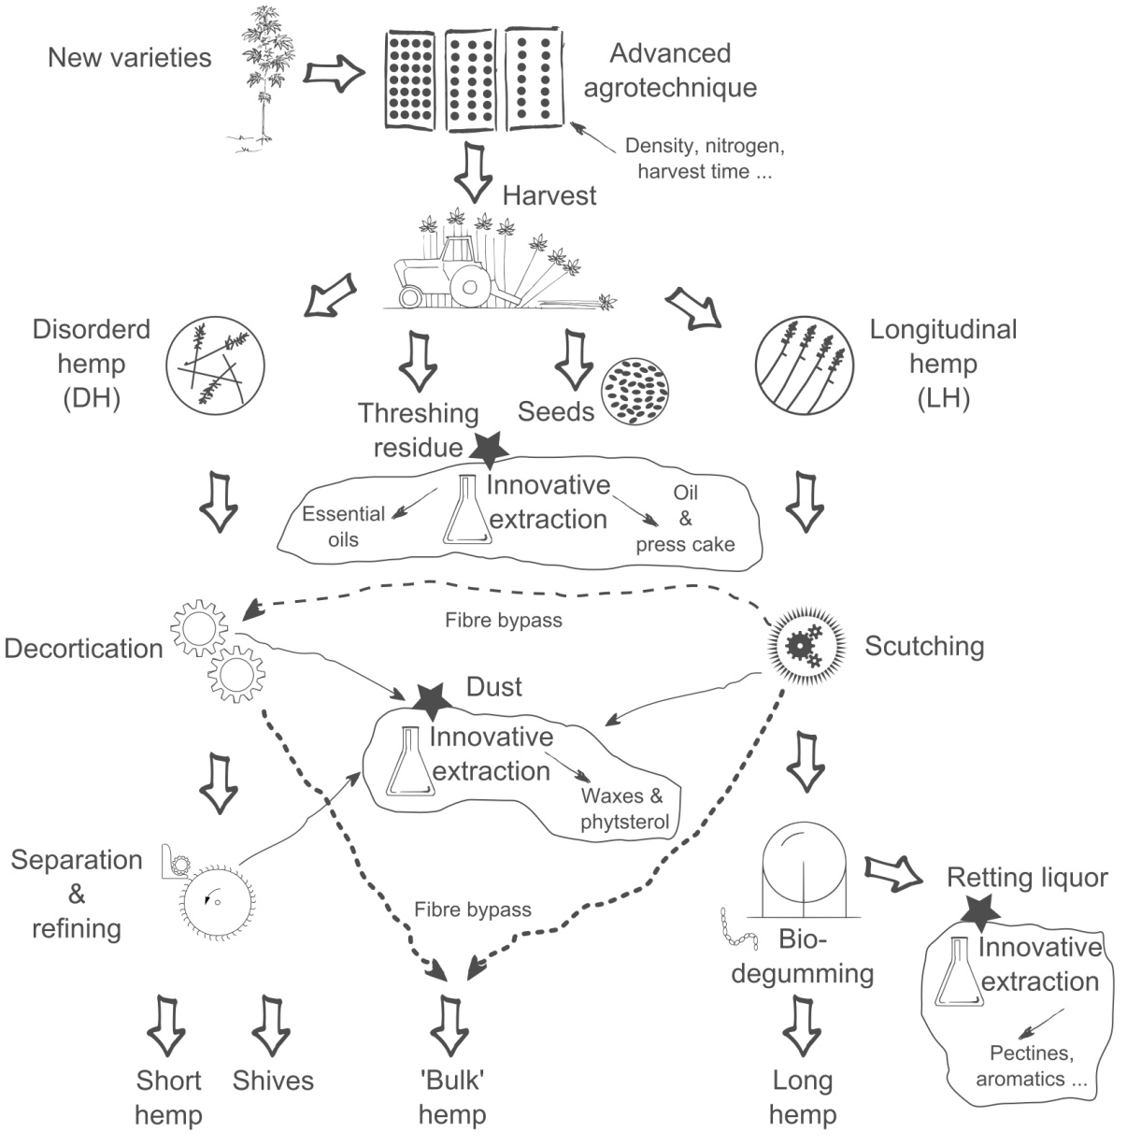

***Figure A****: Scheme of the MultiHemp biorefinery concept. Large arrows indicate raw material flow along the production chain; Stars highlight innovative processing to upgrade by-products into high added value end uses.*

**Rapid improvement of hemp using modern molecular breeding approaches**

The breeding strategy followed in Multihemp comprises the characterization of natural variability genome-wide using modern high-throughput technologies, by deep sequencing of over 100 contrasting genotypes for different morphological and quality traits development of molecular markers for multiple traits in hemp, in-depth transcriptomic data for hemp, and a working platform for heteroduplex mapping.

**Agronomic evaluation and crop modelling**

Field trials have a central role in MultiHemp: supporting breeding activities; evaluating the effect of genotype, environment and management (G x E x M) on yield and main quality traits; improving and parameterising a crop growth model that will be implemented with empirical and mechanistic relations to simulate the effect of environment and management on quality traits, and further to optimise G x E x M.

Data from field trials will be used to improve and parameterise a crop growth model (GECROS) to simulate and optimise the effect of G x E x M on fibre yield and quality. An elegant property of GECROS is that while the model uses physiologically sophisticated algorithms to quantify crop growth, it requires minimum input parameters that can be easily measured with little destructive sampling needed, so it best suits for predicting the performance of a large number of genotypes under various environmental conditions. Model validation will be carried out with data collected from multi-location trials carried out at the end of the project.

**Quality integration along the hemp production chains**

Unravelling the genetic basis of complex traits, like fibre quality, is limited by the lack of appropriate phenotyping platforms that enable high-throughput screening of many genotypes in multi-location field trials (Montes et al., 2007) or numerous fibre samples obtained with contrasting agronomic techniques. The situation is further complicated considering that fibre quality cannot be univocally defined, in fact it depends on many parameters and the desired combination of these parameters varies with the specific end use destination. Within MultiHemp integrated activities will be dedicated to the development of a high-throughput evaluation system to determine the suitability of hemp fibre for its main end use destinations (i.e. technical textiles, composites, insulation and building materials).

A further challenge in the determination of quality along the production chain is the influence of harvesting and the combination of processing technologies (i.e. retting, fibre extraction, fibre separation). Trials on commercial scale processing plants will be coupled to lab scale fibre extraction to study how fibre quality parameters evolve from the plant (potential quality) until end use application.

**Economic and environmental evaluation**

The MultiHemp concept aims to maximise economic returns from hemp and strive for environmental efficiency by using the whole biomass in the best possible way in an integrated biorefinery. A techno-economic evaluation in MultiHemp will assess the costs and revenues at every process step of the hemp biorefinery, compare these with achievable prices of marketable products (Target Costing approach) and will derive from this calculation maximum prices for straw and/or seeds to be paid to farmers. There are good reasons to believe that hemp, and even more so in an integrated concept as proposed in this project, will fair well on many of economic and environmental criteria. The environmental implications of the hemp biorefinery will be evaluated by conducting Life Cycle Assessments (LCA) for the marketable products. Their production in a conventional hemp production system as well as petro-chemical substitutes will form the reference systems.

Both the results of the techno-economic evaluation and the LCA will be combined in an integrated sustainability assessment.

Multihemp objectives

The **overall objective** of MultiHemp is to advance the scientific and technical research needed to consolidate and expand the market of hemp renewable materials.

**Specific objectives** are:

• A substantial gain in understanding the physiological and genetic basis of the relevant hemp traits will be achieved by applying modern molecular tools, evaluating the effect of environment and management in field trials, improving and parameterising a sophisticated crop model and developing a high-throughput evaluation system to determine the suitability of hemp fibre for its main end use destinations;

• Develop hemp genotypes with enhanced traits suitable for diverse cultivation environments and a wide array of actual and innovative industrial applications;

• Characterization of hemp varieties that are commercially available or in the phase of registration to identify their suitability for specific end-use destination;

• Advances in agronomic practices;

• Develop a modular biorefinery, in which market forces will dictate the flow of raw material into differing product options. The production of long bast fibre for textiles will be coupled to that of short bast fibre for bio-composites, shives for low carbon construction materials, oil for health and personal care applications, protein for food, and high value chemicals such as phytosterols, waxes, and essential oils. Innovative applications will be developed for the waste and by-products from processing routes including: dust from fibre processing, retting liquor from fibre degumming, flour (or cake) from oil extraction, and threshing residues from seed harvesting

• An integrated sustainability assessment including Life Cycle Assessment (LCA) and a techno-economic evaluation will be carried out for the whole production system from breeding till end product marketing.

• Dissemination and exploitation activities will be applied to raise the awareness of the versatility and sustainability of industrial hemp, to generate commercial value from research results and to provide a scientific basis for policy recommendations.

Description of main Scientific & Technological results and foregrounds

The main goal of MultiHemp, to sustain the use and production of sustainable and biodegradable materials from hemp biomass, has been pursued through an integrative approach involving the main phases of the production chain. Actors and end users were consulted to define quality targets for hemp fibre and oil so to drive research activities within Multihemp on stakeholder requirements. Breeding of new varieties suitable for biorefinery applications followed both forward and reverse genetics. The latter approach was used in WP1 to target candidate genes for fibre characteristics (ease of retting and fibre separation, improved surface characteristics and higher digestibility for fuel production) and oil composition (High Oleic Hemp and High GLA Hemp). Beneficial mutations related to fibre and oil quality were introgressed into elite varieties. A complementary approach was adopted in WP2 where association mapping was carried out to identify useful markers for breeding, and potential candidate genes for relevant fibre quality traits. For the scope an innovative, high-throughput fibre characterisation system was designed and developed in WP6.

Advances in agronomic practices to improve environmental sustainability and technical suitability of hemp cultivation for specific end use destinations were achieved through a series of field experiments carried out in WP3. Evaluation of the effect of G x E x M on quality traits that influence end use destinations and increase hemp biomass exploitability was carried out in close integration with partners of WP6.

In parallel to the above mentioned actions aiming at improving varieties and agronomic practices, multi-location trials were carried out to assess commercial varieties for specific quality traits. Two commercial varieties of contrasting quality were used for demonstration trials involving industrial partners (WP4) to evaluate how extremes in their fibre quality affect the product quality along the production chain until end use application (WP5). In WP4 innovative and existing harvesting and processing systems were evaluated to demonstrate their effectiveness in determining yield and quality of hemp raw materials. System optimisation was performed in particular to increase exploitability of hemp biomass. For the same purpose an innovative harvesting system was designed to recover threshing residues during seed harvest. In WP5 threshing residues, dust from fibre processing and retting liquor, that are at the moment considered wastes or residual biomass, were analysed to disclose their potential for valuable applications. Industrial partners provided (to WPs 1-4) indications on desirable quality traits for specific end use destinations and assessed and demonstrated the effectiveness and technical feasibility of the developments implemented along the production chains introducing new varieties and optimising agronomic practices, harvesting and processing. Partners of WP6 performed quality analysis on the materials produced along the production chain (WPs 1 to 4) providing an essential contribution to the understanding on how quality is affected by single production factors (from genotype to fibre processing) and particularly integrating the concept of quality along the production chain. An integrated sustainability assessment including Life Cycle Assessment (LCA) and a techno-economic evaluation of the whole production chain was carried out in WP7 with the overall scope of identifying the most effective combination of production steps and the most efficient use of resources in the hemp biorefinery. In WP 8 a strategy for the dissemination and exploitation of research results was developed and implemented. This activity will also aid the development of efficient marketing strategies for hemp products and provide policy recommendations on how to better reap the potential societal benefits of hemp cultivation, processing and product development in Europe in terms of higher value added, employment and environmental sustainability of hemp.

WP1 Heteroduplex mapping to improve hemp target traits

**Objectives**

The aim of WP1 was to use a reverse genetic approach, Heteroduplex Mapping to improve hemp for biorefining applications. The project did not generate new varieties within the span of the project however it has demonstrated the potential and limitations of using HDM to create new varieties in hemp. Key genes associated with lignin accumulation and phenotypic traits were identified in the project description for their potential effect on fibre quality and processability. They were Cinnamyl Alcohol dehydrogenase (CAD), Galacturonosyltransferase (GAUT), Reduced Wall Acetylation (RWA), pectin methyl esterase (PME). The aim was also to carry out field trials and demonstration activity with a mutant line already available at the University of York containing high oleic acid and high omega-3 in the seeds.

An extensive analysis of gene expression in hemp was carried out using 18 cDNA libraries from which gene sequence information was retrieved and in silico expression analysis completed using clustering and co-expression. This led to a database of 26 000 genes where homologs of our selected target genes were identified. Figure 1 shows the results obtained for the CAD family, a protein shown to affect lignin accumulation. Using the Arabidopsis lignin CAD (AtCAD5), 16 hemp contigs were pooled and three showed higher number of occurrence in the stem libraries (Figure 1A). CsCAD1 was identified as the hemp lignin CAD as it clustered in the same clade as all the functionally characterised lignin CADs (Figure 1B). qPCR showed that CsCAD1gene expression is specific to fibres (Figure 1C) and highly expressed in fibres in comparison to CsCAD2and CsCAD3 (Figure 1D). A similar analysis was carried out for the other targets and the final list of selected targets is described in table 1. This work was completed with a second transcriptomic experiment focused on fibres at different stages of development. Analysis of the expression of the selected targets in the fibre samples confirmed that all the selected targets were the main gene expressed in fibre for each gene family. Together, a large transcriptomic database of hemp genes (300 000 contigs) has been generated with relevance for fibre applications but also most areas of hemp improvement. This database will be available for further projects.

Homozygous material has been produced for three targets csMHO41b (CAD1), csMH034b (CsRWA2) and csMH045 (CsCAD2) but not for csMHO69 (CsPME1). A summary of the most promising mutant lines identified is shown in Table 2. CsCAD1 is an important target for mutation breeding of hemp fibre characteristics because homologs in other fibre crops such as flax display a mutant phenotype (Chantreau et al. BMC Plant Biol. 13:159, 2013). One missense mutation MH041b (E308K) has been taken forward and led to a decrease in lignin content in fibres (Figure 2A). For CsRWA2 a mutation introducing a premature stop codon (MH034b) has been taken forward and brought to homozygosity. The mutant lines exhibited a reduction in cell wall acetylation associated with a dwarf phenotype (Figure2B). This mutation was introgressed into the elite line Futura and heterozygous lines were identified. It has been possible to alter the cell wall properties of hemp fibres in two targets out of four showing that it was possible to reduce lignin and acetylation properties of hemp fibres and that the reverse genetic approach could be a powerful tool to generate new hemp lines. While the phenotype of the csRWA2 mutant would not be desirable for fibre applications, they provide an insight to better understand bast fibre cell wall which may have relevant applications. To ensure that the achievement of this project can be taken forward, backcrosses for all the targets have been generated and the seeds will be available for further introgression (Table2).

**Oil trait**: At the University of York, we had used the same reverse genetic approach to develop High Oleic Hemp lines, the purpose being to obtain hemp oil with a longer shelf life and high omega3 line for increase health qualities. Backcrossed homozygous lines were already available at the start of the project. A large field trial for the High Oleic Acid line was carried out within Multihemp producing 28kg seeds which were used by WP5. A High Omega 3 line was bulked ready for assessment by end users.

The project has demonstrated the potential and limitations of using HDM to create new varieties in hemp and established a strong platform that will be of continuing value for hemp improvement.

Within Multihemp, it is interesting to note that the potential targets identified by WP2 using forward genetic were two genes belonging to the same gene families as the ones selected in WP1. This confirmed that, in the area of cell wall properties, WP1 and WP2 reached similar conclusions. The tools and information generated within these WPs could be potentially combined to validate conclusions. For example, our extensive transcriptomic work has confirmed that our target gene family members were highly expressed in fibre during development in comparison to other family members. It would be interesting to investigate if any of the WP1 target genes have been identified within the QTL generated by WP2 for lignin (CAD) or decortication (PME). Also, information on gene expression from WP1 could help select the most relevant genes within a QTL in WP2, and this would not be restricted to cell wall genes. There are also potential opportunities to complement the two genetic approaches with the work of WP4. No fibre quality analysis was carried out for our line because of a lack of material but WP4 data may provide insights on what define fibre quality which would lead to new targets for a reverse genetic approach

***Table 1****: List of fibre traits and selected gene targets*

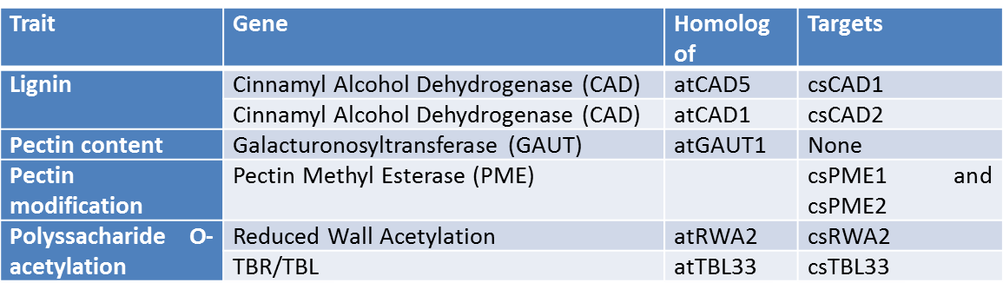

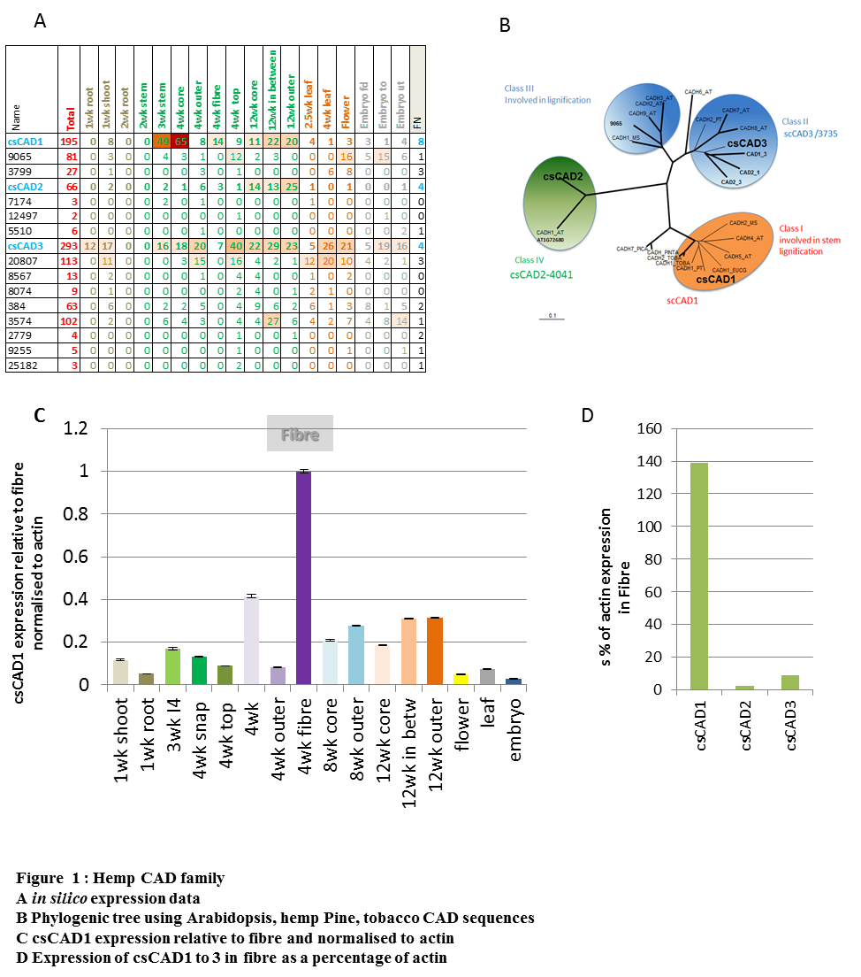

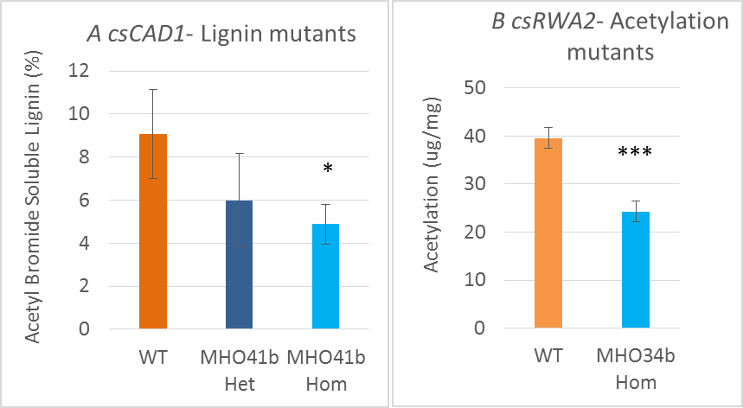

***Figure 2****: Homozygous mutant lines showing a decrease in lignin and acetylation in the fibres (in comparison to Wild Type Finola WT).*

***Table 2:*** *Summary of mutant lines available in WP1*

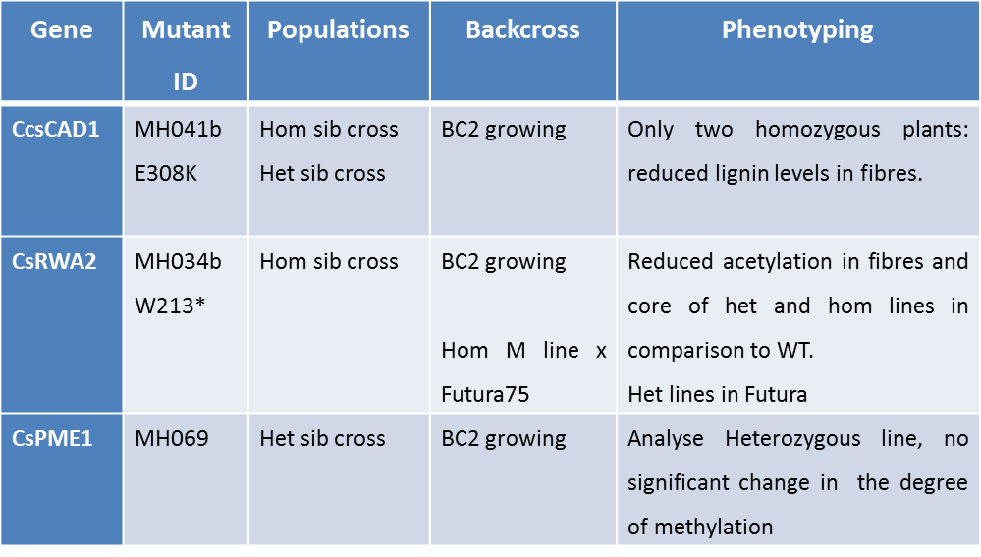

*Het means heterologous and hom homologous. Het sib crossing means crossing between 2 heterologous lines, hom sib crossing means crossing between 2 hom lines. BC means back cross to Finola wild type.\* means that the mutation create a stop codon*.

WP2 Genome-wide association mapping for hemp breeding

**Objectives**

This WP supported the development of new hemp varieties optimized for different industrial processes resulting in bioproducts and biomass with an high added value. Specific objectives of this WP were:

• Characterization of the natural genetic and phenotypic diversity in hemp, represented here in a highly diverse collection of 100 hemp accessions, using a genome-wide association study.

• Identify genes/QTLs (or regions in the genome) underlying morphologic traits, such as plant height, number and length of the internodes and flowering time.

• Identification of genes associated with the quality of hemp biomass such as fibre quality for different industrial applications.

• Integrate this knowledge into existing and new hemp breeding programs to generate novel hemp varieties which can more efficiently be converted into biobased products.

• Develop a set of tools for the breeding of hemp, both for genotyping and phynotyping.

• Develop a pipeline for the generation of new hemp varieties for the different European environments and needs.

After genotyping and phenotyping the 124 hemp accession of the mapping panel association mapping was performed to identify significant associations between 32,872 SNP markers in the DNA and important traits. In complex traits, such as e.g. “flowering time”, many genes are involved that all contribute to a certain (quantitative) extent to the outcome of the phenotype. Regions in the DNA (loci) associated with such traits are termed, quantitative trait loci (QTLs). The outcome of traits is not only determined by the DNA but is also influenced by the environment. Association models can correct for the effect of environment (E) and interactions between environment and genotype (G x E). Correcting for the environmental background effects can help to unmask QTLs that have only a low effect on the trait in the mapping population (false negatives). However, in case of strong environmental effects, which is the case for hemp, a correction for environmental effects, is sometimes not fitting in an association model. Also, correction for environmental effects may reduce relevant phenotypic variation caused by responses of regulatory genes to environmental stimuli.

Therefore, two strategies of association mapping were performed to detect significant phenotype x marker associations:

1) mixed modeling per single location without correction for environmental background effects (Genstat library, Qsassociate, single environment, significance threshold -10log(P)>5) and,

2) mixed modeling on multiple environments to correct for location effects (Genstat library, Qmassociate, multiple environments, significance threshold -10log(P)>4).

In this way 1800 QTL regions were found with an SNP marker in significant association to one or more of the complex traits, as phenotyped in one or more environments. Subsequently, the genomic regions, scaffolds, harboring significant QTLs were studied for the presence of candidate genes located in or nearby QTL region (expressed genes, mRNA, in the CanSat draft genome).

In a first scan QTL regions for quality traits have been identified in the hemp canSat3 genome. Genes in these QTL regions were studied for the presence of candidate genes. For instance the QUA1/QUA2 genes involved in pectin biosynthesis pathway, are likely candidate gene for fibre quality

WP3 Optimisation of hemp cultivation and crop modelling

**Objectives**

The overall objective of WP3 is to carry out all field trials needed to support phenotyping of existing and improved genotypes and to evaluate the effect of genotype, environment and management (G x E x M) on yield and main quality traits. Relevant data collected during trials in open field and controlled environment will be used to improve and parameterise a crop growth model that will be implemented with empirical and mechanistic relations to simulate the effect of environment and management on quality traits, and further to optimise G x E x M.

Specific objectives of WP3 are:

• Characterisation of hemp varieties that are commercially available or in the phase of registration to identify their suitability for specific end-use destination;

• Advances in agronomic practices to improve environmental sustainability and technical suitability of hemp cultivation for specific end use destinations;

• Improve and parameterise a crop growth model to simulate and optimise the effect of G x E x M on fibre yield and quality and to aid hemp breeding

In the frame of Multihemp a very large number of field trials were carried out to study the effect of agronomic management (planting density, nitrogen fertilisation, harvesting time) and variety on yield and quality of hemp.

Two large multilocation trials (in Italy, France, Czech Republic, The Netherlands, Latvia) were carried out in 2013 and 2016 with up to **16 commercial varieties**. The difference in biomass yield among genotypes was large at all locations but mainly in southern locations where the largest difference of flowering times was recorded. The variation of stem and seed yield among genotypes was mainly determined by the difference in flowering time, which is under control of temperature and photoperiod. In late varieties stem yield was high and seed yield was low. When harvesting was postponed from full flowering to seed maturity, the stem yield of monoecious varieties significantly increased but that of the dioecious varieties decreased, with the exception of Italy. Among the tested varieties, not one combined the highest stem with the highest seed yield. The late variety CS is suitable for stem production as it had the highest stem yield. Both FED and FUT are suitable for dual-purpose production in IT, FR and CZ, with FED producing the highest seed yield and FUT the highest stem yield.

The effects of **planting density** and **nitrogen fertilization** on hemp stem and seed productions were assessed in eight environments (combinations of year and location) at five contrasting locations throughout Europe. The effects of these two factors on hemp stem and seed yields neither interacted with each other nor with cultivar. Changing planting density over a wide range had limited effect on both stem and seed yields while plant height and stem diameter decreased with increasing population. The optimum planting density for dual-purpose hemp cultivation could be set at 90-150 plants m-2. Nitrogen deficiency reduced stem yield and seed yield. The effect of nitrogen deficiency on plant height and stem diameter was in accordance with its effect on stem yield. Hemp has a high nitrogen use efficiency and 60 kg N ha-1 was generally sufficient in the tested environments for dual-purpose hemp cultivation. However, optimization of nitrogen fertilization requires assessment of plant nitrogen status. Direct determination of nitrogen status for hemp is too complex while SPAD based diagnosis techniques requires further researches.

In a field trial carried out at two locations in Italy, the **dynamic of accumulation of three bioactive phytocannabinoids** (CBD, CBG and Δ9-THC) was comparatively evaluated with the one of the anti-inflammatory flavonoid **cannflavin A** during flowering and seed ripening in three distinct chemotypes of monoecious hemp grown. Genetics, namely the type of variety, was the main factor affecting the concentration of cannflavin A, whose accumulation was increased by low air temperature, while harvesting time did not significantly altered its concentration in the threshing residue. On the other hand, climatic conditions and harvest time significantly affected the cannabinoid content of the CBD chemotype but were largely uninfluential in the CBG chemotype. These data, while highlighting the complexity of secondary metabolites regulation in hemp, also provide a basis to evaluate the contribution of inflorescences and threshing residues to the overall economy of hemp cultivation.

A specific task was devoted to the **parameterization and validation of the GECROS** model for hemp. This task was performed in three stages. In the first stage, G×E interaction of the phenology of hemp was modelled, according to the phenology model as described by Amaducci et al. (2012). The phenology model forms intrinsic part of GECROS and was parameterized with data on sowing and flowering time of different cultivars from field trials at different locations (experiments in 2013, 2014 and 2015) and sowing dates (2016). In the second stage, leaf- and canopy photosynthesis was parameterized by leaf- and canopy level measurements, to validate the canopy photosynthesis simulated with the photosynthesis model in GECROS. In the third stage, the parametrized GECROS model was used to simulate biomass of hemp under different environmental conditions and the effect of N supply. The model was validated by comparison of the observed- and measured growth and biomass in the field trials at the different locations (experiments in 2013 to 2016).

As reviewed by Amaducci et al. (2012) and Tang et al. (2016), **hemp flowering time**, which is mainly determined by G×E interaction, is a predominant factor for both stem and seed production. Subsequently, the choice of planting date and available cultivars with differences in photoperiod sensitivity are important determinants of the final hemp yield, both for stem and seed. The parameterization of the hemp phenological model proposed by Amaducci et al. (2012) is described, for a number of commercial hemp cultivar, in Tang et al. (2016). To capture the variation of hemp phenology in the simulation of hemp growth and yield, the above described phenology model was integrated into the framework of GECROS, specifically, into sub-model called PHENO (Yin and van Laar, 2005). Using cultivar specific phenological parameters, the PHENO sub-model was used to predict flowering times of each cultivar in different environments over several years.

The good correspondence between model-predicted and observed (measured) values of flowering time for different cultivars under different environments (locations and years) illustrates that the parameterized phenology model is able to simulate the interaction between genotype (cultivar) and environment (location and year) very well. Therefore, it allows the model to be used to capture genotype by environment (G×E) interaction for hemp and forms the basis for an integrative hemp crop model

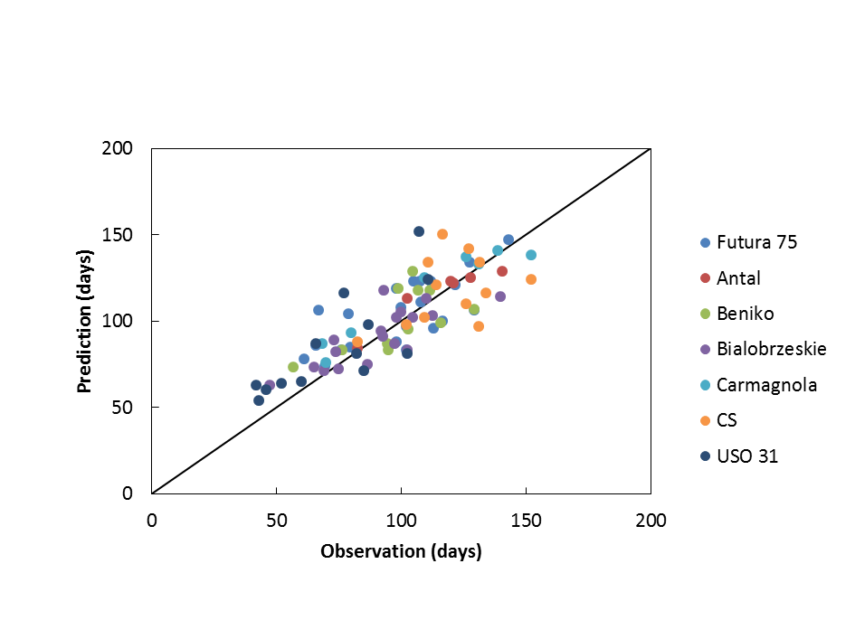

***Figure 3.*** *Predicted (model) and observed (measured) values of flowering time of seven different cultivars in different environments. Colours correspond to the different cultivars, points represent flowering time in a particular location and for a particular year. The solid line represents the 1:1 ratio.*

**Photosynthesis** is often (over-)simplified in many crop models, and therefore it receive little attention in the proposal stage of this project. Upon implementation, we immediately noticed that it was necessary to devote more attention to photosynthesis in order to make GECROS capable of predicting G×E×M in these crops. In Multihemp, both leaf- and canopy photosynthesis measurements have been conducted. Leaf photosynthetic capacity was measured on plants grown in both outdoor (2013 and 2014) and greenhouse conditions (2015). Light-saturated net photosynthesis rate (Amax) increased with an increase in leaf nitrogen up to 31.2 ± 1.9 μmol m-2 s-1 at 25 oC. The Amax initially increased with an increase in leaf temperature (TL), levelled off at 25-35 °C and decreased when TL became higher than 35 °C. Based on the C3 leaf photosynthesis model (Farquhar et al., 1980), a complete set of photosintetic parameters were estimated following procedures described in Yin et al., 2009. The effects of leaf nitrogen and temperature on photosynthesis were consistent at different leaf positions and among different growth environments (Figure 4).

This study (Tang et al.) on hemp leaf photosynthesis and its parameter estimation has recently been accepted for publication in GCB Bioenergy, titled: ”Hemp (Cannabis sativa L.) leaf photosynthesis in relation to nitrogen content and temperature: implications for hemp as a bio-economically sustainable crop”.

***Figure 4.*** *The response of leaf respiration in dark (Rdk, Panels a and c) and maximum light-saturated net photosynthesis rate (Amax; Panels b and d) to specific leaf nitrogen (SLN; Panels a and b) and leaf temperature (TL; Panels c and d). Rdk was measured after adapting leaves in dark for 15 minutes after measuring the A - Iinc curve. Amax was measured at 2000 μmol m-2 s-1 for incident light intensity and 400 μmol mol-1 for ambient CO2 concentration. The data presented in Panel a and Panel b were obtained in the N-trial while those in Panel c and Panel d were obtained in the T-trial. The bars in Panels c and d indicate standard errors of the mean (n = 3). From Tang et al. (Accepted)*

Although rates and responses of leaf photosynthesis reported here are an important basis for simulation of the interaction of photosynthesis and the environment, scaling these to the canopy level is not trivial. To achieve accurate scaling from leaf to canopy level, measurements of complete canopies were done with a purpose-built gas exchange system. These measurements were then compared to simulated values, on the basis of leaf level photosynthesis under the prevailing environment. Results of these experiments are now in course of publication and concluded that both leaf- and canopy gross photosynthesis can be accurately simulated under different conditions, including different nitrogen- and water levels. The model presented for simulating canopy gross photosynthesis includes the effect of stomatal closure and can simulate diurnal fluctuations, which allows sufficient accuracy for the hourly time steps used by GECROS. Our results validate the model physiologically, with correct scaling from the leaf- to the canopy level. They validate the correct interaction of photosynthesis with the environment with daily water, light and temperature variations. Furthermore, it validated the interaction with management (e.g. nitrogen supply). These interactions form the basis of simulation of growth, development and biomass.

With the phenological and physiological parameterization of the crop model for hemp validated it is now possible to simulate biomass- and stem yield of a crop for a given environmental condition. In principle, the model would allow for assessment of biomass and growth on a day-to-day basis, since this is the time step at which the GECROS model framework can simulate.

WP4 Harvesting and Processing

**Objectives**

The main objective of WP4 was the evaluation and demonstration of the effectiveness of innovative and existing harvesting and processing systems. Developed innovative technologies will allow to optimize the production of hemp raw materials and to understand the effect of mechanisation on the determination of yield and quality of hemp raw materials.

Specific objective were:

• Evaluation and demonstration of existing harvesting and processing systems to determine the effect of mechanisation on raw material quality on existing and improved hemp genotypes;

• Development and demonstration of an innovative system for harvesting high quality seeds and recover threshing residues;

• Evaluation and demonstration of innovative processing systems (i.e. wet line);

• Design and development of a new (semi) automated methodology and equipment for sample preparation and fibre extraction to objectively determine main quality characteristics of hemp fibre

**Improved harvesting technology**. An innovative technological concept has been developed based on results from previous trials in order to realize a gentle uptake of the hemp swath, its active movement and removal of seeds and threshing residues from the straw as well its deposit on field ground. After some preliminary tests on suitable shaking systems the design and construction of a prototype started in 2014. The machine prototype was completed and tested at harvest season 2015 as well demonstrated in field experiments after necessary revisions in harvesting season 2016.

|  |  |
| --- | --- |
|  |  |
| ***Figure 5*** *Design and prototype of a new machine concept for harvesting hemp seeds from swath* | |

**Adaptation of innovative bio-degumming system for longitudinal fibre and fine tuning of a disordered fibre decortication process**.

**Bio-degumming for longitudinal line**

In 2015 hemp straw from variety “Futura” was pre-processed using a scutching line of MultiHemp partner AgriT (CZ). The resulting fibre materials were bio-degummed in 9 cycles: 4 for long fibre and 5 for scutching waste. At the end of each bio-degumming cycle, the fibres samples were washed and then dried in controlled condition. Additionally sampling of the liquor was carried out during the bio-degumming and monosaccharides content analysis was carried out from MultiHemp partner University of York. The results of the preliminary monosaccharide analysis show that no significant difference in composition between the liquor squeezed out from the fibre and the one sampled inside the bio-degumming tank can be recognized (Fig 6). In 2016 2016 further varieties “Carmaleonte” (IT), “Ivory” (NL) and “Fedora” (FR) were grown, harvested and pre-processed similar to the previous procedure. The resulting long scutched fibres were bio-degummed in 11 cycles: 7 for 1° meter stem portion and 4 for 2° meter. All the cycles were performed following the character colour of the stem; less than two, one for each stem portion, performed with all the varieties.

During both test biodegumming process was adjusted to optimise fibre yield, energy consumption and fibre quality.

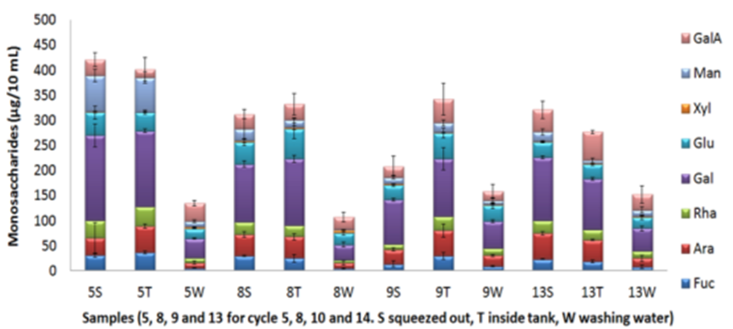

***Figure 6*** *Monosaccharides composition of bio-degumming liquor*

**Raw material for bio-building from disordered line**

In 2014 raw material, in form of 350 Kg square bale of hemp straw, was supplied by MultHemp partner CREA-CIN, Rovigo, Italy. The bales were opened by hand and the plant material was fed in a processing chain composed of four conveyor belt and three shredding machines. Number of passages through the machines, speed of machines, energy consumption were regulated in order to optimise processing and fibre quality. The resulting bulk fibre was conferred to MultiHemp partner CMF Technologies for building materials preparation.

A subsequent processing trial was carried out in 2016, using Futura 75, Fedora 17 harvested at contrasting stages and then immediately baled or left retting on the field. Bulk fibre extraction was per-formed using one shredding machine and one carding prototype to obtain short fibre (4-10 cm) and two shredding machine and two carding prototypes for very short fibre.

**Adaptation of Innovative supply and processing technology**

ATB has evaluated the innovative processing system based on anaerobically stored hemp from two selected MultiHemp varieties and processing into semi-finished products (fibre boards). Results showed that utilization of Futura 75 for the alternative supply and processing line seems to be preferable compared to Białobrzeskie for most of the measured values.

Parameters like throughput and energy consumption have been recorded for the primary processing of the two variants. The measurements for the consumption of processing energy for “Białobrzeskie” have been affected by technical problems for one experiment. Thus, the results cannot be compared directly to the others. But in general it was observed that the processing of the French variety “Futura” required less energy than the Polish variety.

The resulting plant material was characterized for its particle size distribution in order to compare the characteristics of the two varieties but as well the influence of different processing steps. The pro-cessing of “Futura” resulted in more fines compared to “Białobrzeskie” while the latter shows higher content of coarse particles. An additional processing with disc mills leads to increase of fines but seems to have less influence on the resulting share of coarse particles.

|  |  |
| --- | --- |
|  |  |
| ***Figure 7*** *Thickness swelling of board samples of wet preserved hemp from two different varieties* | ***Figure 8*** *Bending strength of board samples of wet preserved hemp from two different varieties* |

In the final step the resulting fibres have been used for the manufacturing of fibre boards. Therefore a binding agent was added, formed to a mat and finally densified with a heating press. An urea-formaldehyde as well as a polyester binder have been used and boards pressed to 2 different densities. The polyester binder was not optimized for this purpose and the pressing experiments failed due to cross-like cracking of the board samples. Resulting board samples with appropriate characteristics have been further analysed for material specific properties. Distinct but no significant differences between the properties of board samples from the two varieties could be observed. Boards manufactured from fibre of the Polish variety seem to swell slightly more than the counterpart but this result is highly dependent on the particle morphology as well (Fig. 7). The mechanical properties of the boards made from French variety are remarkable better independent of the sample density (Fig. 8).

**Development of quality quick test equipment.**

The development of equipment for sample preparation and fibre extraction was the main focus in this task. Based on the development of the methodologies in WP6 relevant apparatus to decorticate and re-fine fibre samples in a quality preserving way have to been introduced to laboratory practise (Fig. 9,10). Necessary methodologies have been developed and tested as well as finally drawn into measuring instructions. Primary at HSB an overall software based quality management system has been developed in order to collect and assess the gathered data from specimen characterisation as well its lab based processing with mentioned devices.

|  |  |
| --- | --- |
|  |  |
| ***Figure 9*** *Worthmann laboratory breaker unit* | ***Figure 10*** *Coarse separator* |

A specific procedure is carried out to refer the initial dimensions and weight of each single stem to the related values after 2 and after additional six passages through the decorticator as reported earlier in more detail (see report D 6.1) and the according measuring instruction. The determination of the geometric dimensions is comparable time-consuming when carried out in an approved traditional manual procedure. Due to this fact an innovative system and procedure of (semi) automated generation of these values was developed and implemented. The stem width as well as the length and the weight of each single stems are measured by means of a photo-sensor system or a micrometer screw and directly transferred into a computer data acquisition tool.

A new quality determinative parameter is introduced as well related equipment realised in terms of methods development in the MultiHemp project. The “specific energy demand” necessary for the decortication of a hemp stem is evaluated additional to the already known and practiced determination of the decortication index (see measuring instruction for lab decortication). Following the completion of methods and equipment for the biomass evaluation (WP2 and 3) the two beneficiaries continued the investigations on different new and innovative quick test possibilities for the characterisation of geometric characteristics (fibre width, length) by means of image analysis.

Two procedures were selected from a preceding study for the generation of single fibre images by means of optical devices like high-speed camera resp. photo diodes.

Preliminary experiments were carried out with the particle analyser PartAn 3001 l from the company AnaTec (Skien; Norway). The device is equipped with a high-speed, high-resolution full-frame camera and fulfils the basic pre-condition for the generation of single particle pictures for a further image analysis. The combined 3D-software analyses every single particle at different orientations. In the pre-test it became clear that fibres with an uneven distribution of dimensions and mass not in every single case allow the generation of suitable pictures. Nevertheless, first results of image analysis could be achieved by the selection of appropriate pictures.

The pre-test shows promising results compared to a manual reference measurement.

WP5 End use applications for hemp raw material

**Objectives**

The main objective of WP5 is the evaluation of the suitability of raw material obtained from the hemp biorefinery to industrial processing.

Fibre from longitudinal and disordered system was used to produce biobased composites, insulation and building materials. Oil from the seeds was evaluated for the production of cosmetics.

Secondary metabolites such as essential oils are not currently recovered but could add value in a whole crop processing scenario. Other metabolites such as waxes, and phytosterol could be extracted from fibre processing wastes.

**Task 5.1 Use of hemp fibre for biocomposite**

**High-tech Biobased composites applications**

Long hemp fibres were used for manufacturing and testing unidirectional fibre composites. Two hemp accessions were selected for testing composite properties. The nominal tensile strengths are 639.8±174.1 MPa and 782.6±164.4 MPa for FNPC-251 and FNPC-253 respectively, according to the tensile fibre tests. Polyvinylidene fluoride was used as the matrix phase.

Unidirectional composites were prepared by compression moulding of 4 or 5 stacks of prepregs consisting of aligned technical fibres, compressed between thermoplastic films at 200 °C and a pressure of 20 bars. The fibre volume fraction was set at 40% by weight measurements. The flexural properties of hemp reinforced composites are evaluated by the three point bending test according to ASTM standard D790.

The strength of a hemp fibre reinforced thermoplastic composite can reach values close to the theoretical one (91% efficiency factor) with the appropriate processing conditions and parameters. The strength values (~240MPa) are comparable to those reported for bamboo and flax thermoplastic composites, showing that hemp-based composites have a real potential in replacing less environmental friendly materials, like glass fibres, in some applications like transport, where their low density and high specific properties make them interesting for this industry.

A substantial improvement of the Young’s modulus can be observed at the composite level if compared with the values obtained for a technical fibre. This indicates the technical fibres showed partial debonding of the elementary fibres after extraction; these can be reconnected by the matrix inside a composite.

**“Mid-tech” Biobased composites applications**

The use of fibre “lost” during hackling for “Mid-Tech” composites represents an interesting and promising solution explored to sustain the bio-refinery concept of MultiHemp. All fibre samples were successfully compounded with PLA and afterwards injection moulded. With the specially adapted compounding and injection moulding process aesthetically appealing materials of homogeneous quality could be produced. The use of only 20 mass% hemp fibre bundles from harvest 1 already significantly increased the strength values compared to the pure PLA polymer and shows a better reinforcing potential than hemp fibre bundles from harvest 2.

The use of hemp fibre bundles from harvest 1 significantly increases the Young’s modulus values compared to the pure PLA polymer and shows a slightly better reinforcing potential than hemp fibre bundles from harvest 2. In general, adding stiff bast fibres to a polymer like PLA leads to a lower unnotched Charpy impact strength compared to the unreinforced polymer. The impact of the hemp/PLA samples is still on an acceptable level.

On the basis of the existing data there are some varieties behaving better than others. For example, FNPC 251 and VDS 303 show both in strength and impact the highest values for harvest 1 samples.

We see a significant influence of harvest time which is stronger than the variety influence on the composite properties.

**Task 5.2 Use of hemp fibre for construction and insulation materials**

**Insulation material**

A blow-in insulation material was developed using short hemp, shives and “bulk” hemp by Ventimola and Zimic. Hemp from different locations (FR and NL) harvested with different techniques was used. The samples were processed with a ‘Whirlwind Mill’ to produce a range of samples suitable for use in blow-in insulation. The target value for the thermal conductivity was set to λ = 0.040 W / (m \* K). The lowest thermal conductivity values were achieved for the samples from the fibre/shive mixture. It has also been shown that the variety nor the cultivation or harvesting process has an influence on the properties of the blow-in insulation material. The ‘Whirlwind Mill’ process was the strongest factor influencing the properties of the blow-in material.

**Biobuilding materials**

Fibre obtained from a simplified disordered processing system was used to produce building materials following the patented system “Canapalithos” and to compare this with the same material produced with hemp shives. An optimal mix between the fibre and the natural binder, correcting formulations or steps process or machinery typologies was carried out to adapt the Canapalithos system to bulk fibre. Innovative, low cost and low impact panels were developed and produced with bulk fibre and shives. Panels produced with bulk fibre have very similar characteristics to those produces with only shives. Problems were encountered feeding the bulk fibre through the processing lines, it was estimated that these problems could be solved by grinding the fibre.

**Task 5.3 Use of seed oil for cosmetic applications**

Several trials have been carried out in order to look for the best way to obtain hemp seeds oil.

Different trials were developed:

A) EXTRACTION OF SEED OIL BY PRESSING IN PILOT PLANT

For mechanical extraction of seed oils used press one model KOMET SCREW OIL, CA CA59G- Expeller 5963, Oekotec, IBG Monforts, (Germany).

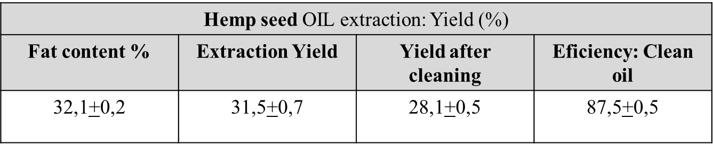

The operational conditions of the extraction process were evaluated in order to establish the feasibility of the process and performance in oil, for which the technological variables of the machine are considered as extraction nozzles variable internal diameters and different speeds of rotation of the screw and the intrinsic characteristics of each seed in particular. The efficiency was measured in terms of the amount of oil remaining retained in the cake. In all cases, the residual cake samples were taken which they were analysed for remaining oil content as a measure of the process efficiency and yield of extraction.

After extraction, the oil has been cleaned by decantation and centrifugation.

B) EXTRACTION OF SEED OIL BY SUPERCRITICAL FLUID CO2

Extraction trials by supercritical fluids with CO2 were carried out with hemp seed as raw material. The optimum test was carried out and was obtained greater amount of lipid fraction composed of waxes + oil. The total yield of the trial is 24,8 %. The hemp seeds have a total fat content of 30%.

Hemp seed oil has 1-2% minority compounds, among which g - tocopherol, the polyphenolic compounds, and phytosterols, which have antioxidant and also anticancer action, so they can be used as a cosmetic ingredient too

Some cosmetic products from the wide range of them that exist in the market, have been developed: Shower gel; Shampoo; Face cream; Hand cream; Body milk; Sunscreen cream; After-sun cream.

Raw materials used for developing the cosmetics products have been provided by a suitable supplier and specialist in these ingredients.

After the different analyses on the skin, (Number of irritative reactions, Mean Index of irritation, Finn Chambers), the results of dermatological study are NOT IRRITATING if applied to human skin.

To establish the storage test, the European and Spanish regulations have been followed.

All the cosmetic products formulated, representative of the types of emulsions were submitted to storage test.

The evaluated parameters depend on the characteristics of the test product and the ingredients used in the formulation. Generally, they are evaluated from three points of view:

• Organoleptic Parameters: appearance, colour, odour and taste

• Physical-Chemical Parameters: pH value and viscosity

• Microbiological Parameters: various microbial counts

The conclusions of this study are as follows:

Once the cosmetic products prepared were submitted to Protocol of the Stability Preliminary Studies (Screening Test, Accelerated Stability), all the parameters studied did not show significant changes throughout the storage period, except the rancidity, expressed as peroxide index due to the richness in polyunsaturated fatty acids (PUFA) especially linoleic and gamma-linoleic acids, of hemp seed oil

• The rest of the parameters, organoleptic, physical-chemical and microbiological, remain constant during the storage test period.

• Supercritical Fluid Extraction with CO2 (SFE-CO2) applied to hemp seeds to obtain oil is a valid and reproducible process

• The yield of the process is high from industrial point of view.

• The quality of this oil is quite good for cosmetic products

• New cosmetic products have been developed with hemp seed oil from SFE-CO2 + more quantity of alpha-tocopherol (Vitamin E) as a natural antioxidant agent.

**Task 5.4 Use of residual biomass and by-products for high added value production**

Different varieties of hemp were studied, including Finola, Santhica and Fedora-17. For the Finola variety, the effects of time on the composition were also studied. The essential oils, the compounds were identified as as α-pinene, β-pinene, myrcene, d-limonene, β-ocimene, Terpinolene, β-caryophyllene, α-caryophyllene, α-bergamotene, β-selinene and caryophyllene oxide but concentrations of these compounds were found to be low. The concentrations of these essential oils were limited but the profile is consistent throughout the growth cycle. The compounds were extracted by soxhlet extraction using heptane or acetone, depending on the sample. The composition was then studied using GC, GC-MS and DSC analyses. It was demonstrated that dust residues from fibre processing contain significant quantities of high value lipophilic molecules including fatty acids, policosanols (fatty alcohols), fatty aldehydes, hydrocarbons, sterols, triterpenoids and cannabinoids (Cannabidiol (CBD)). ScCO2 extraction was conducted on dust samples and optimisation of the process was carried out using the factorial experimental design. The scale-up of hemp extraction was conducted and significant quantities of CBD were isolated as well as other lipophilic compounds. The results obtained in this study may open new doors in hemp waste utilisation.

WP6 Quality integration

**Objectives**

Main objective WP6 were: (i) Integrate quality along production chains and (ii) Evaluate quality of raw material and end uses.

**Fibre quality on a single plant cell level**

For the strength test 30 accessions were selected from three different locations (NL, IT and FR), and 2 accessions from only two locations (NL and IT), making a total of 94 samples. It was possible to identify weak and strong variants in terms of strength. DIC (digital image correlation – strain mapping) analysis revealed two different mechanisms of failure for the weak and the strong fibre variants. In the case of weak variant samples, fibre bundle failure takes place at the interphase that bonds single fibres together, producing a fracture relatively parallel to the tensile direction. The non-linear behaviour of the stress-strain curve is explained by the development of shear strain at the single fibre interphases from very low levels of global strain on, until fibre bundle breakage occurs.

**Fibre quality on a fibre bundle level**

For the analysis of the fibre bundle length or/and fineness, image analysis tools were developed and used. Based on the standardised manual preparation process, a fast image analysis tool named FibreScanner has been developed. With this system we are able to analyse much more fibre samples regarding their length compared to a standard evaluation using tweezers (DIN 53808-1:2003). These length measurements can be done with hemp fibre bundles mechanically extracted using a decorticator in combination with the lab-scaled separation (Wang et al., 2017 and Müssig et al., 2017). We further develop the concept of a scanner based image analysis tool to characterise the influence of agronomic factors on hemp fibre fineness. We evaluated fibre/fibre bundle fineness with the Fibreshape system and come to the conclusion that this system could be a very useful cost efficient tool to evaluate fibre samples regarding fineness (Müssig & Amaducci, 2017).

**Fibre interface and performance**

The determination of the critical fragment length and interfacial shear strength was used to compare the adhesion between fibre and matrix of Futura 75 (MH-FNPC-255) harvested at three different locations at three different blocks resulting in nine samples. The influence of the different origins on the fibre/matrix adhesion was evaluated with the single fibre fragmentation test. With regard to the reinforcing effect in a composite, fibre bundles from Italy showed the best reinforcing potential.

**Pilot-scale pultrusion testing**

Varieties that were evaluated as having the highest performance in composites were processed with the pilot-scale pultrusion technique. The composites were tested regarding strength, modulus, and impact strength. The results are very promising, because our hemp UD pultrusion composites reach properties comparable to high-quality flax UD composites.

**Insulation product evaluation**

A blow-in insulation material was developed using short hemp, shives and “bulk” hemp. Hemp from different locations (FR and NL) harvested with different techniques was used. The samples were processed with a ‘Whirlwind Mill’ to produce a range of samples suitable for use in blow-in insulation. The target value for the thermal conductivity was set to λ = 0.040 W / (m \* K). The lowest thermal conductivity values were achieved for the samples from the fibre/shive mixture. It has also been shown that the variety nor the cultivation or harvesting process has an influence on the properties of the blow-in insulation material. The ‘Whirlwind Mill’ process was the strongest factor influencing the properties of the blow-in material

**Testing & Evaluation of the biobuilding materials**

Seven hemp-based building materials were received from CMF for testing at Aalto. The product “Canapalithos” which was produced from selected hemp varieties processed from “bulk fibre” by GFibra was tested regarding the following properties: degree of humidity after acclimatization (equilibrium moisture content), Modulus of Elasticity, internal bond strength, swelling after 24 hours, change in length and width due to humidity, coefficient of thermal dispersion, coefficient of resistance to vapour pressure, air penetrability, frost resistance, nail fixing and screw fixing as well as mould/fungal resistance

WP7 Economical / Environmental assessment

An economic and environmental sustainability assessment has been conducted for a set of hemp cultivation and processing scenarios. These scenarios were based on the field trials conducted in WP3 as well as the research on harvesting, processing and end use applications in WP4 and WP5. However, not all processing routes could be included in the sustainability assessment due to data availability at the end of the project.

In the end, twelve different cultivation scenarios have been assessed which are comprised of four different fertilisation strategies and three different harvesting strategies (single use of straw, harvest of straw and leaves, and harvest of straw and seeds). While the cultivation scenarios are based on the field trials, the transfer of field trial results to commercial scale can result in significant differences and these are discussed in the final deliverable D7.3.

Fertilisation strategies were defined as hemp straw and seed yields at different levels of nitrogen, phosphorous and potassium fertilisers (minimum, average and maximum mineral fertilizer rates as well as maximum nutrient supply using pig slurry). Due to the function derived from the field trials, the yield increase due to the increase in fertilizer appeared to be rather low, possibly due to already high nutrient supply on the trial fields. As a result, the overall environmental performance of the minimum scenario is superior compared to the average, maximum and pig slurry scenarios. This implies that the additional environmental impact from the additional inputs in the average, maximum and pig slurry scenario are not offset by the increased yield. The application of pig slurry results in reduced global warming potential and abiotic depletion, but on the other hand, it also results in increased acidification and eutrophication. In terms of economics, the pig slurry scenarios turned out as the most profitable since they allow high yields at low fertilizer costs. The three mineral fertilizer scenarios all resulted in approximately the same costs per tonne of dry, retted hemp straw since the increase in yield is offset by the increased fertilizer costs. Again, this result based on the field trial data and may be very different in commercial situations.

In terms of harvesting strategies it is concluded that the dual use of hemp results in a lower environmental impact since the burden is spread over the different products rather than all on one. The effect is more pronounced when economic allocation is used due to the high value of the leaves and seeds, assuming that it is possible to valorise these side products. However, due to the high volatility of the market for hemp leaves for CBD-extraction, the dual use of straw and leaves cannot be recommended per se.

Whether straw and leaves or straw and seeds is the better dual use option depended on the allocation method: in mass allocation, straw and leaves scored better compared to straw and seeds, while the opposite is true in economic allocation. This signifies the potential environmental benefit for multipurpose hemp cultivation.

In terms of economic performance, the conclusion, that a dual use is superior to a single of straw is also valid. However, the pig slurry scenario resulted in the highest profit and value added in all cultivation scenarios. This effect was only due to the fact that the nutrient supply from pig slurry was assumed to be cheaper than mineral fertilizer while in the environmental assessment, pig slurry did only score better than the maximum mineral fertilizer scenario in some of the impact categories.

The comparison of technical hemp fibres with other natural fibres (flax, jute, kenaf as well as commercial hemp) was only done in terms of their environmental performance and not in terms of economics. On most environmental impact categories, the hemp fibres performed almost similar to the other technical fibres. While comparing commercial data and field trial data is difficult, it seems that the hemp fibres cultivated in the MultiHemp project perform slightly better compared to commercial hemp products. The main reason for this difference is a higher yield with less or similar fertiliser application. Cultivation of dual purpose hemp further reduces the environmental impact of the technical fibres.

In the hotspot analysis, the fertiliser production and the field emissions cause significant environmental impacts in most assessment categories. This is also true for the other technical fibres. The processing of straw into hemp fibres is the third biggest contributor to the environmental impact in most scenarios. In scenarios with low fertiliser application, the processing of straw is responsible for a higher percentage of the impact. For the fertilisers and field emissions, precision farming can offer possibilities to reduce the impact. For the processing, clean electricity (i.e. wind or solar) and a better process efficiency can reduce the environmental impact.

In terms of end products, a sustainability assessment for a blow-in insulation material from hemp short and super short fibres as well as construction panels from shives has been conducted.

The GWP of hemp blow-in Insulation material, produced from the short and super short fibres developed in MultiHemp, can be found between 1,350 kg CO2eq./t and 1,800 kg CO2eq./t blow-in insulation. The main impact is associated with the electricity consumption during the production of the insulation material. The global warming potential for THERMO HANF®, a hemp based insulation material produced from technical fibres, is found between 1,300 kg CO2eq./t and 1,750 kg CO2eq./t. In the comparison of the blow-in insulation and THERMO HANF® it was concluded that the abiotic depletion for the blow-in was lower. The acidification potential of the blow-in was also lower, but the values were close to each other. For eutrophication, THERMO HANF® performed better but the values were close. When the electricity consumption for the blow-in insulation material and the production of dust could be reduced, the blow-in insulation will most likely outperform THERMO HANF® in all impact categories assessed in this environmental assessment.

Also the economic assessment showed that the blow-in insulation material could become a competitor of THERMO HANF®, given indicative prices of THERMO HANF® of around 3 €/kg and necessary prices for the blow-in of around 1 €/kg. Note, however, that differences in the costs of installation and further costs during the product lifetime have not been taken into account.

For the shive-based construction panels, an environmental hotspot analysis has been conducted for two types of panels (CA 350 and CA 1100). Hotspots regarding the GWP were the evaporation of water and the magnesium oxide. For the 1100 panel, the magnesium oxide was the biggest hotspot as there was less energy required for the evaporation per tonne product compared to the 350 panel. From the comparison of CA 350 hemp panels with wood wool panels, it was concluded that the wood wool panels have a lower impact. This comparison should be interpreted carefully, as forestry and agricultural value chains are difficult to compare. Magnesium oxide appears to be not only a major contributor to the GWP but also a major cost item in the production of the panels. This is the main result from the techno-economic assessment, according to which MgO accounts for 20%-30% of productions costs (for the CA 350 and CA 1100, respectively). The MgO is a major part of the Canapalithos panel, associated with significant costs and environmental impact and therefore it is recommended to research potential alternatives to MgO in the product.

Demonstration activities

A large number of activities were carried out in Multihemp to demonstrate and upscale the results achieved in the RTD work packages.

**Demonstration of harvesting and processing**

Demonstrative field trials have been set up with contrasting genotypes to evaluate the effect of harvesting and processing systems on yield and quality of raw material. Hemp fields were harvested with available harvesting technologies at the end of 2014 and 2016 growing season. Further actions have been taken in order to process the resulting hemp straw into technical and other fibre qualities.

|  |  |
| --- | --- |
|  |  |
| ***Figure 11*** *Demonstration of harvesting and processing at PlanC (Aulnoy; France)* | |

Planet Chanvre used a combine harvester developed in Germany that can be defined as a well-established system of the one-phase harvest across Europe.

Gathering of threshing residues was one further goal. Beside the development of a specific harvesting technology (task 4.1) it became possible to evaluate the existing machines for their ability to gather such threshing residues additionally to the other (by) product streams.

|  |  |
| --- | --- |
|  |  |
| ***Figure 12*** *Gathering of threshing residues from the sieve section of a hemp combine harvester* | |

This biomass stream from sieve cleaning section of the combine is commonly just spread back to the field ground. All plant of the part separated from the seed and the straw stream was intercepted in the attached bigpack.

The harvesting technology DunAgro is developed and used in a partly different sense of production and gathering of raw materials for further processing. As a full ripening necessary for a high quality and quantity seed harvest is not possible in the Netherlands the company decided to collect the green top of the plant while cutting and shortening of the stem. Leaves, the inflorescence and all other parts which are attached to the plant top are harvested with a stripper device above resp. in front of the cutter device (Fig. 13 left).

|  |  |
| --- | --- |
|  |  |
| ***Figure 13*** *Demonstration of harvesting and processing at DunA (Oude Pekela, The Netherlands)* | |

This biomass stream is collected in a special bunker system, immediately stacked to a transport vehicle and transported to a drying facility.

Retted and field dried straw is collected by means of a so called field-processing unit and resulting biomass stored at field edges or close to the processing facility.

At CREA field trials were carried out to obtain stem for the long fibre system and were harvested with a prototype machine for the longitudinal harvest (originally designed and manufactured by company Kranemann). Longitudinal stems where therefore processed in a traditional flax scutching line at AgriT and therefore fibre was bio-degummed at Fibranova

|  |  |
| --- | --- |
|  |  |
| ***Figure 14*** *Cutting machine for the harvest of longitudinal hemp* | |

**Improved harvesting technology**

Field tests were performed with the prototype harvester built and designed in WP4. Results were promising even though technical and procedural difficulties became evident. The quality and throughput of the uptake section is highly dependent on the structure of the swath. In some cases blockages caused from pile forming of the hemp stems in front of the belt which was a direct result of wrong mowing technology. Additional problems with blockages have been caused from the mentioned uneven uptake of straw stems from field in back parts of the machine, as well.

**Demonstration of Innovative supply and processing technology**

ATB has evaluated and demonstrate the innovative processing systems based on anaerobic stored whole crops and processing into semi-finished or final products like fibre boards (wet line).

|  |  |  |
| --- | --- | --- |
|  |  |  |
| ***Figure 15*** *Harvest and experimental storage of hemp crop for the “wet line” procedure* | | |

An adequate amount of plant material from two selected varieties was stored under anaerobic conditions and processed to fibre material in the pilot plant in Potsdam. A biomass extruder and a disc mill were used to carry out the particle disintegration of the biomass following to the storage period. In general it was observed that the processing of “Futura” required less energy than Białobrzeskie. Boards manufactured from fibre of seem to swell slightly more than the counterpart but this result is highly dependent on the particle morphology as well. The mechanical properties of the boards made from French variety are remarkable better independent of the sample density

**Use of hemp fibre for construction and insulation materials**

Following the set-up of processing lines developed and described in WP4 demonstration trials were carried out, using biomass of 2 varieties grown in large scale field trials, both by Zimic/Ventimola for the production of fibre for insulation material and by CMF for the production of a series of panels. In both cases the genotype had no direct effect on the production process or on the quality and performance of the final material.

Potential impact and the main dissemination activities and exploitation of results

The aim of the MultiHemp project was to have significant impacts from both scientific and economic aspects by building on fundamental scientific understanding in the development of hemp raw materials through to providing the basis for innovations in the areas of crop breeding, agronomy and harvesting, and biorefining. The project aimed to generate significant environmental and economic benefits by increasing the use of biodegradable, eco-friendly biomaterials and biomass as a result of improved hemp varieties and innovative processing technologies. The work has the potential to build the development of a competitive biorefinery based around hemp for the integrated production of fibres, oil, construction materials, fibre composites, essential oils, phytosterols, waxes and biofuels. Such integrated biorefineries can help stimulate the rural economy by the generation of jobs in the knowledge based bioeconomy.

The strategic relevance of the work is accentuated by the large number of SMEs in relevant areas that are partners in the consortium. The MultiHemp consortium is committed to developing products that are sustainable from both economic and environmental perspectives and such considerations are fully integrated into relevant aspects of the work programme. The international dimension of the project bridged gaps between scientists, growers, breeders and industrial hemp users in Europe but will also bridge gaps between European scientists and other international project initiatives on hemp in Canada and China, thereby creating a joined-up network where the outputs of the work can move all the way from the laboratory to the end product. MultiHemp is closely engaged with relevant European industry and aimed at improving its competitiveness, through targeted research and innovation.

**Targeted impacts of Multihemp included:**

• **Improved scientific understanding of the relationships between genetics, metabolism and traits in plants**. **Fibre and oil traits**. **Improved hemp varieties for fibre and non-food oil production**. **Genetic improvement of hemp**.

The previous impact categories were dealt with in WP1 and WP2.

Modern breeding technologies had not been applied to hemp varieties and the aim of the project was to use a reverse genetic approach to demonstrate the potential of this tool to generate new hemp lines adapted to the novel applications being developed for hemp fibres.

Our main stakeholders were plant breeders and we have, within the Multihemp community, described and shared the tools and techniques related to Hetero Duplex Mapping. The results from our work on fibre traits has been made available for further developments: a large transcriptomic database containing more than 300 000 genes and the two mutant Finola lines with altered fibre traits.

Dissemination was carried out through the presentation of the work at two international scientific conferences (Renewable Resources and Biorefineries 11, 2015 and LBNET conference 2016). The results will also be published in a peer reviewed scientific publication (manuscript in progress). Data were also presented at a Multihemp workshop on fibre traits with scientific experts working on bast fibre cell wall. The project gave the opportunity to increase awareness in the hemp crop through UK based outreach activities targeted to the public (Yornight, hemp in everyday products) and young researchers (workshop on Building a Biobased Economy for Europe).

In WP2, the identification of QTLs associated with interesting traits is accomplished. Above all, QTLs are localized near obvious candidate genes. However, the genotype used in this QTL scan was based on a single plant per hemp accession whereas the hemp accessions are to some extent heterogeneous. Furthermore, the QTL regions have to be defined more precise to determine candidate genes more reliable. For this, we need flanking markers on the same allele (phasing of the SNPs) which requires studying the underlying haplotype structure and linkage disequilibrium in the population. Because the draft hemp genome (canSat3) contains gaps and is still fragmented, candidate genes may also be located on scaffolds that differ from the QTLs scaffold location. A more completed hemp genome sequence is needed to improve the QTL mapping.

**Oil trait**: At the University of York, we had used the same reverse genetic approach to develop High Oleic Hemp lines with a longer shelf life. This line was ready for exploitation, field trial and demonstration activities were carried out within Multihemp. Since, there has been interest in the novel oil varieties from breeders and growers for the hemp seed oil industry. Discussions about incorporating the novel hemp seed oil varieties into their product portfolio are currently ongoing.

• **Field trials and scaling up**

The previous impact category was dealt with in WP3 Agronomic activities and crop modelling.

In the frame of Multihemp an unprecedented large number of field trials have been carried out at multi-locations to gather the information needed to optimise hemp cultivation technique and to perform crop modelling.

Results from agronomic field trials will be used by growers to improve their cultivation technique in order to increase yield of fibre and oil. For the first time information on the effect of crop management on cannabinoids content was generated and now farmers have complete set of information to address dual (fibre+seeds) or multiple (fibre+seeds+cannabinoids) hemp cultivation. New information on the effect of agro-technique on fibre quality will be of great benefit not only to the farmers, who will increase their revenues, but also for the processing companies that will obtain higher quality fibres. Overall these results will positively affect the whole hemp production chain. Improved yields and quality could result in a more competitive hemp industry were fibre could be produced at a lower cost or new high added value applications could be addressed.

With the phenological and physiological parameterization of the crop model GECROS for hemp validated, it is now possible to simulate biomass- and stem yield of a crop for a given environmental condition. In principle, the model would allow for assessment of biomass and growth on a day-to-day basis, since this is the time step at which the GECROS model framework can simulate. The model can be extended with new genotypes in future, following the same parameterization protocol as described in this report. Given the mentioned possibilities of the model, this model has the potential to become a valuable tool for both growers and breeders in the ongoing development of a sustainable hemp production

For growers, the model has the potential to be used to search for a suitable variety for their current location, or a location of interest.

For breeders, the model can provide a tool to design and breed for cultivars adapted to specific environments or management practices, or for a particular purpose (e.g. fibres, seeds, or both). In the model, each phenological, photosynthetic or other physiological parameter can be linked to a quantitative trait locus (QTL), a genetic marker that allows for selection in the breeding process. The use of such a crop model can greatly facilitate the selection process, as traits can be evaluated in silico under different environments and management practices

Results obtained in WP3 have been presented at various national and international conferences. So far 3 scientific manuscripts have been published on international journal, 2 have been submitted and 4 are in preparations and more are planned.

Research carried out in the frame of WP3 will continue in 2 BBI projects that have been recently financed. One (GRACE, starting 1/6/2017) will regard the cultivation of hemp in marginal environments, for the use of fibre for biocomposites and building materials, seeds for the extraction of oil for bioproducts and threshing residue for pharmaceutical applications. The (SSUCHY, starting 1/9/2017) only focussed on the production of high value composite materials from bast fibres.

• **Harvesting and processing of hemp**:

The previous impact category was dealt with in WP4

**Improved harvesting technology**

A new technological concept has been developed which will enable the harvest of seeds as well in regions with unfavourable climatic conditions where the related value added commonly is not possible. The sole production of stems (straw) is economically not viable and limits the competiveness of hemp in comparison to other crops. The ripening of hemp panicles in swathes allows the additional gathering of seeds in more than now known regions in Europe. From now, this potential can be exploited as machines based on the new technology will be available. A specific ad-vantage is the possible integration of the respective procedure step in existing production schemes. No further or additional field operation has to be conducted as the new machine enables the anyway necessary swath turning in the same time of seed gathering. The seasonal integration of an earlier mowing of the hemp crop can imply advantages in regard to a potential reduction of the weather-related procedure risk of field drying and retting. The utilization of simpler mowing technologies instead of costly combines can contribute to a reduction of overall procedure costs as well. Furthermore, side products from seed generation hand harvest – defined as threshing residues – can be yielded for an additional value added from the extraction of its constituents. Thus, the whole crop utilization potential of hemp in a bio-refinery context is remarkably strengthened.

**Adaptation of innovative bio-degumming system for longitudinal fibre and fine tuning of a disordered fibre decortication process**

The interest in polymer or cotton replacing fibres for apparel applications or such in high-end composites is increasing worldwide. The European textile industry lost its former leading position in regard to hemp based raw materials due to a continuously decreasing production and, in the same time loss of knowledge and experiences. New and promising development possibilities have been brought to the edge of industrialization with the innovative bio-degumming processes developed by Gruppofibranova. The professional preparation of raw fibres delivered from the pre-processing industry in regard to the removal of pectins (fibre gluing substances) and lignins by means of designed degumming technologies is the most important prerequisite for the supply of hemp fibres in an appropriate quality to the following process steps of spinning. Additionally the results of related R&D activities enable an improved general understanding of the decomposition of gluing substances by retting.

**Adaptation of Innovative supply and processing technology**

The innovative supply and processing technology based on the wet preservation of the raw material enables the whole crop utilization in contrast to the separation of the stem components in traditional procedures. The main advantage has to be seen in the realization of such a production sys-tem in regions where the traditional supply of dry hemp straw is not possible due to unfavourable weather conditions for field drying and retting. Experiences of the last decades of hemp cultivation in middle and northern regions of Europe have shown that every 5 … 7 years parts or the whole harvest can be lost due to too wet weather conditions in the retting period.

All procedure steps in the “wet line” require no special machineries and the existing accoutrement of farms or contractors can be used for the harvest and storage of hemp. Expenditures for storage are reduced compared to the traditional straw line by the utilization of common ensiling procedures. The resulting biomass can be used in a multitude of application like mineral bond building or insulation materials, composites or for the manufacture of particle and fibre boards. At least the latter refers to an ongoing public discussion regarding the protection of natural forests as well as perspectively limited wood resources and increased competition on their availability.

**Development of quality quick test equipment**

Understanding, evaluation and assessment of quality characteristics of a raw material is one of the main prerequisites for its utilization and application for further processing and the manufacturing of end products. Missing or simple organoleptic methods and procedures still have to be seen as respective bottlenecks in the field of natural fibres. The new quality quick test equipment serves especially for science as well as service providers a reliable tool and method for the characterisation of hemp samples form variety trails and/or cultivation experiments. In the influence of given genomic potential respectively different agronomic practices can be evaluated and assessed with proven methods in combination with the additionally developed software based quality management system (combined results with WP6). Thus, an essential precondition is available now which is enabling and strengthen the understanding of the effects of genomic and agronomic background on hemp crop/fibre quality characteristics.

• **Innovative bio-based composites, insulation and building materials**

The previous impact category was dealt with in WP5

Regarding **bio-building materials** biomasses such as Multihemp Shive, compatible with C.M.F technology process can develop solid industrial realities. On this regard, it is relevant to highlight that during Multihemp, CMF technology started the spin off company CMF Greentech. A brand new industry was officially inaugurated in November 2016, but industrial production started earlier in 2016 and this gave us the chance to test results obtained in the frame of the Multihemp project at large scale industrial level. CMF Greentech is now a new business reality currently active in Emilia Romagna, near Modena with the first facility able to produce industrially panels based on hemp biomass and Royal Jelly. About this reality, started in 2015, today are working 10 people and they could increase in the coming years, considering the trend of bio-building and the growing interest in natural materials. In fact the demand for bio-building doubles every three years. To say it is Dodge Data & Analytics, one of the most important American research companies in the construction industry.

The advantages of bio-building are numerous: a homemade with ecological materials does not harm those who live there, lowers external pollution levels and also entails considerable economic savings against a slightly higher initial investment. In order to build a bio-building home, spending is in fact about 10% more, but maintenance costs in 20 years are less than 20 to 50%.

Furthermore in comparison with the hemp-based building products (hemp-lime technology or hemp-lime blocks), the panels realized with CMF technology using the biomasses of project, they can reduce considerably the times of building yard. This is linked to the simplicity and rapidity of panels installation, the absence of water and the consequently elimination of long aging times.

At last, the panels have a higher reliability and durability, guaranteed by the industrial standardization process.

CMF has disseminated their products and results of the Multihemp project participating to 9 exposition and trade fairs.

The hemp-based **blow-in insulation materials** have reached TRL 6 (Prototype systems). According to the project partner Ventimola, there are currently discussions with German cellulose producers who are interested in developing the idea further and an actually consider an EU licencing. However, until now, patents or utility models could not yet be filed

• **The generation of new bioproducts from materials previously treated as waste**

One of the core ideas of Multihemp was the generation of added value along the hemp biorefinery by exploiting by products and wastes. A major target of this activity was the recovery of high value cannabinoids from the threshing residues. For this purpose field trials were carried out in WP3, harvesting trials and development of dedicated harvesting machine was carried out in WP4 and material analysis were carried out in WP3 and WP5.

The impact of these activities on actual and developing hemp production chains can be considered large. This is proved by the significant increase in the annual turnover of hemp processors that have also target the extraction of cannabinoids from their cultivations and side streams. Results from field trials carried out to estimate the potential yield of cannabinoids from threshing residues was presented at the EIHA conference in 2016 and a scientific paper was submitted in February to a peer reviewed journal. More scientific publications are in preparation.

Work carried out in WP5 may lead to the development of cost effective solutions to the extraction of cannabinoids (including Cannabidiol (CBD)) from waste streams. This could provide additional revenue stream for hemp growers and fibre processors. The work was disseminated at the 250th ACS National Meeting & Exposition (Boston, USA), where a talk presented on the activities conducted in by York in WP5. A poster was also presented at the Global Green Chemistry Groups (G2C2) event.

During the project, contacts were developed with hemp growers and processors in the Yorkshire area enabling the development of a £50k Proof Of Concept project on hemp waste valorisation linked to the work in WP5. This involved linking growers with other hemp industrials and could lead to further projects/novel products/job based on the hemp biorefinery concept

Results obtained from the evaluation of other side streams as phytosterol and wax extraction from dust or sugars from retting liquor proved less interesting.

Potentially interesting could be the use of dust obtained during stem processing, as such or after extraction of cannabinoids, for the production of sugars or ethanol.

Following the EIHA meeting in 2015, a contact was also made with a lab in Germany expert in fermentation (Joachim Venus, ATB). A proof of principle experiment was carried out where a hemp dust sample was pretreated and sugar saccharified at the University of York following protocols developed in Multihemp before fermentation in ATB. Preliminary tests showed that it was possible to ferment lactic acid from hemp dust and the yield was considered very promising. Further collaboration on the subject may be developed using a range of hemp by-product biomass

The **cosmetic products** based in hemp seed oil will have significant impacts from both scientific and economic aspects by building on fundamental scientific understanding in the development of oils through to providing the basis for innovations in the areas agronomy and harvesting, and biorefining. The Work Package 5 aims to generate significant environmental and economic benefits by increasing the use of biodegradable, eco-friendly biomaterials and biomass as a result of improved hemp varieties and innovative processing technologies. The work has the potential to build the development of a competitive biorefinery based around hemp for the integrated production of fibres, oil, construction materials, fibre composites, essential oils, phytosterols, waxes and biofuels. Such integrated biorefineries can help stimulate the rural economy by the generation of jobs in the knowledge based bioeconomy.

The strategic relevance of the work is accentuated by the large number of SMEs in relevant areas that are partners in the consortium. The consortium of this Project is committed to developing products that are sustainable from both economic and environmental perspectives and such considerations are fully integrated into relevant aspects of the work programme

The cosmetics products formulated with hemp seed oil are closely engaged with relevant European industry and will improve its competitiveness, through targeted research and innovation. The partners working in relevant areas of the biorenewables supply chain and this will ensure that the desired impacts of the work will be achieved.

The dissemination has been carried out at EU scale in order to facilitate effective exploitation of the outputs from the research.

The project should engage European industry and improve its competitiveness, as well as increase competition in research and innovation.

• **Quality evaluation**

Based on the developed quality assessment within the MultiHemp project we are able to control and to analyse how fibre properties, that are relevant for specific end-use applications, can be successfully optimised along the production chains. Quality analysis can be used to support breeding activities and agronomic trials with the final aim of having new hemp accessions and improved agronomic practices suited for: technical textiles, composite applications based on thermoplastic materials, composite applications based on thermoset materials and insulation and bio-building products. With the developed quality concept we are able to analyse how fibre quality at the plant level is affected by processing and influences the above mentioned end-use applications.

Beside the long hemp, which can be used in high-tech applications like technical textiles for composite materials, short hemp, shives and “bulk” hemp occur as by-products in the MultiHemp biorefinery processing concept. Those by-products have the potential to be used as innovative injection moulded bio-composites, low carbon constructions materials and insulation products. These products are meeting the growing consumer demand for lower-carbon products. Hemp as a plant, coming from European agriculture which can be produced all over Europe, can be used to reduce the impact of products on the environment and help the consumers to make lifestyle changes to reduce their CO2-footprint associated with the production and consumption of raw-materials and products.

A list of exploitable foreground generated within WP6 project and its related applications, is summarized hereafter:

• Improved knowledge on defining fibre characterisation protocols.

• Measurement instrumentation and characterization procedures for a mechanical extraction technique using decortication and separation devices.

• Expertise in integration of a quality management concept along the production chains.

• Development of faster evaluation method to measure stems and fibre properties like decorticability, dislocations and fineness.

• Improved knowledge on the role of the chemical composition on the fibre mechanical properties.

• Expertise in using DIC analysis (digital image correlation – strain mapping) to visualise the strain fields on hemp fibre bundles.

• Testing equipment and procedures to measure dislocations in a much faster way.

• Improved knowledge on the role of the location and the accession on the fibre/matrix interphase.

• Measurement instrumentation and characterization procedures for the application of an automated image analysis for length and width of hemp fibre bundles as part of an industrial quality management system.

• Expertise to deliver well-founded recommendations regarding the variety selection process.

• Improved knowledge on evaluating the quality of raw material and end uses based on hemp fibres.

• Building up a quality assessment for the following products: (i) blow-in insulation and (ii) “high-tech” biobased composites applications and (iii) “mid-tech” biobased composites applications.

• Testing equipment and procedures for testing the performance of hemp building material.

• Production procedures for hemp fibre-reinforced “Mid-tech” biobased composites.

• Production device and characterisation procedures for the pilot-scale pultrusion for “high-tech” hemp fibre-reinforced composites.

• Design, development, assembly and calibration of a measurement system for hemp blow-in insulation products.

• Testing equipment and procedures for the evaluation of the performance of hemp building material.

Results related to WP6 have been presented at trade fairs, scientific conference and workshops. 1 scientific paper was published, 5 are in preparation and more will be published in the near future.

• **Economical / Environmental assessment**

The sustainability assessment has accompanied the product developments in WP5. Especially the blow-in insulation material and the shive-based construction panels have much progressed in terms of commercialisation. While the construction panels are ready to be marketed (TRL 9), prototypes of the insulation material have been produced and discussions with manufacturers indicated real interest in the product (TRL 6). As such, the potential impact of WP7 is a contribution to the commercialisation of new hemp-based products which could become a benefit for the whole hemp value chain.

The dissemination of interim results of WP7 has taken place throughout the project. One of the main outputs was a brochure on the topic of "Carbon Footprint and Sustainability of Different Natural Fibres for Biocomposites and Insulation Material" that has been developed and printed in April 2015. This brochure was also publicised by a press release introducing the MultiHemp project on 20 April, 2015. The results have also been presented at the Annual Conference of the European Industrial Hemp Association (EIHA) in May 2015. An update of this report, which will include the final results of the MultiHemp sustainability assessment, is still planned to be published in 2017.

Regarding the **commercial exploitation of project results**, several advancements of products developed in the course of the project in terms of their Technology Readiness Levels (TRL) could be reported, although at this stage, no patents or utility models have been filed by any of the partners. Therefore, the exploitation part in WP8 was comparably small and the focus was on the dissemination part, resulting in a merge of D8.2 and D8.3 (Final dissemination and exploitation report).

The hemp-based blow-in insulation materials have reached TRL 6 (Prototype systems). According to the project partner Ventimola, there are currently discussions with German cellulose producers who are interested in developing the idea further and an actually consider an EU licencing. However, until now, patents or utility models could not yet be filed. Hemp-oil based cosmetics developed in WP5 reached TRL5 (Small scale prototype built in a laboratory environment) according the project partner Ctaex. According to the project partner CMF, the development of hemp-shive based panels has reached TRL 9, i.e. they are ready to be marketed. Regarding the panels based on hemp bulk fibre, advancements have been made but difficulties have been encountered so that only TRL 4 has been reached.

In order to help the industrial partners in the commercialisation of their products, the idea of developing a sustainability certification for hemp products has been brought into the project as an additional task in October 2013. Certification is a suitable instrument to prove sustainability. At the same time certification expresses and allocates the added value of sustainability within the market as well as it yields further positive economic effects. However, based on the proposal made for the development of an own sustainability certification scheme, the MultiHemp partners decided together not to further pursue this in the framework of the MultiHemp project. Nevertheless, the European Industrial Hemp Association (EIHA) worked on this idea of having a sustainable certified fibre for the automotive industry.

Dissemination activities by the WP8 Leader and all partners have taken place throughout the project. At the start of the project, the website www.multihemp.eu has been set up which served both as an internal and external communication platform. Furthermore, a poster ("Hemp - a natural biorefinery") has been developed in November 2015 jointly with the FP7-project FIBRA which introduces the hemp plant as a multipurpose crop. This poster has been made publicly available on the MultiHemp website. As a further activity, a general PowerPoint slide kit has been prepared for the partners with a general introduction to the project.

The forum of the annual international conference of the **European Industrial Hemp Association** (EIHA) has been used very actively throughout the duration of the project for an exchange between the project and scientific and industrial community. At the EIHA conference in **2013**, a **dedicated session on MultiHemp** had been organised which included presentations from the coordinator UCSC and several partners. At the **2014** conference, a **joint session for the two FP7-projects MultiHemp and FIBRA** took place and at the 2015 conference, two internal project meetings had been organised, one of the Dissemination Committee at which the strategies for dissemination and exploitation have been discussed and one on the status of data collection. Finally, at the 2016 EIHA conference, nova-Institute presented interim results of the techno-economic and environmental sustainability assessment. Also at the 2016 EIHA conference, a **Stakeholder workshop** had been organised. This workshop has been attended by 10 external stakeholders and 10 representatives from the MultiHemp consortium.

Another highlight of activities included the organisation of a **Fibre quality workshop** by the Coordinator at the Université de Lille (FR) on January 18th, 2016. This was as a free of charge 1 day multidisciplinary workshop to PhD students and young researchers interested in the multifaceted world of using natural fibre crops for industrial applications and included several presentations by MultiHemp partners.

All these dissemination and exploitation activities helped in spreading scientific information about European hemp cultivation and processing which could potentially result in higher market shares.

The Multihemp Consortium

|  |  |
| --- | --- |
| Università Cattolica del Sacro Cuore Via Emilia Parmense 84 29122 Piacenza, Italy [www.unicatt.it](http://www.unicatt.it) | unicatt_logoorizzontale_pos_cmyk_19821.jpg |
| Wageningen Universiteit Droevendaalsesteeg 1 6708PB Wageningen, The Netherlands [www.wageningenur.nl](http://www.wageningenur.nl) | [dun-agro](http://www.wageningenur.nl/) |
| University of York CNAP, Biology Department Heslington, York, YO10 5DD, United Kingdom [www.york.ac.uk](http://www.york.ac.uk) | [dun-agro](http://www.york.ac.uk/) |
| Hochschule Bremen Neustadtswall 30 28199 Bremen, Germany [www.hs-bremen.de/de/](http://www.hs-bremen.de/de/) | [dun-agro](http://www.hs-bremen.de/de/) |
| Leibniz Institute for Agricultural Engineering and Bioeconomy (ATB) Max-Eyth-Allee 100 14469 Potsdam-Bornim, Germany [www.atb-potsdam.de](http://www.atb-potsdam.de) |  |
| Consiglio per la Ricerca e la Sperimentazione in Agricoltura Sede distaccata di Rovigo Viale G. Amendola 82 45100 Rovigo, Italy <http://sito.entecra.it> | [dun-agro](http://sito.entecra.it/) |
| Aalto University School of Chemical Technology Department of Forest Products Technology Tekniikantie 3 02150 Espoo, Finland [www.aalto.fi/fi/](http://www.aalto.fi/fi/) | [dun-agro](http://www.aalto.fi/fi/) |
| Katholieke Universiteit Leuven Department of Metallurgy and Materials Engineering (MTM) Kasteelpark Arenberg 44 – box 2450 3001 Heverlee, Belgium [www.kuleuven.be](http://www.kuleuven.be) | [dun-agro](http://www.kuleuven.be/) |
| Fédération Nationale des Producteurs de Chanvre (FNPC) 20, rue Paul Ligneul 72 000 Le Mans, France | **FNPC** |
| Vandinter Semo BV Stationsstraat 124 9679 EG Scheemda P.O. Box 2 9679 ZG Scheemda, The Netherlands [www.vandintersemo.nl](http://www.vandintersemo.nl) | [dun-agro](http://www.vandintersemo.nl/) |
| Latgales Lauksaimniecības zinātnes centrs SIA Dzirnavu Street 72 – 8 LV 1050, Riga, Latvia <http://org.daba.lv/LLZC/> | [**Agriculture Science Center of Latgale**](http://org.daba.lv/LLZC/) |
| Gruppo Fibranova SRL Via Pacini 107/1 56031 Bientina, Italy [gruppofibranova.it](http://gruppofibranova.it) | [dun-agro](http://gruppofibranova.it/) |
| C.M.F. Technology S.P.A. Via Bottegone, 73 41026 Pavullo nel Frignano Modena, Italy [www.cmftechnology.com](http://www.cmftechnology.com) | [dun-agro](http://www.cmftechnology.com/) |
| Ventimola GmbH & Co. Dämmtechnik KG Friedrich-Karl-Straße 96 28205 Bremen, Germany [www.ventimola.de](http://www.ventimola.de) | [dun-agro](http://www.ventimola.de/) |
| Montažna gradnja Tadej Zimic s.p. Ul.bratov Komel 29 1210 Ljubljana, Slovenia [www.zimic.si](http://www.zimic.si) | [dun-agro](http://www.zimic.si/) |
| Asociación Empresarial de Investigación Centro Tecnológico Agroalimentario Extremadura (CTAEX) Carretera de Villafranco-Balboa, km 1.2 06195 Villafeanco del Guadiana, Badajoz, Spain [www.ctaex.com](http://www.ctaex.com) | [dun-agro](http://www.ctaex.com/) |
| Nova-Institut GmbH Chemiepark Knapsack, Industriestrasse 50354 Huerth, Germany [www.nova-institut.de](http://www.nova-institut.de) | [dun-agro](http://www.nova-institut.de/) |
| Agritec, výzkum, šlechtění a služby, s.r.o. Zemědělská 2520/16 78701 Šumperk, Czech republic <http://agritec.cz/cs> | [dun-agro](http://agritec.cz/cs) |
| Hennepverwerkingsbedrijf Dun Agro B.V. Raadhuisweg 11 9665 Je Oude Pekela, The Netherlands [www.dunagro.nl](http://www.dunagro.nl) | [dun-agro](http://www.dunagro.nl/) |
| Kranemann GmbH Hof 2 17194 Blücherhof, Germany [www.kranemann.org](http://www.kranemann.org) | [Planete_chanvre_copie](http://www.kranemann.org/) |
| Planète Chanvre 3 route de Glairet Romeny 77640 Jouarre, France [www.planetechanvre.com](http://www.planetechanvre.com) | [Planete_chanvre_copie](http://www.planetechanvre.com/) |
| Institute of Bast Fiber Crops, Chinese Academy of Agricultural Sciences 348 Western Xianjiahuxi Road, Changsha, 410205, Hunan, China <http://english.caas.net.cn> | [dun-agro](http://english.caas.net.cn/) |