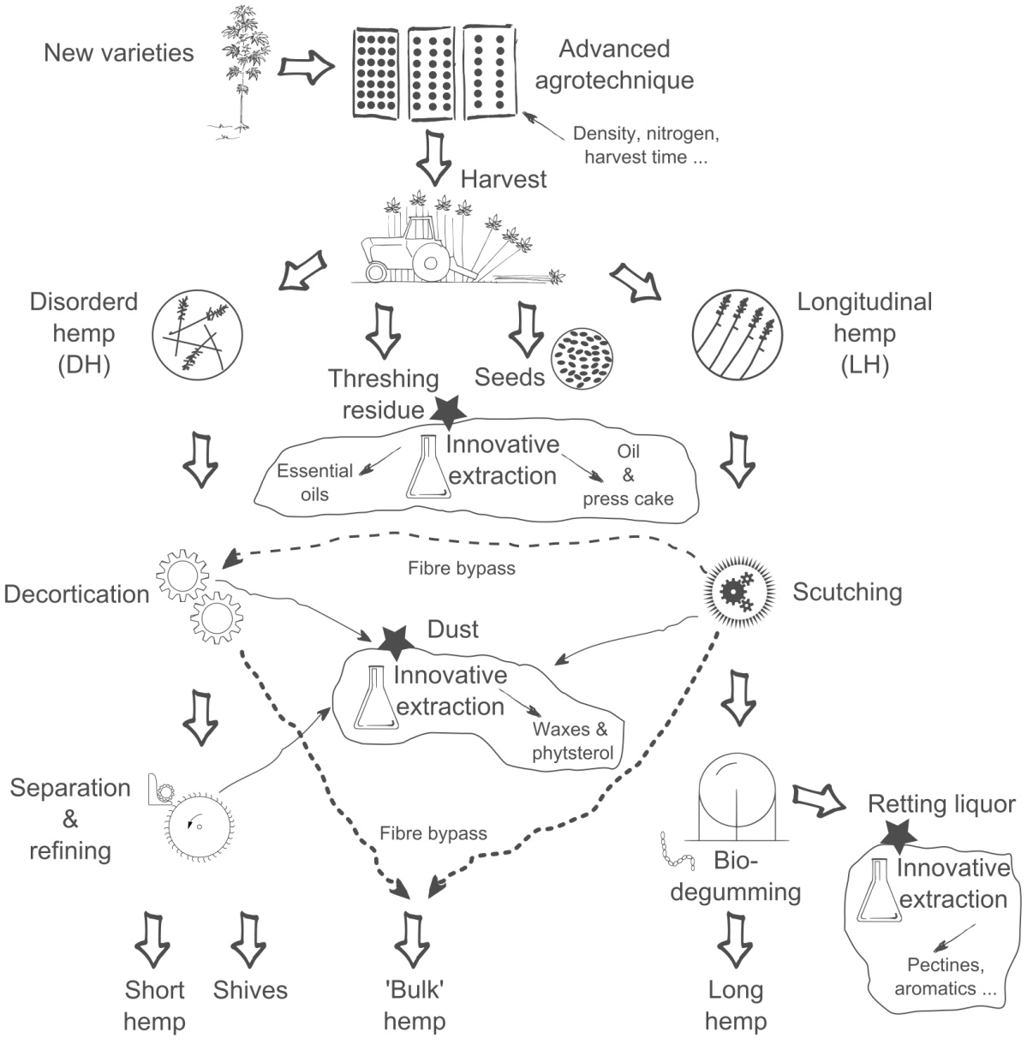

*Figure A: Scheme of the MultiHemp biorefinery concept. Large arrows indicate raw material flow along the production chain; Stars highlight innovative processing to upgrade by-products into high added value end uses.*

***Table 1****: List of fibre traits and selected gene targets*

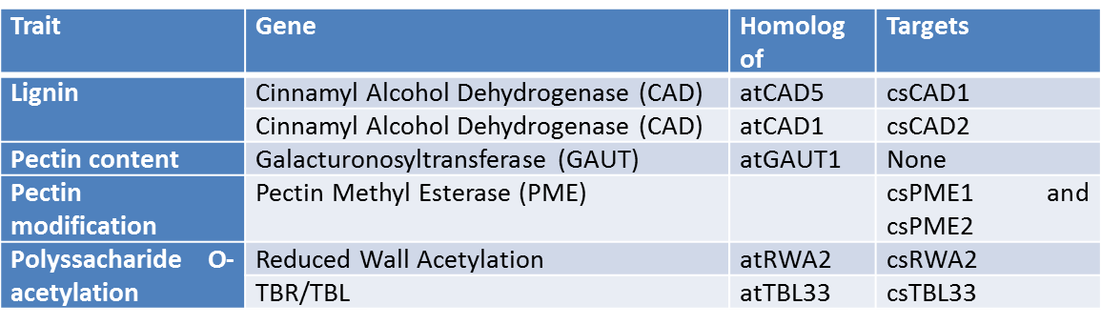

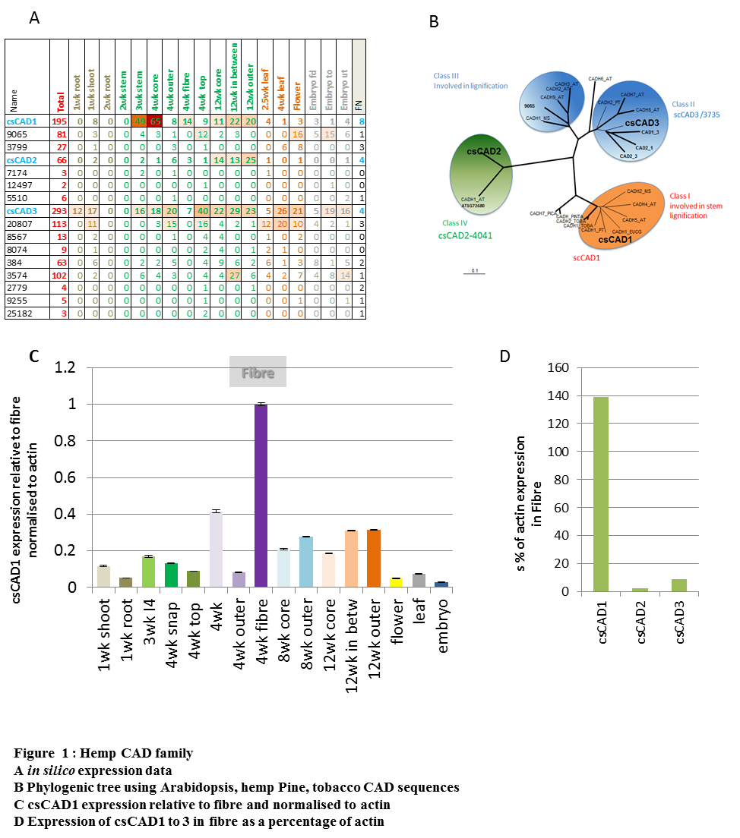

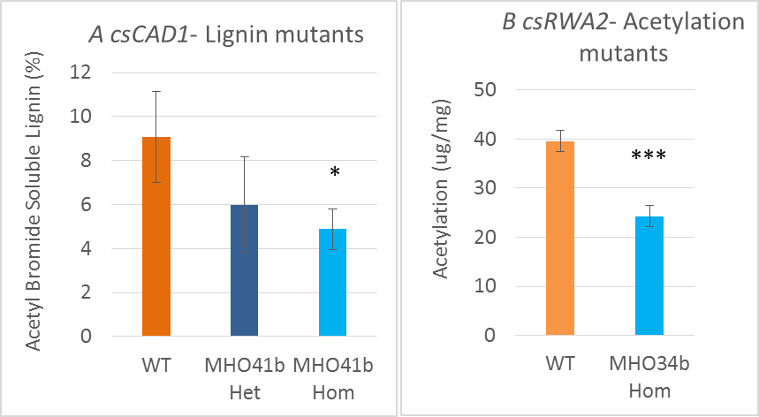

**Figure 2**: Homozygous mutant lines showing a decrease in lignin and acetylation in the fibres (in comparison to Wild Type Finola WT).

**Table 2:** Summary of mutant lines available in WP1

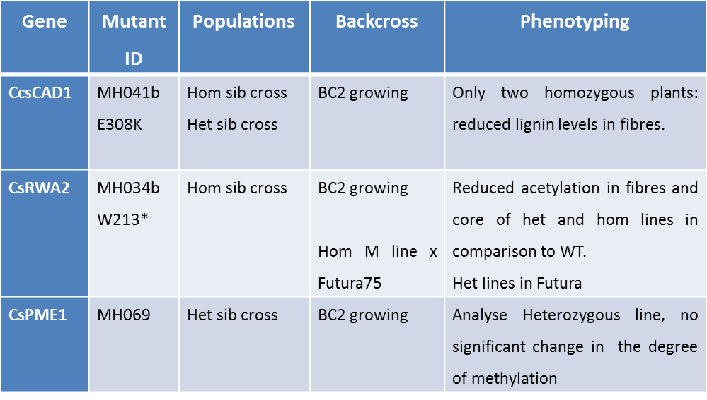

Het means heterologous and hom homologous. Het sib crossing means crossing between 2 heterologous lines, hom sib crossing means crossing between 2 hom lines. BC means back cross to Finola wild type.* means that the mutation create a stop codon.

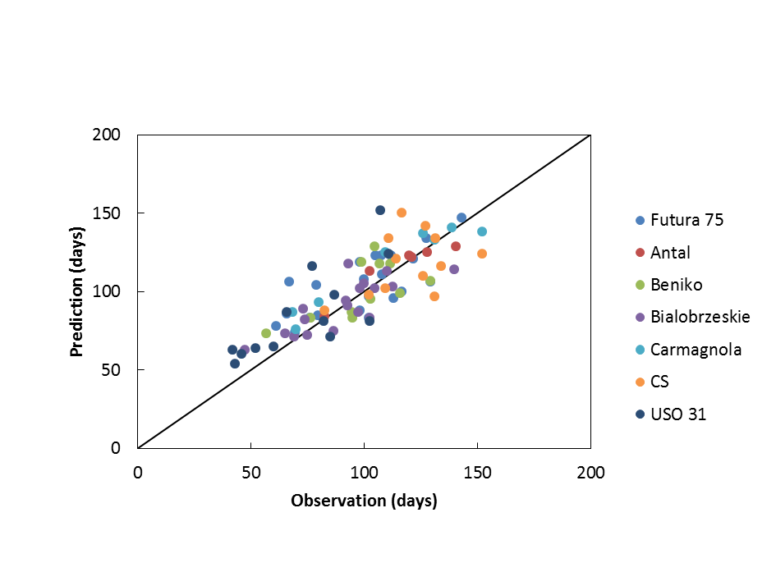

Figure 3. Predicted (model) and observed (measured) values of flowering time of seven different cultivars in different environments. Colours correspond to the different cultivars, points represent flowering time in a particular location and for a particular year. The solid line represents the 1:1 ratio.

*Figure 4. The response of leaf respiration in dark (Rdk, Panels a and c) and maximum light-saturated net photosynthesis rate (Amax; Panels b and d) to specific leaf nitrogen (SLN; Panels a and b) and leaf temperature (TL; Panels c and d). Rdk was measured after adapting leaves in dark for 15 minutes after measuring the A - Iinc curve. Amax was measured at 2000 μmol m-2 s-1 for incident light intensity and 400 μmol mol-1 for ambient CO2 concentration. The data presented in Panel a and Panel b were obtained in the N-trial while those in Panel c and Panel d were obtained in the T-trial. The bars in Panels c and d indicate standard errors of the mean (n = 3). From Tang et al. (Accepted)*

|  |  |
| --- | --- |
|  |  |
| Fig. 5 Design and prototype of a new machine concept for harvesting hemp seeds from swath | |

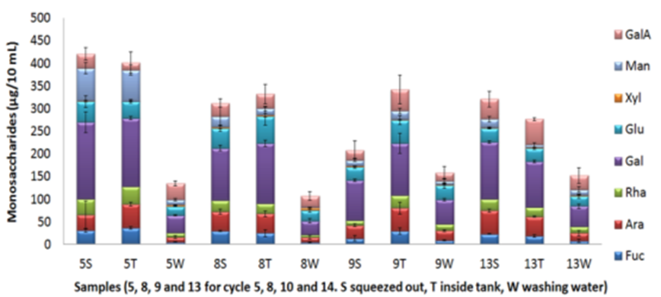

Fig. 6 Monosaccharides composition of bio-degumming liquor

|  |  |
| --- | --- |
|  |  |
| Fig. 7 Thickness swelling of board samples of wet preserved hemp from two different varieties | Fig. 8 Bending strength of board samples of wet preserved hemp from two different varieties |

|  |  |
| --- | --- |
|  |  |
| Fig. 9 Worthmann laboratory breaker unit | Fig. 10 Coarse separator |

|  |  |
| --- | --- |
|  |  |
| Fig. 11 Demonstration of harvesting and processing at PlanC (Aulnoy; France) | |

|  |  |
| --- | --- |
|  |  |
| Fig. 12 Gathering of threshing residues from the sieve section of a hemp combine harvester | |

|  |  |
| --- | --- |
|  |  |
| Fig. 14 Cutting machine for the harvest of longitudinal hemp | |

|  |  |  |
| --- | --- | --- |
|  |  |  |
| Fig. 15 Harvest and experimental storage of hemp crop for the “wet line” procedure | | |