Annex 1: Figures, Tables and Pictures

Grant Agreement number: HEALTH-F5-2012-305421
Project acronym: EUROFANCOLEN
Project title: Phase I/II Gene Therapy Trial of Fanconi anemia patients with a new
Orphan Drug consisting of a lentiviral vector carrying the FANCA gene: A Coordinated
International Action
4.1.3. DESCRIPTION OF THE MAIN S&T RESULTS/FOREGROUNDS

Table 1.1: Summary of chromosome fragility tests and diagnosis of new FA patients performed during the course of EUROFANCOLEN.

Figure 1.1: Updated distribution of FA subtypes among the 201 genetically characterized FA patients from Spain including the genetic studies carried out in EUROFANCOLEN

Figure 1.2. Representative complementation assay conducted in a FA-A patient using two different FANCA-retroviral vectors

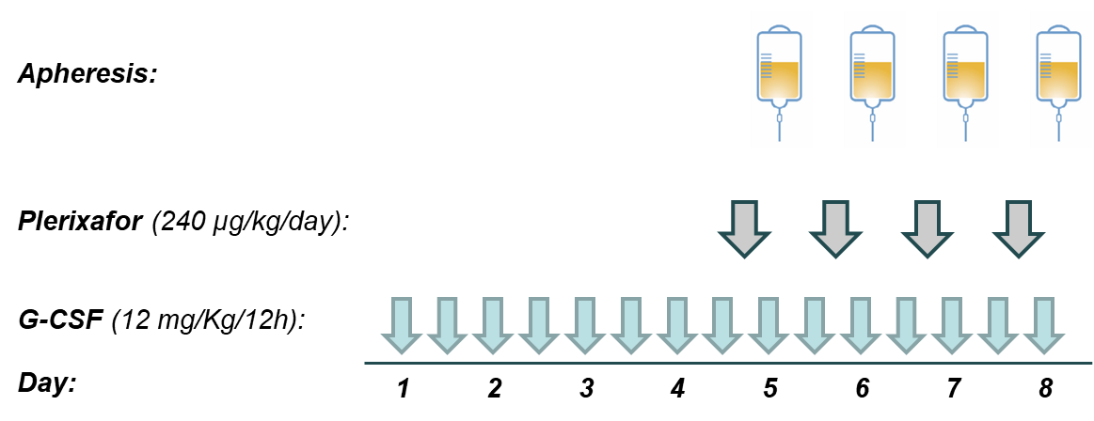

Figure 2.1. Mobilization protocol used for the collection of CD34⁺ cells from FA patients.
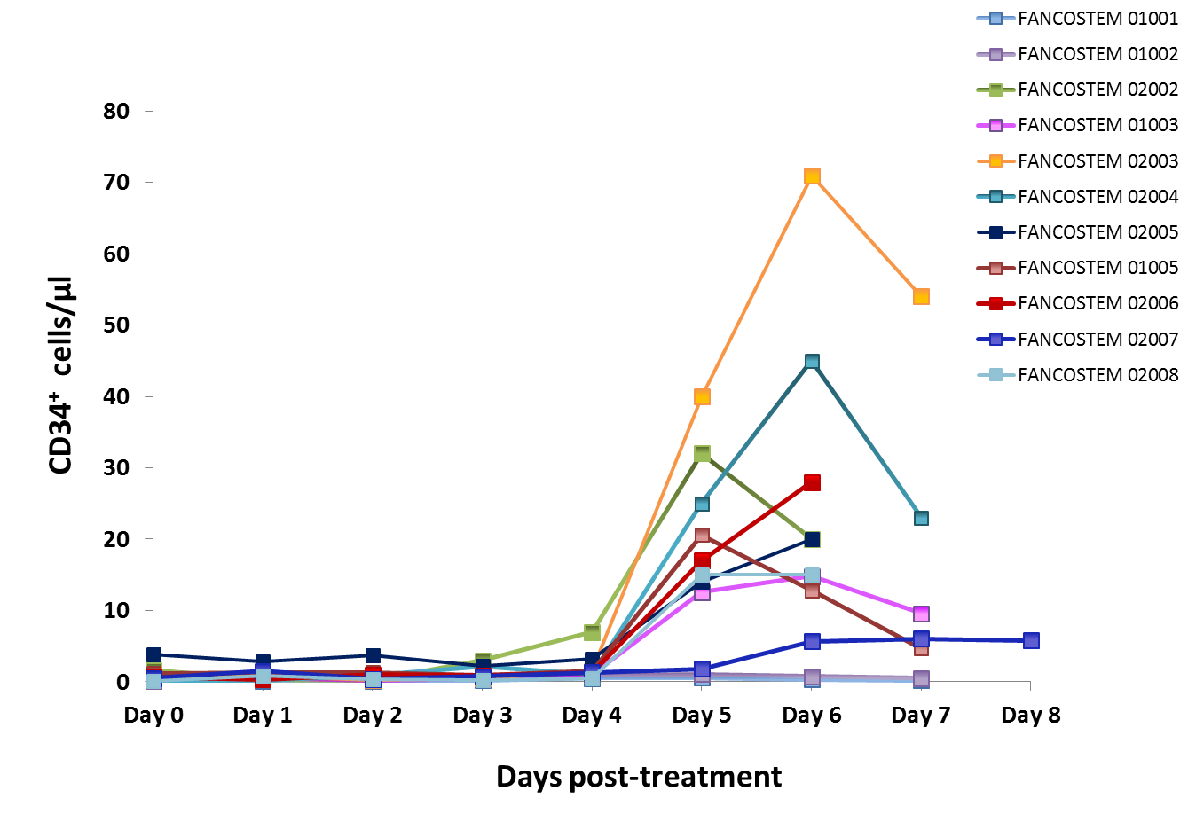

Figure 2.2: Kinetics of CD34⁺ cells mobilization in patients treated with G-CSF and plerixafor. V0 to V7 correspond to the different visits with respect to the initiation of the mobilization treatment (V0).

.

Samples | Mappable reads | Unique IS | RefSeq | RefSeq  ±5 Kb | TSS  ±5 Kb | CpG island  ±5 Kb
FANCA-LV
Pre-BMT | 1,646 | 321 | 199  62.0% | 207  64.5% | 19  5.9% | 20  6.2%
Primary  (n=31) | 156,245 | 5,451 | 2915  53.5% | 3129  57.4% | 311  5.7% | 359  6.6%
Secondary  (n=24) | 76,532 | 1,019 | 489  48.0% | 526  51.6% | 51  5.0% | 58  5.7%

Table 3.1 Summary of insertion sites analyzed by LAM-PCR and NGS. TSS: transcription start site, CpG: cytosine-phosphate-guanine, IS: integration site, BMT: bone marrow transplantation, LV: lentiviral vector, RV: gamma-retroviral vector

Figure 3.1: Schematic representation of the integrated proviral genome. HIV: human immunodeficiency virus/Psi: incapsidation sequence /LTR: Long Terminal Repeat 5’ or 3’/ HIV R: HIV R region/ HIV delta U3: U3 region with a deletion/ RRE: Rev responsive element / cPPT cts: central polypurine tract – central terminal sequence/ hPGK: human phosphoglycerate kinase promoter / hFANCA: human FANCA gene / WPRE4: mutated woodchuck hepatitis virus posttranscriptional regulatory element

A)
B)

Figure 4.1: Analysis of the proportion of gene corrected cells purified PB cells (Panel A) and BM cells (Panel B), expressed as percentage of corrected cells or VCN/cell at different times post-infusion.
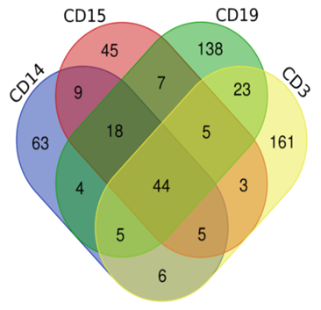

Figure 4.2: Genome-wide Mapping of Vector Unique Integration Sites in purified myeloid and lymphoid populations from a FA patient treated by gene therapy

    - POTENTIAL IMPACT (INCLUDING THE SOCIO-ECONOMIC IMPACT AND THE WIDER SOCIETAL IMPLICATIONS OF THE PROJECT SO FAR) AND THE MAIN DISSEMINATION ACTIVITIES AND EXPLOITATION OF RESULTS (NOT EXCEEDING 10 PAGES).

Address of the public web site, if applicable as well as relevant contact details Project logo, diagrams or photographs illustrating and promoting the work of the project (including videos, etc…), as well as the list of all beneficiaries with the corresponding contact names can be submitted without any restriction.
- EUROFANCOLEN Webpage: www.eurofancolen.org

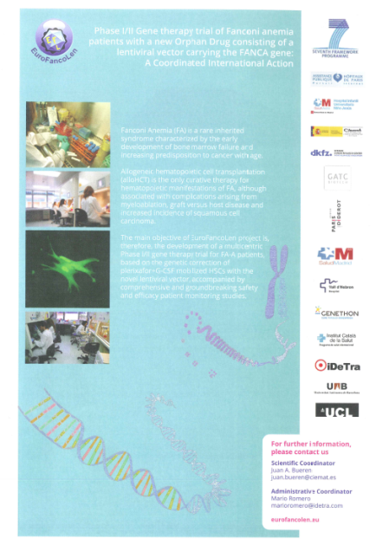

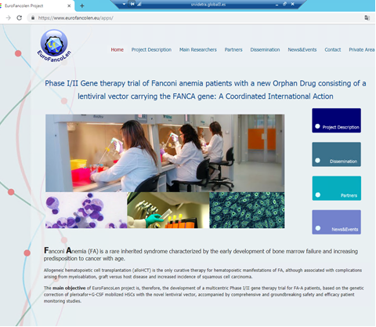

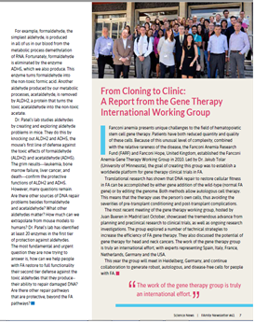
- Report published in the FARF Newsletter summarizing the news of the International FA Gene Therapy Working Group Meeting held at CIEMAT (October 2016) with an update of the results of the EUROFANCOLEN Trial.

- Publication in RESEARCH EU MAGAZINE: February 2019
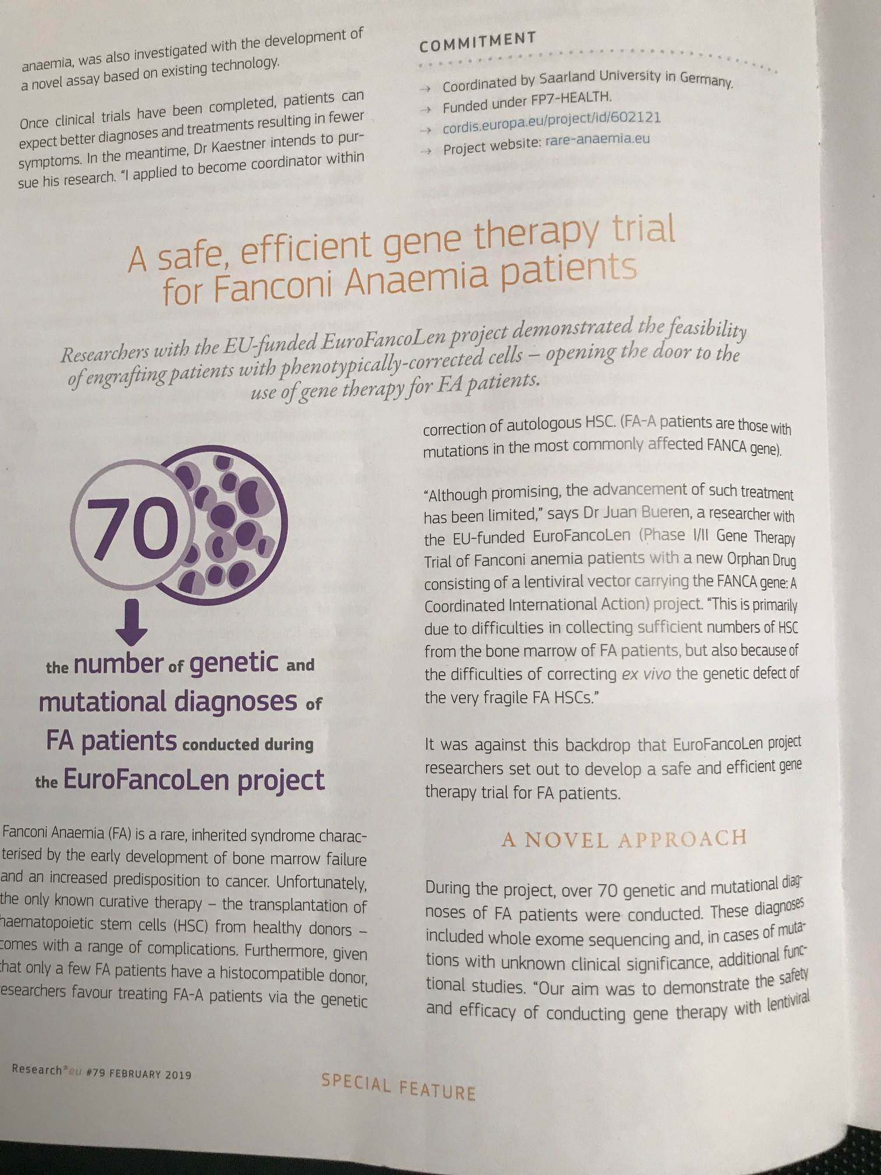

- Schematic protocol developed for the gene therapy of FA patients:
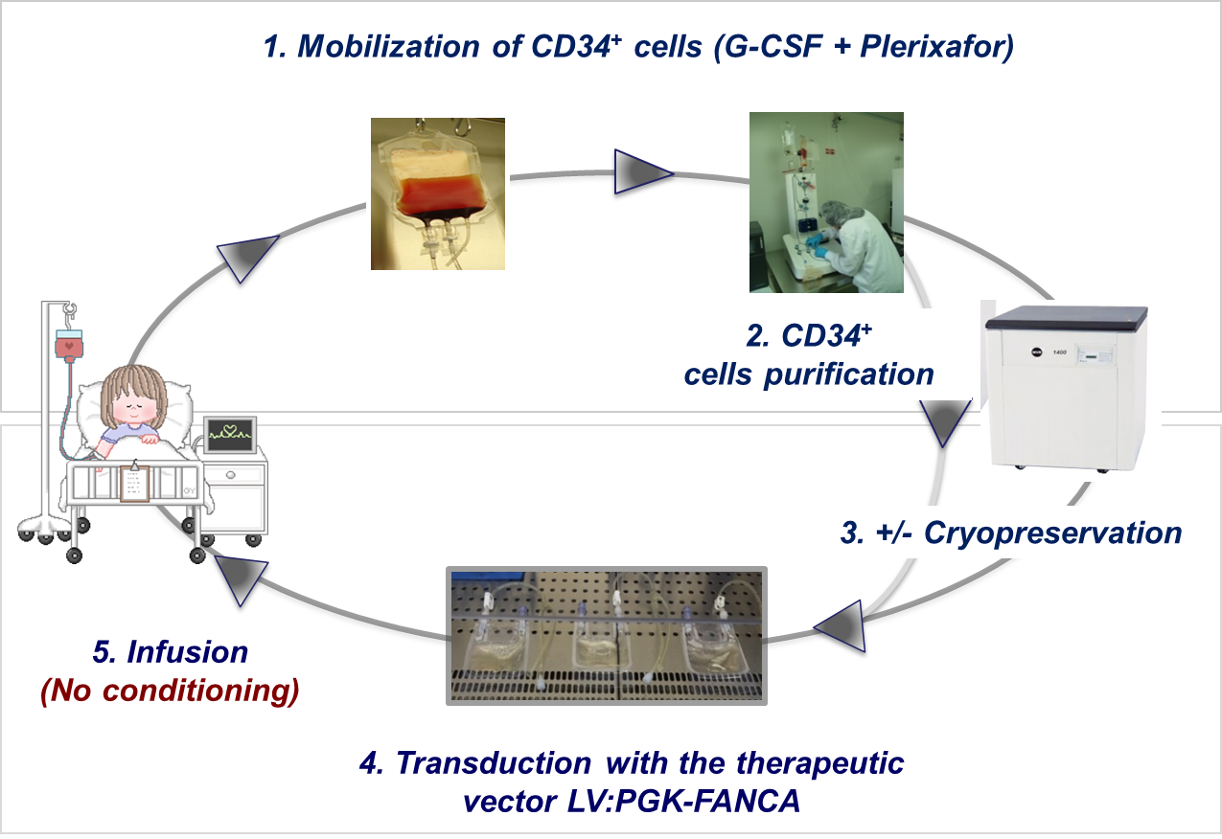

- Presentation of the preliminary conclusions of EUROFANCOLEN in the Plenary Session of the American Society for Gene and Cell Therapy. Chicago, May 2018
