**DIOGENES: Dust Impacts on Glaciated Environments**

S. Kutuzov, M. Shahgedanova, K.H. White and M. Woodage

Department of Geography and Environmental Science, University of Reading, UK

http://www.reading.ac.uk/geographyandenvironmentalscience/Research/ESS/ges-DIOGENES.aspx

DIOGENES is an interdisciplinary project addressing impacts of mineral aerosol (dust) on glaciers and bringing together two major issues in climate change research: glacier shrinkage and impacts of mineral aerosol on climate system. Glacier wastage is observed worldwide in response to the observed climatic warming and in addition to rising air temperatures, the state of glacier surface affects glacier melt rates due to the presence of debris cover, black carbon and mineral dust. Mineral dust can originate locally making glacier tongues darker and enhancing their melt and from distant desert sources travelling thousands of kilometres in the atmosphere to be deposited over glaciated and snow-covered areas.

DIOGENES was set in the Caucasus Mountains in southern Russia (Fig. 1). Data were collected on Mt. Elbrus, which due to its elevation (5642 m a.s.l.) and relative proximity to the Sahara and the Middle East, is a perfect dust trap. The project examined sources, seasonality and meteorological conditions of desert dust transportation and deposition as well as physical and chemical properties of desert dust which affect glacier melt and geochemistry of glaciated regions. It also examined the effects of both types of dust on glacier melt. The observed pathways of desert dust in the atmosphere were compared with those simulated by HadGEM and HiGEM general circulation models (GCM).

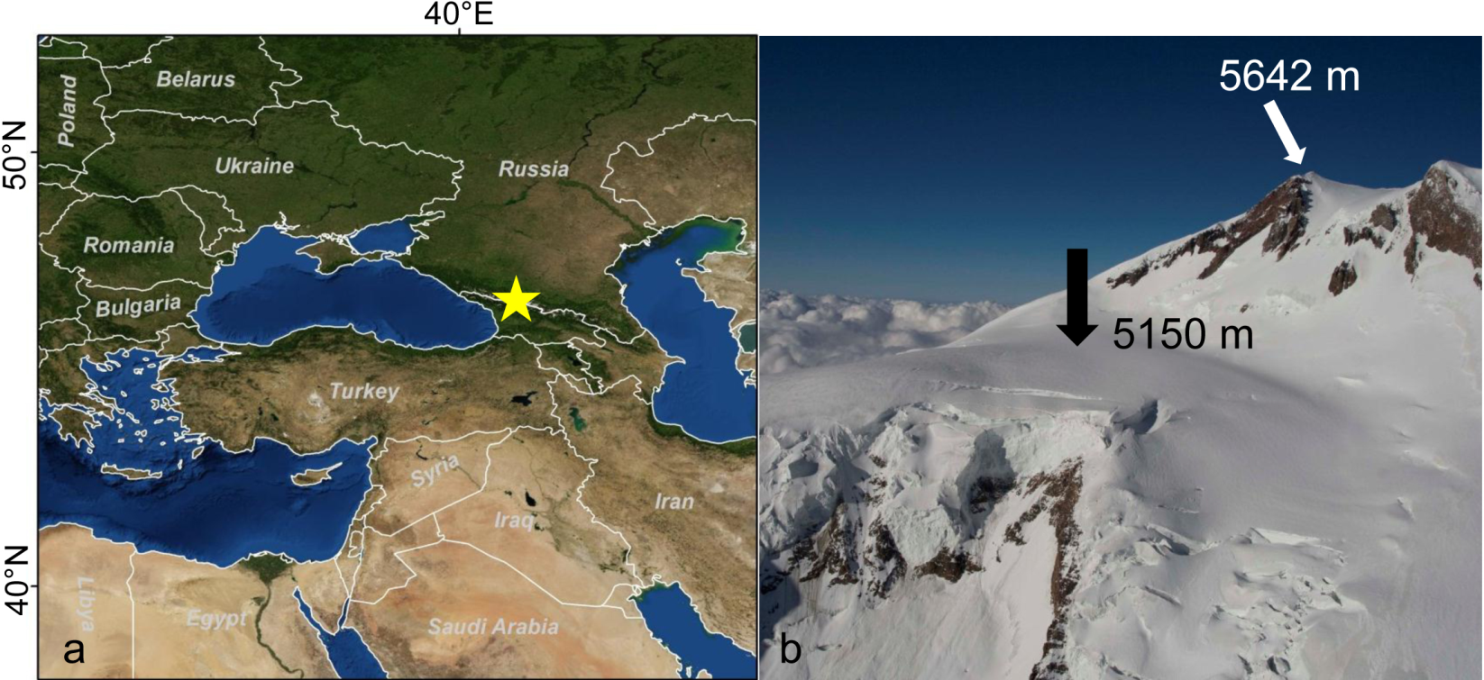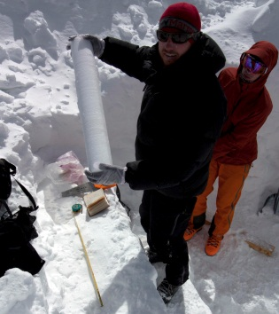

Fig. 1. Location of the study area, ice core extraction and sample collection sites (indicated by the black arrow).

Ice and firn cores are the best archives of desert dust deposition events. We extracted two shallow firn cores at the altitude of 5150 m a.s.l. at Mt. Elbrus in 2012 and 2013 covering the periods of 2009-2012 and 2007-2013 respectively. The cores were analysed for the presence of mineral dust, its chemical composition and particle size distribution. Isotopic analyses using stable oxygen and deuterium isotopes were used to date the cores. This approach enables approximate dating of dust deposition events with precision of seasons but does not provide information about the source regions of desert dust. It is important to both date and ‘provenance’ dust deposition events with high precision because radiative forcing of dust depends on time of deposition (i.e. how close to the onset of melt) and chemical composition of dust varies between the source regions. To date and ‘provenance’ dust deposition events with high precision, we developed a novel methodology based on the use of multiple independent sources including meteorological data, HYSPLIT back trajectory model, MODIS Deep Blue atmospheric optical depth (AOD) data and Spinning Enhanced Visible and Infra-Red Imager (SEVIRI) composite red-green-blue (RGB) imagery developed specifically for tracking dust in the atmosphere but never before used in glaciological studies. SEVIRI is installed on board MSG satellite, positioned in a geostationary orbit at 0oW over the equator, and provides data with 15 minute temporal resolution, which is key to high resolution ‘provenancing’ and dating of dust events.

We have established that desert dust deposition events occur on Mt. Elbrus 5-6 times a year. Dust originates most frequently from the Middle East, more specifically from the northern Mesopotamia and the Syrian Desert. Dust from northern Sahara is transported to the Caucasus once or twice per year and, although these events are less frequent, they result in higher dust load. The developed methodology enabled timing of dust entrainment and deposition events with a precision of hours and ‘provenancing’ with a precision of 30-50 km for the Middle East and 50-100 km for the Sahara. The spatial resolution is predetermined by the size and nature of sources: larger natural sources dominate in the Sahara and a mixture of smaller natural (dry lakes and river beds) and anthropogenic (agricultural fields) sources dominates in the Middle East. A comparison between the observed trajectories and those modelled by HiGEM and HadGEM GCM has shown that GCM resolve the Saharan dust events but not those from the Middle East.

Dust flux was calculated for the first time for the Caucasus Mountains and was 264 μg cm-2 a-1. Desert dust contributed approximately 40% of the total. Desert dust deposition was highest in 2008 when the particularly strong Saharan dust storms reached the Caucasus. Analysis of dust storm activity in the Middle East indicated more frequent dust storms in 2007-2010 when the region experienced a prolonged drought and rain-fed fields were abandoned stressing the interactions between climatic variability and human activities.

Dust deposition has clear seasonality with a maximum in March-June. Depending on elevation, snow melt starts in the Caucasus in May-June and, therefore, the timing of desert dust deposition maximises its impact on glacier melt. Spectral reflectance measurements were conducted in the Caucasus in the summer 2013 collecting data on changes in glacier and snow pack surface reflectance due to the deposition of both locally produced and desert dust. The locally produced dust mixed with products of biogenic decay makes a stronger impact: surface reflectance decreases from 80-85% for clean snow to 10-20% in the visible spectrum. Reflectance drops to 30-40% due to the deposition of desert dust but desert dust covers much larger areas enhancing melt at higher elevations. Modelling has shown that the impact of desert dust deposition on melt is approximately the same as that of 1K warming.

Desert dust affects snow and ice chemistry. It is particularly rich in calcium and oxides of iron. The latter serve as a fertiliser for the aquatic system and whose role may become important in high-altitude areas as lakes grow. It also transports such elements as magnesium, copper, vanadium, chromium and zinc. Dust from the Middle East blown off the agricultural fields is enriched in nitrates and ammonium. Both are absent in the Saharan dust and may serve as a tracer helping to distinguish between the Saharan and Middle Eastern sources when analysing samples from the pre-2005 period when SEVIRI was not available.

DIOGENES achievements and contributions can be summarised as follows:

(i) A novel methodology has been developed enabling very high-resolution and ‘provenancing’ of dust events which can be applied in other high-altitude regions of Europe with extensive snow cover. It improved our knowledge of pathways of mineral aerosol in the atmosphere and of impacts of climatic variability on dust emission and deposition;

(ii) A significant advancement was achieved in obtaining information on environmental and climate change from ice cores which will have a wide generic application;

(iii) Data on spectral reflectance of dust can be implemented in glacier mass balance and hydrological models. Their improved performance is of importance to both, scientific community and practitioners;

(iii) Knowledge on chemical and physical properties of desert dust and its impacts on geochemistry of the high-altitude environments has been improved significantly.