**PUBLISHABLE SUMMARY – FP7-IRSES “IPRABIO”**

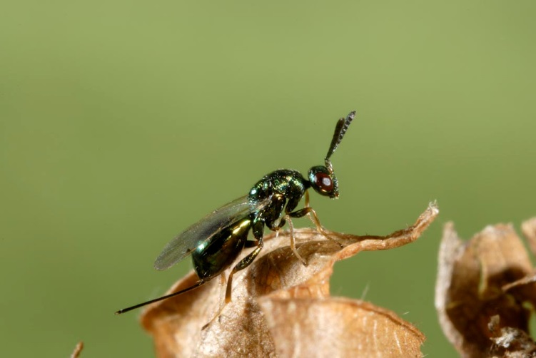IPRABIO aimed at promoting new practices, for example the use of molecular characterization techniques, within the biological control community. This was performed by demonstrating their relevance and efficiency to address common and key biocontrol issues faced in practice in several biological control programmes carried out by the involved consortium and their collaborators against the following insect pests: *Tuta absoluta*, *Pseudococcus viburni*, *Pseudococcus comstocki*, *Planococcus ficus*, *Delottococcus aberiae*, *Protopulvinaria pyriformis*, *Dryocosmus kuriphilus,* Aphis spiraecolaand *Aphis glycines*,

A first challenge for IPRABIO was to convince biological control practitioners of the interest of using molecular-based techniques. The collaboration between teams experienced in molecular characterisation, teams experienced in morphological characterization and teams responsible for biological control activities has rapidly generated added-value to the research of the consortium. Teams that had not used molecular techniques so far have rapidly adopted the proposed techniques. The resulting enthusiasm for the multi-criteria characterization (DNA, morphology, ecology) of pests and natural enemies has generated abundant data on the identification and distribution of pests within or outside Europe (Beltrá et al., 2012; Correa et al., 2012; Abd-Rabou et al., 2012; Bernardo et al., 2013; Urbaneja et al., 2013; Pacheco et al., 2014; Gebiola et al., 2015; Gomez-Marco et al., 2015; Nugnes et al., 2015). This work even led to the description of new species of pests and natural enemies: one mealybug (Correa et al., 2011), one chestnut pest species (Bernardo et al., 2013), and four natural enemies of *T. absoluta* (Gebiola et al., 2015). In addition, the development of microsatellite markers for several species (A’Hara et al., 2011; Correa et al., 2014) and the associated genotyping data has allowed the investigation of the origin and pathways of invasions for the pests *Tuta absoluta* and *Pseudococcus viburni* (Correa, 2015; Guillemaud et al., 2015).

Overall, the use of molecular characterization methods has strongly impacted the implementation of the biocontrol programmes. For example, the DNA data have confirmed the interest of seeking natural enemies of the mealybug *Delottococcus aberiae* in South Africa for future releases into Europe, based on the fine-scale comparison of mealybugs collected in Spain and South Africa. Multi-criteria characterization of the natural enemies (parasitoid micro-wasps) has further helped spot candidate biological control agents for the biological control of the pest in Spain (Beltrà et al., submitted). Actually, one of the main outcomes of IPRABIO is to provide evidence that fine-scale multi-criteria characterization of pests really matters in biological control. Indeed, unexpected complications have been revealed in the programs against *Pseudococcus viburni* and *Planococcus ficus*. In these two programs, the non-EU regions where natural enemies were surveyed (Egypt for *P. ficus* and South America for *P. viburni*) proved to be infested by pest populations displaying high genetic divergence from the target populations in Europe. The divergent populations might be different species and the consequence is that the natural enemies collected from them there might not be efficient on the target, and/or may not be specialist of the target species. This observation has considerably changed the strategy in these programs and redirected the research to other areas where pest populations similar to the European ones have been found. In addition, in the most advanced programmes, the production of DNA barcodes for the surveyed and laboratory-reared biological material, together with the development of simple molecular tools for the rapid identification of species (Villard & Malausa, 2013), has also contributed to the smooth implementation of traceability procedures in the biological control programmes.

A second challenge of IPRABIO was to drive the consortium to build collaborative innovative research on two recurrent challenges in biological control: (i) the improvement of our capacity to characterize and predict the specificity of natural enemies (Workpackage 2) and (ii) the determination of factors affecting the establishment success and performance of natural enemies when released to control a pest (Workpackage 3). IPRABIO has supported collaborations between the “Institut National de la Recherche Agronomique” (INRA, France), the Universidad Nacional de La Plata (UNLP, Argentina) and the University of Minnesota (USA) that has generated results on the mechanisms impacting the specificity and efficiency of natural enemies against aphids and *Tuta absoluta* (Asplen et al., 2014; Brady et al., 2014). IPRABIO has also allowed the start of both short-term and long-term laboratory and field experiments on the factors affecting the performance and establishment success of natural enemies, carried out by INRA, the Universitat Politécnica de Valencia (Spain), the Instituto Valenciano de Investigaciones Agrarias (Spain), the Pontificia Universidad Católica de Chile, UNLP, the Stellenbosch University and the University of California (e.g. Tena et al., 2013).

Apart from the strictly scientific results, IPRABIO has deeply impacted the collaborative strategy of the involved consortium. The networking activities carried out in IPRABIO have directly given birth to new collaborative projects, both at the national and international level. The research activities focusing on the integration multi-criteria characterization of pests and natural enemies in biological control has attracted the interest of the biocontrol industry and created connections to three enterprises, concretized by a new large-scale project FP7-IAPP (“Colbics”, 2013-2016). The research oriented axes of IPRABIO (WP2, WP3) have been extended through two new FP7-IRSES projects (Aphiweb, Biomodics) further supported by two national research projects in France (EcoPhyto Program) and Chile (Fondecyt program). These new projects ensure the transfer of the research results obtained in IPRABIO, the continuity and reinforcement of the activities started in IPRABIO (e.g. the next steps of the biological control program against *D. aberiae* and *P. ficus* in Spain), and also enable the start of new biological control activities by our consortium (e.g. joint biological control programme of *Cydia pomonella* common to France, Chile and New Zealand).

Finally, IPRABIO has significantly impacted the career of the seconded researchers. In addition to the international experience and the network extension it has provided, IPRABIO has accompanied several researchers towards new responsibilities in the consortium. Most notably, four Early-Stage researchers have progressively developed their skills to become experienced researchers playing key roles in the most recently started projects. IPRABIO has also naturally driven the involved experienced researchers to roles of coordinators in the current ongoing EU projects or project proposals.

**References:**

A'Hara SW, Amouroux P, Argo EE, Avand-Faghih A, et al. Mol Ecology Resources Primer Dev. 2012. Permanent Genetic Resources added to Molecular Ecology Resources Database 1 August 2011-30 September 2011. Molecular Ecology Resources 12:185-189.

Asplen MA, Bano N, Brady CM, Desneux N, Hopper KR, Malouines C, Oliver KM, White JA, Heimpel GE. (2014). Specialisation of bacterial endosymbionts that protect aphids from parasitoids. Ecological Entomology 39:736-739.

Beltrá A, Soto A, and Malausa T. 2012. Molecular and morphological characterisation of Pseudococcidae surveyed on crops and ornamental plants in Spain. Bulletin of Entomological Research 102:165-172.

Bernardo U, Iodice L, Sasso R, Tutore VA, Cascone P, Guerrieri E, 2013. Biology and monitoring of *Dryocosmus kuriphilus* (Hymenoptera: Cynipidae) on *Castanea sativa* in Campania (Southern Italy). Agricultural and Forest Entomology 15: 65-76.

Brady CM, Asplen MK, Desneux N, Heimpel GE, Hopper KR, Linnen CR, Oliver KM, Wulff JA, White JA. 2014. Worldwide populations of the aphid *Aphis craccivora* are infected with diverse facultative bacterial symbionts. Microbial Ecology 67:195–204.

Correa MCG, Aguirre C, Germain JF, Hinrichsen P, Zaviezo T, Malausa T & Prado E. 2011. A new species of *Pseudococcus* (Hemiptera: Pseudococcidae) from Chile: morphological and molecular description. Zootaxa 2926: 46-54.

Correa MCG, Zaviezo T, Le Maguet J, Herrbach E, Malausa T. 2014. Characterization of microsatellite DNA libraries from three mealybug species and development of microsatellite markers for *Pseudococcus viburni* (Hemiptera: Pseudococcidae). Bulletin of Entomological Research, 104, 213–220.

Correa MCG. Characterization, population genetic structure and invasion history of the mealybug *Pseudococcus viburni*. PhD Thesis. Pontificia Universidad Católica de Chile, Santiago, 2015.

Gebiola M, Bernardo U, Ribes A, Gibson G. 2015. An integrative study of *Necremnus* Thomson (Hymenoptera: Eulophidae) associated with invasive pests in Europe and North America: Taxonomic and ecological implications. Zoological Journal of the Linnean Society 173, 352-423.

Gomez-Marco F, Urbaneja A, Jaques JA, Rugman-Jones PF, Stouthamer R, Tena A. 2015. Untangling the aphid-parasitoid food web in citrus: Can hyperparasitoids disrupt biological control? Biological Control 81: 111–121.

Guillemaud T, Blin A, Le Goff I, Desneux N, Reyes M, Tabone E, Tsagkarakou A, Niño L, and Lombaert E. 2015. The tomato borer, *Tuta absoluta*, invading the Mediterranean Basin, originates from a single introduction from Central Chile. Sci. Rep. 5: 8371

Nugnes F, Gebiola M, Monti MM, Gualtieri L, Giorgini M, Wang J, Bernardo U. 2015. Genetic diversity of the invasive gall wasp *Leptocybe invasa* (Hymenoptera: Eulophidae) and of its Rickettsia endosymbiont, and associated sex-ratio differences. Plos One, in press.

Pacheco da Silva VC, Bertin A, Blin A, Germain J-F, Bernardi D, Rignol G, Botton M, and Malausa T. 2014. Molecular and Morphological Identification of Mealybug Species (Hemiptera: Pseudococcidae) in Brazilian Vineyards. PLoS ONE 9, e103267.

Tena A, Hoddle CD, Hoddle MS. 2013. Competition between honeydew producers in an ant-hemipteran interaction may enhance biological control of an invasive pest. Bulletin of Entomological Research 103: 714–723.

Urbaneja A, Desneux N, Gabarra R, Arno J, González-Cabrera J, Mafra-Neto A, Pinto AdS, Parra JRP. 2013. Biology, Ecology and Management of the tomato borer, *Tuta absoluta*. In: Peña JE (Ed), Potential Invasive Pests of Agricultural Crops, CABI series. pp. 98-125.

Villard P and Malausa T. 2013. SP-Designer: a user-friendly program for designing species-specific primer pairs from DNA sequence alignments. Molecular Ecology Resources 13:755-758.