During my fellowship I have directed my attention on different aspects of trafficking and plasticity of KARs at MF to CA3 synapses. During my study I have used a variety of different experimental approaches such as slice electrophysiology, molecular biology and imaging. I have followed the working plan proposed in the Annex I and in the summary below I’m presenting the results and progress for each one of the aims of the first year of my project.
Molecular interactions that govern targeting of GluR6 to MF synapses through its CTD in vivo.
I’ve characterized the properties of the rescued KAR mediated synaptic current at MF to CA3 synapses by re-expression of wt GluR6a in the GluR6-/- mice background. To quantify the level of synaptic KARs I have compared the KAR mediated synaptic current with respect the total MF response. In wild type animal the KAR mediated response resulted to be about 10% of the total MF response. I have found that, after 3-7 days of transfection of GluR6a in slice from GluR6-/- mice, the KAR mediated current was restored to a level comparable to the one observed in slice of wild type animal, about 10% of the total MF response.
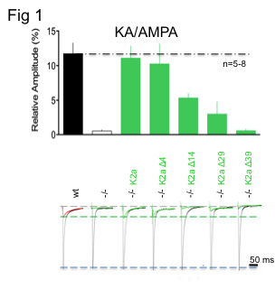
After the characterization of the properties of the KAR mediated current rescued with GluR6a, I’ve started to study the possible molecular interactions that govern targeting of GluR6a to MF synapses through its CTD. For this purpose I’ve used GluR6a mutants, already present in the host lab, that have sequential deletion of the CTD (54 amino acids). I’ve used mutants missing the last 39, 29, 14 and 4 amino acids (see summary of these results inf fig 1). As expected, in cell transfected with the Δ39 mutant (a mutant that does not go to the membrane when expressed in non neuronal cells) no synaptic KAR mediated currents was detected. Transfection with Δ29 mutant (that can go to the membrane in non neuronal cells) also failed to rescue the synaptic KAR mediated current, suggesting that the last 29 amino acids are necessary for proper synaptic localization of GluR6a subunit at synaptic location. Interestingly, also transfection with the Δ14 mutant (that does not interact with the N-cadherin/β-catenin complex) fail to completely rescue the synaptic current, suggesting a role of this adhesion complex in stabilizing KAR at this synapse. Finally, Δ4 mutant (that does not have the PDZ binding domain) fully rescue the synaptic response mediated by KAR, suggesting that PSD95 or other proteins that can interact with PDZ domain are not playing a role major in targeting KAR at MF synapse.
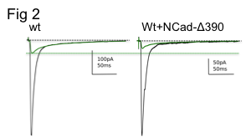
In order to understand the mechanism by which GluR6a is stabilized at MF by N-cadherin/β-catenin complex I’ve transfected slice prepared from wilt type mice with a mutated form N-cadherin (Ncad-Δ390) that works as a dominant negative. Intestingly I’ve found, after this genetic manipulation, reduced KAR mediated responses when compared to not transfected slice (fig 2). These data confirm our original hypotesis that N-cadherin/β-catenin plays a fundamental role in the regulation of propper targeting of KAR at Mf-CA3 synapse.

CaMKII-dependent phosphorylation of GluK5 mediates plasticity of kainate receptors via lateral diffusion.
CaMKII is a key element for the induction of long term potentiation of synaptic transmission mediated by AMPA receptors. Whether CaMKII is involved in the activity-dependent plasticity of other ionotropic glutamate receptors is not known. Here we show that spike-timing dependent depression (STDP-LTD) of kainate receptor-mediated responses at hippocampal mossy fiber synapses depends on Ca²⁺ influx and activation of CaMKII. We have identified three serine residues as CaMKII-phosphorylation sites in the C-terminal domain of the GluK5 subunit of kainate receptors (KARs). In phosphomimetic mutants of GluK5, the binding of the scaffolding protein PSD-95 to GluK5 was inhibited. In addition, single-particle tracking of KARs indicated that CaMKII activation markedly increased surface mobility of GluK5-containing KARs. Finally, we found that STDP-LTD was absent in mice deficient mice for GluK5 but was restored when WT GluK5 was re-expressed in postsynaptic CA3 pyramidal cells, but not with re-expression of GluK5 phosphomutants. Our results, summarized and simplified in figure 3, indicate that CaMKII-dependent phosphorylation of GluK5 is necessary and sufficient for a novel form of spike-timing plasticity by mechanisms that likely rely on untrapping of KARs diffusion away from synaptic sites.
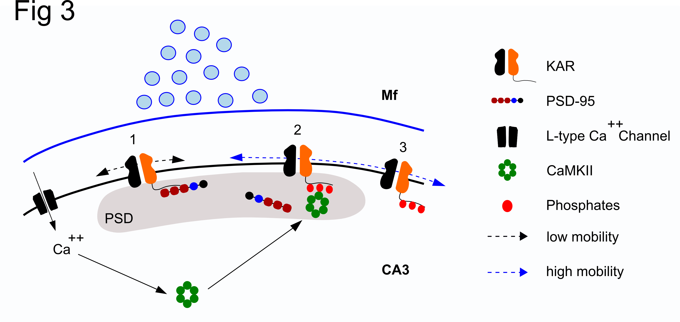
Conclusions:
By means of a multidisciplinary approach study I was able to discover the molecular mechanisms governing the proper targeting of KAR at MF-CA3 synapses I also discover and characterize a novel form of synaptic plasticity.
Similar multidisciplinary approach can be applied to the study of other synapses and receptors in the brain, contributing to the precise understanding of physiological and patophysiological processes.

