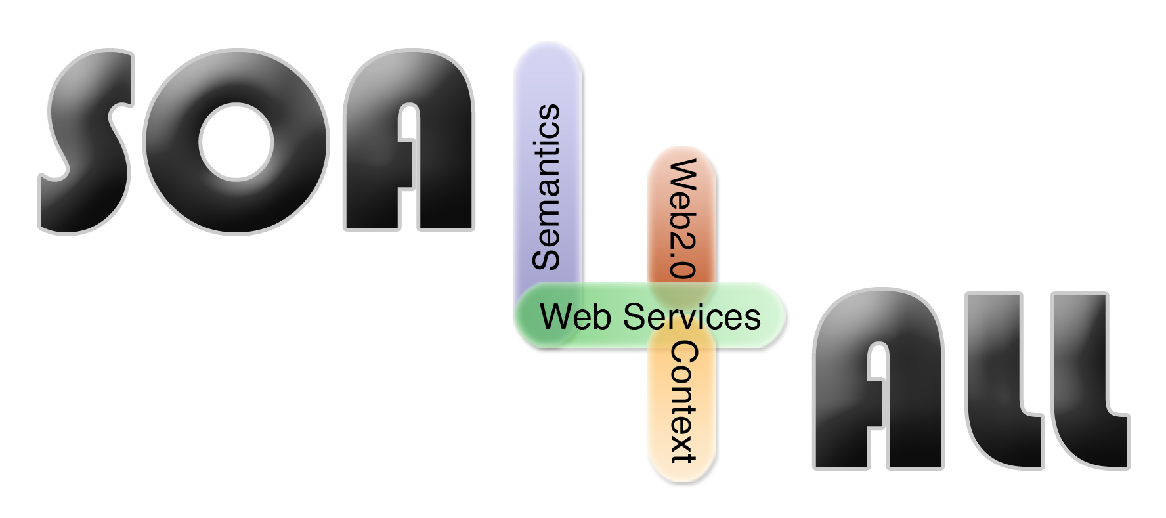
Project Number: | 215219
Project Acronym: | SOA4All
Project Title: | Service Oriented Architectures for All
Instrument: | Integrated Project
Thematic Priority: | Information and Communication Technologies
Annex I
D6.5.1. Specification and first prototype of the composition framework

Activity: |  | Activity 2 - Core R&D Activities
Work Package: |  | WP6 - Service Construction
Due Date: |  |  | M12
Submission Date: |  |  | 13/04/2009
Start Date of Project: |  |  | 01/03/2008
Duration of Project: |  |  | 36 Months
Organisation Responsible of Deliverable: |  |  | CEFRIEL
Revision: |  |  | 1.0
Author(s): |  | Gianluca Ripa, Teodoro De Giorgio (CEFRIEL)

Project co-funded by the European Commission within the Seventh Framework Programme (2007-2013)
Dissemination Level
PU | Public | X

Version History

Version | Date | Comments, Changes, Status | Authors, contributors, reviewers
0.1 | 07/04/09 | First draft | Gianluca Ripa, Teodoro De Giorgio (CEFRIEL)
1.0 | 09/04/09 | Final | Gianluca Ripa (CEFRIEL)

Table of Contents
1. Introduction 6
1.1 Purpose and scope of this deliverable 6
1.2 Structure of the document 6
2. Content of the release 7
3. Installation and use 8
3.1 Prerequisites 8
3.2 Installation and Use 8
3.3 Running the sample test cases on Windows 9
4. References 10
Annex A. TheWeather Service SAWSDL 11
Annex B. Forecast service SAWSDL 14
Annex C. TheWeather2Forecast.xml 16
Annex D. PaymentCC SAWSDL 18
Annex E. CCpayment SAWSDL 20
Annex F. PaymentCC2CCpayment.SAWSDL 23

Glossary of Acronyms

Acronym | Definition
SAWSDL | Semantic Annotated WSDL
WP | Work Package
WSDL | Web Service Description Language

List of Figures
Figure 1 - Content of the mappingScriptGenerator_v1.zip file 7
Figure 2 - Usage 8
Figure 3 – The console during the execution. 8
Figure 4 – Demo scenario 9

Introduction

Purpose and scope of this deliverable
The first prototype of the composition framework is built on top of SCENE [1] that represents the baseline for development. The main achievement already realized during the first year of the SOA4All project and the main new functionality added is the Mapping Script Generator component that implements a new approach for adapting service requests to actual service interfaces through semantic annotations. The approach is described in detail in [2] and in section 3.3.2 of the document “D6.5.1. Specification and first prototype of the composition framework”. At the time of writing of that document:
- the implementation of our solution was under way and we planned to release a first prototype by the end of February 2009;
- we planned also to develop a 1st demonstrator of the case study coming from the WP7 of SOA4All.
This document complements the deliverable ““D6.5.1. Specification and first prototype of the composition framework” and contains the description of the software release of a first running prototype with basic functionality of the Mapping Script Generator. This document is intended also as a user manual of the Mapping Script Generator itself.
Furthermore the document describes the 1st demonstrator developed just after the release of the prototype.

Structure of the document
This deliverable is organised as follows. Section 1 introduces the scope and content of this deliverable. Section 2 describes the content of the software release. In Section 3, we present the instructions for installing the prototype and for running some sample test cases. The sample SAWSDLs and the generated mapping scripts are also annexed to this document.

Content of the release
The first prototype of the Mapping Script Generator is released as a zip file named “D6.5.1.zip”.
Figure 1 depicts the content of the “D6.5.1.zip”file:
- the root folder contains some sample sawsdl files and some batch file for testing on Microsoft® Windows(TM).
- the bin folder contains the compiled java classes;
- the doc folder contains this document and some references;
- the lib folder contains the libraries required for compiling and executing the component;
- the src folder contains the source java files;
- the tests folder contains the result of the execution of some test cases;

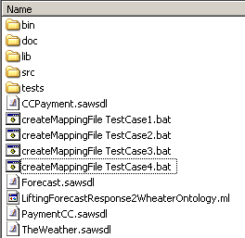
Figure 1 - Content of the mappingScriptGenerator_v1.zip file

The most relevant java classes that compose the release are organized in java packages as follows:
- it.adapter: IAdapter interface and Adapter class represents the access point of the component from outside;
- it.adapter.performers: contains the GenerateMappingFilePerformer class that contains the method that generates the mapping file given 2 SAWSDLs description;
- it.adapter.tools.xml: contains the parsers of the xml formats used (e.g. SAWSDL) and the classes that generates as output mapping script xml file;
- it.adapter.tools.utils: contains other utility classes (e.g.: InterfaceRulesUtils, ProtocolRulesUtils);

Installation and use

Prerequisites
The only prerequisite for using the Mapping Script Generator in his standalone version is the installation of a Java Virtual Machine. The prototype was tested with Java(TM) SE Runtime Environment (build 1.6.0_07-b06) and with Java(TM) 2 Runtime Environment, Standard Edition (build 1.5.0_06-b05).
For using the resulting mapping script is needed the installation of the SCENE platform available for download at [3], complete with installation and usage instructions.

Installation and Use
The MappingScriptGenerator component provides a class for a standalone usage. For using the component with a new developed use case scenario the user needs two WSDL annotated with semantic annotations and compliant with the SAWSDL specification [4].
Figure 2 shows how to execute the mapping script generation.
set classpath=./bin;./lib/Adapter.jar;./lib/axiom-api-SNAPSHOT.jar;./lib/axiom-dom-SNAPSHOT.jar;./lib/axiom-impl-SNAPSHOT.jar;./lib/axis2-adb-codegen-SNAPSHOT.jar;./lib/axis2-adb-SNAPSHOT.jar;./lib/axis2-codegen-SNAPSHOT.jar;./lib/axis2-java2wsdl-SNAPSHOT.jar;./lib/axis2-jaxbri-SNAPSHOT.jar;./lib/axis2-jibx-SNAPSHOT.jar;./lib/axis2-kernel-SNAPSHOT.jar;./lib/axis2-soapmonitor-SNAPSHOT.jar;./lib/axis2-xmlbeans-SNAPSHOT.jar;./lib/forecastServiceBean.jar;./lib/MFSv5.jar;./lib/MSGenerator.jar;./lib/theweatherBean.jar;./lib/v0.2AbstractServiceSchema.jar;./lib/xmlbeans-2.3.0.jar;./lib/log4j-1.2.13.jar;./lib/jsr173-1.0.jar

java it.adapter.Adapter source.sawsdl target.sawsdl mappingFileName.xml

Figure 3 shows the console of the mapping script generator during the execution of TestCase1.
Figure 2 - Usage
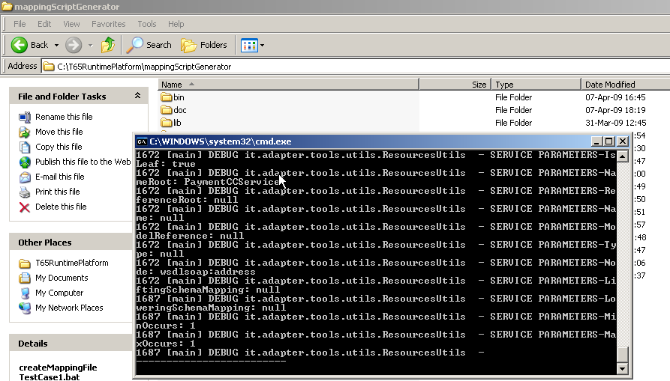
Figure 3 – The console during the execution.

Running the sample test cases on Windows
The zip file named “D6.5.1.zip” contains 4 batch scripts intended for use with Microsoft® Windows(TM) operating system. They can be launched and they execute 4 different test cases:
- “createMappingFile TestCase1.bat” parses PaymentCC.sawsdl (Annex D) and the CCPayment.sawsdl (Annex E) files and it generates the PaymentCC2CCPayment.xml (Annex F) file
- “createMappingFile TestCase2.bat” parses CCPayment.sawsdl and the PaymentCC.sawsdl files and it generates the CCPayment2PaymentCC.xml file
- “createMappingFile TestCase3.bat” parses TheWeather.sawsdl (Annex A) and the Forecast.sawsdl (Annex B) files and it generates the TheWeather2Forecast.xml file (Annex C)
- “createMappingFile TestCase4.bat” parses the Forecast.sawsdl files and the TheWeather.sawsdl and it generates the Forecast2TheWeather.xml file
PaymentCC.sawsdl and CCPayment.sawsdl are 2 sample service descriptions generated by us for demo purposes. TheWeather.sawsdl and Forecast.sawsdl are two real WSDL services annotated by us with semantic annotations.
It is possible to change annotations inside the input SAWSDL files for generating different results or using other SAWSDL files as described in 3.2.
The execution of the TestCase1 complete with the execution of the process that invokes the services is also shown in the screen cast available at the following URL: http://www.soa4all.eu/pdocs/t651_demo.htm. The screen cast shows the sequence of steps depicted in Figure 4.
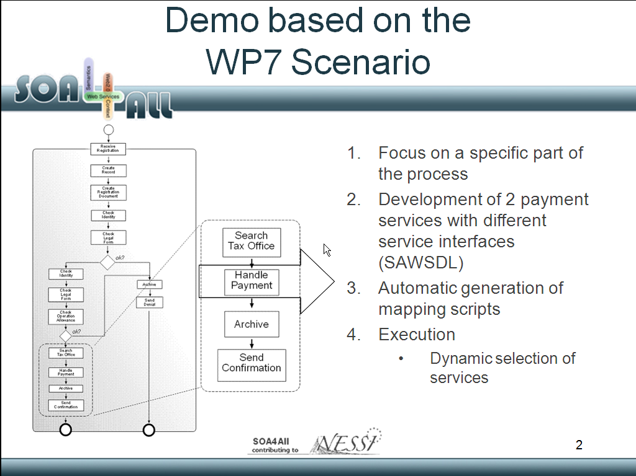
Figure 4 – Demo scenario

References
- M. Colombo, E. Di Nitto, and M. Mauri. Scene: A service composition execution environment supporting dynamic changes disciplined through rules. In ICSOC, pages 191–202, 2006.
- L. Cavallaro, G. Ripa and M. Zuccalà. Adapting Service Requests to Actual Service Interfaces through Semantic Annotations. To appear in Proceedings of PESOS ’09
- http://www.secse-project.eu/?page_id=192
- http://www.w3.org/TR/sawsdl/
- TheWeather Service SAWSDL
<?xml version="1.0" encoding="UTF-8"?>
<wsdl:definitions
xmlns:soap="http://schemas.xmlsoap.org/wsdl/soap/"
xmlns:tm="http://microsoft.com/wsdl/mime/textMatching/"
xmlns:soapenc="http://schemas.xmlsoap.org/soap/encoding/"
xmlns:mime="http://schemas.xmlsoap.org/wsdl/mime/"
xmlns:tns="http://it.crf.TheWeather/"
xmlns:xs="http://www.w3.org/2001/XMLSchema"
xmlns:soap12="http://schemas.xmlsoap.org/wsdl/soap12/"
xmlns:http="http://schemas.xmlsoap.org/wsdl/http/"
targetNamespace="http://it.crf.TheWeather/"
xmlns:wsdl="http://schemas.xmlsoap.org/wsdl/"
xmlns:sawsdl="http://www.w3.org/ns/sawsdl/">
<wsdl:types>
<xs:schema elementFormDefault="qualified" targetNamespace="http://it.crf.TheWeather/">
<xs:element name="getForecast"
sawsdl:modelReference="http://www.soa4all.eu/models/weatherForecasts#weatherForecastRequest">
<xs:complexType>
<xs:sequence>
<xs:element minOccurs="1" maxOccurs="1" name="latitude" type="xs:double"
sawsdl:modelReference="http://www.soa4all.eu/models/GPS#latitude" />
<xs:element minOccurs="1" maxOccurs="1" name="longitude" type="xs:double"
sawsdl:modelReference="http://www.soa4all.eu/models/GPS#longitude" />
<xs:element minOccurs="1" maxOccurs="1" name="hour" type="xs:int"
sawsdl:modelReference="http://www.soa4all.eu/models/time#timeDistance_hours" />
<xs:element minOccurs="1" maxOccurs="1" name="min" type="xs:int"
sawsdl:modelReference="http://www.soa4all.eu/models/time#timeDistance_minutes" />
</xs:sequence>
</xs:complexType>
</xs:element>
<xs:element name="getForecastResponse"
sawsdl:modelReference="http://www.soa4all.eu/models/weatherForecasts#weatherForecastResponse">
<xs:complexType>
<xs:sequence>
<xs:element minOccurs="0" maxOccurs="1" name="getForecastResult" type="tns:Forecast" />
</xs:sequence>
</xs:complexType>
</xs:element>
<xs:complexType name="Forecast"
sawsdl:modelReference="http://www.soa4all.eu/models/weatherForecasts#weatherForecast">
<xs:sequence>
<xs:element minOccurs="0" maxOccurs="1" name="utc" type="xs:string"
sawsdl:modelReference="http://www.soa4all.eu/models/time#UTCTime" />
<xs:element minOccurs="0" maxOccurs="1" name="wx" type="xs:string"
sawsdl:modelReference="http://www.soa4all.eu/models/weatherForecasts#WeatherConditionsIconURL" />
<xs:element minOccurs="1" maxOccurs="1" name="weather" type="tns:Weather"
sawsdl:modelReference="http://www.soa4all.eu/models/weatherForecasts#WeatherConditionsShortDescription" />
<xs:element minOccurs="0" maxOccurs="1" name="mslp" type="xs:string"
sawsdl:modelReference="http://www.soa4all.eu/models/weatherForecasts#Pressure_hPa" />
<xs:element minOccurs="0" maxOccurs="1" name="temp" type="xs:string"
sawsdl:modelReference="http://www.soa4all.eu/models/weatherForecasts#Temperature_Centigrades" />
<xs:element minOccurs="0" maxOccurs="1" name="relh" type="xs:string"
sawsdl:modelReference="http://www.soa4all.eu/models/weatherForecasts#Humidity_Percentage" />
<xs:element minOccurs="0" maxOccurs="1" name="prcp" type="xs:string"
sawsdl:modelReference="http://www.soa4all.eu/models/weatherForecasts#Precipitation_mm" />
<xs:element minOccurs="0" maxOccurs="1" name="wind" type="xs:string"
sawsdl:modelReference="http://www.soa4all.eu/models/weatherForecasts#Wind_Knots"/>
</xs:sequence>
</xs:complexType>
<xs:simpleType name="Weather">
<xs:restriction base="xs:string">
<xs:enumeration value="Unavailable" />
<xs:enumeration value="Clear" />
<xs:enumeration value="Cloudy" />
<xs:enumeration value="Overcast" />
<xs:enumeration value="Rain" />
<xs:enumeration value="Shower" />
<xs:enumeration value="Thunderstorm" />
<xs:enumeration value="Variable_with_rain" />
<xs:enumeration value="Variable_with_showers" />
<xs:enumeration value="Variable_with_thunderstorms" />
<xs:enumeration value="Sleet" />
<xs:enumeration value="Snow" />
<xs:enumeration value="Fog" />
</xs:restriction>
</xs:simpleType>
<xs:element name="getWeatherStation">
<xs:complexType>
<xs:sequence>
<xs:element minOccurs="1" maxOccurs="1" name="latitude" type="xs:double" />
<xs:element minOccurs="1" maxOccurs="1" name="longitude" type="xs:double" />
</xs:sequence>
</xs:complexType>
</xs:element>
<xs:element name="getWeatherStationResponse">
<xs:complexType>
<xs:sequence>
<xs:element minOccurs="0" maxOccurs="1" name="getWeatherStationResult" type="xs:string" />
</xs:sequence>
</xs:complexType>
</xs:element>
</xs:schema>
</wsdl:types>

<wsdl:message name="getForecastSoapIn">
<wsdl:part name="parameters" element="tns:getForecast" />
</wsdl:message>
<wsdl:message name="getForecastSoapOut">
<wsdl:part name="parameters" element="tns:getForecastResponse" />
</wsdl:message>
<wsdl:message name="getWeatherStationSoapIn">
<wsdl:part name="parameters" element="tns:getWeatherStation" />
</wsdl:message>
<wsdl:message name="getWeatherStationSoapOut">
<wsdl:part name="parameters" element="tns:getWeatherStationResponse" />
</wsdl:message>

<wsdl:portType name="TheWeatherCRFSoap">
<wsdl:operation name="getForecast"
sawsdl:modelReference="http://www.soa4all.eu/models/weatherForecasts#WeatherForecastByTimeLocation" >
<wsdl:input message="tns:getForecastSoapIn" />
<wsdl:output message="tns:getForecastSoapOut" />
</wsdl:operation>
<wsdl:operation name="getWeatherStation">
<wsdl:input message="tns:getWeatherStationSoapIn" />
<wsdl:output message="tns:getWeatherStationSoapOut" />
</wsdl:operation>
</wsdl:portType>

<wsdl:binding name="TheWeatherCRFSoap" type="tns:TheWeatherCRFSoap">
<soap:binding transport="http://schemas.xmlsoap.org/soap/http" />
<wsdl:operation name="getForecast" >
<soap:operation soapAction="http://it.crf.TheWeather/getForecast" style="document" />
<wsdl:input>
<soap:body use="literal" />
</wsdl:input>
<wsdl:output>
<soap:body use="literal" />
</wsdl:output>
</wsdl:operation>
<wsdl:operation name="getWeatherStation">
<soap:operation soapAction="http://it.crf.TheWeather/getWeatherStation" style="document" />
<wsdl:input>
<soap:body use="literal" />
</wsdl:input>
<wsdl:output>
<soap:body use="literal" />
</wsdl:output>
</wsdl:operation>
</wsdl:binding>
<wsdl:binding name="TheWeatherCRFSoap12" type="tns:TheWeatherCRFSoap">
<soap12:binding transport="http://schemas.xmlsoap.org/soap/http" />
<wsdl:operation name="getForecast">
<soap12:operation soapAction="http://it.crf.TheWeather/getForecast" style="document" />
<wsdl:input>
<soap12:body use="literal" />
</wsdl:input>
<wsdl:output>
<soap12:body use="literal" />
</wsdl:output>
</wsdl:operation>
<wsdl:operation name="getWeatherStation">
<soap12:operation soapAction="http://it.crf.TheWeather/getWeatherStation" style="document" />
<wsdl:input>
<soap12:body use="literal" />
</wsdl:input>
<wsdl:output>
<soap12:body use="literal" />
</wsdl:output>
</wsdl:operation>
</wsdl:binding>

<wsdl:service name="TheWeatherCRF">
<wsdl:port name="TheWeatherCRFSoap" binding="tns:TheWeatherCRFSoap">
<soap:address location="http://inrete.dyndns.info/TheWeather/TheWeatherCRF.asmx" />
</wsdl:port>
</wsdl:service>
</wsdl:definitions>
- Forecast service SAWSDL
<?xml version="1.0" encoding="UTF-8"?>
<wsdl:definitions xmlns:axis2="http://zulu-53.nebula.fi"
xmlns:http="http://schemas.xmlsoap.org/wsdl/http/"
xmlns:mime="http://schemas.xmlsoap.org/wsdl/mime/"
xmlns:ns0="http://zulu-53.nebula.fi/xsd"
xmlns:ns1="http://org.apache.axis2/xsd"
xmlns:soap="http://schemas.xmlsoap.org/wsdl/soap/"
xmlns:soap12="http://schemas.xmlsoap.org/wsdl/soap12/"
xmlns:wsaw="http://www.w3.org/2006/05/addressing/wsdl"
xmlns:wsdl="http://schemas.xmlsoap.org/wsdl/"
xmlns:xs="http://www.w3.org/2001/XMLSchema"
targetNamespace="http://zulu-53.nebula.fi"
xmlns:sawsdl="http://www.w3.org/ns/sawsdl/">
<wsdl:documentation>ForecastService</wsdl:documentation>
<wsdl:types>
<xs:schema xmlns:ns="http://zulu-53.nebula.fi/xsd" attributeFormDefault="qualified" elementFormDefault="qualified" targetNamespace="http://zulu-53.nebula.fi/xsd">
<xs:element name="Forecast"
sawsdl:modelReference="http://www.soa4all.eu/models/weatherForecasts#WeatherForecastRequest">
<xs:complexType>
<xs:sequence>
<xs:element minOccurs="0" name="latitude" type="xs:double"
sawsdl:modelReference="http://www.soa4all.eu/models/GPS#latitude"/>
<xs:element minOccurs="0" name="longitude" type="xs:double"
sawsdl:modelReference="http://www.soa4all.eu/models/GPS#longitude"/>
<xs:element minOccurs="0" name="hours" type="xs:int"
sawsdl:modelReference="http://www.soa4all.eu/models/time#timeDistance_hours"/>
<xs:element minOccurs="0" name="mins" type="xs:int"
sawsdl:modelReference="http://www.soa4all.eu/models/time#timeDistance_minutes"/>
</xs:sequence>
</xs:complexType>
</xs:element>
<xs:element name="ForecastResponse"
sawsdl:modelReference="http://www.soa4all.eu/models/weatherForecasts#WeatherForecastResponse">
<xs:complexType>
<xs:sequence>
<xs:element minOccurs="0" name="return" nillable="true" type="xs:string"
sawsdl:liftingSchemaMapping="LiftingForecastResponse2WheaterOntology.ml"/>

</xs:sequence>
</xs:complexType>
</xs:element>
</xs:schema>
</wsdl:types>
<wsdl:message name="ForecastRequest">
<wsdl:part element="ns0:Forecast" name="parameters"/>
</wsdl:message>
<wsdl:message name="ForecastResponse">
<wsdl:part element="ns0:ForecastResponse" name="parameters"/>
</wsdl:message>
<wsdl:portType name="ForecastServicePortType">
<wsdl:operation name="Forecast"
sawsdl:modelReference="http://www.soa4all.eu/models/weatherForecasts#WeatherForecastByTimeLocation">
<wsdl:input message="axis2:ForecastRequest" wsaw:Action="urn:Forecast"/>
<wsdl:output message="axis2:ForecastResponse" wsaw:Action="urn:ForecastResponse"/>
</wsdl:operation>
</wsdl:portType>

<wsdl:binding name="ForecastServiceSOAP11Binding" type="axis2:ForecastServicePortType">
<soap:binding style="document" transport="http://schemas.xmlsoap.org/soap/http"/>
<wsdl:operation name="Forecast">
<soap:operation soapAction="urn:Forecast" style="document"/>
<wsdl:input>
<soap:body use="literal"/>
</wsdl:input>
<wsdl:output>
<soap:body use="literal"/>
</wsdl:output>
</wsdl:operation>
</wsdl:binding>
<wsdl:binding name="ForecastServiceSOAP12Binding" type="axis2:ForecastServicePortType">
<soap12:binding style="document" transport="http://schemas.xmlsoap.org/soap/http"/>
<wsdl:operation name="Forecast">
<soap12:operation soapAction="urn:Forecast" style="document"/>
<wsdl:input>
<soap12:body use="literal"/>
</wsdl:input>
<wsdl:output>
<soap12:body use="literal"/>
</wsdl:output>
</wsdl:operation>
</wsdl:binding>
<wsdl:binding name="ForecastServiceHttpBinding" type="axis2:ForecastServicePortType">
<http:binding verb="POST"/>
<wsdl:operation name="Forecast">
<http:operation location="ForecastService/Forecast"/>
<wsdl:input>
<mime:content part="Forecast" type="text/xml"/>
</wsdl:input>
<wsdl:output>
<mime:content part="Forecast" type="text/xml"/>
</wsdl:output>
</wsdl:operation>
</wsdl:binding>
<wsdl:service name="ForecastService">
<wsdl:port binding="axis2:ForecastServiceSOAP11Binding" name="ForecastServiceSOAP11port_http">
<soap:address location="http://zulu-53.nebula.fi/ws/services/ForecastService"/>
</wsdl:port>
</wsdl:service>
</wsdl:definitions>
- TheWeather2Forecast.xml
<?xml version="1.0" encoding="UTF-8"?>
<map:Mapping xmlns:map="http://www.soa4all.eu/MappingLanguageSchema">
<map:RequestorNameSpace>http://it.crf.TheWeather/</map:RequestorNameSpace>
<map:ServiceNameSpace>http://zulu-53.nebula.fi</map:ServiceNameSpace>
<map:StartEndpoint>http://inrete.dyndns.info/TheWeather/TheWeatherCRF.asmx</map:StartEndpoint>
<map:FinalEndpoint>http://zulu-53.nebula.fi/ws/services/ForecastService</map:FinalEndpoint>
<map:InterfaceRule ID="getForecast2Forecast">
<map:OperationRename>
<map:Input>
<map:Name>getForecast</map:Name>
<map:Side>ExpectedService</map:Side>
</map:Input>
<map:Mapping>
<map:Name>Forecast</map:Name>
<map:Side>AvailableService</map:Side>
</map:Mapping>
</map:OperationRename>
<map:MappingFunction>
<map:Name>RenameOperation</map:Name>
<map:Location>http://zulu-53.nebula.fi/ws/services/ForecastService</map:Location>
</map:MappingFunction>
</map:InterfaceRule>
<map:InterfaceRule ID="getForecast2Forecast_0">
<map:ReferenceRuleID>getForecast2Forecast</map:ReferenceRuleID>
<map:DataTypeRename total="false">
<map:Input>
<map:Name>getForecast</map:Name>
<map:Side>ExpectedService</map:Side>
<map:type>getForecast</map:type>
</map:Input>
<map:Mapping>
<map:Name>Forecast</map:Name>
<map:Side>AvailableService</map:Side>
<map:type>Forecast</map:type>
</map:Mapping>
<map:Input>
<map:Name>getForecast.latitude</map:Name>
<map:Side>ExpectedService</map:Side>
<map:type>double</map:type>
</map:Input>
<map:Mapping>
<map:Name>Forecast.latitude</map:Name>
<map:Side>AvailableService</map:Side>
<map:type>double</map:type>
</map:Mapping>
<map:Input>
<map:Name>getForecast.longitude</map:Name>
<map:Side>ExpectedService</map:Side>
<map:type>double</map:type>
</map:Input>
<map:Mapping>
<map:Name>Forecast.longitude</map:Name>
<map:Side>AvailableService</map:Side>
<map:type>double</map:type>
</map:Mapping>
<map:Input>
<map:Name>getForecast.hour</map:Name>
<map:Side>ExpectedService</map:Side>
<map:type>int</map:type>
</map:Input>
<map:Mapping>
<map:Name>Forecast.hours</map:Name>
<map:Side>AvailableService</map:Side>
<map:type>int</map:type>
</map:Mapping>
<map:Input>
<map:Name>getForecast.min</map:Name>
<map:Side>ExpectedService</map:Side>
<map:type>int</map:type>
</map:Input>
<map:Mapping>
<map:Name>Forecast.mins</map:Name>
<map:Side>AvailableService</map:Side>
<map:type>int</map:type>
</map:Mapping>
</map:DataTypeRename>
<map:MappingFunction>
<map:Name>RenameDataType</map:Name>
<map:Location>http://zulu-53.nebula.fi/ws/services/ForecastService</map:Location>
</map:MappingFunction>
<map:ReturnMappingRuleID>getForecast2ForecastResponseMessageType</map:ReturnMappingRuleID>
</map:InterfaceRule>
<map:InterfaceRule ID="getForecast2ForecastResponseMessageType">
<map:UnformattedStringSplit total="false">
<map:Input>
<map:Name>ForecastResponse</map:Name>
<map:Side>AvailableService</map:Side>
<map:type>ForecastResponse</map:type>
</map:Input>
<map:Mapping>
<map:Name>getForecastResponse</map:Name>
<map:Side>ExpectedService</map:Side>
<map:type>getForecastResponse</map:type>
</map:Mapping>
<map:Input>
<map:Name>return</map:Name>
<map:Side>AvailableService</map:Side>
<map:type>string</map:type>
<map:StringSplitter>,</map:StringSplitter>
</map:Input>
<map:Mapping>
<map:Name>getForecastResult.temp</map:Name>
<map:Side>ExpectedService</map:Side>
<map:type>Forecast.string</map:type>
</map:Mapping>
<map:Mapping>
<map:Name>getForecastResult.weather</map:Name>
<map:Side>ExpectedService</map:Side>
<map:type>Forecast.Weather</map:type>
</map:Mapping>
</map:UnformattedStringSplit>
<map:MappingFunction>
<map:Name>RenameDataType</map:Name>
<map:Location>http://inrete.dyndns.info/TheWeather/TheWeatherCRF.asmx</map:Location>
</map:MappingFunction>
</map:InterfaceRule>
</map:Mapping>
- PaymentCC SAWSDL
<?xml version="1.0" encoding="windows-1252" ?>
<wsdl:definitions targetNamespace="http://payment.crf.it" xmlns:apachesoap="http://xml.apache.org/xml-soap" xmlns:impl="http://payment.crf.it" xmlns:intf="http://payment.crf.it" xmlns:wsdl="http://schemas.xmlsoap.org/wsdl/" xmlns:wsdlsoap="http://schemas.xmlsoap.org/wsdl/soap/" xmlns:xs="http://www.w3.org/2001/XMLSchema" xmlns:sawsdl="http://www.w3.org/ns/sawsdl/">
<wsdl:types>
<xs:schema elementFormDefault="qualified" targetNamespace="http://payment.crf.it" xmlns="http://www.w3.org/2001/XMLSchema">
<xs:element sawsdl:modelReference="http://www.soa4all.eu/models/CreditCard/CheckRequest" name="checkCreditCard">
<xs:complexType>
<xs:sequence>
<xs:element sawsdl:modelReference="http://www.soa4all.eu/models/CreditCard/CreditCardNumber" name="userID" type="xs:string"/>
</xs:sequence>
</xs:complexType>
</xs:element>
<xs:element sawsdl:modelReference="http://www.soa4all.eu/models/CreditCard/CheckResponse" name="checkCreditCardResponse">
<xs:complexType>
<xs:sequence>
<xs:element sawsdl:modelReference="http://www.soa4all.eu/models/CreditCard/CreditCardCheckResult" name="checkUserCreditCardReturn" type="xs:boolean"/>
</xs:sequence>
</xs:complexType>
</xs:element>
<xs:element sawsdl:modelReference="http://www.soa4all.eu/models/CreditCard/PaymentRequest" name="paymentCC">
<xs:complexType>
<xs:sequence>
<xs:element name="id" sawsdl:modelReference="http://www.soa4all.eu/models/CreditCard/CreditCardNumber" type="xs:string"/>
<xs:element name="PRICE" sawsdl:modelReference="http://www.soa4all.eu/models/CreditCard/PaymentAmount" type="xs:double"/>
<xs:element name="PRICE_um" sawsdl:modelReference="http://www.soa4all.eu/models/CreditCard/PaymentAmountUM" type="xs:string"/>
<xs:element name="dest" sawsdl:modelReference="http://www.soa4all.eu/models/CreditCard/PaymentBeneficiary" type="xs:string"/>
</xs:sequence>
</xs:complexType>
</xs:element>
<xs:element sawsdl:modelReference="http://www.soa4all.eu/models/CreditCard/PaymentResponse" name="paymentCCResponse">
<xs:complexType>
<xs:sequence>
<xs:element name="paymentCCReturn" sawsdl:modelReference="http://www.soa4all.eu/models/CreditCard/PaymentResult" type="xs:boolean"/>
</xs:sequence>
</xs:complexType>
</xs:element>

</xs:schema>
</wsdl:types>

<wsdl:message name="ccPaymentRequest">
<wsdl:part element="impl:ccPayment" name="parameters"/>
</wsdl:message>
<wsdl:message name="paymentCCRequest">
<wsdl:part element="impl:paymentCC" name="parameters"/>
</wsdl:message>
<wsdl:message name="ccPaymentResponse">
<wsdl:part element="impl:ccPaymentResponse" name="parameters"/>
</wsdl:message>
<wsdl:message name="paymentCCResponse">
<wsdl:part element="impl:paymentCCResponse" name="parameters"/>
</wsdl:message>
<wsdl:message name="checkCreditCardResponse">
<wsdl:part element="impl:checkCreditCardResponse" name="parameters"/>
</wsdl:message>
<wsdl:message name="setupConfResponse">
<wsdl:part element="impl:setupConfResponse" name="parameters"/>
</wsdl:message>
<wsdl:message name="checkCreditCardRequest">
<wsdl:part element="impl:checkCreditCard" name="parameters"/>
</wsdl:message>
<wsdl:message name="setupConfRequest">
<wsdl:part element="impl:setupConf" name="parameters"/>
</wsdl:message>

<wsdl:portType name="PaymentCC">
<wsdl:operation sawsdl:modelReference="http://www.soa4all.eu/models/CrediCard/PaymentOperation" name="paymentCC">
<wsdl:input message="impl:paymentCCRequest" name="paymentCCRequest"/>
<wsdl:output message="impl:paymentCCResponse" name="paymentCCResponse"/>
</wsdl:operation>
<wsdl:operation sawsdl:modelReference="http://www.soa4all.eu/models/CrediCard/CheckOperation" name="checkCreditCard">
<wsdl:input message="impl:checkCreditCardRequest" name="checkCreditCardRequest"/>
<wsdl:output message="impl:checkCreditCardResponse" name="checkCreditCardResponse"/>
</wsdl:operation>
</wsdl:portType>
<wsdl:binding name="PaymentCCSoapBinding" type="impl:PaymentCC">
<wsdlsoap:binding style="document" transport="http://schemas.xmlsoap.org/soap/http"/>
<wsdl:operation name="setupConf">
<wsdlsoap:operation soapAction=""/>
<wsdl:input name="setupConfRequest">
<wsdlsoap:body use="literal"/>
</wsdl:input>
<wsdl:output name="setupConfResponse">
<wsdlsoap:body use="literal"/>
</wsdl:output>
</wsdl:operation>
<wsdl:operation name="paymentCC">
<wsdlsoap:operation soapAction=""/>
<wsdl:input name="paymentCCRequest">
<wsdlsoap:body use="literal"/>
</wsdl:input>
<wsdl:output name="paymentCCResponse">
<wsdlsoap:body use="literal"/>
</wsdl:output>
</wsdl:operation>
<wsdl:operation name="checkCreditCard">
<wsdlsoap:operation soapAction=""/>
<wsdl:input name="checkCreditCardRequest">
<wsdlsoap:body use="literal"/>
</wsdl:input>
<wsdl:output name="checkCreditCardResponse">
<wsdlsoap:body use="literal"/>
</wsdl:output>
</wsdl:operation>
<wsdl:operation name="ccPayment">
<wsdlsoap:operation soapAction=""/>
<wsdl:input name="ccPaymentRequest">
<wsdlsoap:body use="literal"/>
</wsdl:input>
<wsdl:output name="ccPaymentResponse">
<wsdlsoap:body use="literal"/>
</wsdl:output>
</wsdl:operation>
</wsdl:binding>
<wsdl:service name="PaymentCCService">
<wsdl:port binding="impl:PaymentCCSoapBinding" name="PaymentCC">
<wsdlsoap:address location="http://localhost:8084/axis/services/PaymentCC"/>
</wsdl:port>
</wsdl:service>
</wsdl:definitions>
- CCpayment SAWSDL
<?xml version="1.0" encoding="windows-1252" ?>
<wsdl:definitions targetNamespace="http://payment.crf.it" xmlns:apachesoap="http://xml.apache.org/xml-soap" xmlns:impl="http://payment.crf.it" xmlns:intf="http://payment.crf.it" xmlns:wsdl="http://schemas.xmlsoap.org/wsdl/" xmlns:wsdlsoap="http://schemas.xmlsoap.org/wsdl/soap/" xmlns:xs="http://www.w3.org/2001/XMLSchema" xmlns:sawsdl="http://www.w3.org/ns/sawsdl/">
<wsdl:types>

<xs:schema elementFormDefault="qualified" targetNamespace="http://payment.crf.it" xmlns="http://www.w3.org/2001/XMLSchema">
<xs:element sawsdl:modelReference="http://www.soa4all.eu/models/CreditCard/CheckRequest" name="checkCreditCardRegistered">
<xs:complexType>
<xs:sequence>
<xs:element sawsdl:modelReference="http://www.soa4all.eu/models/CreditCard/CreditCardNumber" name="userID" type="xs:string"/>
</xs:sequence>
</xs:complexType>
</xs:element>
<xs:element sawsdl:modelReference="http://www.soa4all.eu/models/CreditCard/CheckResponse" name="checkCreditCardRegisteredResponse">
<xs:complexType>
<xs:sequence>
<xs:element sawsdl:modelReference="http://www.soa4all.eu/models/CreditCard/CreditCardCheckResult" name="checkCreditCardRegisteredReturn" type="xs:boolean"/>
</xs:sequence>
</xs:complexType>
</xs:element>
<xs:element sawsdl:modelReference="http://www.soa4all.eu/models/CreditCard/PaymentRequest" name="payByCreditCard">
<xs:complexType>
<xs:sequence>
<xs:element name="id" sawsdl:modelReference="http://www.soa4all.eu/models/CreditCard/CreditCardNumber" type="xs:string"/>
<xs:element name="PRICE" sawsdl:modelReference="http://www.soa4all.eu/models/CreditCard/PaymentAmount" type="xs:double"/>
<xs:element name="PRICE_um" sawsdl:modelReference="http://www.soa4all.eu/models/CreditCard/PaymentAmountUM" type="xs:string"/>
<xs:element name="dest" sawsdl:modelReference="http://www.soa4all.eu/models/CreditCard/PaymentBeneficiary" type="xs:string"/>
</xs:sequence>
</xs:complexType>
</xs:element>
<xs:element sawsdl:modelReference="http://www.soa4all.eu/models/CreditCard/PaymentResponse" name="payByCreditCardResponse">
<xs:complexType>
<xs:sequence>
<xs:element name="payByCreditCardReturn" sawsdl:modelReference="http://www.soa4all.eu/models/CreditCard/PaymentResult" type="xs:boolean"/>
</xs:sequence>
</xs:complexType>
</xs:element>

<xs:element name="setupConf">
<xs:complexType>
<xs:sequence>
<xs:element name="percentExceptionsR" type="xs:int"/>
<xs:element name="executionTimeR" type="xs:long"/>
<xs:element name="numberOfResultsR" type="xs:int"/>
</xs:sequence>
</xs:complexType>
</xs:element>
<xs:element name="setupConfResponse">
<xs:complexType/>
</xs:element>
</xs:schema>

</wsdl:types>
<wsdl:message name="setupConfRequest">
<wsdl:part element="impl:setupConf" name="parameters"/>
</wsdl:message>
<wsdl:message name="payByCCRequest">
<wsdl:part element="impl:payByCC" name="parameters"/>
</wsdl:message>
<wsdl:message name="checkCreditCardRegisteredRequest">
<wsdl:part element="impl:checkCreditCardRegistered" name="parameters"/>
</wsdl:message>
<wsdl:message name="setupConfResponse">
<wsdl:part element="impl:setupConfResponse" name="parameters"/>
</wsdl:message>
<wsdl:message name="payByCCResponse">
<wsdl:part element="impl:payByCCResponse" name="parameters"/>
</wsdl:message>
<wsdl:message name="checkCreditCardRegisteredResponse">
<wsdl:part element="impl:checkCreditCardRegisteredResponse" name="parameters"/>
</wsdl:message>
<wsdl:message name="payByCreditCardResponse">
<wsdl:part element="impl:payByCreditCardResponse" name="parameters"/>
</wsdl:message>
<wsdl:message name="payByCreditCardRequest">
<wsdl:part element="impl:payByCreditCard" name="parameters"/>
</wsdl:message>

<wsdl:portType name="CCpayment">
<wsdl:operation sawsdl:modelReference="http://www.soa4all.eu/models/CrediCard/PaymentOperation" name="payByCreditCard">
<wsdl:input message="impl:payByCreditCardRequest" name="payByCreditCardRequest"/>
<wsdl:output message="impl:payByCreditCardResponse" name="payByCreditCardResponse"/>
</wsdl:operation>
<wsdl:operation sawsdl:modelReference="http://www.soa4all.eu/models/CrediCard/CheckOperation" name="checkCreditCardRegistered">
<wsdl:input message="impl:checkCreditCardRegisteredRequest" name="checkCreditCardRegisteredRequest"/>
<wsdl:output message="impl:checkCreditCardRegisteredResponse" name="checkCreditCardRegisteredResponse"/>
</wsdl:operation>
</wsdl:portType>

<wsdl:binding name="CCpaymentSoapBinding" type="impl:CCpayment">
<wsdlsoap:binding style="document" transport="http://schemas.xmlsoap.org/soap/http"/>
<wsdl:operation name="payByCC">
<wsdlsoap:operation soapAction=""/>
<wsdl:input name="payByCCRequest">
<wsdlsoap:body use="literal"/>
</wsdl:input>
<wsdl:output name="payByCCResponse">
<wsdlsoap:body use="literal"/>
</wsdl:output>
</wsdl:operation>
<wsdl:operation name="payByCreditCard">
<wsdlsoap:operation soapAction=""/>
<wsdl:input name="payByCreditCardRequest">
<wsdlsoap:body use="literal"/>
</wsdl:input>
<wsdl:output name="payByCreditCardResponse">
<wsdlsoap:body use="literal"/>
</wsdl:output>
</wsdl:operation>
<wsdl:operation name="checkCreditCardRegistered">
<wsdlsoap:operation soapAction=""/>
<wsdl:input name="checkCreditCardRegisteredRequest">
<wsdlsoap:body use="literal"/>
</wsdl:input>
<wsdl:output name="checkCreditCardRegisteredResponse">
<wsdlsoap:body use="literal"/>
</wsdl:output>
</wsdl:operation>
<wsdl:operation name="setupConf">
<wsdlsoap:operation soapAction=""/>
<wsdl:input name="setupConfRequest">
<wsdlsoap:body use="literal"/>
</wsdl:input>
<wsdl:output name="setupConfResponse">
<wsdlsoap:body use="literal"/>
</wsdl:output>
</wsdl:operation>
</wsdl:binding>
<wsdl:service name="CCpaymentService">
<wsdl:port binding="impl:CCpaymentSoapBinding" name="CCpayment">
<wsdlsoap:address location="http://localhost:8084/axis/services/CCpayment"/>
</wsdl:port>
</wsdl:service>
</wsdl:definitions>
- PaymentCC2CCpayment.SAWSDL
<?xml version="1.0" encoding="UTF-8"?>
<map:Mapping xmlns:map="http://www.soa4all.eu/MappingLanguageSchema">
<map:RequestorNameSpace>http://payment.crf.it</map:RequestorNameSpace>
<map:ServiceNameSpace>http://payment.crf.it</map:ServiceNameSpace>
<map:StartEndpoint>http://localhost:8084/axis/services/PaymentCC</map:StartEndpoint>
<map:FinalEndpoint>http://localhost:8084/axis/services/CCpayment</map:FinalEndpoint>
<map:InterfaceRule ID="paymentCC2payByCreditCard">
<map:OperationRename>
<map:Input>
<map:Name>paymentCC</map:Name>
<map:Side>ExpectedService</map:Side>
</map:Input>
<map:Mapping>
<map:Name>payByCreditCard</map:Name>
<map:Side>AvailableService</map:Side>
</map:Mapping>
</map:OperationRename>
<map:MappingFunction>
<map:Name>RenameOperation</map:Name>
<map:Location>http://localhost:8084/axis/services/CCpayment</map:Location>
</map:MappingFunction>
</map:InterfaceRule>
<map:InterfaceRule ID="paymentCC2payByCreditCard_0">
<map:ReferenceRuleID>paymentCC2payByCreditCard</map:ReferenceRuleID>
<map:DataTypeRename total="false">
<map:Input>
<map:Name>paymentCC</map:Name>
<map:Side>ExpectedService</map:Side>
<map:type>paymentCC</map:type>
</map:Input>
<map:Mapping>
<map:Name>payByCreditCard</map:Name>
<map:Side>AvailableService</map:Side>
<map:type>payByCreditCard</map:type>
</map:Mapping>
<map:Input>
<map:Name>paymentCC.id</map:Name>
<map:Side>ExpectedService</map:Side>
<map:type>string</map:type>
</map:Input>
<map:Mapping>
<map:Name>payByCreditCard.id</map:Name>
<map:Side>AvailableService</map:Side>
<map:type>string</map:type>
</map:Mapping>
<map:Input>
<map:Name>paymentCC.PRICE</map:Name>
<map:Side>ExpectedService</map:Side>
<map:type>double</map:type>
</map:Input>
<map:Mapping>
<map:Name>payByCreditCard.PRICE</map:Name>
<map:Side>AvailableService</map:Side>
<map:type>double</map:type>
</map:Mapping>
<map:Input>
<map:Name>paymentCC.PRICE_um</map:Name>
<map:Side>ExpectedService</map:Side>
<map:type>string</map:type>
</map:Input>
<map:Mapping>
<map:Name>payByCreditCard.PRICE_um</map:Name>
<map:Side>AvailableService</map:Side>
<map:type>string</map:type>
</map:Mapping>
<map:Input>
<map:Name>paymentCC.dest</map:Name>
<map:Side>ExpectedService</map:Side>
<map:type>string</map:type>
</map:Input>
<map:Mapping>
<map:Name>payByCreditCard.dest</map:Name>
<map:Side>AvailableService</map:Side>
<map:type>string</map:type>
</map:Mapping>
</map:DataTypeRename>
<map:MappingFunction>
<map:Name>RenameDataType</map:Name>
<map:Location>http://localhost:8084/axis/services/CCpayment</map:Location>
</map:MappingFunction>
<map:ReturnMappingRuleID>paymentCC2payByCreditCardResponseMessageType</map:ReturnMappingRuleID>
</map:InterfaceRule>
<map:InterfaceRule ID="paymentCC2payByCreditCardResponseMessageType">
<map:ReferenceRuleID>paymentCC2payByCreditCard</map:ReferenceRuleID>
<map:DataTypeRename total="false">
<map:Input>
<map:Name>payByCreditCard</map:Name>
<map:Side>ExpectedService</map:Side>
<map:type>payByCreditCardResponse</map:type>
</map:Input>
<map:Mapping>
<map:Name>paymentCC</map:Name>
<map:Side>AvailableService</map:Side>
<map:type>paymentCCResponse</map:type>
</map:Mapping>
<map:Input>
<map:Name>payByCreditCard.payByCreditCardReturn</map:Name>
<map:Side>ExpectedService</map:Side>
<map:type>boolean</map:type>
</map:Input>
<map:Mapping>
<map:Name>paymentCC.paymentCCReturn</map:Name>
<map:Side>AvailableService</map:Side>
<map:type>boolean</map:type>
</map:Mapping>
</map:DataTypeRename>
<map:MappingFunction>
<map:Name>RenameDataType</map:Name>
<map:Location>http://localhost:8084/axis/services/CCpayment</map:Location>
</map:MappingFunction>
</map:InterfaceRule>
<map:InterfaceRule ID="checkCreditCard2checkCreditCardRegistered">
<map:OperationRename>
<map:Input>
<map:Name>checkCreditCard</map:Name>
<map:Side>ExpectedService</map:Side>
</map:Input>
<map:Mapping>
<map:Name>checkCreditCardRegistered</map:Name>
<map:Side>AvailableService</map:Side>
</map:Mapping>
</map:OperationRename>
<map:MappingFunction>
<map:Name>RenameOperation</map:Name>
<map:Location>http://localhost:8084/axis/services/CCpayment</map:Location>
</map:MappingFunction>
</map:InterfaceRule>
<map:InterfaceRule ID="checkCreditCard2checkCreditCardRegistered_1">
<map:ReferenceRuleID>checkCreditCard2checkCreditCardRegistered</map:ReferenceRuleID>
<map:DataTypeRename total="false">
<map:Input>
<map:Name>checkCreditCard</map:Name>
<map:Side>ExpectedService</map:Side>
<map:type>checkCreditCard</map:type>
</map:Input>
<map:Mapping>
<map:Name>checkCreditCardRegistered</map:Name>
<map:Side>AvailableService</map:Side>
<map:type>checkCreditCardRegistered</map:type>
</map:Mapping>
<map:Input>
<map:Name>checkCreditCard.paymentCCReturn</map:Name>
<map:Side>ExpectedService</map:Side>
<map:type>boolean</map:type>
</map:Input>
<map:Mapping>
<map:Name>checkCreditCardRegistered.payByCreditCardReturn</map:Name>
<map:Side>AvailableService</map:Side>
<map:type>boolean</map:type>
</map:Mapping>
<map:Input>
<map:Name>checkCreditCard.userID</map:Name>
<map:Side>ExpectedService</map:Side>
<map:type>string</map:type>
</map:Input>
<map:Mapping>
<map:Name>checkCreditCardRegistered.userID</map:Name>
<map:Side>AvailableService</map:Side>
<map:type>string</map:type>
</map:Mapping>
</map:DataTypeRename>
<map:MappingFunction>
<map:Name>RenameDataType</map:Name>
<map:Location>http://localhost:8084/axis/services/CCpayment</map:Location>
</map:MappingFunction>
<map:ReturnMappingRuleID>checkCreditCard2checkCreditCardRegisteredResponseMessageType</map:ReturnMappingRuleID>
</map:InterfaceRule>
<map:InterfaceRule ID="checkCreditCard2checkCreditCardRegisteredResponseMessageType">
<map:ReferenceRuleID>checkCreditCard2checkCreditCardRegistered</map:ReferenceRuleID>
<map:DataTypeRename total="false">
<map:Input>
<map:Name>checkCreditCardRegistered</map:Name>
<map:Side>ExpectedService</map:Side>
<map:type>checkCreditCardRegisteredResponse</map:type>
</map:Input>
<map:Mapping>
<map:Name>checkCreditCard</map:Name>
<map:Side>AvailableService</map:Side>
<map:type>checkCreditCardResponse</map:type>
</map:Mapping>
<map:Input>
<map:Name>checkCreditCardRegistered.checkCreditCardRegisteredReturn</map:Name>
<map:Side>ExpectedService</map:Side>
<map:type>boolean</map:type>
</map:Input>
<map:Mapping>
<map:Name>checkCreditCard.checkUserCreditCardReturn</map:Name>
<map:Side>AvailableService</map:Side>
<map:type>boolean</map:type>
</map:Mapping>
</map:DataTypeRename>
<map:MappingFunction>
<map:Name>RenameDataType</map:Name>
<map:Location>http://localhost:8084/axis/services/CCpayment</map:Location>
</map:MappingFunction>
</map:InterfaceRule>
</map:Mapping>

SOA4All deliverable D6.5.1 due at month 12

