

VOIce-based Community-cEntric mobile Services for social development

Grant Agreement Number 269954

Deliverable No D7.3

Report on local Social Networking and Community Building activities

March 2013

PROJECT DELIVERABLE REPORT

Project
Grant Agreement number | 2699542
Project acronym: | VOICES
Project title: | VOIce-based Community-cEntric mobile Services for social development
Funding Scheme: | Collaborative Project
Date of latest version of Annex I against which the assessment will be made: | 18 February 2011
Document
Deliverable number: | D7.3
Deliverable title | Report on local Social Networking and Community Building activities
Contractual Date of Delivery: | 31 March 2013
Actual Date of Delivery: | 28 March 2013
Editor (s): | Anna Bon
Author (s): | Anna Bon, Hans Akkermans, Victor de Boer, Chris van Aart, Wendelien Tuyp, Stefan Schlobach, Nana Baah Gyan, Mary Allen, Moustafa Zouinar (Photography by Bruno van Moerkerken)
Reviewer (s): | Carole Salis and Pieter Verhagen
Work package no.: | WP7
Work package title: | Dissemination, exploitation & community building
Work package leader: | VUA
Work package participants: | Web Foundation, FT, TNO, W3C, CSIR
Distribution: | PU
Version/Revision: | 1.0
Draft/Final: | Draft
Total number of pages (including cover): | 27
Keywords: | Community building, social networks, Africa

Change Log

Reason for change | Issue | Revision | Date
Creation of document; Chapters 1 and 3, 4 and 5 | 0.1 | Anna Bon | 25-2-2013
Section about m-health pilot | 0.2 | Moustafa Zouinar  (FT) | 11-3-2013
Section about activities Sahel Eco and WF | 0.3 | Mary Allen  (SE) | 11-3-2013
Review | 0.4 | Wendelien Tuyp  Nana B. Gyan | 18-3-2013
Review | 0.5 | Carole Salis (CRS4)  Pieter Verhagen  (TNO) | 26-3-2013
Final version | 1.0 | Anna Bon | 28-3-2013
Disclaimer
This document contains description of the VOICES project work and findings.
The authors of this document have taken any and all available measures in order for its content to be accurate, consistent and lawful. However, neither the project consortium as a whole nor the individual partners that implicitly or explicitly participated in the creation and publication of this document hold any responsibility for actions that might occur as a result of using its content.
This publication has been produced with the assistance of the European Union. The content of this publication is the sole responsibility of the VOICES consortium and can in no way be taken to reflect the views of the European Union.
The European Union is established in accordance with the Treaty on European Union (Maastricht). There are currently 27 Member States of the Union. It is based on the European Communities and the member states cooperation in the fields of Common Foreign and Security Policy and Justice and Home Affairs. The five main institutions of the European Union are the European Parliament, the Council of Ministers, the European Commission, the Court of Justice and the Court of Auditors. (http://europa.eu.int/) | 
VOICES is a project funded in part by the European Union.

Table of Contents

Contents

Change Log 4
Disclaimer 5
Table of Contents 6
List of Acronyms 7
Executive Summary 8
1. VOICES Community Building Strategy 9
1.1 Strategic goals 9
2. Partner roles and target groups 11
3. Community building related to the m-health pilot 13
3.1 Community building in Senegal related to m-health 13
3.2 Presentation of applications to end-users in Senegal related to m-health 13
3.3 Field trip in rural regions in Senegal related to m-health 14
3.4 Field trip in rural regions in Senegal related to m-health 15
4. Community building activities for m-agro pilot 16
1.1 Community building Road Show – Mali, Burkina Faso, Northern Ghana 16
1.2 Community building with local stakeholders in Mali – November 2011 18
1.3 Foroba Blon: A project funded by the International Press Institute in support of Citizen Journalism and Community Radio in Mali 19
1.4 Community building with local stakeholders in Mali – February 2012 20
1.5 Community building with local stakeholders in Mali – November 2012 21
5.6 Proposal: Regional Initiative for Food and Water regarding Knowledge-Sharing and (Two-way) Communication Facilities 22
5.7 Community building: Master’s course ICT4D @ VUA 23
5.8 Other community building activities related to global communities 24
5.9 MPOWER – A new proposal for further deployment of VOICES results 26
5.10 Development of Project Proposal and Submission to Comic Relief 27
Conclusion 28

List of Acronyms

ESMT École Supérieure Multinationale des Télécommunications
FMX Fondation Mérieux
ICT4D Information and communication technologies for development
NGO Non-Governmental Organization
RNL Réseau National des Laboratoires
SE Sahel Eco
SME Small - medium enterprise
VUA VU University Amsterdam
WF Web Foundation
WP7 Work Package 7

Executive Summary

This report presents the activities of the VOICES consortium aimed at encouraging social networking, amongst local stakeholders, and establishing communities of practice that will help adopt, use and sustain the results of VOICES beyond the lifetime of the project. These activities will enhance uptake and prove the fitness of the project results and the adaptability to the local African context.

The social networking and community building activities of the VOICES consortium are focused on two local target groups (i) end-users and other local stakeholders who benefit from adoption and use of the project results; (ii) partners who want to collaborate and help further the results of the project, to make them sustainable beyond its lifetime.

The activities of the consortium partners towards the first target group (i) were not limited to the target countries Mali, where the m-agro pilot of Work Package 5 was rolled out, or to Senegal, where the m-health pilot of Work Package 4 was implemented, but were extended to other developing regions in Sub-Sahara Africa, including Burkina Faso, Ghana and South Africa.

In this deliverable (D7.3) we present all community building efforts undertaken by the VOICES consortium partners, since the start of the VOICES project in January 2011.The activities in VOICES aimed at dissemination of results to e.g. industry, the global academic community, or the general public, are not part of this report. These activities have already been reported in detail in the Dissemination and Use Plan (D7.2) and they will be reported in the Technology Implementation Plan (D 7.4), which is due at the end of the VOICES project (M30).

The report is structured as follows: in Chapter 1 we describe the VOICES strategy for social networking and community building, and how this fits in the overall VOICES objectives. We describe the strategic goals, the target groups and the expected outcomes. In Chapter 2 the community building activities related to the m-health pilot in Senegal (WP4) are presented. In Chapter 3 the partner role and the target groups are described for the m-agro knowledge sharing pilot in Mali (WP5). In Chapter 4 the activities are described in detail. In Chapter 5 we summarize the results and give our conclusions up to present (M27).

VOICES Community Building Strategy
  - Strategic goals
Community building and local social networking are an integral part of the VOICES objectives. The strategic goals of the activities marked as Community Building and Social Networking are twofold:
- To support the establishment of local communities that will adopt, use and sustain the results beyond the lifetime of the project.
- To enhance uptake and ensure sustainability of its results and its adaptability to the African context through social networking and the establishment of communities of practice.

These are in line with the overall objectives of the VOICES project, as outlined below:

VOICES general Objectives:
Open and Wider Access: VOICES will improve voice-based access to content and mobile ICT services by building a toolbox for the development of voice services that will be made available to local communities and entrepreneurs as Open Source.

Integration of Local Community Radios and ICT: Among its features and functionalities, the toolbox will enable the bridge with local community radios, by offering a Web archiving option and off-line individual voice access, thereby making broadcast audio content widely available to people, independently of radio programming schedules.

Better Support of Languages: It will deliver tool support and methodology for under-researched and under-resourced languages that facilitates the local creation of content in African languages.

Long-term Sustainability: To ensure the local adoption and exploitation of the VOICES tools and methods beyond the project, it will provide a sustainable architecture and business model for its results that is co-developed with local partners and communities.

Faster Uptake: VOICES will furthermore enhance uptake through community-building activities, including delivery and roll-out of a mobile training lab that offers education for local partners and entrepreneurs in developing mobile ICT and Web services.

VOICES will prove the fitness of its results and its adaptability to the African context by extensive local pilots and associated community building: focused on health services in Senegal, and on agricultural and reforestation knowledge sharing in the Sahel countries.

Target groups
To this end, the VOICES project identifies two different target groups that are seen as strategically important to achieve these goals:

- Local stakeholders who benefit directly or indirectly from adoption and use of the project results, e.g. farmers, farmer organizations, rural communities, local pastoralists, local radio stations, local NGOs, medical lab technicians, Réseau National de Laboratoires (RNL=Network of Laboratories in Senegal).
- Partners who want to become collaborators and help maintain and further the results of the VOICES project in the African context, beyond its lifetime. This group includes e.g. SMEs, NGOs, local governments and governmental agencies, experts in development, ICT service providers, local African academic partners, communities of (web, ICT) developers.

In this report we do not describe activities aimed at two other target groups: the general public and the international communities of professionals, experts, and researchers. These target groups are properly addressed in other dissemination activities, described in D7.2 (Dissemination and Use Plan) and D7.4 (Technology Implementation Plan).

It is noted that the access to the target groups usually takes place via individual consortium partners. In our view, each specific consortium partner knows best how to address “its own” target group, because uptake by potential end-users and stakeholders can only be successful when the local African context is properly understood. Thus, VOICES considers the individual partner contributions not as an “add-on” but as central to its community building and social networking strategy.

Intended outcomes
The intended outcomes of the VOICES capacity building and social networking strategy are twofold:

- Establishing collaborative relationships involving the final beneficiaries who use the new technologies and will further diffuse the project results in their own environments.
- Establishing long-lasting contacts through social networking with entrepreneurs, NGOs, local governments, local experts in development or engineering, service providers, academic partners, local and global communities of practice, who are able to sustain the results beyond the project life-time, ensuring open and wider access, faster uptake and long-term sustainability.

Partner roles and target groups

Partner roles in community building activities, related to the VOICES pilots

The two pilots - WP4, related to the health domain in Senegal and WP5, related to the agriculture domain in Mali - are typically the activities in the VOICES project, that relate to community building activities, because the pilot deal with end-users and local stakeholders and their context.

Orange labs lead the m-health pilot within work package 4 (WP4), in collaboration with Fondation Mérieux (FMX) and two partners in Senegal, ESMT (École Supérieure Multinationale des Télécommunications) and the Senegalese Network of Medical Laboratories (Réseau National des Laboratoires, RNL). The objective of WP4 is to design and test voice-based services aiming at enhancing both medical laboratories’ participation to national epidemiological surveillance and medical lab technicians’ training.

VU University Amsterdam leads the m-agro knowledge sharing pilot in several Sahel countries, especially Mali, in work package 5 (WP5), and is assisted by Web Foundation and Sahel Eco. The objective of WP5 is to design and deploy a rural community voice-based service system and voice toolbox by involving local communities in innovation creation, and diffusion. Since VUA also leads the work package on dissemination and community building, VUA has taken the initiative in several the activities related to the community building and social networking strategy. VUA works closely with African partners, within and outside the VOICES consortium to ensure that activities are deeply rooted in the local context: African regreening organizations such as Sahel Eco - Mali, African Regreening Initiatives, Réseau Marp – Burkina Faso, World Vision – Ghana, ICRAF – Kenya, and local community radios in Sahel countries: Radio Segou, Radio Moutian, Radio Konobougou, Radio Seno Bankass, Radio Mopti, (Mali), Radio La Voix du Paysan(Burkina Faso). These contacts are channelled through the Web Alliance for Regreening in Africa (W4RA), an initiative that started at VUA in 2009, and aligns well with WP5.

Target groups of the m-health pilot
The community building activities of VOICES target two categories of stakeholders: (i) local end-users and related stakeholders that can benefit directly from adoption and use of the project results (lab technicians, RNL); (ii) local government (ministry of health) who can help further the VOICES project, beyond its lifetime; (iii) citizens that can benefit indirectly from the use of the services (e.g. better diagnosis and control of epidemic diseases)

Final beneficiaries:
- Medical lab technicians
- RNL (National network of laboratories in Senegal)

Support partners:
- ESMT

In the following chapter the various community building activities since 1-1-2011 are described in detail.

Target groups of the m-agro pilot
The community building activities of VOICES target two categories of stakeholders: (i) Final beneficiaries: these are local end-users and related stakeholders that can benefit directly or indirectly from adoption and use of the project results; (ii) Support partners (SME’s, NGOs, local governmental agencies, local experts in development, ICT or engineering, service providers, local African research institutes) who want to become collaborators and help further the results of the VOICES project, beyond its lifetime. These two categories of target groups are addressed by VUA in the m-Agro Knowledge Sharing Pilot (WP5) and in the Dissemination, Exploitation and Community Building work package (WP7).

Final beneficiaries:
- Rural communities in Mali, Burkina Faso and Ghana.
- Farmer organizations in Mali, Burkina Faso and northern Ghana.

Support partners:
- ICT entrepreneurs, web developers, especially in African countries.
- Local community radio stations in Africa, (however, these are also end-users and can be considered part of target group, depending on their role.)
- NGOs that actively support and promote re-greening initiatives in rural areas
- certain local NGOs can also have the role of final beneficiaries/end-users so group.
- Academic partners in African countries who will learn from and adopt the new research methodologies developed in VOICES, to apply them in research in the benefit of development of their own regions.
- Global communities of developers that are willing to further develop and support voice services over a longer period of time.

In the following chapter the various community building activities, that originated from WP5, and contribute to the sustainability of the VOICES results since 1-1-2011, are described in detail.

Community building related to the m-health pilot
  - Community building in Senegal related to m-health

Period: March 2011
Participation of VOICES partners: Orange, Fondation Mérieux and ESMT
Locations (Senegal): Dakar, Khombole, Kaolack, Diamniadio

Target groups: Lab technicians, RNL.

Community building activities: Meetings and workshops with stakeholders, presentation and discussion of VOICES project, visits of laboratories, interviews with lab technicians, presentation of the project to the health advisor of the Ministry of Health in Senegal. These activities aimed at creating a shared understanding of the project, users’ needs and the settings in which the services developed in the project would be used. Another goal was to explore how end users (lab technicians and RNL) may benefit from voice and mobile technologies. This goal was accomplished through workshops dedicated to the co-creation of a series of use cases.

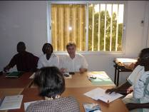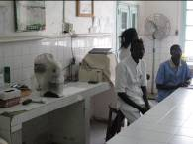
Figure 1: Meeting at Dakar in Fann’s Hospital Figure 2: Visit of Kaolack’s laboratory

  - Presentation of applications to end-users in Senegal related to m-health

Period: April 2012
Participation of VOICES partners: Orange, Fondation Mérieux and ESMT
Locations (Senegal): Dakar,

Target groups: Lab technicians, RNL.

Community building activities: presentation of the m-health applications to end users. This activity aimed at getting feedback from RNL and end users about the usability and usefulness of the services that had been developed. Lab technicians from different labs participated to these tests. These tests allowed us to involve in a more concrete and active way lab technicians in the project.

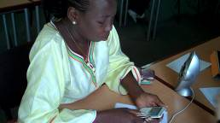
Figure 3: A lab worker testing the m-health services in Dakar

  - Field trip in rural regions in Senegal related to m-health

Period: October 2012
Participation of VOICES partners: Orange, Fondation Mérieux and ESMT
Locations (Senegal): Dakar, Khombole, Kaolack, Diamniadio, Touba, M’bourg, Kaffrine

Target groups: Lab technicians, RNL.

Community building activities: first cycle deployment, field trip to Senegal, visit of five laboratories. The goal was to meet end users and RNL after deployment of the m-health applications in order to get their feedback. Another objective was to include two more laboratories in the field trial. Feedback collected during the field trip was very positive and encouraging.
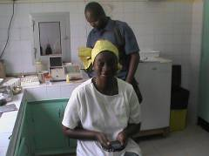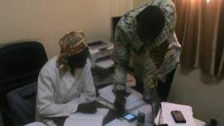
Figure 4: Meeting lab technician in Pout’s lab Figure 5: Lab technician from M’bour

  - Field trip in rural regions in Senegal related to m-health

Period: December 2012
Participation of VOICES partner: Orange
Location (Senegal): Dakar

Target group: Ministry of Health of Senegal

Community building activities: presentation of the m-Health project to the Health advisor of the Ministry of Health. Discussion about how to extend the m-health applications to other health sectors (e.g. health posts).

Community building activities for m-agro pilot

  - Community building Road Show – Mali, Burkina Faso, Northern Ghana

Period: 15-28 January 2011
Participation of VOICES partners: VUA, SE, WF
Locations: Bamako, Segou, Tominian, Bankass, Bandiagara (Mali), Gourcy, Ouahigouya, Ouagadougou (Burkina Faso), Bolgatanga, Tamale, Yamariga, Tongo-Beo (Ghana).

Target groups: Community radio stations, NGO partners (Réseau MARP, World Vision), agro- extension agents, local farmers, farmer organizations, local seed producers, local ICT practitioners and Web developers, academic partners from the University of Development Studies (UDS Ghana). Various rural communities.
VUA and partners WF and SE kick-started the VOICES project with a two-week road show through Mali, Burkina Faso and northern Ghana.

Community building activities: focus group discussions with smallholder farmers, workshops and demonstrations of voice technologies to all target groups, field visits to farms in Bandiagara, Gourcy, (Burkina Faso) official visits to rural communities in Yameriga, Tongo-Beo (Ghana). Various radio interviews. The VOICES project was presented during a live radio interview at “La Voix du Paysan”, a local radio in Burkina Faso.

Intended results
Create a common understanding of the local information needs, and share ideas. Use case and requirements analysis. Establish a relationship with local stakeholders to kick-start co-creation development of voice services.

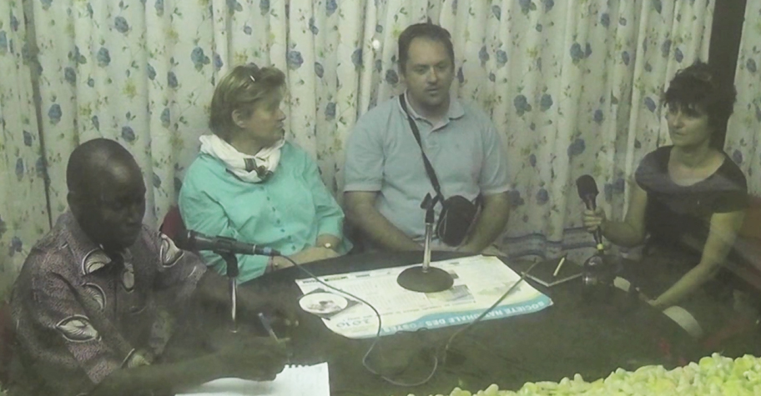
Figure 6: Radio interview, broadcasted life, to inform the listeners of this region in Burkina Faso, about the VOICES project. Mary Allen (SE) Stephane Boyera (WF) and Anna Bon (VUA) are interviewed by the radio animateur” of “La Voix du Paysan”, Gourcy, Burkina Faso, January 2011.

  - Community building with local stakeholders in Mali – November 2011
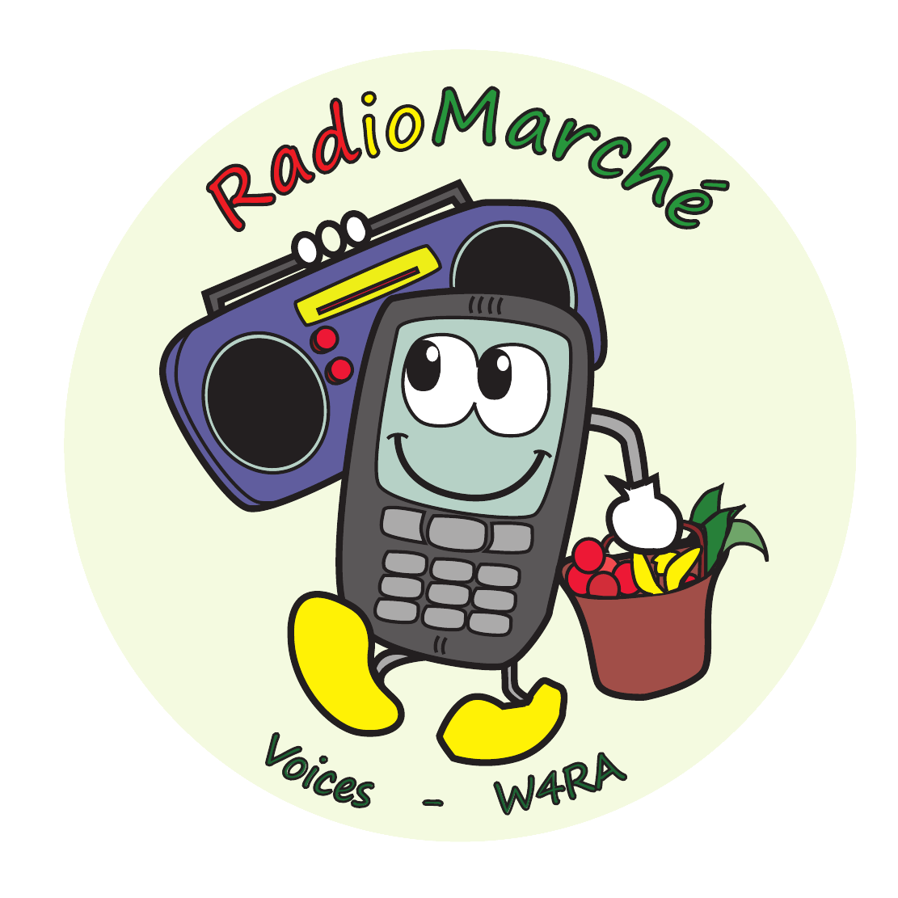
Period: November 12th - 19th 2011
Participation of partners: Sahel Eco, VUA, WF, CSIR, TNO
Locations: Bamako, Segou, San, Tominian
Target groups: Community Radio stations ORTM Segou and Radio Moutian,
Farmer organizations in Segou and Tominian, extension workers of Sahel Eco.

Community building activities: Focus groups discussions with local producers of shea butter and honey. First cycle deployment of m-Agro Pilot, through presentations and meetings with radio stations in Ségou and Tominian. Several meetings with Sahel Eco staff members in the field. Co-creation activities were focused at recording voice prompts in local language (Malian French dialect, Bomu and Bambara) and receiving feed-back on the first prototypes.

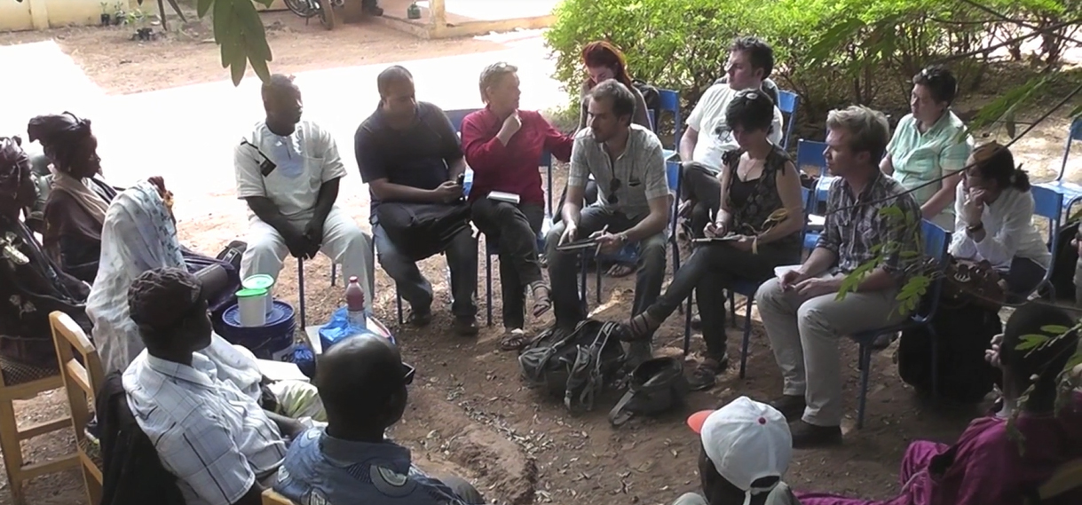

Figure 7: Focus group discussion of farmer representatives of the Segou region, Mali with VOICES group (VUA, WF, SE, CSIR, TNO), November 2011.

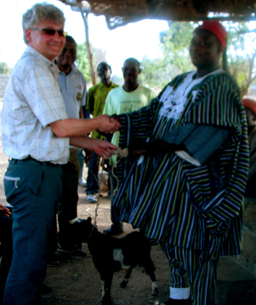
Figure 8: The Chief of the Tongo-Beo village, in northern Ghana allows audience to the VOICES WP5 team. As sign of the village Chief’s sympathy towards the project, and to enforce the partnership of his village with the team, he offers a goat (also seen on the picture) to VUA professor Hans Akkermans.

  - Foroba Blon: A project funded by the International Press Institute in support of Citizen Journalism and Community Radio in Mali
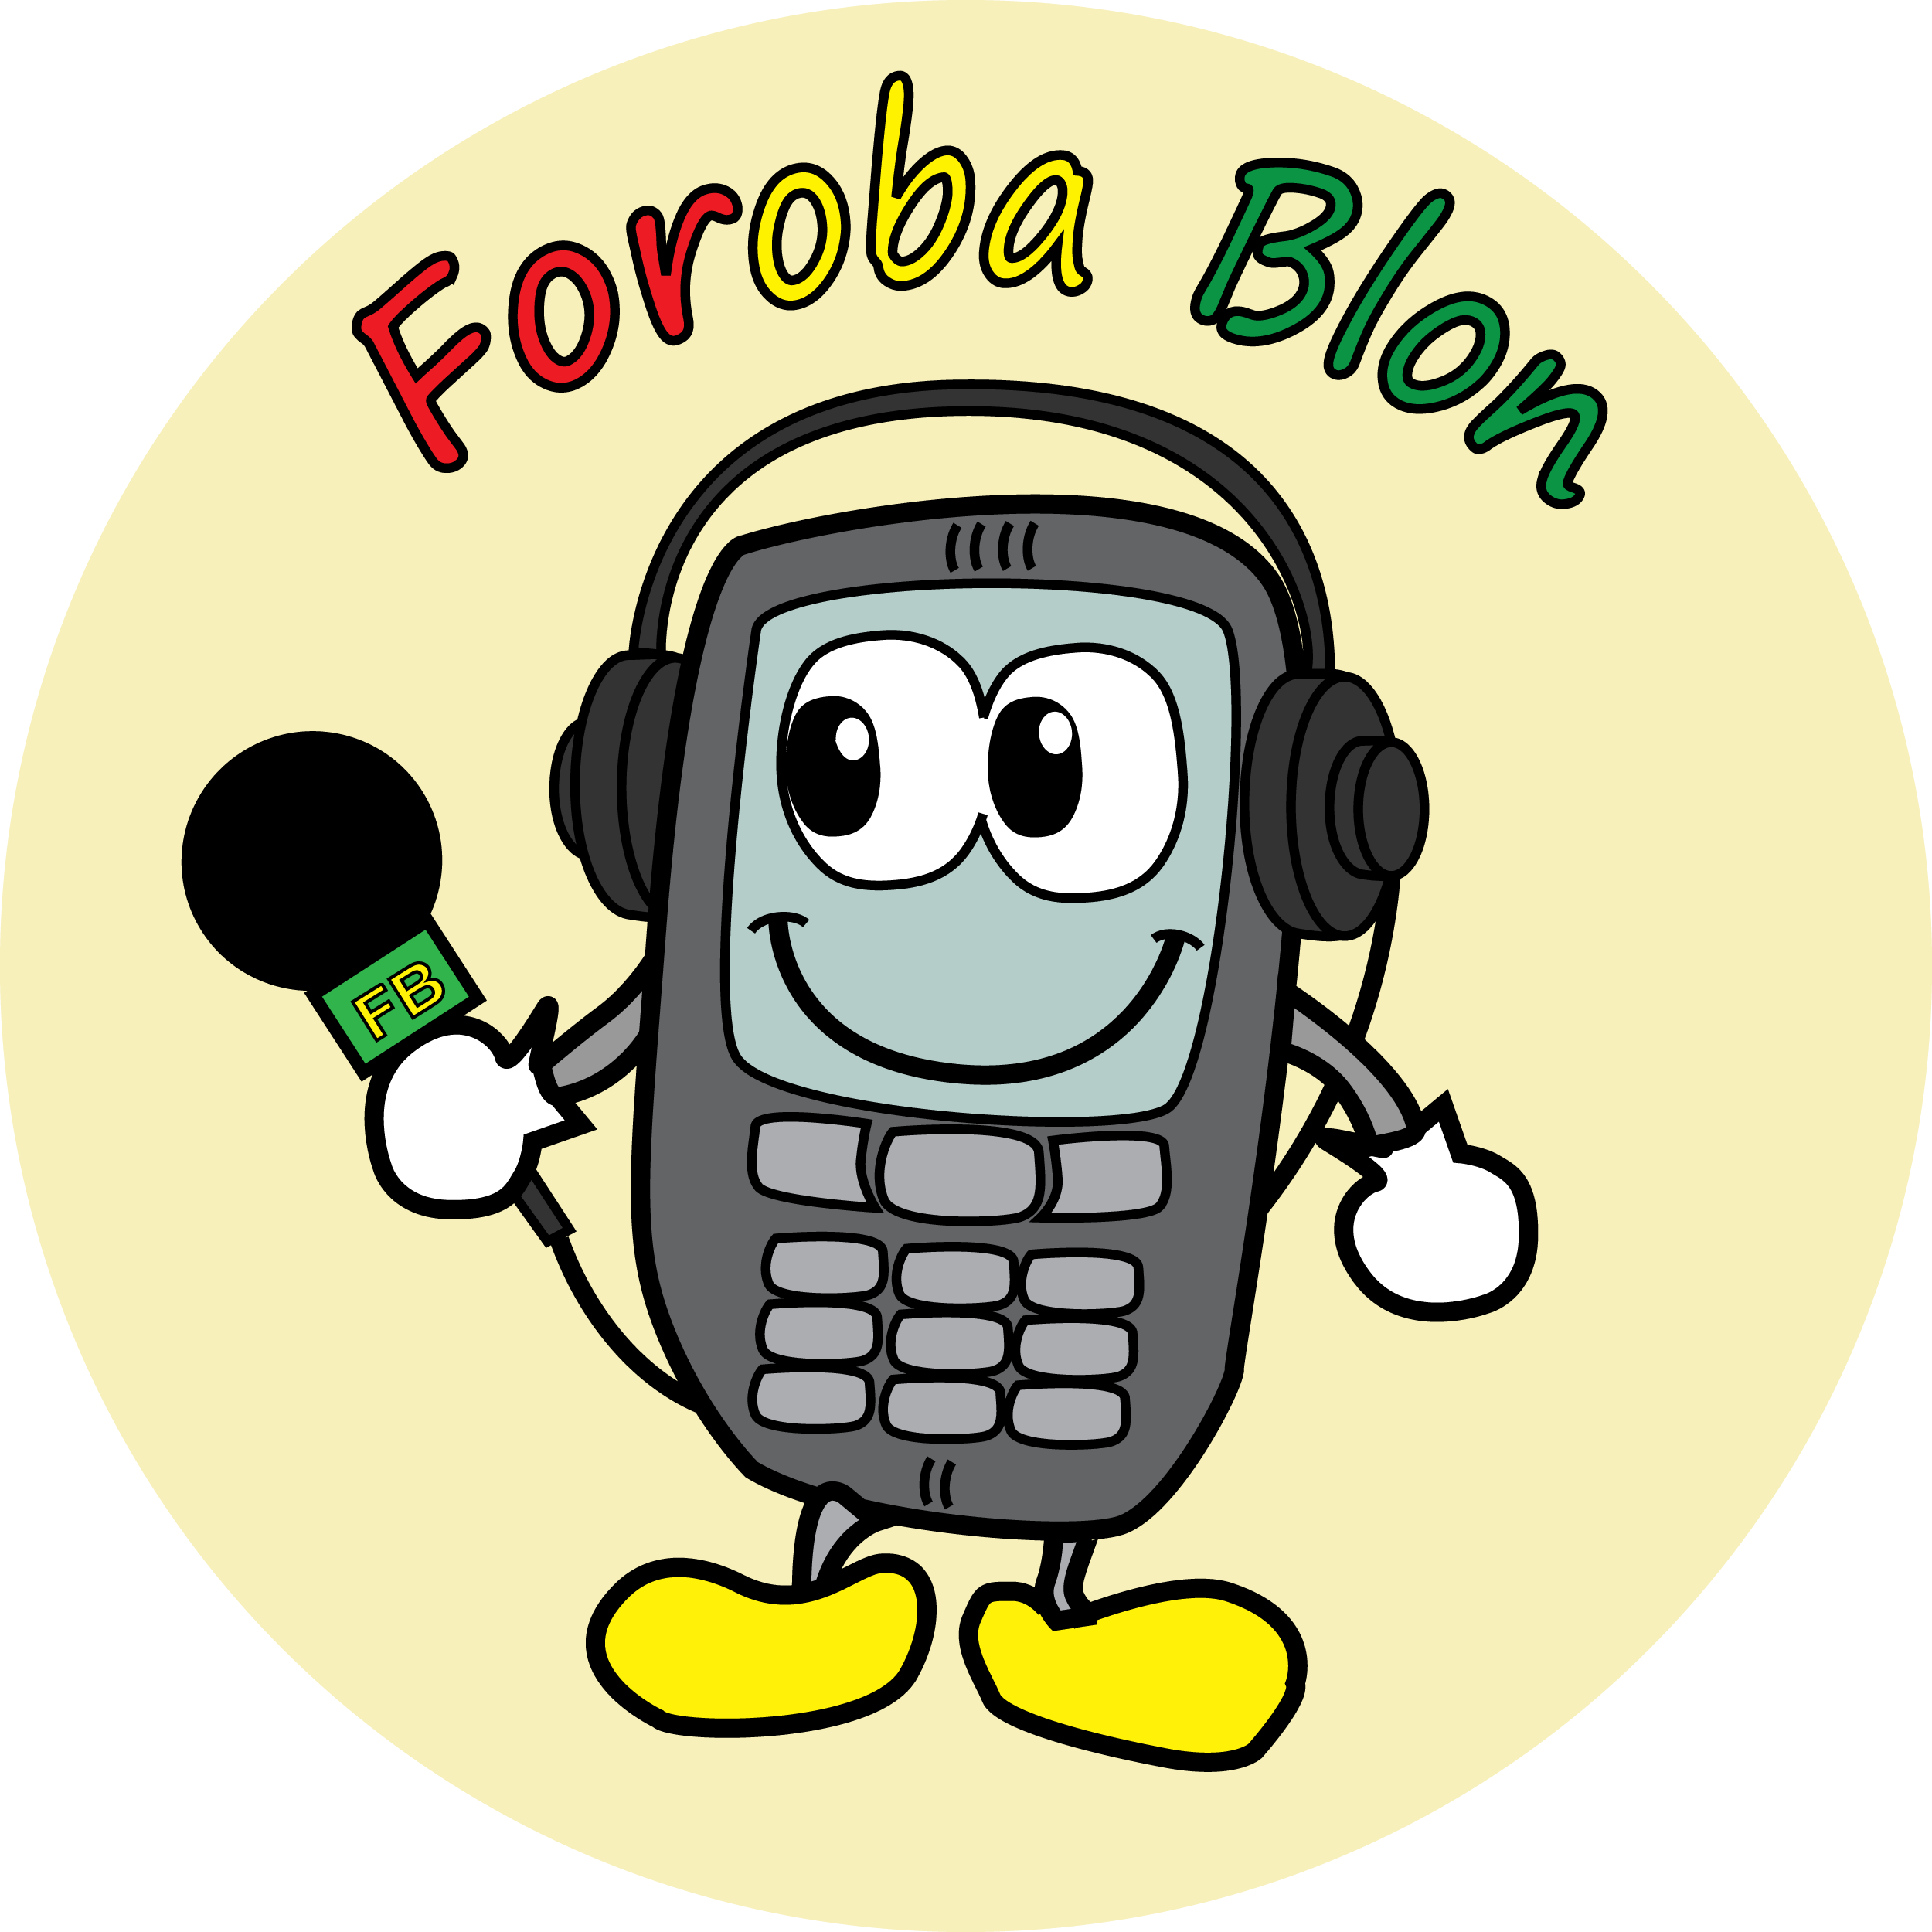

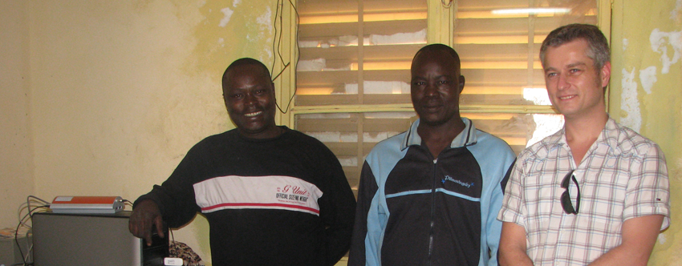
Figure 9: Meeting at Tominian, February 2012 Fltr: Gustave Dialla, Bakary (Radio Moutian) and Chris van Aart (VUA).

Period: 1st December-2011 - 1st December-2012
Project budget: funded by IPI: 240.000 EUR
Participation of VOICES partners: Web Foundation, VUA, Sahel Eco
Locations: Bamako, Segou, Tominian, Bankass, Mopti
Target groups: Community radio stations in Mali (partners are ORTM Segou, Radio Moutian, Radio Mopti, Radio Seno Bankass) and their village reporters and citizen journalists. Other community radios became interested in the adoption of the new technologies, after the first workshop.
Community building activities: February 12th – 16th 2012: Meeting local stakeholders in Bamako, and two radio stations in Segou, Tominian. Meeting NGO Farm Radio International in Bamako. Co-creation activities: recording of voice prompts, user feedback on the system. Collection of user requirements for development of new voice technologies.
Set-up a voice-based communication platform for local community radio stations and their stakeholders (Village reporters and listeners (rural communities in a radius of 100 km around the stations).
Intended results:
Community radio stations in Mali use the voice & web-based service to organize, manage and broadcast voice-based reports entered via mobile by village reporters, in the surrounding villages. (i) Allow village reporters to make a living (business out of their activities using the voice-platform. (ii) Listeners can react on radio broadcasts by entering messages via phone.
A community of users of the services, sharing information using the voice services and the radio. (iii)

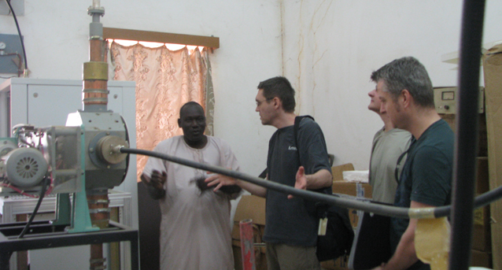
Figure 10: Max Froumentin (WF) and Chris van Aart (VUA) meeting journalist Fousseyni in February 2012 at ORTM Segou. Visit to technical installations.

  - Community building with local stakeholders in Mali – February 2012

Period: February 12-16th 2012
Participation of VOICES partners: Sahel Eco, VUA, Web Foundation
Locations: Bamako, Segou, San, Tominian

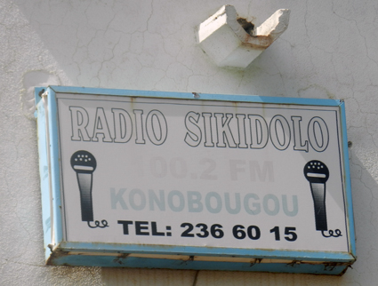
Figure 11: Logo of Radio Sikidolo, in Konobougou (Mali). This radio was not primarily selected for the WP5 pilot, but became interested in getting involved in the community of users of voice technologies for citizen journalism.

Target groups: Community radio stations in Mali who actively participate (ORTM Segou, Radio Moutian, Radio Mopti, Radio Seno Bankass) and their village reporters and citizen journalists. Community radios who are interested in adoption of the new technologies.
Community building activities: Second cycle deployment of m-Agro Pilot, through presentations and meetings with radio stations in Konobougou, Ségou and Tominian, focus group discussions with local producers, and meetings with Sahel Eco staff.
Intended results: facilitate communication amongst all stakeholders, establish a good working relationship to ensure adaptation and uptake of the VOICES results. Fine-tuning the VOICES results according to the requirements of the communities.

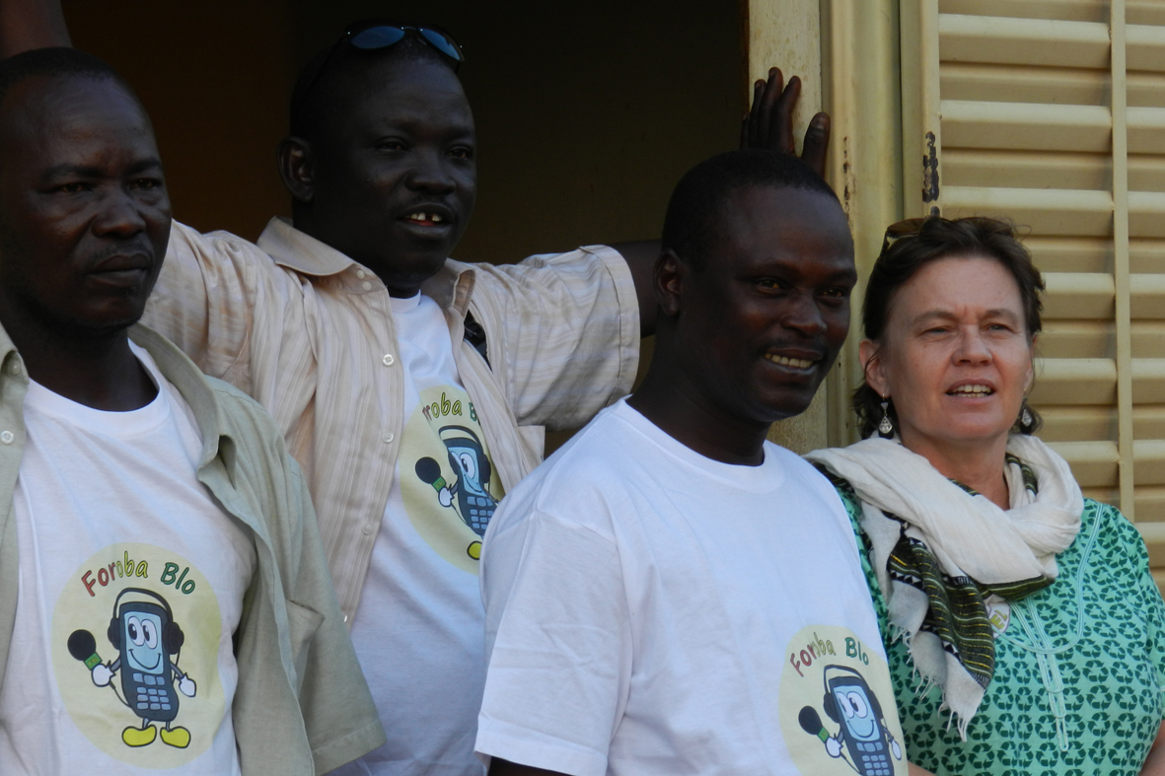
Figure 12: Radio journalists Bakery and Dialla at Radio Moutian and Amadou Tangara (SE) all wearing Foroba Blon project logo T-shirts. Mary Allen (SE) is wearing a green “Sahel Eco Regreening” dress.

  - Community building with local stakeholders in Mali – November 2012
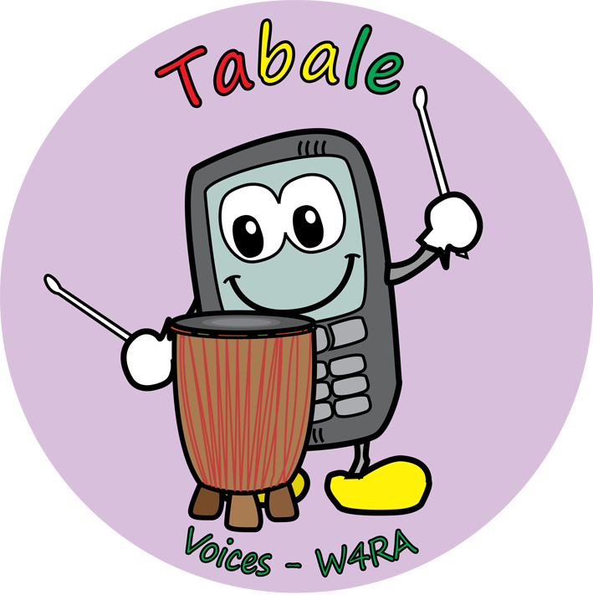
Period: November 11th - 20th 2012
Participation of partners: Sahel Eco, VUA
Locations: Bamako, Segou, San, Tominian
Target groups: Community Radio stations ORTM Segou and Radio Moutian,
Farmer organizations in Segou and Tominian, extension workers of Sahel Eco.
Community building activities: Second cycle deployment of m-Agro Pilot, through presentations and meetings with radio stations in Ségou and Tominian. Several meetings with Sahel Eco staff members to evaluate the newly developed system Tabale. Co-creation activities were focussed at recording voice prompts in local language and receiving feed-back on the latest adjustments. Focus groups discussions with local producers of shea butter and honey. Training of a group of farmers, how to use the mobile interface to the Tabale system.
Collect information for a publication on the used methodology, in co-creation with the Malian stakeholders.
Intended results: Collect user evaluations on the voice-based systems. Adjust and fine-tune the systems according to the validation and verification by end-users. A scientific paper published on the methodologies for use case and requirements analysis in a multi-disciplinary multi-cultural team, involving end-users actively. The paper (Use case and requirements analysis in a Remote Rural Context in Mali) has recently been accepted for publication, and will be presented at the REFSQ 2013 Conference in Essen, Germany.

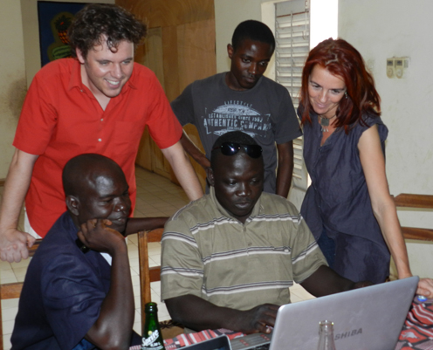
Figure 13: End-user evaluation of second cycle of the m-agro pilot in San, Mali. VUA researchers Victor de Boer, Nana Gyan and Wendelien Tuyp, and Sahel Eco staff members Drissa and Tangara are testing and evaluating the Tabale system.
5.6 Proposal: Regional Initiative for Food and Water regarding Knowledge-Sharing and (Two-way) Communication Facilities

Period: TBD, intended period 3-5 years project starting 2013. Still to be approved.
Participation of VOICES partners: VUA, Sahel Eco, Web Foundation
Locations: Rural areas in five Sahel countries: Mali, Burkina Faso, Niger, Ethiopia, Kenya
Target groups: Rural communities in these countries involved in Regreening, local NGOs, community radio stations.
Community building activities: November 2012 this proposal was submitted to DGIS (Dutch Ministry of Foreign Affairs) by a consortium led by ICRAF (International Centre of Research of Agroforestry), including VUA together with Web Foundation. It proposes to support the initiative by implementation and roll-out service facilities/technologies that are suitable for mass deployment in remote and rural areas in Africa.

Intended results: The proposed contribution by VUA/W4RA is to set up and deploy, in the countries addressed by the Regional Initiative for Food and Water, a service platform for knowledge spreading, sharing and two-way communication in rural and remote areas. It integrates multimedia Web content hosting (visual/text content as well as speech content such as radio broadcasts, spoken news items, posted voice messages) with voice-based interaction services
That can be accessed and used via simple mobile phones. Key target users are NGOs, extension workers, leading farmer innovators, village representatives, and rural community radio stations, involved in the initiative. Sahel Eco is one of the partners involved and targeted by this proposal, for Mali. Local NGO Réseau MARP is the key partner for Burkina Faso. Another NGO: CARE is the key partner for Niger.

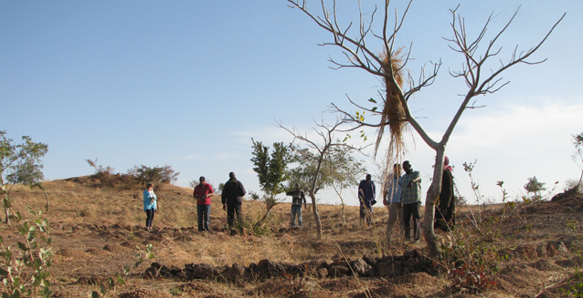
Figure 14: Field of farmer innovator Ousseini Kindo in the Gourcy area, Burkina Faso, January 2011. WP5 team and local NGO Reseau Marp. These are partners in the Food & Water Initiative for this region.
5.7 Community building: Master’s course ICT4D @ VUA

Period: 1-31 January 2013, to be continued in the following years.
Participation of VOICES partners: VUA, (also using training materials from WF).
Location: Amsterdam, NL

Target groups: Master students in Computer Science, Information Science and Artificial Intelligence of VU University Amsterdam who want to learn about ICT.

Community building activities: A group of three students develop a mobile, voice-based system for entry and processing of market data, in different languages. The system is closely related to the m-agro pilot, specifically designed and built using the requirements and use case of the rural communities in Mali, who are currently involved in the VOICES m-agro pilot. This prototype is an extended module for the already implemented first cycle system of WP5: named RadioMarché. The student’s prototype will be tested and deployed in Mali, during the next field visit, scheduled in April 2013.

Intended results of the ICT4D course:
In the developed world Computers are ubiquitous, and ICT has rapidly grown into a critical asset for economic, technological, scientific and societal progress. The main objectives of this course are:
- to make the next generation of Computer Scientists aware of:
  - The importance of ICTs for the developing world and the unexpected way developing countries are leapfrogging into the information age
  - The opportunities and challenges that exist for an information scientist in the area of 'development4development'
  - The influence of context in a typical ICT4D project
  - The complexity of deploying an ICT project within a development context, and how to tackle this.

- to equip the students with some initial project management, technological and programming skills specific to an ICT deployment in a developing country.
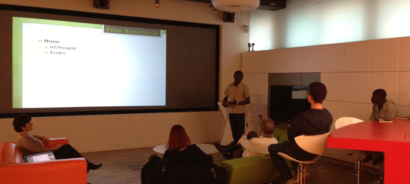
Figure 15: Student of VUA (Computer Science department) presenting a research proposal related to VOICES.
In the ICT4D course several African students participate, who have links with partners in their home countries: Ghana, Ethiopia. They intend to help further the VOICS results in their own regions and encourage community building.

  - Other community building activities related to global communities
Period: started 2011- ongoing
Participating VOICES partners: VUA
Location: global
Target groups: Partners who want to become collaborators and help maintain and further the results of the VOICES project in the African context, beyond its lifetime. This group includes e.g. SMEs, NGOs, local governments and governmental agencies, experts in development, ICT service providers, local African academic partners, communities of (web, ICT) developers.
Community building activities: VUA is currently working, in collaboration with Orange Labs, to ensure the sustainability of the Emerginov Voice platform, beyond the lifetime of the VOICES project. Emerginov is developed in WP2 by Orange Labs, and is recently released as Open Source software. VUA wants to ensure sustainability of the voice platform by:
- Setting up a global community of developers of voice technologies, as to set up a common-based peer production system;
- Set up long term arrangements with Orange Mali, to ensure that phone lines will be available after the end of the VOICES project;
- Doing research on possible alternative (robust, inexpensive) voice platforms that can be hosted locally in African environments;
- Testing inexpensive alternative setups that may be deployed locally by partners not related to VOICES;

Vision: Positioned at the heart of the VUA's vision of social relevance as one of the guiding principles, the core aim of the course is to raise the awareness that we as Computer Scientists can make a significant difference by sharing our expertise according to well established principles of international development. We present initiatives in which VUA is involved in: a project to use voice technology for local data exchange in small markets in Mali.

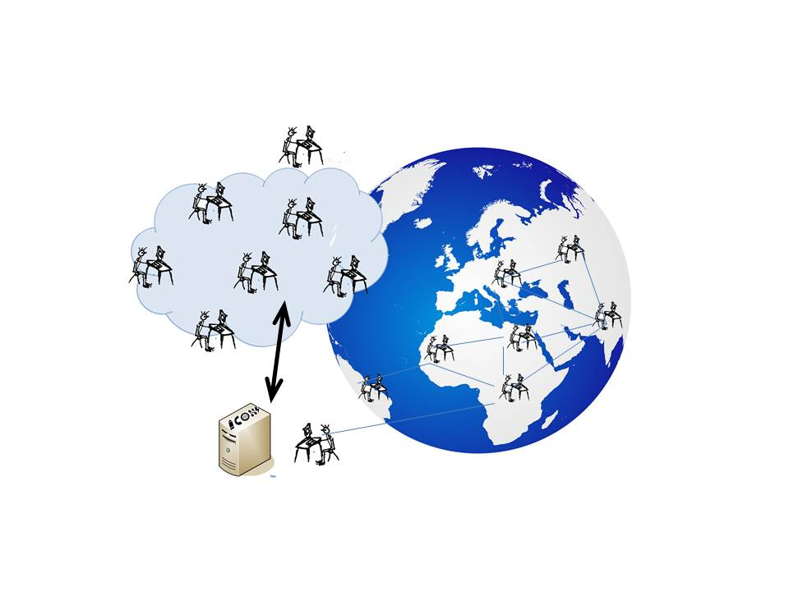
Figure 16” This picture visualizes the global “community of voice & web developers” that VUA is aiming to establish, that is to support the results of VOICES over a longer period of time, to ensure sustainability.
The new ICT4D course (started in 2013) is one of the activities that supports this vision.

  - MPOWER – A new proposal for further deployment of VOICES results

Period: 1st September 2013 – 1st September 2016 . The proposal has still to be approved.
Participation of VOICES partners: VUA, NWU, Sahel Eco, WF
Location: Mali, Burkina Faso, Ghana

Target groups: Rural communities in the Sahel countries, SMEs, NGOs, local governments and governmental agencies, experts in development, ICT service providers, local African academic partners, communities of (web, ICT) developers.

Community building activities:
VUA has developed this proposal, in collaboration with SE, NWU and WF, and two other African partners for continuation and further deployment of VOICES activities and results towards Burkina Faso and Northern Ghana.
Other consortium partners are: Réseau Marp (a local NGO in Burkina Faso), University of Development Studies, Ghana, SB Consultancy. Associate partners are 10 radio stations in Burkina Faso and Mali. A local ICT SME in Burkina Faso (Yam Pukri).
This proposal has been submitted to EuropAID on 7 February 2013 regarding a call from ACP-EU Science and Technology II.
Name of the proposed project is MPOWER: Mobile Participatory knOWledge sharing for Regreening.

Intended results of the MPOWER project:
- Further development of voice technologies and toolbox adapted to the local contexts;
- Deliver tool support and methodology for speech technologies as to facilitates the local creation of content in African languages;
- Build new language packs for under-resourced languages for northern Ghana and Burkina Faso;
- Facilitate local uptake of results of the VOICES project;
- Transfer of knowledge to local partners in voice technologies, entrepreneurship, end-user support;
- Build local capacity of African academic partners in methodologies related to VOICES;
- Ensure overall long term sustainability of VOICES results after the end of the VOICES project.

  - Development of Project Proposal and Submission to Comic Relief

Period: April – August 2012
Participation of VOICES partners: WF, SE, NUW
Locations: Working remotely (Email, Skype) plus one F2F meeting in London (Europe)

Target group: Comic Relief (http://www.comicrelief.com/home) is a major independent UK-based donor organisation working to achieve a just World free from poverty. Its Trade programme focuses on sustainable and equitable wealth creation for small-scale producers and workers in global supply chains in all countries in Africa, and also supports work which engages partners along the supply chain, whether in implementing countries or internationally, including consumers.

Community building activities: A concept note and full proposal were developed and submitted to Comic Relief for a project entitled: Voice-based trading platform for small-scale farmers in Mali. A demonstration of the technology involved was made to one of the Project Assessors at a face to face meeting in August 2012 (see presentation overview). The project will build on results of the Voices project (WP5) to deploy a new generation of interactive voice-based Agricultural Market Information System (AMIS), directly accessible to illiterate producers speaking Bambara, the most widely used trading language in West Africa and to develop a self-sustaining business model and cost effective remote training strategies to scale-up from 670 to 4000 users.

Intended results
The project aims to demonstrate that voice based systems can provide a pro-poor, pro-female and cost-effective alternative to more conventional AMIS, replicable in other countries, contexts and languages and which can help small scale producers overcome unfair barriers to trade. In November 2012 Comic Relief awarded a grant of £250,000 to co-fund this £500,000 project over 3 years. WF, SE and NUW are seeking partners to secure the remaining funds required.

Conclusion

In this report we presented the activities of the VOICES consortium, aimed at social networking and community building. All activities since the start of the VOICES project, in January 2011, up to present (M27) March 2013 are reported.

The goals of these activities are to support the establishment of local communities that will adopt, use and sustain the results beyond the lifetime of the project, and to enhance uptake and ensure sustainability of its results and its adaptability to the African context through the establishment of communities of practice.

The VOICES project has identified two different target groups that are addressed in community building activities. These are local stakeholders who benefit directly or indirectly from adoption and use of the project results, and local or global partners who want to become collaborators and help maintain and further the results of the VOICES project by adopting them in their own business or work, or by providing assistance to end-users.

Many community building activities have been initiated and supported by the VOICES consortium, as part of the VOICES project, or as a spin-off of the VOICES results. Several of these activities have already led to new successful partnerships, whereas new collaborations and projects have emerged.

No final conclusions can be drawn before the end of the VOICES project, but there are strong indications that local partners are willing to continue the partnerships and further deployment and diffusion of the project results. Several of the partners of the VOICES consortium already have set up joint initiatives to build on the results of the VOICES project. We expect to present more evidence of this commitment, at the final conference of VOICES.

We in this document refer to connections and social interactions between people as social networks. Social networks should not be confused with social media.
W4RA, Web Alliance for Regreening in Africa, http://www.w4ra.org
This is described in D 1.1 and D 5.1.
REFSQ2013 :19th International Working Conference on Requirements Engineering: Foundation for Software Quality
See http://www.reseaumarpbf.org
See http://www.care.org
Dev4d : development for development, a new field of research, related to ICT4D

