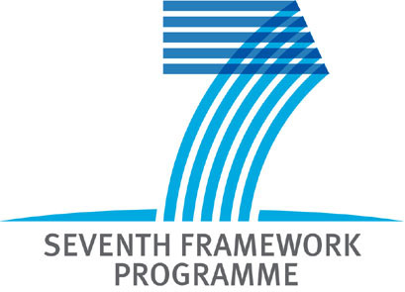 | Project Acronym: Giraff+  Project Title: Combing social interaction and long term monitoring for promoting independent living  Grant agreement no.: 288173  Starting date: 1st January 2012  Ending date: 31st December 2014



D7.1 Brief project presentation in English

WP related to the Deliverable: | 7
Nature: | R
Dissemination Level : | PU
Version: | V0.4
Author(s): | OrU, Giraff
Project Participant(s) Contributing: | OrU, Giraff
Contractual Date of Delivery: | 20120229
Actual Date of Delivery: | 20120229

Deliverable Summary

This document provides a short description in English of the Giraff+ project.

Table of Contents
1 Introduction 3
1.1 Scope of the document 3
1.2 Deliverable structure 3
2 Brief Project Description in English 3
2.1 Summary 3
2.2 Impact 3
2.3 Technical Approach 3
2.4 Project Info 3
2.5 Participants 3

Introduction

Scope of the document
The document summarizes the Giraff+ project and its main components in English. The document is a technical description of the project and its working methodology. This document can be used as basis for generating more popular text for dissemination material e.g. brochures.

Deliverable structure
The document contains an overview of the Giraff+ system, a description of its impact and finally provides a brief outline of the workpackages and their timings.

Brief Project Description in English

Summary
The prolongation of independent living for promotion of a healthier society is a social and economic challenge. Most elderly people wish to remain in their homes as long as possible as this is in general conducive of a richer social life and paramount to maintaining established habits. To adhere to this wish is also positive from an economic perspective as the cost of care at home is almost always much less than the cost of residential care. However, several issues need to be addressed in order to prolong independent living. One is early detection of possible deterioration of health so that problems can be remediated in an early stage and timely involvement of health care and family can be assured. A second issue is to provide adaptive support which can offer services to assist in coping with age-related impairments. Third, ways of supporting preventive medicine must be found as it has been increasingly recognized that preventive medicine can contribute to promoting a healthy lifestyle and delay the onset of age-related illnesses. It is indeed increasingly apparent that it is more cost-effective for an ageing society to invest also in methods for prevention rather than focusing only on the treatment of the illness when it occurs.

The Giraff+ project aims at developing a system that addresses the above challenges. The system consists of a network of home sensors that measure e.g. blood pressure or temperature, or detect e.g. whether somebody occupies a chair, falls down or moves inside a room. The data from these sensors are interpreted by an intelligent system in terms of activities, and health and wellbeing, e.g. the person is tired or well rested or the person is going to bed,. These activities can then trigger alarms or reminders to the person or his/her caregivers, or be analysed over time by a health professional. The system should automatically adapt to perform specific services such as checking the person’s sleeping patterns. There is also a telepresence robot, the Giraff, which can be moved around in the home by somebody connected to it over internet, e.g. a caregiver. The Giraff is effectively a mobile communication platform, equipped with video camera, display, microphone and speakers, and it helps the user to maintain his/her social contacts. Particular emphasis is put on user evaluation outside the laboratories. The Giraff+ system will be installed and evaluated in at least 15 homes of elderly people distributed in three European countries (Italy, Spain and Sweden). These evaluations will drive the development of the system. The concept of “useworthiness” will be central in order to assure that the Giraff+ system provides services that are easy and worth using. In addition, by using existing and affordable components (besides the Giraff robot also sensors from two participating companies: Tunstall and IntelliCare) we strive to achieve a system that is affordable and close to commercialization.

Impact
In order to sustain a good quality of life for an aging population, independent living is a key requirement. Three elements must be in place: 1) the elderly must be of sufficient health to live safely at home; 2) there must be of the opportunity for good social interaction habits within the home to avoid isolation and loneliness; 3) intervention must occur in a timely fashion that is beneficial to the elderly and efficient for the caregiver system.

Creating an infrastructure to continuously monitor activities of persons in the home enables an assessment of health degradation in a manner which has not been previously possible. Such an assessment aims to contribute to a reduction in healthcare costs as many health ailments can be addressed in an early stage of on-set. For the elderly, the concept presented in this proposal provides a tool to address concerns about isolation and safety by encouraging social contact and thereby increasing quality of life and possibilities to prolong independent living. For the caregiver, the specific technologies developed in this project allow for continuous information about the status of the elderly, encourage a meaningful interaction concerning patient wellbeing, enable timely involvement, provide time effective care and not least lead to economical savings.

The integration and deployment effort put forth by this project constitutes a significant step towards applying artificial intelligence in a real-world context where usual simplifying assumptions cannot be made. Thus in addition to providing solutions for an extremely important future market niche for European industry, this project will have a strong impact with respect to the advancement of European excellence in smart environment development.

Technical Approach
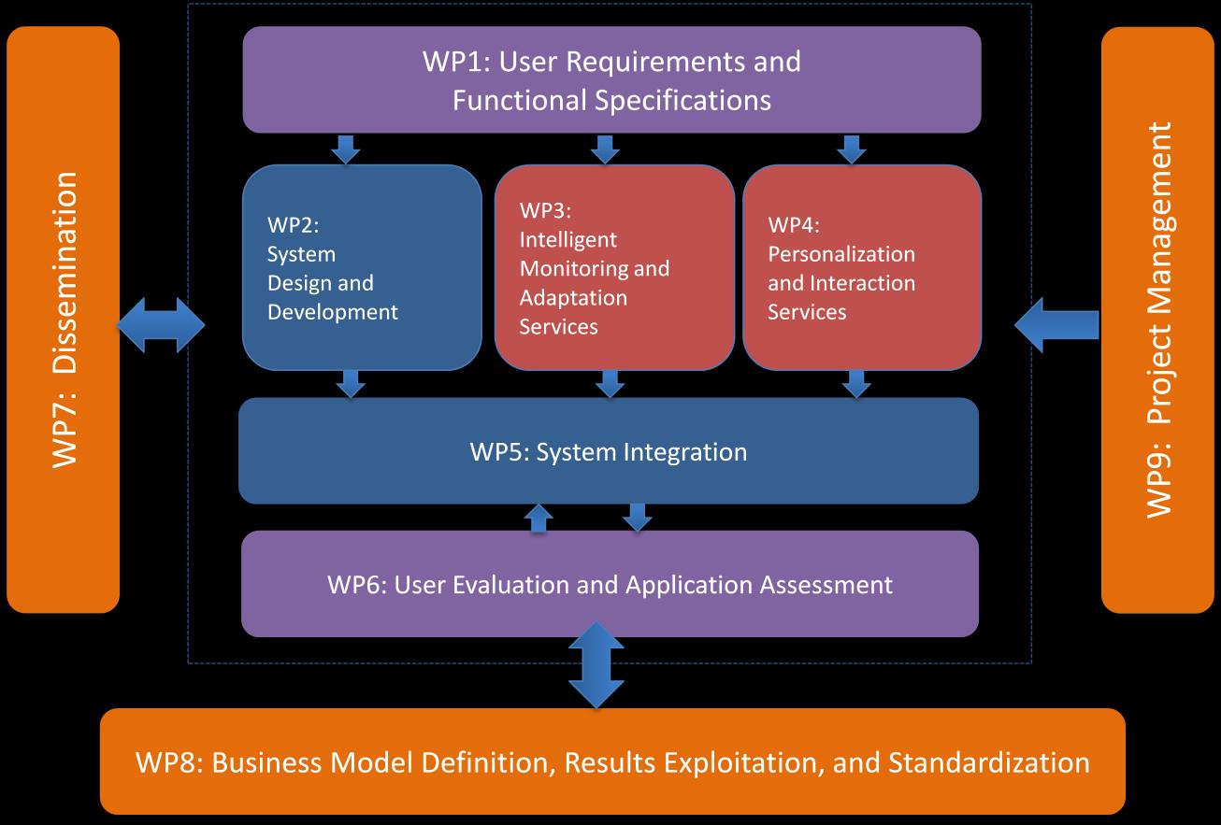
The overall strategy of the work plan is driven by the user requirements and a functional specification of the Giraff+ system. The phase of concrete system development is organized around an iterative process of technical implementation and validation/evaluation. Three major aspects can be identified: system, services and evaluation. Two work packages are dedicated to the system development: WP2 focuses on the development of the basic components of the Giraff+ physical system and basic infrastructure and WP5 is dedicated to system integration and testing. Two work packages are focused on service development: WP3 contends with context recognition and configuration planning and WP4 focuses on development of the personalization service and a number of interfaces needed to present the services to diversified users. Two work packages are dedicated to user evaluation. The work started in WP1 with the collection of user requirements and the definition of a functional specification of the system is continued in WP6 where a thorough user evaluation of the system is performed. The important aspects of exploitation and dissemination of the achieved results are covered in WP8 and WP7 respectively. A WP9 of Project Management completes the work plan.

The motivation of the development-evaluation cycle is to (1) involve the users early in the process and allow their input to drive the development of the Giraff+ system and (2) enable the Giraff+ system components to develop each at its own pace. The aim is to have a deployable system early in the project which can be tested and evaluated. When new versions of the system have been verified in lab conditions, they can be re-deployed for evaluation at the test-sites. Re-deployment can be viewed as one approach to maintaining interest for users to volunteer as test-site while the regular input from the users and demand for more advanced services and new functionalities will require that the technology is continuously developed to its full capacity and the scientific objectives are pushed forward. Finally, the input of users during the iterative cycle may also push the scientific research and the technological development in other directions, perhaps non-foreseeable at the project start in a manner which differs from traditional projects which are driven by the developers of the technology alone.

In Giraff+, the business model development is to be woven with the evaluation activities and consequently, the iterative approach also allows for user evaluation to be a major driver for the development of the business model and the exploitation strategy. Part of the user evaluation will be dedicated to investigate the potential for the services to be commercialized either through purchase or leasing models. From the onset of the project, all system architecture, functional specifications, feature development and other major technical decisions will be evaluated against the emerging business model. In particular, feasibility of these issues with respect to practical cost, implementation and support considerations will be assessed. Interoperability, adherence to (or development of) relevant standards, and “open source” philosophy are all key factors in these assessments.

Project Info
Project Acronym: Giraff+
Project Title: Combing social interaction and long term monitoring for promoting independent living
Grant agreement no.: 288173
Starting date: 1st January 2012
Ending date: 31st December 2014

Coordinator Contact: Silvia Coradeshchi, tel: +4619303298, email: silvia.coradeschi@oru.se
Coordinator Organization: Örebro University, Örebro 70182, Sweden

Participants
Participant organisation name | Country
Örebro universitet | Sweden
Lund universitet | Sweden
Universidad de Malaga | Spain
Giraff Technologies AB | Sweden
Consiglio Nazionale delle Ricerche ISTC | Italy
Consiglio Nazionale delle Ricerche ISTI | Italy
IntelliCare - Intelligent Sensing in Healthcare, Lda | Portugal
Tunstall Healthcare | UK
Mälardalen universitet | Sweden
Örebro County Council | Sweden
XLAB | Slovenia
Azienda sanitaria locale Roma/A | Italy
Distrito sanitario costa del sol | Spain

