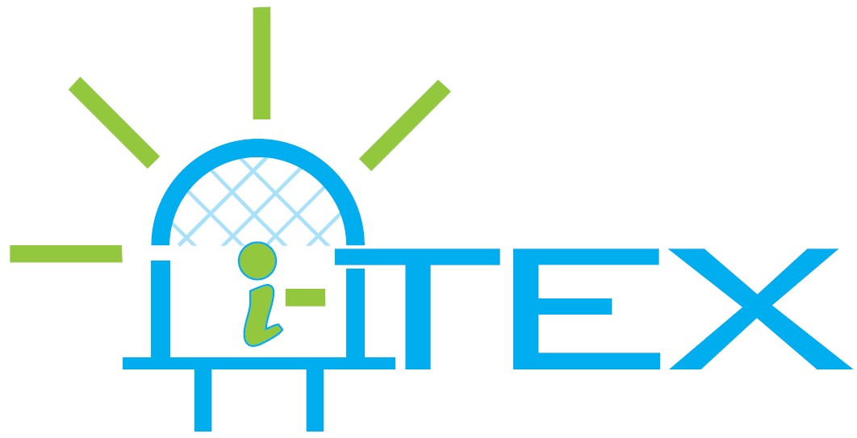

FP7-ICT-2011-7

i-Tex

Intelligent and luminous textiles

Contract Nr: 288262

Deliverable: D8.1 – Public summary of project

Due date of deliverable: month 1
Submission date: 21/9/2012

Start date of Project: October 1, 2011 | Duration: 36 months

Responsible WP: PHILIPS

Revision: accepted

Dissemination level
PU | Public

DOCUMENT INFO

Author

Author | Company | E-mail
Giovanni Cennini | Philips | giovanni.cennini@philips.com
Ernst Hermens | Philips | ernst.hermens@philips.com

Documents history
Document version # | Date | Change
V0.1 | Nov. 2011 | Starting version, template
V0.3 | Dec. 2011 | Proposed version
V0.4 | Jan. 2012 | Final version, submitted to the EC
V0.5 | Sept. 2012 | Website link included & Approved by Giovanni Cennini

Document data
Keywords | Project summary
Editor Address data | Name: Giovanni Cennini  Partner: Philips  Address: High Tech Campus 34, Eindhoven  Phone: +31-402747738  Fax: -  E-mail: giovanni.cennini@philips.com
Delivery date | 21 September 2012

Table of Contents

0 DOCUMENT INFO 2
0.1 Author 2
0.2 Documents history 2
0.3 Document data 2
1 ABSTRACT 4
2 Public summary 5
3 CONCLUSIONS 6

ABSTRACT
This deliverable provides the public summary of the i-Tex project.

Public summary
Driven by advances in R&D and in inorganic light-emitting diodes (LEDs), the Lighting industry is expected to change substantially in the next five years. At the same time, a shift in the value chain from components (LEDs) towards intelligent lighting systems is expected. This technology trend is mirrored by similar market trends substantiated by end-users expectations for miniaturization of electronic devices and integration of intelligence in light emitting devices. Consumers will wish to have a more pervasive presence of intelligence (e.g. to communicate, to display information, and to process data). In order to lead in R&D as well as in manufacturing and market applications, the European Lighting industry has to fully harness the potential of the inorganic LEDs-based illumination by investing in new technologies that will allow for new types of lighting solutions via cost-competitive highly reliable manufacturing processes. These future energy efficient lighting solutions will not only drive and be driven by requirements of low total ownership costs (e.g. in B2B sales), but will also take into account new consumers’ needs such as a more pervasive intelligence, novel design possibilities and novel user interfaces.

i-Tex targets the Research, Development & Production feasibility of large area intelligent lighting systems based on smart coated textiles. Although numerous research projects have investigated smart textiles with LED integration, none of them has targeted the development of technology and system architecture for reliable large area illumination systems. The main reasons for this are
1) The high costs and complexity in manufacturing of such smart textiles,
2) Demanding reliability requirements of general illumination requirements and
3) The optical output needed for lighting applications.

The i-Tex project proposes to overcome the above limitations by research and development of:
• novel large area system architectures for electronic interconnections and thermal management of inorganic LEDs in coated textiles
• cost-competitive roll-to-roll (RTR) manufacturing processes for the heterogeneous integration of lights, sensors in coated textiles. • novel material classes (e.g. tunable pigments) for new appearances and high optical output.
• concurrent reliability study and robustness approach over the entire value chain of the targeted products.

By identifying a number of indoor and outdoor applications for intelligent functional, and decorative lighting, we will be able to define sets of clear product specifications. Based on these requirements we will simultaneously develop unique large area interconnections for LEDs and other electronics, identify the most appropriate coating technique and coating materials for RTR manufacturing, investigate smart textile optics, resulting in a smart system with high reliability and high optical output.

Public website i-Tex: http://www.i-tex.nl/

CONCLUSIONS
This public summary consists of may be used for dissemination and consists of about 420 words and about 2500 characters.

